**Admin Manual**

Contents

Overview 1

Installation 2

Database Setup 2

Run server 4

Admin Account 5

Administration Tasks 6

User Management 6

Product Management 7

Update Product 7

Delete Product 8

Create new product 9

# Overview

This manual is addressed to users who want to run the source code. It gives installation instructions, describes post-installation tasks, and provides information about administration tasks.

Guide to this Document:

The document is organized as follows:

* Installation
* Database Setup
* Run server
* Admin account
* Administration tasks

User management

Product management

Update Product

Delete Product

Create Product

# Installation

The major tasks involved in Installation are:

* Install Visual Studio Code (recommendation)
* Install MongoDB
* Install NodeJS

# Database Setup

In MongoDB Compass,

1. create new database named web_SQA, and create 3 new collection named as 3 files in folders db

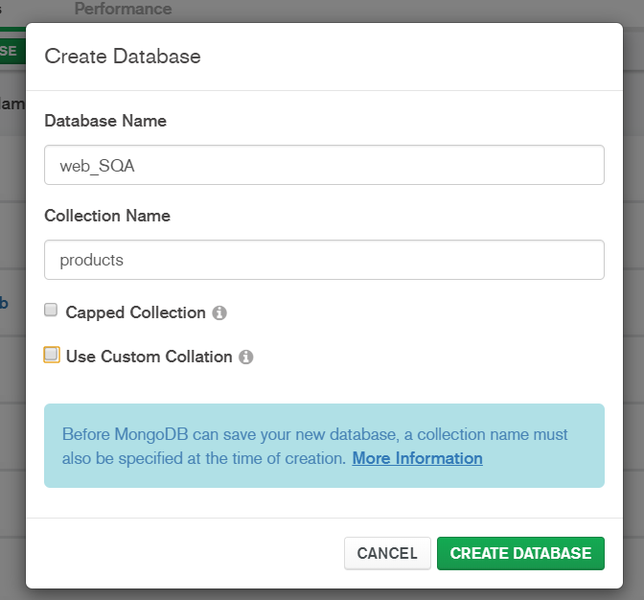

1. Import 3 files below which are in db folder to the web_SQA database

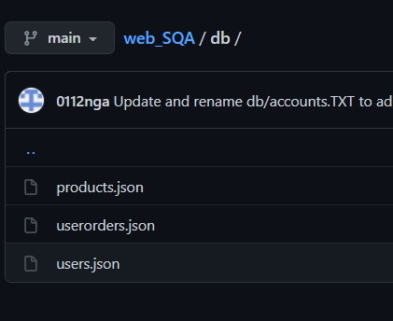

# Run server

To run your web server, in command:

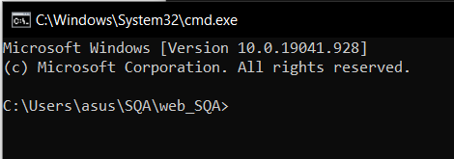

* Type “npm install” to install modules:

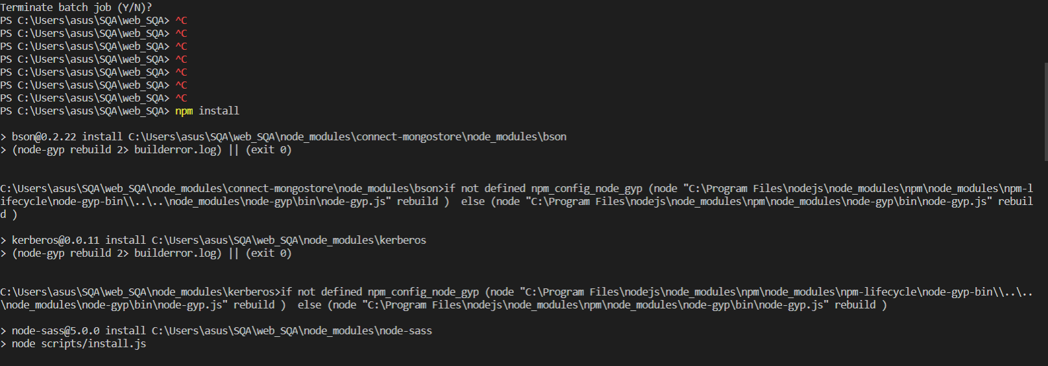

* Type “npm start” to run web server:

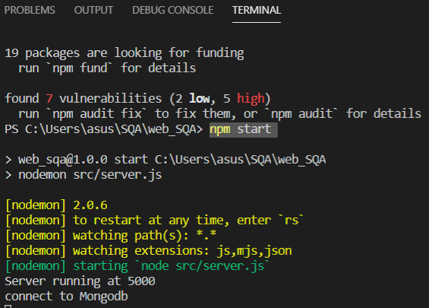

* Visit http://localhost:5000 and you will see Kimi Cosmetic Website.

# Admin Account

Admin account for login:

email: admin@test.com

password: 123456

You can access to website to be administrator to gain access to privilleges as following : editing, adding, removing and updating products in the database.

# Administration Tasks

When you log in by using admin account, you will see 3 following functions in the Nav bar:

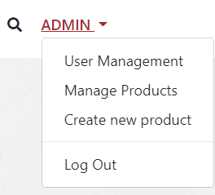

## User Management

This will display list of orders of users as below and allow you to change status of the user’s orders

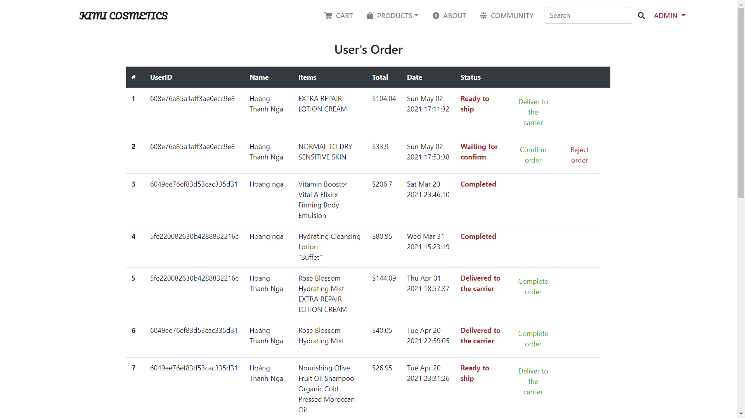

Click the green statement status if you accept the order status, click “reject order” if not.

## Product Management

This will display list of products as below:

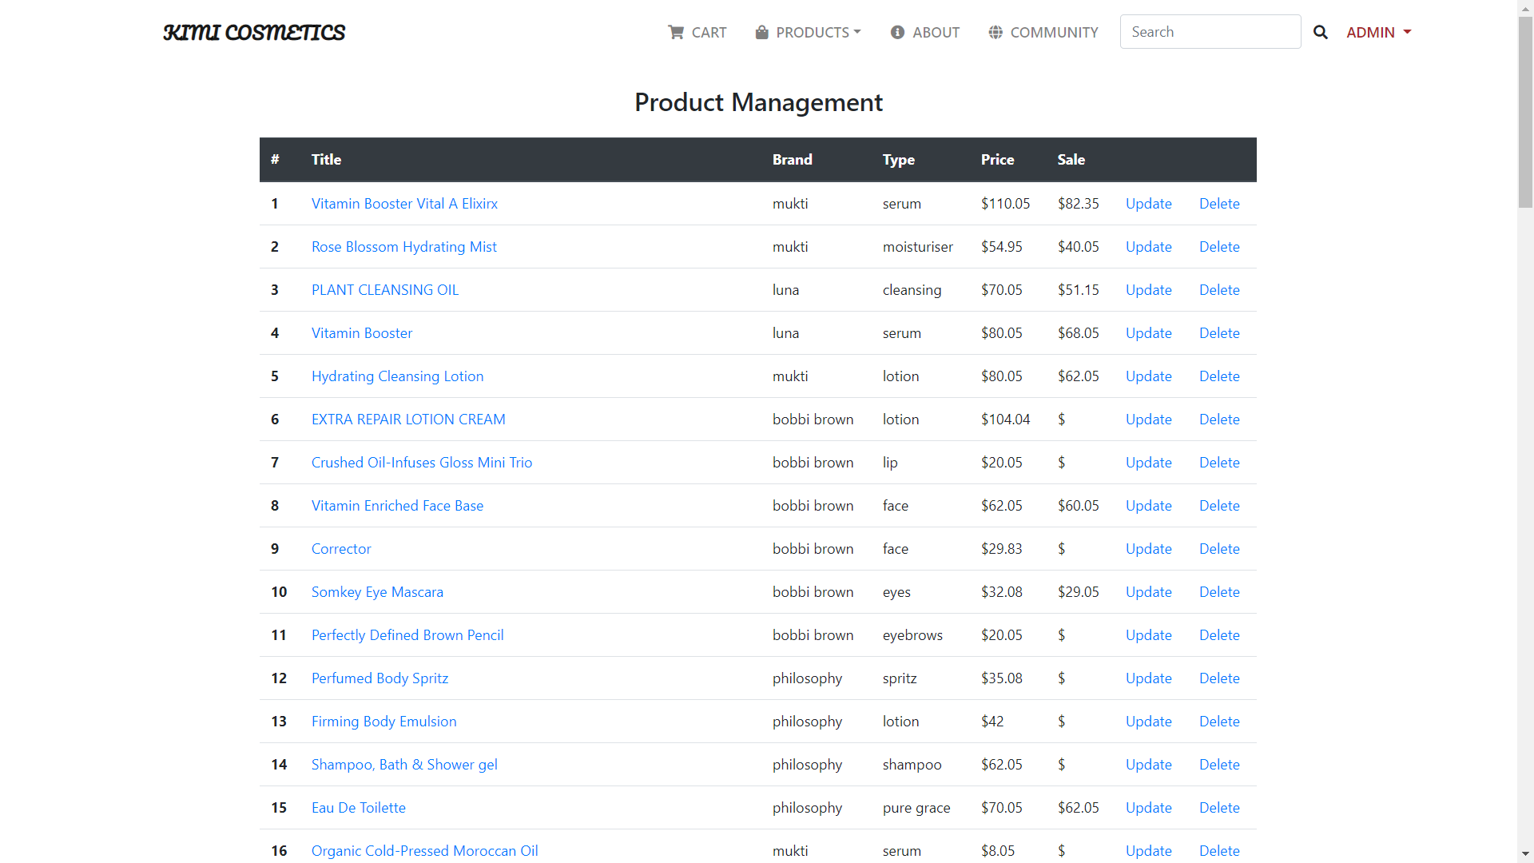

### Update Product

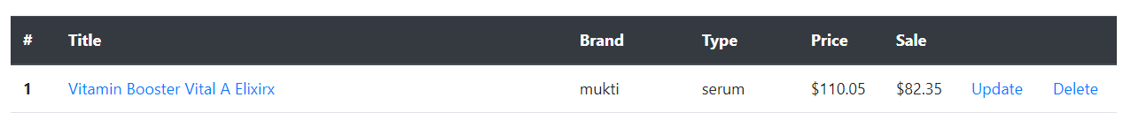

You can update a specific product by selecting the “update ” in the end of that product’s row. This will display a form with previous information and allow you to make any necessary updates.

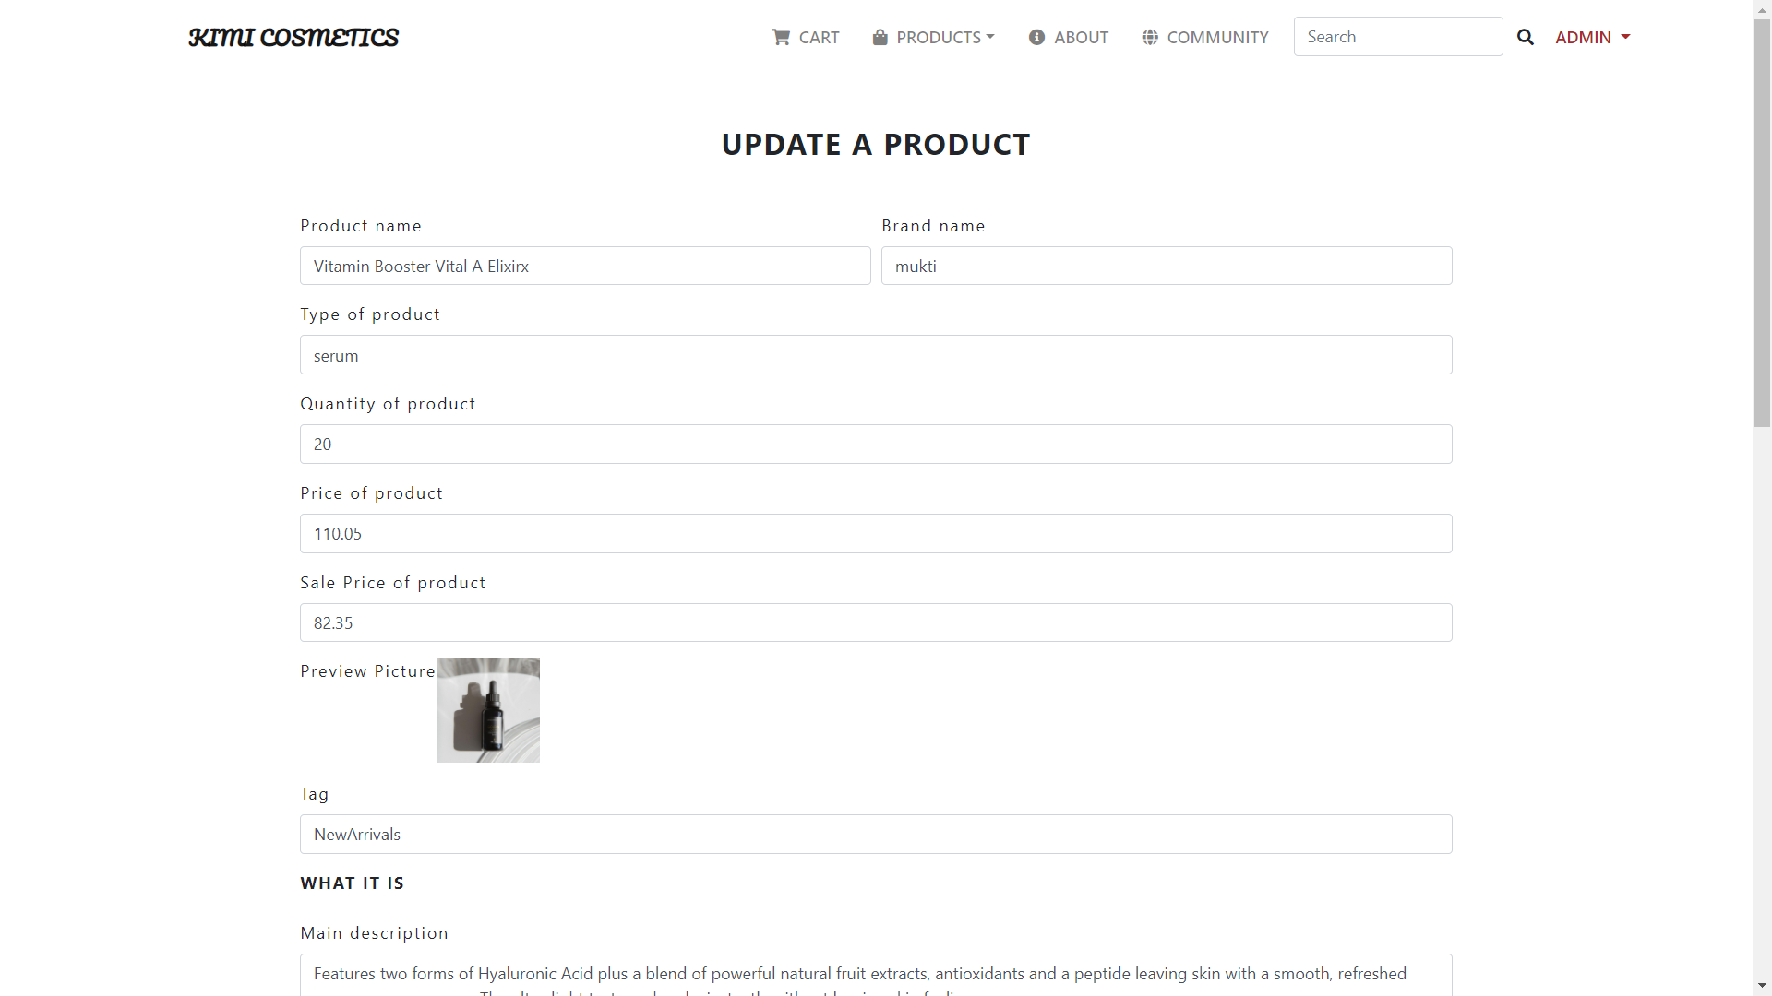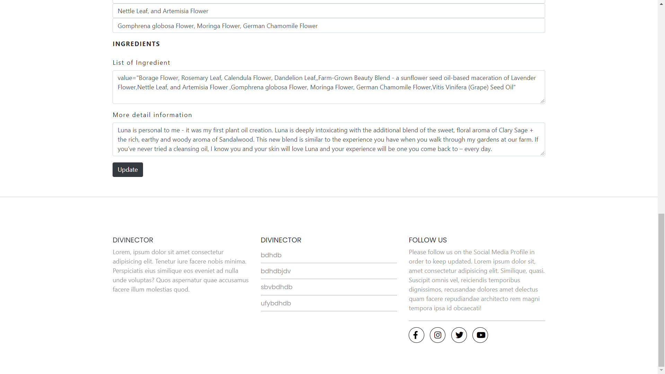

Double click to the image to change suitable image.

Once you are happy with your updates, click “Update”.It will redirect you to the Product Management page with your new updated product.

### Delete Product



Select “delete ” in the end of that product’s row to remove product. This will pop up a dialog to confirm your action.

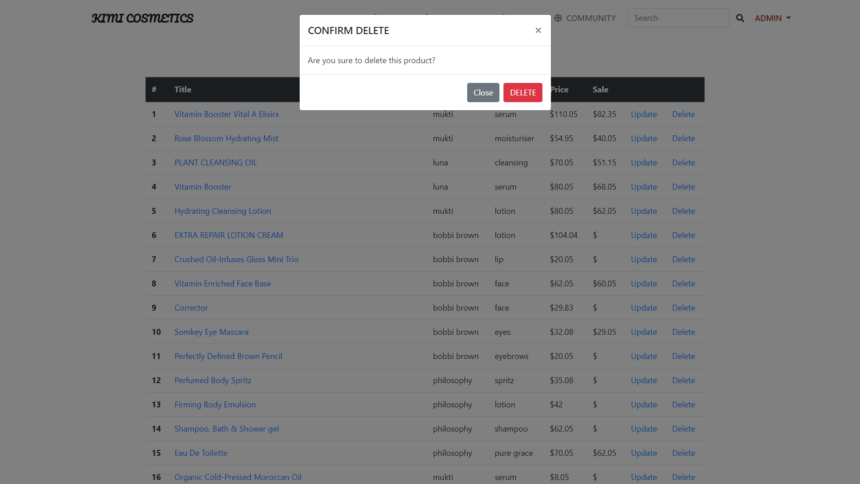

Click “Delete” button if you want to delete the product, click “Close” to cancel the action.

### Create new product

To create new product click the “Create new product” button on the box on the left hand side of the screen.



The sceen will display as below:

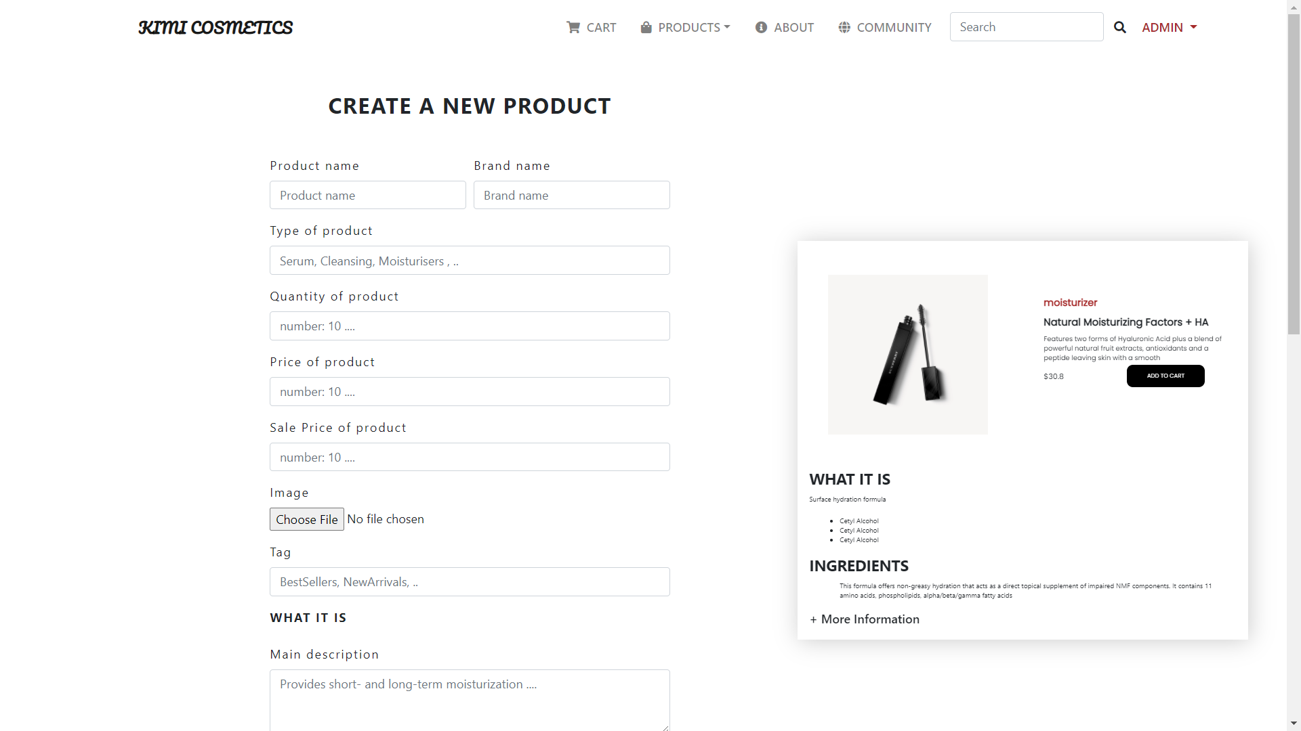

In the left hand side is a form that require you to provide the information of new product. In the right hand side is a live demo of the product which will be displayed when you finish submitting information.

* Notice:

In Feature part, if you want to display more additional information, separate them by “ , “:

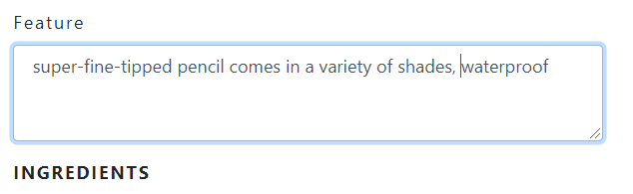

This will display the information of product like below:

