**Instruction of how to configure the server and setup the website:**

Installation: Visual Studio Code, MongoDb, Nodejs

In mongodb, create new database named web_SQA, and create 3 new collection named as 3 files in folders db

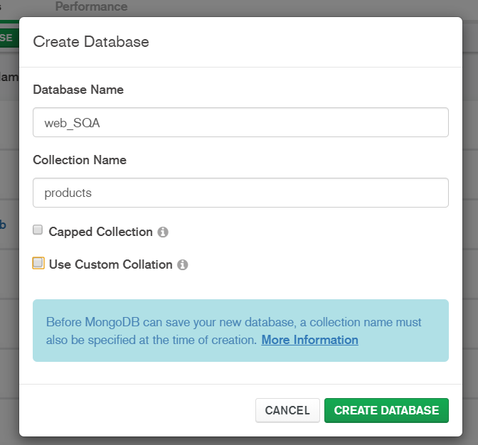

Import 3 files below which are in db folder to the web_SQA database

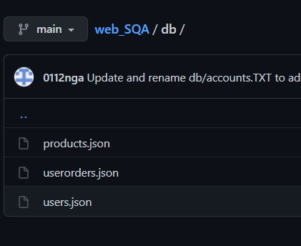

In command:

Install using npm:

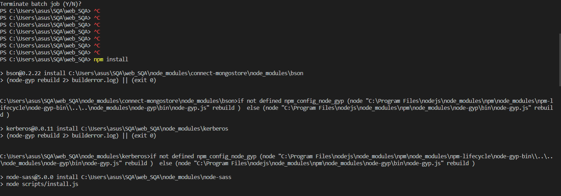

Run web:

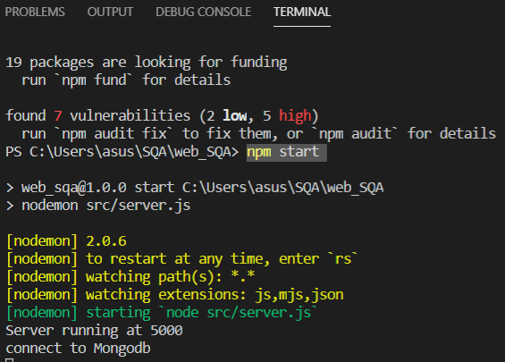

Admin account for login:

email: admin@test.com

password: 123456

You can access to website to be administrator to gain access to privilleges as following : editing, adding, removing and updating products in the database.