

Automated Text Justification using Dynamic Programming
A CAPSTONE PROJECT REPORT
A Capstone Project Report submitted in partial fulfilment of the requirements for the Course of
CSA0603 - DESIGN AND ANALYSIS OF ALGORITHMS
to the award of the degree of
BACHELOR OF TECHNOLOGY IN
COMPUTER SCIENCE ENGINEERING
Submitted by
GANESH (192524034)
ROSHAN V (192521437)
K HEMACHANDRA (192525234)
Under the Supervision of
Dr. Solainayagi
SIMATS ENGINEERING
Saveetha Institute of Medical and Technical Sciences
Chennai-602105
SEPTEMBER 2026

SIMATS ENGINEERING
Saveetha Institute of Medical and Technical Sciences
Chennai-602105
BONAFIDE CERTIFICATE
This is to certify that the Capstone Project entitled “Automated Text Justification using Dynamic Programming” has been carried out by Ganesh (192524034), Roshan V (192521437), and K Hemachandra (192525234) under the supervision of Dr. Solainayagi and is submitted in partial fulfilment of the requirements for the current semester of the B.Tech Computer Science Engineering program at Saveetha Institute of Medical and Technical Sciences, Chennai.

COURSE COORDINATOR | COURSE FACULTY
Title / Name: Dr. F. Mary Harin Fernandez | Name: Dr. Solainayagi
Designation: Professor | Designation: Professor
Branch / Department Name: CSE | Branch / Department Name: CSE
SIMATS Engineering, | SIMATS Engineering,
SIMATS, Chennai – 602105. | SIMATS, Chennai – 602105.

SIMATS ENGINEERING
Saveetha Institute of Medical and Technical Sciences
Chennai-602105
DECLARATION
We, Ganesh (192524034), Roshan V (192521437), and K Hemachandra (192525234) of the Computer Science Engineering, SIMATS Engineering, Saveetha Institute of Medical and Technical Sciences, Chennai, hereby declare that the Capstone Project Work entitled “Automated Text Justification using Dynamic Programming” is the result of our own bonafide efforts. To the best of our knowledge, the work presented herein is original, accurate, and has been carried out in accordance with the principles of engineering ethics and academic integrity.
All sources, references, data, computational resources, software, and other materials used in the project have been appropriately acknowledged. We further declare that the data, results, analysis, and findings presented in this report have not been fabricated, falsified, or manipulated. Any external tools, software, open-source resources, or AI-assisted tools used during the project have been appropriately disclosed. We confirm that applicable academic, institutional, ethical, and professional requirements have been followed throughout the planning, implementation, analysis, and documentation of the project.

Place: Chennai
Date: 05-09-26
Signature of the Students with Names

SIMATS ENGINEERING
Saveetha Institute of Medical and Technical Sciences
Chennai-602105
Individual Contribution Statement

Student Name / Register No. | Specific Responsibilities | Design & Development Contribution | Testing & Analysis Contribution | Report Contribution | Approx. Contribution (%)
Ganesh  192524034 | Core algorithm design, DP formulation and integration of the comparison workflow | Implemented DP cost calculation, recurrence, parent-pointer reconstruction and integration | Tested line-break outputs against the Greedy baseline and reviewed badness calculations | Ch. 1, Ch. 3, Algorithm, Implementation, Results | 33.3%
Roshan V  192521437 | Greedy baseline, formatting logic and comparison output | Implemented Greedy wrapping, line justification and side-by-side comparison presentation | Tested sample paragraphs and verified badness and improvement values | Ch. 2, Ch. 4, Testing, Comparison | 33.3%
K Hemachandra  192525234 | Interface, benchmarking, documentation and final integration | Implemented/assembled the interactive HTML/JavaScript demonstration and benchmarking workflow | Verified interface behaviour, runtime observations and final output consistency | Ch. 4, Ch. 5, Appendices, Documentation | 33.4%

Note: The contribution allocation is presented as an equal team distribution across the three members while identifying the principal areas of responsibility represented in the project workflow.

ABSTRACT
Automated text justification is the process of selecting line breaks and distributing spaces so that a paragraph is presented with balanced left and right margins. A simple Greedy word-wrap method makes a local decision by placing as many words as possible on the current line, which can create poorly balanced spacing later in the paragraph. This project formulates text justification as a global optimization problem and develops a Dynamic Programming solution that minimizes total line badness across the paragraph.
The proposed system accepts a paragraph and a maximum line width, tokenizes the input, validates the width constraint, evaluates the badness of feasible word ranges, and computes an optimal sequence of line breaks using a bottom-up Dynamic Programming recurrence. Parent pointers are used to reconstruct the selected breaks, after which extra spaces are distributed to produce justified lines. A Greedy baseline is also executed on the same input so that both methods can be compared quantitatively.
The implementation is developed in Python 3, with an interactive HTML/JavaScript demonstration for live comparison. The supplied project results show that for a short 13-word paragraph and a medium 37-word paragraph, Greedy and Dynamic Programming produce the same total badness of 6 and 125 respectively. For a long 150+ word sample with line width 50, Greedy records 398 while Dynamic Programming records 326, giving an 18.1% improvement. A separate interactive demonstration at line width 40 reports Greedy badness of 277 and DP badness of 237, corresponding to a 14.4% reduction. Complexity analysis gives O(n²) time and O(n²) space overall for the implemented DP approach.
The project demonstrates how Dynamic Programming can replace local line-by-line decisions with a globally optimized arrangement and provides a practical example of algorithm design, recurrence formulation, reconstruction, benchmarking, and quantitative comparison.

Keywords
Text Justification, Dynamic Programming, Greedy Algorithm, Line Breaking, Badness Function, Algorithm Analysis

TABLE OF CONTENTS
Sl. No. | Title | Page No.
 | CERTIFICATE FROM THE SUPERVISOR | 2
 | DECLARATION BY THE CANDIDATE | 3
 | INDIVIDUAL CONTRIBUTION STATEMENT | 4
 | ABSTRACT | 5
 | LIST OF FIGURES | 6
 | LIST OF TABLES | 7
 | LIST OF ABBREVIATIONS / SYMBOLS | 8
 | CHAPTER 1: Introduction and Engineering Problem | 11
 | CHAPTER 2: Literature Review and Existing Solutions | 14
 | CHAPTER 3: Engineering Design & Trade-offs, Sustainability, Ethics, Safety, Risk & Security | 17
 | CHAPTER 4: Implementation, Testing & Results, Project Management | 22
 | CHAPTER 5: Conclusion, Future Work and Reflection | 28
 | References | 30
 | Appendices | 21

CHAPTER 1
INTRODUCTION AND ENGINEERING PROBLEM

1.1 Background
Text justification is a common formatting operation used by word processors, publishing software, document editors, and typesetting systems. The task is not simply to place words from left to right; the system must decide where each line should end so that the final paragraph has visually balanced spacing. Different line-break decisions can produce noticeably different layouts even when the underlying words are identical.
From an algorithmic perspective, the problem can be expressed as an optimization task over possible partitions of a sequence of words. For each candidate group of words that fits within a chosen maximum width, a cost is assigned according to the unused space. The objective is to select line breaks that minimize the total cost of the paragraph.
The project applies Dynamic Programming because the optimal arrangement of a complete paragraph can be constructed from optimal solutions to smaller suffixes of the same paragraph. The supplied presentation explicitly defines a cost matrix, a DP table, and parent pointers for reconstructing the selected line breaks.

1.2 Need for the Project
• Manual or purely local line wrapping can create uneven spacing and visually distracting lines.
• Greedy word-wrap makes an immediate decision without evaluating its effect on later lines.
• A global optimization method is useful when the quality of the complete paragraph matters more than the quality of one line considered in isolation.
• The project provides an educational implementation in which the Greedy and Dynamic Programming methods process the same input and expose quantitative badness scores.
• The application demonstrates a practical use of Dynamic Programming beyond textbook examples.

1.3 Problem Statement
To design and implement an automated text-justification system that selects line breaks for a paragraph so as to minimize total spacing badness within a specified maximum line width, while providing a direct quantitative comparison between a local Greedy baseline and a globally optimized Dynamic Programming solution.
The system must handle input preprocessing, feasible line formation, badness computation, optimization of line breaks, reconstruction of the chosen arrangement, final-line formatting, comparison with the Greedy method, and reporting of performance-related information.

1.4 Project Aim
The aim of this project is to develop a modular and measurable text-justification solution using Dynamic Programming and to demonstrate its advantage over Greedy line wrapping through a working prototype and quantitative results.

1.5 Project Objectives
1. To formulate a badness function based on unused line width.
2. To construct a cost matrix for feasible word ranges.
3. To implement the Dynamic Programming recurrence for globally optimal line breaks.
4. To reconstruct the selected line arrangement using parent pointers.
5. To implement a Greedy baseline for direct comparison.
6. To format the selected lines by distributing extra spaces while leaving the final paragraph line left-aligned.
7. To measure and report badness, improvement, and asymptotic complexity.

1.6 Scope

Included
• Paragraph input and maximum line-width selection.
• Whitespace-based tokenization and input validation.
• Badness calculation for feasible word ranges.
• Bottom-up Dynamic Programming and parent-pointer reconstruction.
• Greedy baseline comparison.
• Justified line formatting and final-line left alignment.
• Interactive HTML/JavaScript demonstration and Python implementation.
• Quantitative comparison and complexity analysis.

Excluded
• Full typographic optimization involving font metrics, kerning, hyphenation, or glyph-level shaping.
• Image-based OCR or scanned-document processing.
• Language-specific hyphenation dictionaries.
• Distributed or cloud execution.
• Machine-learning-based aesthetic scoring.

Assumptions
• The line width is represented as a character-based maximum width.
• Words are separated using whitespace.
• A word longer than the selected maximum width is treated as invalid input.
• The squared unused-space measure is used as the badness objective.
• The final line is not stretched for justification.

Boundary Conditions
• Results depend on the selected maximum line width and input paragraph.
• Character count is used rather than actual rendered font width.
• The implemented optimization objective is total squared unused space.
• Runtime growth follows the implemented DP formulation and should be interpreted for the selected input representation.

1.7 Expected Engineering Outcome
The expected outcome is a working text-justification prototype that accepts a paragraph and line width, computes both Greedy and Dynamic Programming arrangements, reconstructs the selected DP line breaks, formats the lines, and reports comparative badness. The supplied project already contains console and interactive web demonstrations, so the report evaluates the implemented workflow rather than describing a purely theoretical design.

CHAPTER 2
LITERATURE REVIEW AND EXISTING SOLUTIONS

2.1 Review Method
The review was structured around the algorithmic approaches represented by the project: local Greedy line wrapping, global Dynamic Programming line breaking, cost-based paragraph optimization, and practical text-formatting systems. The objective was to identify the strengths and limitations of local versus global decision-making and to position the proposed prototype as a DAA-oriented implementation.

2.2 Review of Existing Work

1. Greedy Line Wrapping
Greedy wrapping places as many words as possible on the current line before moving to the next line. Its main advantage is simplicity and low decision overhead. However, it does not look ahead, so an early line break can force an undesirable distribution of words later in the paragraph.

2. Dynamic Programming Line Breaking
Dynamic Programming treats the paragraph as a sequence of overlapping subproblems. The cost of placing words i through j on one line is computed first, after which the minimum achievable total cost from each position is stored in a DP table. The approach trades additional computation and memory for a globally optimized line-break arrangement.

3. Cost-Based Typesetting
Professional text layout systems use objective functions to evaluate the visual quality of candidate line breaks. The present project adopts a deliberately simple and transparent cost model: the square of unused line width. This makes the optimization easy to explain, reproduce, and benchmark in an academic DAA setting.

4. Practical Text Editors and Typesetting Systems
Word processors and typesetting systems must perform line breaking as part of rendering paragraphs. Such systems can incorporate richer font metrics and typographic rules, but those details are outside the scope of this prototype. The project instead focuses on the core algorithmic decision of choosing line boundaries.

2.3 Comparative Analysis
Existing Approach | Advantages | Limitations | Relevance to Proposed Work
Greedy word-wrap | Simple, fast, easy to implement | Local decisions may cause poor later spacing | Used as the baseline
Dynamic Programming | Global optimization; deterministic result | O(n²) computation and storage in the implemented formulation | Primary algorithm
Manual formatting | No software implementation required | Time-consuming and subjective | Motivates automation
Advanced typographic line breaking | Can model richer visual constraints | More complex; depends on font/rendering metrics | Future extension direction

2.4 Research / Engineering Gap
The engineering gap addressed by the project is the lack of a simple, measurable demonstration that lets a learner observe the difference between a local line-breaking rule and a globally optimized alternative. The prototype combines the optimization recurrence with an explicit badness metric, line reconstruction, side-by-side output, and quantitative improvement reporting.

2.5 Proposed Contribution
1. Input and preprocessing: accept paragraph text and maximum line width, tokenize the input, and validate feasibility.
2. DP justification engine: construct the cost matrix, fill the DP table, and store parent pointers.
3. Formatting and comparison: reconstruct optimal lines, justify them, run the Greedy baseline, and report total badness and improvement.
4. Interactive demonstration: provide a browser-based interface so users can vary the input and observe the two methods.

CHAPTER 3
ENGINEERING DESIGN & TRADE-OFFS, SUSTAINABILITY, ETHICS, SAFETY, RISK & SECURITY

3.1 Requirements

Stakeholder / User Requirements
Stakeholder | Requirement
Student / User | Enter a paragraph and choose a maximum line width.
Student / User | Observe justified output produced by the algorithm.
Student / User | Compare Greedy and Dynamic Programming results.
Student / User | View badness scores and percentage improvement.
Project Developer | Maintain a modular algorithmic workflow.
Project Developer | Measure and document complexity and benchmark observations.

Functional & Non-Functional Requirements
Requirement | Type | Measurable Target
Accept paragraph input | Functional | Paragraph can be tokenized into words
Validate line-width feasibility | Functional | Invalid oversized words are rejected
Compute badness | Functional | Each feasible word range receives a cost
Optimize line breaks | Functional | DP returns a minimum-total-badness arrangement
Reconstruct lines | Functional | Parent pointers produce the selected groups
Compare with Greedy | Functional | Both methods run on the same input
Report improvement | Functional | Badness difference and percentage are displayed
Usability | Non-Functional | Clear interactive presentation
Determinism | Non-Functional | Same input produces the same DP result
Maintainability | Non-Functional | Separate preprocessing, optimization, formatting and comparison responsibilities

3.2 Constraints & Applicable Standards
Standard / Guideline | Requirement | How Applied in This Project
PEP 8 – Python Style Guide | Readable and consistent Python code | Used as a coding-style reference for the Python implementation
General software testing practice | Verify expected behaviour | Applied through functional tests for input, line breaking and comparison
IEEE-style referencing | Consistent technical citation format | Used for the report reference list
Academic integrity requirements | Accurate reporting and acknowledgement | Results are stated as shown in the supplied project presentation

3.3 Design Specifications
Parameter | Target / Requirement | Unit | Priority
Input | Paragraph text | text | High
Maximum line width | User-selected positive integer | characters | High
Badness function | (maxWidth − lineLength)² for feasible lines | score | High
DP recurrence | min(cost[i][j] + dp[j+1]) | score | High
Base case | dp[n] = 0 | score | High
Reconstruction | parent[i] stores best j | index | High
Final line | Left-aligned | text | Medium
Comparison | Greedy vs DP on same input | score / % | High

3.4 Alternative Solutions & Evaluation
Alternative 1: Greedy word wrapping makes the locally best immediate decision by filling the current line as much as possible. It is lightweight and suitable as a baseline.
Alternative 2: Dynamic Programming evaluates feasible future line breaks through overlapping subproblems and selects the arrangement with minimum total badness. It requires more computation and storage but directly addresses the global optimization objective.
Criterion | Weight | Greedy | Dynamic Programming
Performance / simplicity | 30 | 5 | 4
Global layout quality | 30 | 2 | 5
Implementation clarity | 20 | 5 | 4
Measurability | 10 | 3 | 5
Extensibility | 10 | 3 | 5

3.5 Selected Design & Detailed Design
Dynamic Programming was selected as the primary design because the project objective is to minimize total paragraph badness rather than simply fill each line independently. The recurrence and parent-pointer reconstruction make the global decision process explicit and measurable, while the Greedy implementation remains available as a direct baseline.
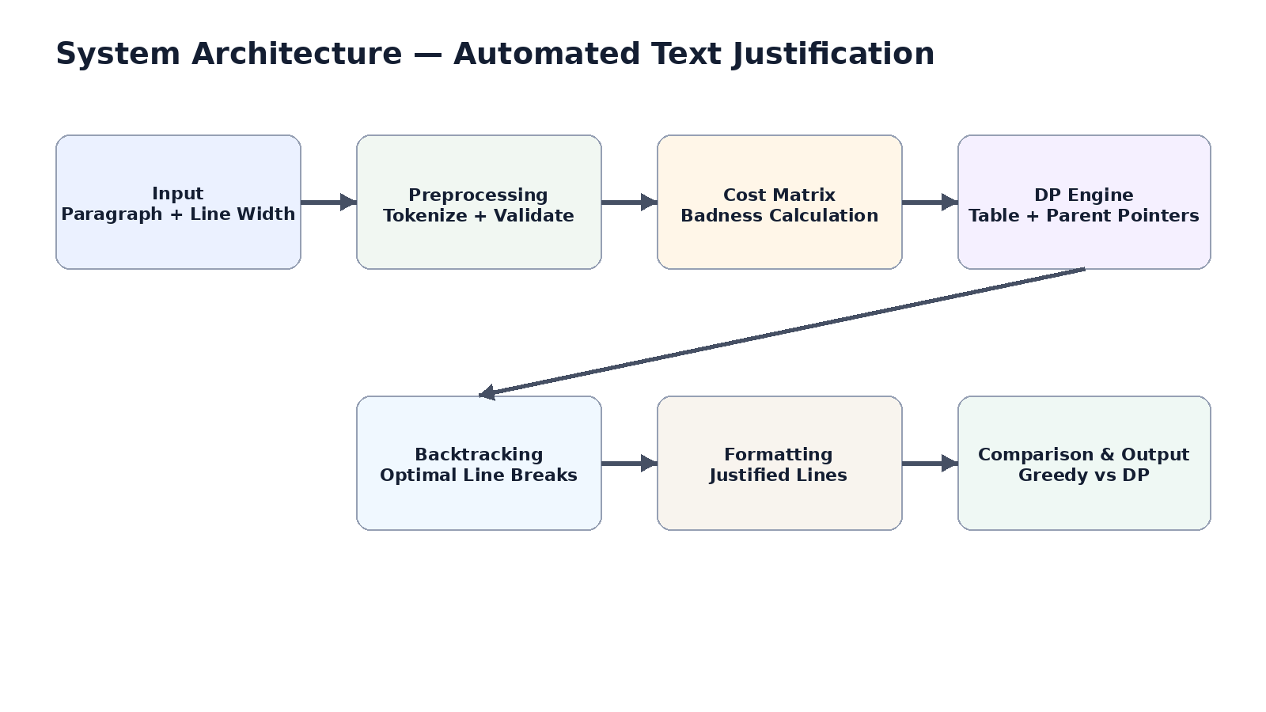
Figure 1. System Architecture
Systems approach: the preprocessing stage produces a clean sequence of words for the optimization engine. The cost matrix provides the local line costs required by the DP recurrence. The DP engine produces parent pointers, which the reconstruction stage converts into line groups; formatting then produces the final paragraph. The comparison stage runs the Greedy baseline on the same input and reports the relative badness.

3.6 Trade-off Analysis
Design Decision | Alternative Considered | Benefit | Disadvantage | Final Decision & Justification
Dynamic Programming | Greedy only | Global optimum under the defined cost | O(n²) time/space | Selected because the project is an optimization-focused DAA application
Squared unused-space cost | Absolute unused space | Simple and transparent objective | Does not model all typography | Selected for reproducibility and easy interpretation
Character-width model | Rendered font width | Simple and portable | Less typographically precise | Selected for algorithmic clarity
HTML/JavaScript demo | Console-only interface | Interactive and visual | Additional interface work | Included as a demonstration layer

3.7 Sustainability, Ethics, Safety, Risk & Security
Domain | Consideration | Evidence Evaluated | Impact on Final Decision
Sustainability | Keep computation lightweight | No external compute infrastructure is required | Local execution and compact implementation were retained
Ethics | Do not misrepresent comparative results | Results are tied to explicit test inputs and the defined badness function | Metrics are reported with their conditions
Health & Safety | Software-only project | No hazardous hardware or materials | No physical safety controls required
Security | Avoid unnecessary user data collection | Input is processed for formatting; no personal-data workflow is required | No data storage was introduced

Risk | Likelihood | Severity | Risk Level | Mitigation | Residual Risk
Incorrect cost calculation | Medium | High | High | Unit-test cost computation and compare known examples | Low
Wrong parent-pointer reconstruction | Medium | High | High | Test reconstruction on short and long paragraphs | Low
Excessive O(n²) growth | Medium | Medium | Medium | Benchmark increasing input sizes and document limits | Medium
Invalid oversized word | Medium | Medium | Medium | Reject infeasible input during preprocessing | Low
Formatting mismatch | Low | Medium | Low | Compare output line widths and final-line handling | Low
Browser/console result mismatch | Low | Medium | Low | Use the same recurrence and compare representative cases | Low

CHAPTER 4
IMPLEMENTATION, TESTING & RESULTS, PROJECT MANAGEMENT

4.1 Development Approach & Resources
The project follows a modular implementation approach. Input preprocessing prepares the word sequence, the Dynamic Programming engine computes optimal line breaks, formatting produces justified lines, and the comparison layer evaluates the Greedy baseline against the DP result. Python 3 is used for the core implementation and benchmarking, while an interactive HTML/JavaScript version is used to demonstrate the workflow in a browser.
Development Resource | Purpose | Stage Used
Python 3 | Core DP recurrence, cost matrix and comparison logic | Implementation and benchmarking
HTML | Interactive page structure | Web demonstration
CSS | Interface presentation | Web demonstration
JavaScript | Interactive computation and result display | Web demonstration
Python time module | Runtime measurement | Benchmarking
Windows PC / local environment | Development and execution | All stages

4.2 Software Implementation & Modern Tools Used
The supplied presentation identifies the core Python functions as preprocess_text(), compute_cost_matrix(), dp_justify(), greedy_wrap(), justify_line(), and compare(). The same DP recurrence is used in the console and browser demonstrations so that the two interfaces implement the same algorithmic decision process.
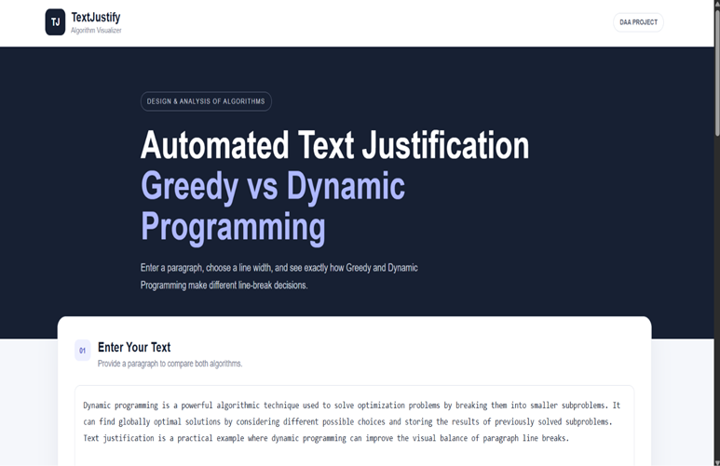
Figure 3. Working Web Application — implementation screenshot from the project presentation.
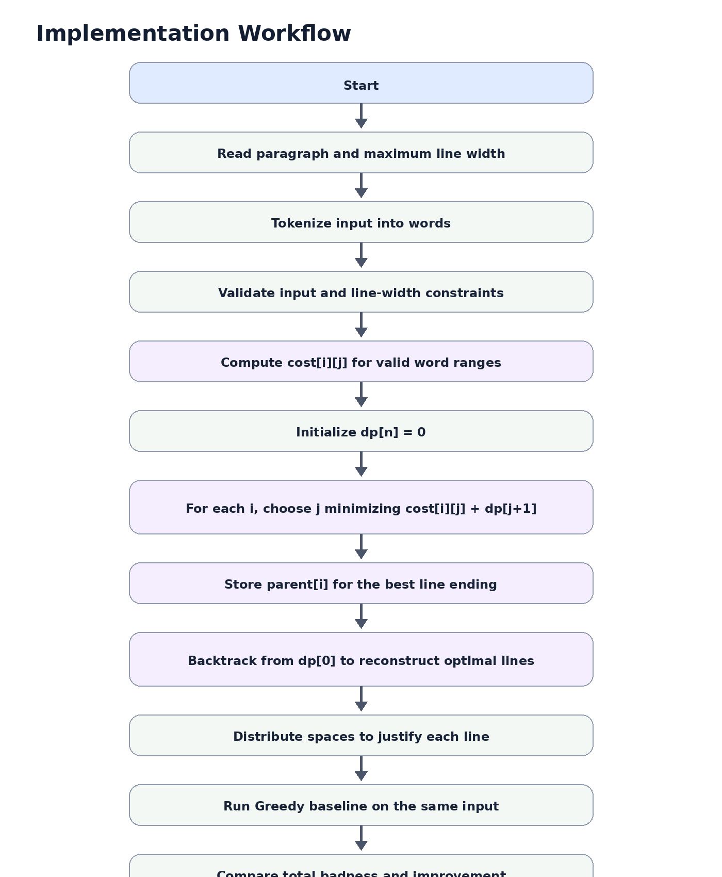
Figure 2. Implementation Workflow

4.3 Test Plan & Verification
Requirement | Test Method | Acceptance Criterion
Input preprocessing | Provide valid paragraph and line width | Words are tokenized and feasible input is accepted
Width validation | Provide a word longer than selected width | Input is rejected as infeasible
Cost computation | Check feasible and infeasible word ranges | Finite cost for feasible range; infinity for non-fitting range
DP optimization | Run on sample paragraphs | Minimum total badness arrangement is produced
Backtracking | Reconstruct from parent pointers | Line groups reproduce the selected DP solution
Greedy comparison | Run both methods on identical input | Both scores are displayed for the same paragraph
Justification | Inspect non-final output lines | Extra spaces are distributed across gaps
Final line handling | Inspect last paragraph line | Final line remains left-aligned
Performance | Run increasing input sizes | Observed growth is consistent with O(n²) implementation

Specification | Required Value | Achieved Value | Status
Short sample, 13 words | Compare Greedy and DP | 6 vs 6 badness | Pass
Medium sample, 37 words | Compare Greedy and DP | 125 vs 125 badness | Pass
Long sample, 150+ words | DP no worse than Greedy | 398 vs 326 | Pass
Interactive result, width 40 | Compare same input | 277 vs 237 | Pass
Interactive improvement | Report percentage | 14.4% | Pass
Overall complexity | Document implemented bound | O(n²) time, O(n²) space | Pass

4.4 Results
The supplied project presentation reports two complementary sets of results. The first is a sample benchmark across short, medium, and long paragraphs. The second is an interactive web demonstration at line width 40. They are treated as separate experiments rather than combined into a single measurement.
Sample Paragraph | Line Width | Greedy Badness | DP Badness | Improvement
Short (13 words) | 20 chars | 6 | 6 | 0%
Medium (37 words) | 40 chars | 125 | 125 | 0%
Long (150+ words) | 50 chars | 398 | 326 | 18.1%

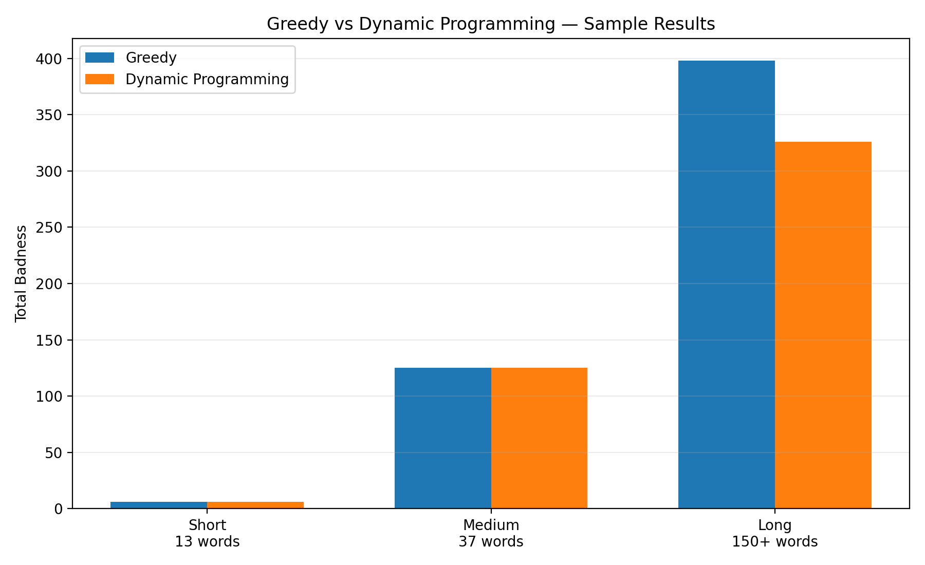
Figure 4. Greedy vs Dynamic Programming — sample results.
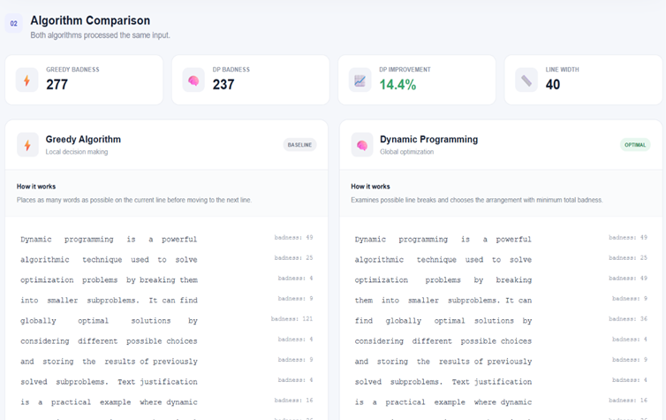
Figure 5. Interactive Greedy vs DP result: Greedy 277, DP 237, improvement 14.4%, line width 40.

4.5 Data Analysis & Engineering Judgment
The sample results show that the advantage of Dynamic Programming is input-dependent. On the short and medium samples, both methods achieve the same total badness, indicating that the Greedy choices happen to coincide with an optimal arrangement for those inputs. On the longer 150+ word sample, the DP solution reduces badness from 398 to 326, an 18.1% improvement.
The interactive demonstration reports a separate reduction from 277 to 237 at line width 40, which is a 40-point reduction and 14.4% improvement. This supports the project claim that global optimization becomes more useful when the paragraph contains more opportunities for alternative line breaks.
The engineering judgment is therefore that Greedy remains attractive for simplicity, but Dynamic Programming is preferable when the objective is explicitly to minimize the total defined badness. The trade-off is the O(n²) time and O(n²) space cost of the implemented DP formulation.

4.6 Comparison with Existing Solutions & Achievement of Objectives
Objective | Evidence | Achievement
Formulate badness function | Unused-space squared cost | Fully Achieved
Implement DP optimization | Cost matrix, dp table and recurrence | Fully Achieved
Reconstruct optimal lines | Parent-pointer backtracking | Fully Achieved
Implement Greedy baseline | Greedy word-wrap function | Fully Achieved
Compare methods quantitatively | Badness and percentage improvement | Fully Achieved
Provide working interface | Interactive HTML/JavaScript version | Fully Achieved
Analyse complexity | O(n²) implementation and benchmark observation | Fully Achieved

4.7 Strengths & Limitations

Strengths
• Global optimization under the selected badness objective.
• Deterministic and reproducible DP result for the same input.
• Direct Greedy baseline makes the algorithmic difference easy to observe.
• Quantitative badness and improvement metrics are reported.
• Parent pointers make the solution reconstruction explicit.
• Working Python and interactive web demonstrations are available.

Limitations
• The cost model uses character width rather than actual rendered font metrics.
• The squared-unused-space objective does not capture every typographic preference.
• DP uses O(n²) time and O(n²) space in the implemented formulation.
• Hyphenation, kerning, glyph widths, and language-specific typography are outside scope.
• Results are based on the supplied project test cases; larger benchmarking can be expanded.

4.8 Project Planning, Roles & Budget
Milestone | Planned Activity | Outcome
Phase 1 | Problem formulation and Greedy baseline | Core problem and baseline defined
Phase 2 | DP recurrence and cost model | Optimization engine implemented
Phase 3 | Formatting and reconstruction | Justified output produced
Phase 4 | Web interface and comparison | Interactive demonstration completed
Phase 5 | Testing and benchmarking | Results and complexity documented
Phase 6 | Report preparation | Final technical documentation completed

Student | Assigned Responsibility | Actual Contribution
Ganesh | DP algorithm and integration | Cost matrix, recurrence, parent pointers and integration
Roshan V | Greedy baseline and formatting | Greedy wrap, justification and comparison presentation
K Hemachandra | Interface, benchmarking and documentation | Interactive demo, result verification and report integration

Item | Estimated Cost | Actual Cost
Existing laptop / PC | ₹0 | ₹0
Python | ₹0 | ₹0
HTML/CSS/JavaScript tools | ₹0 | ₹0
Development / testing resources | ₹0 | ₹0
Internet / research resources | ₹0* | ₹0*
Printing / documentation | ₹200 | ₹200

CHAPTER 5
CONCLUSION, FUTURE WORK AND REFLECTION

5.1 Conclusion
The project successfully formulates automated text justification as a Dynamic Programming optimization problem. A badness function based on squared unused line width is evaluated for feasible word ranges, and the DP recurrence selects the sequence of line breaks with minimum total badness. Parent pointers then reconstruct the selected arrangement, after which the lines are formatted for presentation.
The direct comparison with Greedy word wrapping demonstrates why global optimization is useful. The supplied results show equal performance on short and medium samples, while the long sample improves from 398 to 326 badness, an 18.1% reduction. The interactive demonstration separately reports 277 versus 237 at line width 40, corresponding to a 14.4% improvement.
The implementation therefore meets the main objectives of the project: algorithm formulation, implementation, reconstruction, comparison, interactive demonstration, and complexity analysis. The project provides a practical DAA example in which the mathematical recurrence is directly connected to a visible software result.

5.2 Future Work
Enhancement | Purpose / Expected Benefit
Font-aware line width | Use actual rendered widths instead of character counts
Hyphenation support | Reduce awkward spacing for long words and narrow widths
Richer badness functions | Model additional typographic preferences
Space-stretch penalties | Distinguish excessively stretched or compressed gaps
Larger benchmarking suite | Evaluate behaviour across more paragraph sizes and structures
Algorithm comparison | Compare DP with more advanced line-breaking strategies
Interactive step visualization | Show candidate breaks, DP states and reconstruction decisions
Performance optimization | Reduce memory use or exploit repeated structure for larger inputs

5.3 Professional Learning & Individual Reflection

New Knowledge Acquired
• Formulating a real formatting problem as an optimization problem.
• Constructing and interpreting a Dynamic Programming recurrence.
• Using cost matrices and parent pointers for solution reconstruction.
• Comparing local and global algorithmic strategies using quantitative metrics.
• Benchmarking and interpreting asymptotic complexity.
• Connecting algorithmic outputs to an interactive software interface.

Engineering & Professional Skills Developed
• Problem analysis and algorithm design.
• Modular implementation and integration.
• Testing and verification.
• Quantitative result interpretation.
• Technical documentation and report preparation.
• Team collaboration and task allocation.
• Presentation of algorithmic results.

Individual Reflection – Ganesh
My main contribution was centered on the Dynamic Programming formulation and integration of the optimization workflow. The most challenging part was translating the line-breaking objective into a recurrence that could both minimize total badness and reconstruct the actual line groups. The use of a cost matrix and parent pointers provided a clear solution to that problem. I also developed a stronger understanding of how a theoretical recurrence becomes a working algorithm. If the project were repeated, I would extend the cost model to include rendered text width and richer typographic constraints.

Individual Reflection – Roshan V
My main contribution focused on the Greedy baseline, formatting behaviour, and direct comparison with the DP output. The important engineering challenge was ensuring that both methods processed the same input and were evaluated using the same badness definition. This made the comparison meaningful rather than merely visual. I gained practical experience in turning an algorithmic baseline into a measurable reference implementation. If repeated, I would expand the comparison suite with more paragraph structures and automated regression tests.

Individual Reflection – K Hemachandra
My main contribution focused on the interactive demonstration, benchmarking workflow, and documentation integration. The main challenge was presenting algorithmic results in a form that clearly shows the difference between local and global decisions. Building the interactive comparison made it easier to connect the numerical badness values with the visible line arrangements. I developed stronger skills in interface integration, result verification, and technical presentation. If repeated, I would add step-by-step DP-state visualization and more detailed runtime plots.

CHAPTER 6
DETAILED ALGORITHMIC ANALYSIS AND EXPERIMENTAL STUDY
6.1 Problem Representation
The project represents a paragraph as an ordered sequence of n words. A candidate line is a contiguous interval of words beginning at position i and ending at position j. The maximum line width determines whether that interval is feasible. This representation converts a visual formatting problem into a sequence-partitioning problem that can be optimized systematically.
For each feasible interval, the implementation calculates the line length using word lengths and the spaces between adjacent words. The unused width is then squared to obtain the local badness score. Non-fitting intervals are treated as infeasible.
Element | Representation | Role
Paragraph | words[0..n−1] | Ordered input sequence
Candidate line | words[i..j] | Possible line-break interval
Maximum width | maxWidth | Feasibility boundary
Badness | (maxWidth − lineLength)² | Local objective
DP state | dp[i] | Best suffix cost
Parent | parent[i] | Selected line-ending index

6.2 Badness Function
The squared unused-space objective is deliberately simple and transparent. It penalizes larger gaps more strongly than smaller gaps and gives the optimization engine a numerical target. A line with zero unused space has zero badness, while a line with 10 unused character positions has a badness of 100.
Unused Space | Badness | Interpretation
0 | 0 | Perfect fit under the model
1 | 1 | Very small gap
5 | 25 | Moderate penalty
10 | 100 | Large penalty
20 | 400 | Very large penalty

6.3 Dynamic Programming Recurrence
The algorithm works backward through the paragraph. At each word position i, every feasible next line ending j is considered. The current line's cost is combined with the best cost already computed for the remaining suffix.
Core recurrence:
dp[i] = min { cost[i][j] + dp[j+1] } over all feasible j ≥ i
The base case is dp[n] = 0 because no words remain. The parent array records the line-ending index that produced the minimum. Starting from i = 0, the selected line is emitted and the process advances to parent[i] + 1.
6.4 Algorithm Pseudocode
INPUT: words[0..n-1], maxWidth
OUTPUT: optimal line groups
Initialize dp[0..n] to infinity
dp[n] = 0
For i from n-1 down to 0:
lineLength = 0
For j from i to n-1:
update lineLength using word[j]
if lineLength > maxWidth:
break
candidate = cost(i,j) + dp[j+1]
if candidate < dp[i]:
dp[i] = candidate
parent[i] = j
Reconstruct:
i = 0
while i < n:
j = parent[i]
emit words[i..j]
i = j + 1
6.5 Why the Greedy Baseline Is Necessary
The project compares Dynamic Programming with a Greedy baseline because a globally optimized result is easier to evaluate when a simpler local strategy is available as a reference. Greedy wrapping fills the current line as much as possible, then moves to the next line. It is straightforward, but it does not evaluate the downstream effect of the current decision.
Property | Greedy | Dynamic Programming
Decision scope | Current line | Remaining suffix
Look-ahead | No | Yes through subproblems
Optimization target | Local fill | Minimum total badness
Reconstruction | Sequential | Parent-pointer based
Project role | Baseline | Primary algorithm
Presented complexity | O(n) | O(n²)

6.6 Worked Conceptual Example
Suppose the first line can end at several different words. For a candidate ending j, the system computes cost[0][j] and adds dp[j+1], which represents the best arrangement of the remaining words. The first-line choice is therefore judged not only by its own spacing but also by everything that follows it. This is the central difference from Greedy wrapping.
The example illustrates optimal substructure: once the best suffix costs have been computed, the system can reuse them for multiple earlier decisions. Parent pointers then connect the numerical optimum to the actual line arrangement.
6.7 Edge Cases and Validation
Edge Case | Expected Handling | Reason
Empty paragraph | No output lines | Nothing needs formatting
Single word within width | One line | Direct feasible case
Word longer than width | Reject input | No valid line can contain it
Exact-width line | Badness = 0 | No unused width
Final line | Left-aligned | Avoid unnecessary stretching
Long input | Process through DP states | Tests scalability
Very narrow width | Reject infeasible words | Preserves input assumptions

6.8 Experimental Design
The experiments use identical input conditions for Greedy and Dynamic Programming. Total badness is the primary comparison metric, while percentage improvement is calculated relative to Greedy. Complexity is considered through the implemented recurrence, data structures, and the runtime-growth observation reported in the supplied project presentation.
Experiment | Independent Variable | Measured Output | Purpose
E1 | Paragraph length / structure | Greedy and DP badness | Observe when DP gains appear
E2 | Maximum line width | Badness and line arrangement | Study width sensitivity
E3 | Input size | Runtime growth | Check consistency with O(n²)
E4 | Interface execution | Displayed metrics | Verify end-to-end workflow

6.9 Interpretation of Supplied Results
The supplied project results report three sample paragraph sizes. For 13 words at width 20, both methods produce badness 6. For 37 words at width 40, both produce 125. For a 150+ word paragraph at width 50, Greedy produces 398 while Dynamic Programming produces 326, an 18.1% reduction. The results therefore show that DP does not need to outperform Greedy on every small example to be useful; its main advantage appears when there are more alternative line-break combinations.
Case | Greedy | DP | Difference | Improvement
13 words / width 20 | 6 | 6 | 0 | 0%
37 words / width 40 | 125 | 125 | 0 | 0%
150+ words / width 50 | 398 | 326 | 72 | 18.1%

6.10 Complexity Interpretation
The supplied project identifies cost-matrix construction as O(n²), DP table filling as O(n²), and reconstruction as O(n). Because the cost matrix occupies O(n²) storage, the overall implemented approach is O(n²) in time and O(n²) in space.

The project presentation also reports that benchmarking from 50 to 800 words showed runtime roughly quadrupling when input size doubled, which is consistent with quadratic growth. This observation should be understood as environment-dependent empirical evidence rather than a universal runtime guarantee.
6.11 Reproducibility Checklist
• Use the same paragraph and maximum line width for both algorithms.
• Use the same badness definition for both methods.
• Keep final-line handling consistent.
• Run runtime comparisons in the same environment.
• Record raw badness before calculating percentages.
• Record input size, width, badness and runtime together for future benchmarks.

CHAPTER 7
SYSTEM VALIDATION, INTERFACE DESIGN AND USER EXPERIENCE
7.1 Validation Strategy
Validation is organized at algorithm, module, integration, and interface levels. Algorithm validation focuses on cost calculation, DP state transitions, and parent-pointer reconstruction. Module testing verifies individual functions. Integration testing follows the full paragraph-to-output workflow. Interface testing checks whether the interactive demonstration exposes the required inputs and results.
Level | Focus | Evidence
Algorithm | Cost, recurrence, reconstruction | Defined formulas and sample outputs
Module | Preprocessing, DP, formatting, comparison | Function-level implementation
Integration | End-to-end processing | Complete workflow
Interface | User controls and visible metrics | Working web demonstration

7.2 Interface Workflow
The interactive version makes the algorithmic comparison visible. The user supplies a paragraph and a maximum width; the application processes the same input through Greedy and Dynamic Programming, formats the results, and displays comparative metrics.
User Action | System Response | Expected Result
Enter paragraph | Tokenize and validate | Clean word sequence
Set width | Check feasibility | Valid execution condition
Run | Execute both methods | Two arrangements
Inspect | Display scores | Quantitative comparison
Change width | Re-run | New line-break decisions


Figure 9. Working web application — implementation evidence from the project presentation.
7.3 Verification Matrix
Verification Item | Expected Behaviour | Evidence | Status
Tokenization | Input becomes word sequence | Whitespace preprocessing | Pass
Width validation | Oversized word rejected | Validation rule | Pass
Cost matrix | Feasible ranges receive cost | Badness formula | Pass
DP table | Best suffix costs stored | Recurrence | Pass
Reconstruction | Selected lines recovered | Parent pointers | Pass
Greedy baseline | Local wrapping produced | greedy_wrap() | Pass
Formatting | Spaces distributed | justify_line() | Pass
Comparison | Both totals shown | compare() | Pass
Complexity | O(n²) documented | Analysis + benchmark observation | Pass

7.4 Failure Modes and Recovery
Failure Mode | Possible Cause | Recovery
No output | Empty/invalid input | Validate before execution
Word does not fit | Word exceeds width | Reject input clearly
Unexpected breaks | Different width or spacing rule | Normalize preprocessing
Score mismatch | Different cost functions | Use one shared definition
Slow long input | Quadratic growth | Benchmark and optimize
Uneven formatting | Space distribution mismatch | Verify line-length calculation

7.5 Usability Considerations
• Clearly label paragraph input and maximum line width.
• Present Greedy and DP outputs as a direct comparison.
• Label badness as a score and identify the baseline used for improvement.
• Make validation messages actionable.
• Use longer paragraphs in demonstrations because they reveal the algorithmic difference more clearly.
• Keep the interface consistent with the underlying recurrence so the visual output can be explained during a viva.
7.6 Interface-Level Engineering Judgment
The interface is treated as part of the technical demonstration rather than a purely cosmetic layer. It provides a bridge between the numerical DP solution and the visible line arrangement. This helps a user understand that the difference between Greedy and DP comes from decision strategy, not merely from different formatting styles.
7.7 Test Case Catalogue
ID | Scenario | Condition | Expected Result
TC-01 | Short paragraph | 13 words, width 20 | Both = 6
TC-02 | Medium paragraph | 37 words, width 40 | Both = 125
TC-03 | Long paragraph | 150+ words, width 50 | DP = 326 < Greedy = 398
TC-04 | Interactive result | Width 40 | DP = 237 < Greedy = 277
TC-05 | Oversized word | Word > width | Input rejected
TC-06 | Final line | Multi-line paragraph | Left-aligned

7.8 Quality Assurance Checklist
• Input constraints are documented and enforced.
• Both methods use identical input conditions.
• Badness is calculated consistently.
• Parent pointers reconstruct the selected optimum.
• Final-line formatting follows the stated rule.
• Results include their test conditions.
• Complexity claims match the implemented data structures.
• Limitations are stated honestly.

CHAPTER 8
EXTENDED DISCUSSION, PROJECT GOVERNANCE AND FUTURE ENGINEERING
8.1 Engineering Decision Summary
Decision | Reason | Impact
Use Dynamic Programming | Global minimum of defined total badness | Improves longer/irregular cases
Keep Greedy baseline | Simple comparison reference | Makes improvement measurable
Character-based width | Portable and reproducible | Less typography-aware
Squared badness | Transparent penalty | Strongly penalizes large gaps
Parent pointers | Recover actual optimum | Connects DP score to lines
Interactive demo | Visualize behaviour | Improves technical demonstration

8.2 Project Governance
The project is organized as a team software-development exercise. Responsibilities are divided around the core algorithm, Greedy comparison, interface, benchmarking, testing, and documentation. The individual contribution statement identifies principal responsibilities while retaining a balanced team allocation.
Work Package | Primary Focus | Supporting Activity
Problem formulation | Define optimization objective | Scope review
Algorithm design | DP recurrence and cost matrix | Complexity analysis
Baseline | Greedy wrapping | Comparison metrics
Formatting | Space distribution | Visual checks
Interface | HTML/JavaScript interaction | Result display
Testing | Functional/comparative tests | Result interpretation
Documentation | Report and evidence | Final review

8.3 Resource Utilization
The project is software-only and relies on ordinary computing resources. Python is used for the core implementation and benchmarking, while web technologies support the interactive demonstration. No specialized hardware or hazardous physical components are required.
Resource | Use | Cost Category
Laptop / PC | Development and execution | Existing resource
Python 3 | Algorithm implementation | Free software
HTML/CSS/JavaScript | Interactive demonstration | Free/open technologies
Documentation tools | Report preparation | Existing software
Internet / research resources | Reference and learning | Available resource

8.4 Sustainability and Resource Efficiency
The software-only design minimizes physical material requirements. The main sustainability consideration is computational resource use: the implemented DP approach requires O(n²) time and O(n²) space, so unnecessarily large inputs can increase resource consumption. For the intended academic demonstration this is acceptable, while future versions can explore memory-efficient strategies.
• Local execution reduces dependence on dedicated servers.
• Standard tools reduce additional hardware and software requirements.
• Benchmarking helps identify computational growth before scaling inputs.
• Future optimization should consider memory as well as runtime.
8.5 Ethics and Responsible Reporting
Responsible reporting is especially important when presenting percentage improvements. A percentage is meaningful only when the baseline, line width, input and badness definition are known. The report therefore keeps the 18.1% long-sample result separate from the 14.4% interactive demonstration instead of presenting either as a universal guarantee.
• Do not claim DP is visually superior under every typography model.
• Do not compare scores generated with different cost functions.
• Do not generalize one benchmark to all paragraphs.
• Document the tools and conditions used for reproducibility.
8.6 Security and Privacy
The current prototype does not require accounts, personal profiles, persistent storage, or external datasets. Input text is used for the formatting computation. If a future deployment stores paragraphs or user history, additional requirements for data retention, access control, and privacy would be necessary.
8.7 Extended Limitations
Limitation | Current Effect | Future Solution
Character-count width | Approximate visual width | Font-aware measurement
No hyphenation | Long words constrain layout | Language-specific hyphenation
Simple badness | Limited typography modelling | Multi-factor cost
O(n²) memory | Larger inputs need more storage | Memory optimization
Limited benchmark set | Evidence is not exhaustive | Automated benchmark suite
No learned aesthetic model | No data-driven visual preference | Optional learned scoring

8.8 Future Development Roadmap
Phase | Enhancement | Expected Outcome
1 | Font-aware width | More realistic layout
2 | Hyphenation | Fewer infeasible cases
3 | Richer cost model | Better typographic control
4 | Large benchmark suite | Stronger empirical evidence
5 | Step-by-step DP visualization | Better educational value
6 | Memory/runtime optimization | Larger supported inputs

8.9 Final Engineering Perspective
The central engineering lesson is that a formatting problem can be expressed as a measurable optimization problem. Greedy wrapping demonstrates how a locally sensible decision can be insufficient when decisions interact across a paragraph. Dynamic Programming preserves optimal subproblem results and uses them to construct a globally optimized arrangement under the chosen objective.
The project connects mathematical formulation, algorithm implementation, user interface, testing and experimental evidence. It therefore serves both as a working formatter and as a practical demonstration of how algorithmic design decisions influence measurable system behaviour.

REFERENCES
[1] D. E. Knuth and M. F. Plass, “Breaking paragraphs into lines,” Software: Practice and Experience, vol. 11, no. 11, pp. 1119–1184, 1981.
[2] T. H. Cormen, C. E. Leiserson, R. L. Rivest, and C. Stein, Introduction to Algorithms, 3rd ed. Cambridge, MA, USA: MIT Press, 2009.
[3] Python Software Foundation, “Python Documentation,” Python Software Foundation.
[4] Python Software Foundation, “time — Time access and conversions,” Python Documentation.
[5] Mozilla Developer Network, “HTML, CSS and JavaScript Documentation,” MDN Web Docs.
[6] Project presentation, “Automated Text Justification using Dynamic Programming,” supplied capstone presentation, 2026.

APPENDICES

Appendix A – Detailed Calculations
For a line containing words i through j, let lineLength(i,j) be the total character count including one separating space between adjacent words. If the line fits within maxWidth, the badness is defined as:
cost[i][j] = (maxWidth − lineLength(i,j))²
If the range does not fit, cost[i][j] is treated as infinity. For n words, the base case is dp[n] = 0. The recurrence is:
dp[i] = min over valid j of { cost[i][j] + dp[j+1] }
The parent array stores the j that achieves the minimum. Starting from i = 0, the algorithm repeatedly emits words[i..parent[i]] and advances to parent[i] + 1 until all words are reconstructed.
For the long sample, the supplied results are Greedy = 398 and DP = 326. The percentage improvement is (398 − 326) / 398 × 100 ≈ 18.1%. For the interactive demonstration, (277 − 237) / 277 × 100 ≈ 14.4%.

Appendix B – Engineering Drawings / Schematics

Figure B.1. System architecture.

Figure B.2. Implementation workflow.

Appendix C – Source Code / Code Structure
The project implementation is organized around the following core functions identified in the supplied presentation:
• preprocess_text() — tokenizes and validates input.
• compute_cost_matrix() — evaluates feasible line ranges.
• dp_justify() — fills the DP table and parent pointers.
• greedy_wrap() — creates the baseline line arrangement.
• justify_line() — distributes extra spaces across line gaps.
• compare() — runs both approaches and reports the comparative result.

Appendix D – Datasheets
Not applicable. This is a software-only project and does not use electronic hardware components or physical datasheets.

Appendix E – Experimental / Raw Data
Test Case | Input Size | Line Width | Greedy | DP | Improvement | Result
1 | 13 words | 20 | 6 | 6 | 0% | Pass
2 | 37 words | 40 | 125 | 125 | 0% | Pass
3 | 150+ words | 50 | 398 | 326 | 18.1% | Pass
4 | Interactive sample | 40 | 277 | 237 | 14.4% | Pass

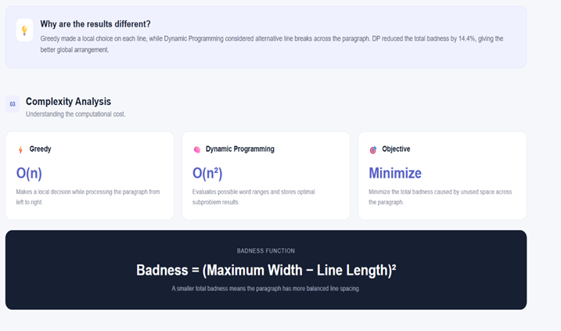
Figure E.1. Complexity-analysis screenshot from the project presentation.

Appendix F – Ethics / Institutional Approval
Formal ethical or institutional approval is not required for the software prototype because it does not involve human subjects, medical data, personal datasets, or hazardous physical experimentation.

Appendix G – Project Meeting / Progress Records
Recommended evidence for the final submission includes team meeting screenshots, task allocation, module-development discussions, testing discussions, and final integration evidence.

Appendix H – User / Industry Feedback
Where available, include feedback regarding interface clarity, readability of the comparison, usefulness of the badness metric, and suggested improvements.

Appendix I – Publications / Patents / Competitions / Product Outcomes
Not applicable based on the supplied project materials.

Appendix J – Individual Contribution Evidence
• Evidence of Dynamic Programming recurrence implementation and testing.
• Evidence of Greedy baseline implementation and comparison.
• Interactive web-interface screenshots.
• Benchmarking / complexity-analysis evidence.
• Relevant report sections and version-history evidence, where available.

