Title

Real-Time Traffic Monitoring System Using Quick Sort

Introduction:

With the rapid growth of urbanization and smart cities, road traffic has become increasingly complex. Every second, thousands of vehicles generate data through GPS devices, traffic cameras, RFID sensors, toll booths, and IoT-enabled devices. This data includes vehicle speed, location, travel time, lane occupancy, and traffic density.

A Real-Time Traffic Monitoring System (RTMS) continuously collects, processes, and analyzes this data to support intelligent transportation systems. One of the primary tasks is sorting vehicle information so that authorities can quickly identify congested roads, detect slow-moving vehicles, estimate travel time, and optimize traffic signal timings.

Since traffic data is continuously changing, an efficient sorting algorithm is required. Quick Sort is one of the most efficient comparison-based sorting algorithms because it follows the Divide and Conquer paradigm, making it suitable for processing large volumes of dynamic traffic data.

Description of the Real-World Problem:
Traffic congestion is one of the biggest challenges in modern cities. Every day, thousands of vehicles travel on roads, generating a large amount of real-time data such as vehicle speed, location, travel time, and traffic density. This information is collected from GPS devices, road sensors, CCTV cameras, and smart traffic signals. To effectively monitor traffic conditions, the system must quickly organize and analyze this continuously changing data.
A Real-Time Traffic Monitoring System (RTMS) is designed to collect, process, and analyze vehicle information as it is received. One of its key functions is sorting vehicle data so that traffic authorities can identify slow-moving vehicles, detect congested road segments, estimate travel times, and provide alternative routes to drivers. Since new vehicle data arrives every second, the sorting process must be fast and efficient to ensure that traffic information remains accurate and up to date.
For example, consider a traffic monitoring system that receives the speeds of vehicles on a highway:
65, 40, 85, 55, 30, 75, 50 km/h
Before analysis, these speeds are unsorted, making it difficult to determine which vehicles are moving slowly or which road sections are experiencing congestion. By applying the Quick Sort algorithm, the data is arranged in ascending order:
30, 40, 50, 55, 65, 75, 85 km/h
The sorted data enables the system to quickly identify the slowest vehicles, calculate average traffic speed, detect congestion patterns, and support better traffic management decisions.
However, implementing Quick Sort in a real-time traffic monitoring system presents several challenges. Since traffic data is continuously changing, the algorithm must repeatedly sort new information with minimal delay. In addition, the performance of Quick Sort depends on selecting an appropriate pivot element. A poor pivot choice can create unbalanced partitions, increasing the execution time to O(n²) in the worst case. Another challenge is uneven data distribution, where many vehicles may have similar speeds or the data may already be partially sorted. These situations can reduce the efficiency of the algorithm if not handled properly.
To overcome these challenges, Quick Sort uses the Divide and Conquer technique. It selects a pivot, divides the data into smaller partitions, recursively sorts each partition, and combines the results to produce a fully sorted list. Techniques such as random pivot selection, median-of-three pivot selection, three-way partitioning, and parallel processing can further improve performance by creating more balanced partitions and reducing processing time.
Therefore, Quick Sort provides a practical and efficient solution for real-time traffic monitoring systems, enabling rapid analysis of large volumes of vehicle data while supporting intelligent traffic management, congestion detection, route optimization, and smart city transportation services.
Problem Statement:
Modern traffic monitoring systems receive a continuous stream of vehicle data, including speed, location, travel time, and traffic density, from sources such as GPS devices, road sensors, and CCTV cameras. As the volume of data increases, the system must sort this information quickly to identify traffic congestion, detect slow-moving vehicles, estimate travel times, and support efficient traffic management decisions.
The main challenge is to perform real-time sorting while handling large and continuously changing datasets. The performance of the sorting process can be affected by factors such as poor pivot selection, uneven distribution of vehicle data, and duplicate speed values, which may lead to unbalanced partitions and increased execution time in Quick Sort.
Therefore, the problem is to design and implement a Real-Time Traffic Monitoring System that uses the Quick Sort algorithm to efficiently sort dynamic vehicle data using the Divide and Conquer approach. The system should achieve fast average-case performance, minimize processing delays, effectively handle large datasets, and improve traffic congestion analysis through appropriate pivot selection and optimization techniques such as random pivot selection, median-of-three pivot selection, and three-way partitioning.
Algorithm Used1:
Algorithm Name: Quick Sort
Overview
Quick Sort is an efficient comparison-based sorting algorithm that follows the Divide and Conquer technique. It is widely used for sorting large datasets because of its fast average-case performance and low memory usage. In a Real-Time Traffic Monitoring System, Quick Sort is used to sort vehicle data such as speeds, travel times, or traffic density, enabling the system to quickly analyze congestion patterns and make timely traffic management decisions.
Working of the Algorithm
Quick Sort performs sorting in the following steps:
- Choose a Pivot
- Select one element from the dataset as the pivot.
- The pivot can be the first element, last element, middle element, a random element, or the median of three elements.
- Partition the Data
  - Rearrange the data so that:
    - All elements smaller than the pivot are placed on the left.
    - All elements greater than the pivot are placed on the right.
After partitioning, the pivot is placed in its correct sorted position.
- Recursively Sort
  - Apply the same process to the left and right partitions until each partition contains only one or zero elements.
- Obtain the Sorted Data
  - Since each pivot is placed in its correct position during partitioning, the entire dataset becomes sorted without requiring a separate merging step.
Example
Suppose the traffic monitoring system receives the following vehicle speeds:
65, 40, 85, 55, 30, 75, 50
Choose 55 as the pivot.
After partitioning:
40, 30, 50 | 55 | 65, 85, 75
Sort the left and right partitions recursively:
30, 40, 50 | 55 | 65, 75, 85
Final Sorted Output:
30, 40, 50, 55, 65, 75, 85

Role in the Traffic Monitoring System:
In a real-time traffic monitoring system, Quick Sort helps to:
- Sort vehicle speeds from lowest to highest.
- Identify slow-moving vehicles that may indicate traffic congestion.
- Analyze traffic density across different road segments.
- Calculate minimum, maximum, and average vehicle speeds.
- Support route optimization and traffic signal control.
- Enable faster decision-making for intelligent transportation systems.

Justification for Choosing the Algorithm:
Quick Sort is chosen for the Real-Time Traffic Monitoring System because it provides a good balance between high sorting speed, low memory usage, and efficient performance when handling large amounts of dynamic traffic data. Since traffic information such as vehicle speeds, travel times, and traffic density is continuously generated from sensors, GPS devices, and cameras, the system requires a sorting algorithm that can process data quickly and support real-time decision-making.
Reasons for Choosing Quick Sort:
1. Fast Average-Case Performance
Quick Sort has an average time complexity of O(n log n), making it one of the fastest comparison-based sorting algorithms. This enables the traffic monitoring system to sort thousands of vehicle records quickly, allowing congestion analysis and traffic updates to be generated in real time.
2. Efficient for Large Datasets
Modern traffic systems collect data from thousands of vehicles every second. Quick Sort performs efficiently on large datasets, making it suitable for smart city traffic management and intelligent transportation systems.
3. Uses the Divide and Conquer Technique
Quick Sort divides the dataset into smaller partitions based on a pivot element and recursively sorts each partition. This approach reduces the overall sorting time and improves processing efficiency, especially for continuously changing traffic data.
4. Low Memory Requirement
Unlike Merge Sort, which requires additional memory for merging, Quick Sort is an in-place sorting algorithm. It requires only O(log n) extra space for recursive calls, making it suitable for systems with limited memory resources.
5. Supports Real-Time Traffic Analysis
Traffic data is dynamic and changes every second as vehicles move through different road segments. Quick Sort processes updated data efficiently, enabling the system to:
- Detect traffic congestion quickly.
- Identify slow-moving vehicles.
- Calculate average traffic speed.
- Recommend alternative routes.
- Improve traffic signal management.

6. Good Cache Performance
Quick Sort accesses data stored in nearby memory locations, which improves CPU cache utilization. This results in faster execution in practical applications compared to some other sorting algorithms.
7. Easily Optimized
The performance of Quick Sort can be further improved by using optimization techniques such as:
- Random Pivot Selection to reduce the probability of worst-case performance.
- Median-of-Three Pivot Selection to create balanced partitions.
- Three-Way Partitioning to efficiently handle duplicate vehicle speeds.
- Hybrid Quick Sort, which switches to Insertion Sort for very small partitions.
- Parallel Quick Sort, allowing left and right partitions to be sorted simultaneously on multiple processors.

Complexity Analysis:
The performance of the Quick Sort algorithm depends on how effectively the selected pivot divides the dataset into smaller partitions. In a Real-Time Traffic Monitoring System, the algorithm sorts vehicle data such as speeds, travel times, and traffic density. Its efficiency directly affects how quickly the system can analyze congestion and provide traffic updates
Time Complexity
Case | Time Complexity | Explanation
Best Case | O(n log n) | Occurs when the pivot divides the data into two nearly equal partitions at every recursive step. This minimizes the number of comparisons and recursive calls.
Average Case | O(n log n) | Occurs when the pivot creates reasonablbalanced partitions. This is the most common case in real-world traffic data when good pivot selection methods are used.
Worst Case | O(n²) | Occurs when the pivot always becomes the smallesorlargestelement,creatinhighlunbalancedpartition This happens when the input is already sorted or reverse sorted and a poor pivot is chosen.

Best Case Example:
Vehicle speeds:
65, 40, 85, 55, 30, 75, 50
Choosing 55 as the pivot divides the data into:
40, 30, 50 | 55 | 65, 85, 75
The partitions are nearly equal, so Quick Sort performs efficiently with O(n log n) complexity.
Average Case Example
Vehicle speeds arrive in a random order:
72, 45, 68, 30, 80, 55, 60
The pivot creates reasonably balanced partitions, allowing Quick Sort to maintain its average complexity of O(n log n).
Worst Case Example
Vehicle speeds are already sorted:
20, 30, 40, 50, 60, 70, 80
If the last element (80) is always selected as the pivot, the partitions become:
20, 30, 40, 50, 60, 70 | 80

Manual Execution (Step-by-Step Process):
Input Data:
65, 40, 85, 55, 30, 75, 50
The system uses Quick Sort to arrange the vehicle speeds in ascending order
Step 1: Choose the Pivot
Select 55 as the pivot element.
Array:
65, 40, 85, 55, 30, 75, 50
Pivot = 55

Step 2: Partition the Data:
Compare each element with the pivot.
- Smaller than 55 → 40, 30, 50
- Pivot → 55
- Greater than 55 → 65, 85, 75
After partitioning:
40, 30, 50 | 55 | 65, 85, 75
Step 3: Sort the Left Partition
Left partition:
40, 30, 50
Choose 40 as the pivot.
Compare elements:
- Smaller than 40 → 30
- Pivot → 40
- Greater than 40 → 50
Sorted left partition:
30, 40, 50
Step 4: Sort the Right Partition:
Right partition:
65, 85, 75
Choose 85 as the pivot.
Compare elements:
- Smaller than 85 → 65, 75
- Pivot → 85
Now sort 65, 75.
Choose 65 as the pivot.
- Smaller than 65 → None
- Pivot → 65
- Greater than 65 → 75
Sorted right partition:
65, 75, 85
Step 5: Combine All Partitions
Combine the sorted left partition, pivot, and sorted right partition.
30, 40, 50 | 55 | 65, 75, 85
Final Sorted Output
30, 40, 50, 55, 65, 75, 85

Applications of Quick Sort in Real-Time Traffic Monitoring System:
- Vehicle Speed Sorting
  - Quick Sort arranges vehicle speeds from low to high.
  - Helps identify slow vehicles and detect traffic problems.
- Traffic Congestion Detection
  - Sorts traffic data to find roads with heavy traffic.
  - Helps authorities take quick actions to reduce congestion.
- Traffic Density Analysis
  - Sorts roads based on the number of vehicles.
  - Helps identify highly crowded areas.
- Route Optimization
  - Sorts travel time and traffic conditions.
  - Helps navigation systems suggest faster route.

- Emergency Vehicle Management
- Helps find less crowded routes for ambulances, fire trucks, and police vehicles.
- Traffic Signal Control
- Analyzes vehicle count at junctions.
- Helps adjust signal timing according to traffic flow.
- Accident Detection
- Sorts changes in vehicle speed and traffic flow.
- Helps identify accident-affected areas quickly.
- Smart City Traffic Management
- Processes large amounts of vehicle data.
- Supports intelligent transportation systems.
- Parking Management
- Sorts available parking spaces.
- Helps drivers find suitable parking locations.
- Traffic Data Analysis
- Organizes traffic records for reports and future planning.

Advantages of Quick Sort in Real-Time Traffic Monitoring System:

- Fast Sorting Speed
  - Quick Sort can sort large amounts of vehicle data quickly.
  - Its average time complexity is O(n log n), making it suitable for real-time traffic analysis.
- Efficient for Large Data
  - It can handle large numbers of vehicle records generated by sensors, GPS devices, and cameras.
- Low Memory Usage
  - Quick Sort requires less extra memory compared to algorithms like Merge Sort.
  - It works mostly within the original data storage.
- Uses Divide and Conquer Technique
  - It divides large traffic data into smaller parts, making the sorting process faster and more efficient.
- Suitable for Real-Time Applications
  - It quickly updates sorted traffic information, helping detect congestion and improve traffic management.
- Easy to Implement
  - The algorithm is simple and can be easily integrated into traffic monitoring software.
- Good Performance in Practice
  - It performs faster than many other sorting algorithms for large datasets.
- Supports Data Analysis
  - Sorted vehicle data helps calculate speed, identify congestion levels, and improve route planning.

Limitations of Quick Sort in Real-Time Traffic Monitoring System:
- Worst-Case Performance
- Quick Sort can take O(n²) time when the pivot selection is poor.
- This may slow down the system when processing large traffic data.
- Pivot Selection Problem
- The performance depends on choosing a good pivot.
- A wrong pivot choice can create unbalanced partitions and increase processing time.
- Not Stable Sorting
- Quick Sort does not maintain the original order of equal elements.
- This can be a problem when sorting vehicle records with the same speed or priority.
- Recursive Overhead
- Quick Sort uses recursion, which requires extra memory for function calls.
- Very large datasets may cause stack overflow problems.

- Poor Performance with Already Sorted Data
- If traffic data is already sorted and a bad pivot is selected, the algorithm becomes slower.
- Handling Duplicate Data
- Large numbers of duplicate values (such as many vehicles with the same speed) can reduce efficiency in normal Quick Sort.
- Frequent Data Updates
- Real-time traffic systems receive continuous data changes.
- Repeatedly sorting updated data can increase processing load.

Comparison with Other Sorting Algorithms:

Algorithm | Best Case | Average Case | Worst Case | Space Complexity | Suitable for Traffic Monitoring
Quick Sort | O(n log n) | O(n log n) | O(n²) | O(log n) | Highly suitable for large real-time data
Merge Sort | O(n log n) | O(n log n) | O(n log n) | O(n) | Suitable but requires extra memory
Heap Sort | O(n log n) | O(n log n) | O(n log n) | O(1) | Good performance but slower in practice
Insertion Sort | O(n) | O(n²) | O(n²) | O(1) | Suitable only for small traffic datasets
Bubble Sort | O(n) | O(n²) | O(n²) | O(1) | Not suitable for large traffic data

Screenshot of the Program:
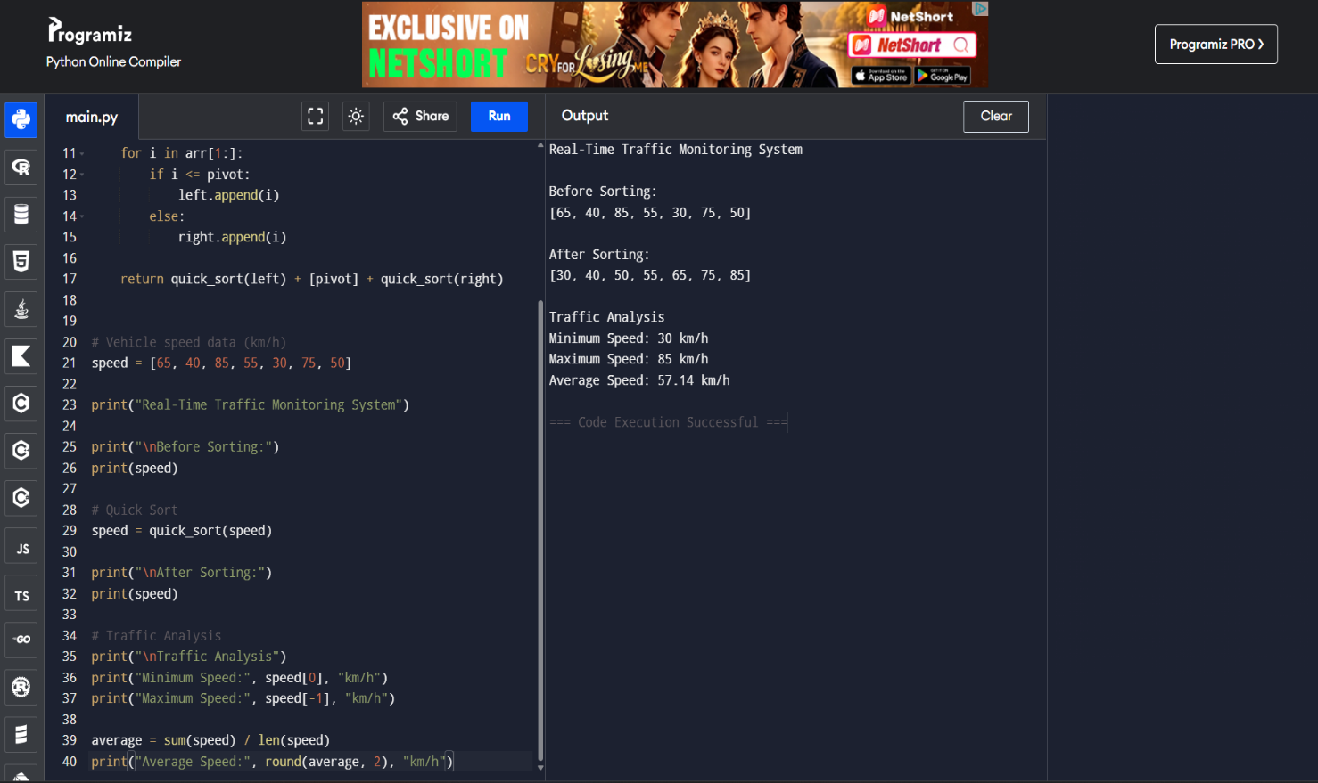

Conclusion:
Quick Sort is an efficient algorithm for a Real-Time Traffic Monitoring System because it can quickly sort large amounts of vehicle data such as speed, travel time, and traffic density. By using the Divide and Conquer technique, Quick Sort divides complex data into smaller parts and processes them efficiently.
The sorted traffic data helps in detecting congestion, analyzing vehicle speeds, improving route selection, and supporting better traffic management decisions. Although Quick Sort may face challenges such as poor pivot selection and worst-case performance, optimization techniques like random pivot selection and balanced partitioning can improve its efficiency.
Overall, Quick Sort is a suitable choice for real-time traffic applications because of its fast average performance (O(n log n)), low memory usage, and ability to handle large dynamic datasets effectively. It plays an important role in developing smarter and more efficient transportation systems.

