INDUSTRIAL TRAINING REPORT

**On**

**Website Development**

**(Portfolio Website)**

**Submitted by**

**Name of Student: Hitesh Sharma**

**Roll No: 181500272**

Department of Computer Engineering & Applications

**Institute of Engineering & Technology**



**GLA University**

**Mathura-281406, INDIA**

**2020**

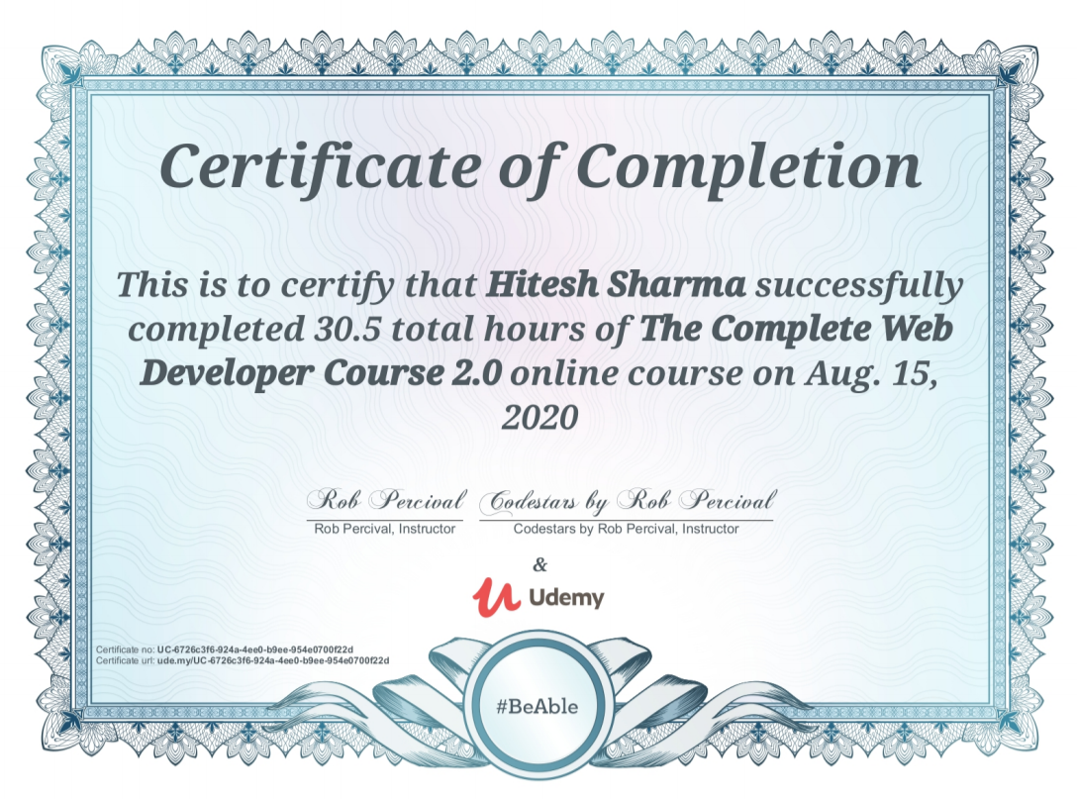

**Synopsis**

**Student Information:**

|  |  |
| --- | --- |
| Name: Hitesh Sharma | University Roll. No. 181500272  111111511815181500714 |
| Mobile: 9729506380 | Email: hitesh.sharma_cs18@gla.ac.in |

**Information about Industry/Organization:**

|  |  |
| --- | --- |
| Industry/Organization Name with full Address | www.udemy.com |
| Contact Person | Name & Designation: Rob Percival (Web Developer And Teacher)  Mobile/email: info@codestars.com |

**Project Information:**

|  |  |
| --- | --- |
| Title Of Project | Web Developer Course |
| Role&Responsibility | Role : Developer  Responsibility : Applying HTML,CSS ,Bootstrap and JS basics in the project |
| Technical Details | Hardware Requirements:  Processor: Minimum 1 GHz; Recommended 2GHz or more.  Ethernet connection (LAN) OR a wireless adapter (Wi-Fi)  Hard Drive: Minimum 32 GB; Recommended 64 GB or more.  Memory (RAM): Minimum 1 GB; Recommended 4 GB or above.  Sound card w/speakers.  Some classes require a camera and microphone.  Software Requirements:  Supported Web Browser  HTML Editor |
| Implementation Details | Fully Implemented |
| Training Period | Start Date: July 28,2020  End Date: August 15,2020  Duration Of Training (In Weeks): 2.7 |

**Summary of the Training Work:**

|  |
| --- |
| It was a online certified course offered by the University of Leeds. It was a three-week course.  In the course, I got introduced to the basics of code types. I explored the role that the coding languages of Hypertext Markup Language(HTML), Cascading Style Sheets(CSS) and JavaScript play in making web pages and sites. I learned about the basics of HTML, CSS and a little about JavaScript. I learned how to make good web pages and how to inspect them using the browser developer tool. I also got to know about how the real-world sites and apps build upon the basics. |

**Acknowledgement**

I express my sincere thanks to the team of Udemy for providing such an outstanding online training course. The course was so well-organised into modules that it had me on the edge of my seat. The facility to download the lectures any time made my work easier.

I am really indebted to my trainers who were extremely supportive throughout the program and helped me to claw my way out of every situations. All doubts raised be me were made clear through proper implementation.

Lastly, I would also express my gratitude towards my brother who guided me all through this time and my parents who took care of me and inspired me.

**Abstract**

This training program was chosen to explore the various technologies required for learning web development and mould the knowledge gained into a seamless website. The e-commerce website is a bundle of all techniques learnt during this program.

The course includes modules of HTML, CSS, Bootstrap which defines how the website looks. This is, therefore, called as front-end of a website. The technology used for the back-end implementation is PHP. These modules power the back-end of a website and helps in data transfer and computations.

Various validations and security features were added too to maintain the privacy of users and secure data transfers.

**Department of computer Engineering and Applications**

**GLA University, Mathura**

**17 km. Stone NH#2, Mathura-Delhi Road, P.O. – Chaumuha,**

**Mathura – 281406**



**Declaration**

I hereby declare that the work which is being presented in the Online Training **“Title: Web Developer Course”,** in partial fulfilment of the requirements for Industrial Training viva voce, is an authentic record of my own work carried under the supervision of Udemy.

Signature of Candidate:

Name of Candidate: Hitesh Sharma

Roll. No. : 181500272

Course: B.Tech (CSE)

Year: 2nd

Semester: IVth

**Table of Contents**

Certificate of Training ii

Synopsis iii - iv

Acknowledgement v

|  |  |
| --- | --- |
| Abstract | vi |
| Declaration | vii |

|  |
| --- |
|  |
|  |
|  |
|  |
|  |
|  |
|  |
|  |
|  |
|  |
|  |
|  |
|  |
|  |
|  |
|  |
|  |
|  |

1. **Introduction 9**
   1. Motivation.......................................................... 9
   2. Objective of Training..........................................9
2. **Software Requirement Analysis 10**
   1. Problem Statement..............................................10
   2. System Analysis..................................................11
   3. Requirement Analysis.........................................11 - 12

2.3.1 Hardware Requirement.......................12

2.3.2 Software Requirement.........................12

2.3.3 Tools & Technology Used...................12

2.4 Feasibility Study.................................................13

2.4.1 Technical Feasibility...........................13 - 14

2.4.2 Operational Feasibility........................14

2.4.3 Economical Feasibility........................15

2.5 Analysis..............................................................15

**3. Software Design 16**

**4. Testing 17**

**5. Implementation and User Interface 18**

5. 1Summary of modules.........................................18 – 23

5.2Conclusion...........................................................24

5.3Limitation............................................................ 25

5.4 Experience............................................................26

**Reference/ Bibliography...................................................... 27**

**6. Appendices 28 - 30**

1. **Introduction**
   1. **Motivation**

Portfolios used well in classrooms have several advantages. They provide a way of documenting and evaluating growth in a much more nuanced way than selected response tests can. Also, portfolios can be integrated easily into instruction, i.e. used for assessment for learning.

**1.2 Objective of Training**

The main reason for selecting this web development course was that it is able to describe the structure and functionality of all coding required for front-end as well as back-end. Using a combination of HTML & CSS, Bootstrap, MySQL, PHP helps to create dynamic web pages which would help to upgrade skills and meet the organizational goals.

1. **Software Requirement Analysis**

**2.1 Problem Statement**

Working on a project website which is a portfolio website. The website provide information about user like skills, education, qualification and some other general knowledge. The project mainly consists of 3 HTML pages. The website will consist of HTML, CSS, BOOTSTRAP, PHP and MYSQLI code. The HTML, CSS and BOOTSTRAP part of your code decides how the website will look, while the PHP and MySQL part decides how it will function. Major three assignments during this program. They will be structured as follows:

1) **HTML, CSS AND BOOTSTRAP:** whether look of each page of website is designed

2) **PHP :** where functionalities will be added to the website. This will allow to register and buy products on the website.

3) **Advanced PHP:** where add advanced features, such as validations and security to the

website.

The 6 main pages that need to be designed are:

1) index.html

2) main.js

3) style.css

4) contact.php

5) innerpage.html

6) portfolio.html

**2.2 System Analysis**

System Analysis is a detailed study of the various operations performed by a system and their relationship within and outside the system. It is a systematic technique that defines goals and objectives the goal of the development is to deliver the system in the line with the user’s requirements, and analysis is this process.

System study has been conducted with the following objectives in mind: -

* + - Identify the client’s need.
    - Evaluate the system concept for feasibility.
    - Perform economical and technical analysis.
    - Allocate functional to hardware, software, people, database and other system elements
    - Establish cost and schedule constraints.
    - Both hardware and software expertise is required to successfully attain the objectives.

## RequirementAnalysis

Information gathering is usually the first phase of the software development project. The purpose of this phase is to identify and document the exact requirements for the system. The user’s request identifies the need for a new information system and on investigation re-defined the new problem to be based on MIS, which supports management. The objective is to determine whether the request is valid and feasible before a recommendation is made to build a new or existing manual system.

The major steps are –

* + - Defining the user requirements.
    - Studying the present system to verify the problem.
    - Defining the performance expected by the candidate to use requirement.

#### Hardware Requirements

Processor : Intel Dual Core or More Processor Speed : 1.5 GHZ

RAM : 2 GB

Hard Disk : 20 GB of free space

**2.3.2 Software Requirements**

Operating System : Window XP and higher

Front End : HTML, CSS, Bootstrap

Back End: JS, PHP

**2.3.3** **Tools and Technology Tools**

2.3.3. 1 Windows 10

2.3.3.2 Google Chrome

#### 2.3.3.2 Technology

* **CSS:** CSS is cascading style sheet which is used to give designer look to HTML using the external file.
* **PHP:** Hypertext Preprocessor is a server-side scripting language designed for web development but also used as a general-purpose programming language.
* **HTML:** Hypertext Markup Language is the standard markup language for creating web pages and web application. HTML element are the building blocks of HTML pages. With HTML constructs, image and other objects, such as interactive form.
* **BOOTSTRAP:** Bootstrap is a potent front-end framework used to create modern websites and web apps.

## Feasibility Study

Feasibility study is the process of determination of whether or not a project is worth doing. Feasibility studies are undertaken within tight time constraints and normally culminate in a written and oral feasibility report. I have taken a fixed time in feasibility study with my co-developer. The contents and recommendations of this feasibility study helped us as a sound basis for deciding how to precede the project. It helped in taking decisions such as which software to use, hardware combinations, etc.

#### Technical feasibility:

This is concerned with specifying equipment of software and hardware that will successfully satisfy the user requirements. The technical needs of the system may vary considerably, but might include:

* The facility to produce output in a given time.
* Response time under certain condition.
* Ability to produce a certain volume of transaction at a particular speed.
* In examining technical feasibility, configuration of the system is given more importance than the actual make of hardware. The configuration should give the complete picture about the system requirements. What speeds of input and output should be achieved at particular quality of printing.

According to the definition of technical feasibility the compatibility between front-end and back-end is very important. In our project the compatibility of both is very good. The degree of compatibility of PHP and SQL Server is very good. The speed of output is very good when we enter the data and click button then the response time is very fast and give result very quick. In ever find difficulty when we use complex query or heavy transaction. The speed of transaction is always smooth and constant. This software provides facility to communicate data to distant location.

The designing of front-end of any project is very important so we selected Active Server Pages, HTML & CSS as front-end due to following reason:

* + Easy implementation of code.
  + Well define interface and database.

At present scenario the no. of backend are available but we have selected JS because of the following number of reasons:

* + - Simplicity
    - Speed
    - Popularity
    - Gives ability to create rich interface

With the help of above support were move defect of existing software. In future we can easily switch over any platform. To ensure that system does not halt in case of undesired situation or events. Problem effected of any module does not affect any module of the system. A change of hardware does not produce problem.

#### Operational Feasibility:

It is mainly related to human organizational and political aspects. The points to be considered are:

* + - 1. What changes will be brought with the system?
      2. What organization structures are distributed structures are distributed.
      3. What new skills will be required? Do the existing staff members have these skills? If not, can they be trained in due course of time?

At present stage all the work is done manually. So, throughput and response time is too much. Major problem is lack of security check that should have been applied.

Now, we will explain the last point of operational feasibility i.e. handling and keeping of software, at every point of designing I will take care that menu options are not too complex and can be easily learned and required least amount of technical skills as operators are going to be from non-computers background.

#### Economic feasibility:

Economic analysis is the most frequently used technique for evaluating the effectiveness of a proposed system. More commonly known as cost/benefit analysis: the procedure is to determine the benefits and saving that are expected from a proposed system and compare them with cost. This is an ongoing effort that improves in accuracy at each phase of the system life cycle.

At present Company has ten systems with following configuration:

* + - 1. Ram 4 GB or above for fast execution and reliability
      2. MOTHER Board x64 based PC
      3. Colour Monitor 14” and17”
      4. Hard Disk 100GB
      5. Hence the economic feasibility is very good.

**2.5 Analysis**

System analysis is the first step towards the software building process. The purpose of system analysis is to understand the system requirements, identify the data, functional and behavioral requirements and building the models of the system for better understanding of the system.

In the process of system analysis one should first understand that, what the present system, how it works (i.e. processes). To begin with, the data objects, processing functions, and behavior of the system are defined in detail. After this models, from three different aspects of the system-data, function and behavior. The models created during the system analysis process helps in better understanding of data and control flow, functional processing, operational behavioral and information content.

**3. Software Design**

A software design document (SDD) is a written description of a [software](http://en.wikipedia.org/wiki/Software) product, that a software designer writes in order to give a [software development](http://en.wikipedia.org/wiki/Software_development) team overall guidance to the architecture of the software project. An SDD usually accompanies an architecture diagram with pointers to detailed feature specifications of smaller pieces of the design. Practically, a design document is required to coordinate a large team under a single vision. A design document needs to be a stable reference, outlining all parts of the software and how they will work. The document is commanded to give a fairly complete description, while maintaining a high-level view of the software.

There are two kinds of design documents called HLDD (high-level design document) and LLDD (low-level design document).

The SDD contains the following documents:

* 1. The [**data design**](http://en.wikipedia.org/wiki/Data-driven_design) describes structures that reside within the software. Attributes and relationships between [data objects](http://en.wikipedia.org/wiki/Data_object) dictate the choice of [data structures](http://en.wikipedia.org/wiki/Data_structures).
  2. The [**architecture design**](http://en.wikipedia.org/wiki/Software_architecture) uses information flowing characteristics, and maps them into the program structure. The transformation mapping method is applied to exhibit distinct boundaries between incoming and outgoing data. The data flow diagrams allocate control input, processing and output along three separate modules.
  3. The [**interface design**](http://en.wikipedia.org/wiki/Interface_design) describes internal and external program interfaces, as well as the design of human interface. Internal and external interface designs are based on the information obtained from the analysis model.
  4. The [**procedural design**](http://en.wikipedia.org/wiki/Procedural_design) describes structured programming concepts using graphical, tabular and textual notations. These design mediums enable the designer to represent procedural detail that facilitates translation to code. This blueprint for implementation forms the basis for all subsequent software engineering worked.

**4. Software Testing**

Software testing is an investigation conducted to provide stakeholders with information about the quality of the software product or service under testing. Software testing is a process of executing a program or application with intent of finding the software bugs. It can also be stated as the process of validating and verifying that a software program or application.

Various test cases are as follows:

**4.1 Testing of webpage:**

|  |  |  |  |  |  |
| --- | --- | --- | --- | --- | --- |
| **Sr. No** | **Test Cases** | **Feature** | **Description** | **Steps to Execute** | **Test Data/Input** |
| 1. | TC-1 | Scrolling | Checks the scrolling of the hole page | Use your mouse and scroll by using the center scroller. | NIL |
| 2. | TC-2 | Working of  buttons | Check the working of all the buttons that are present in the website | Use the mouse and try to click on any of the button | NIL |
| 3. | TC-3 | Image Position | Check all the images positions | NIL | NIL |

**5. Implementation and User Interface**

**5.1 Summary Of Modules**

1. Home
2. About
3. Resume
4. Portfolio
5. Services
6. Contact

#### Home

Home module only refers to basic information and allow to move different section of webpage directly through a navigation bar with responsiveness.

**About**

About module tell the general information like DOB, phone, age, etc.

**Resume**

Provide technical knowledge like skills, qualification.

**Portfolio**

Show you are capable of quality over quantity. Tempting to showcase all the work you have done.

**Services**

Tells about the services provided.

**Conatact**

Contact section allow to get contact information and helps to make contact via message option.

**Home**



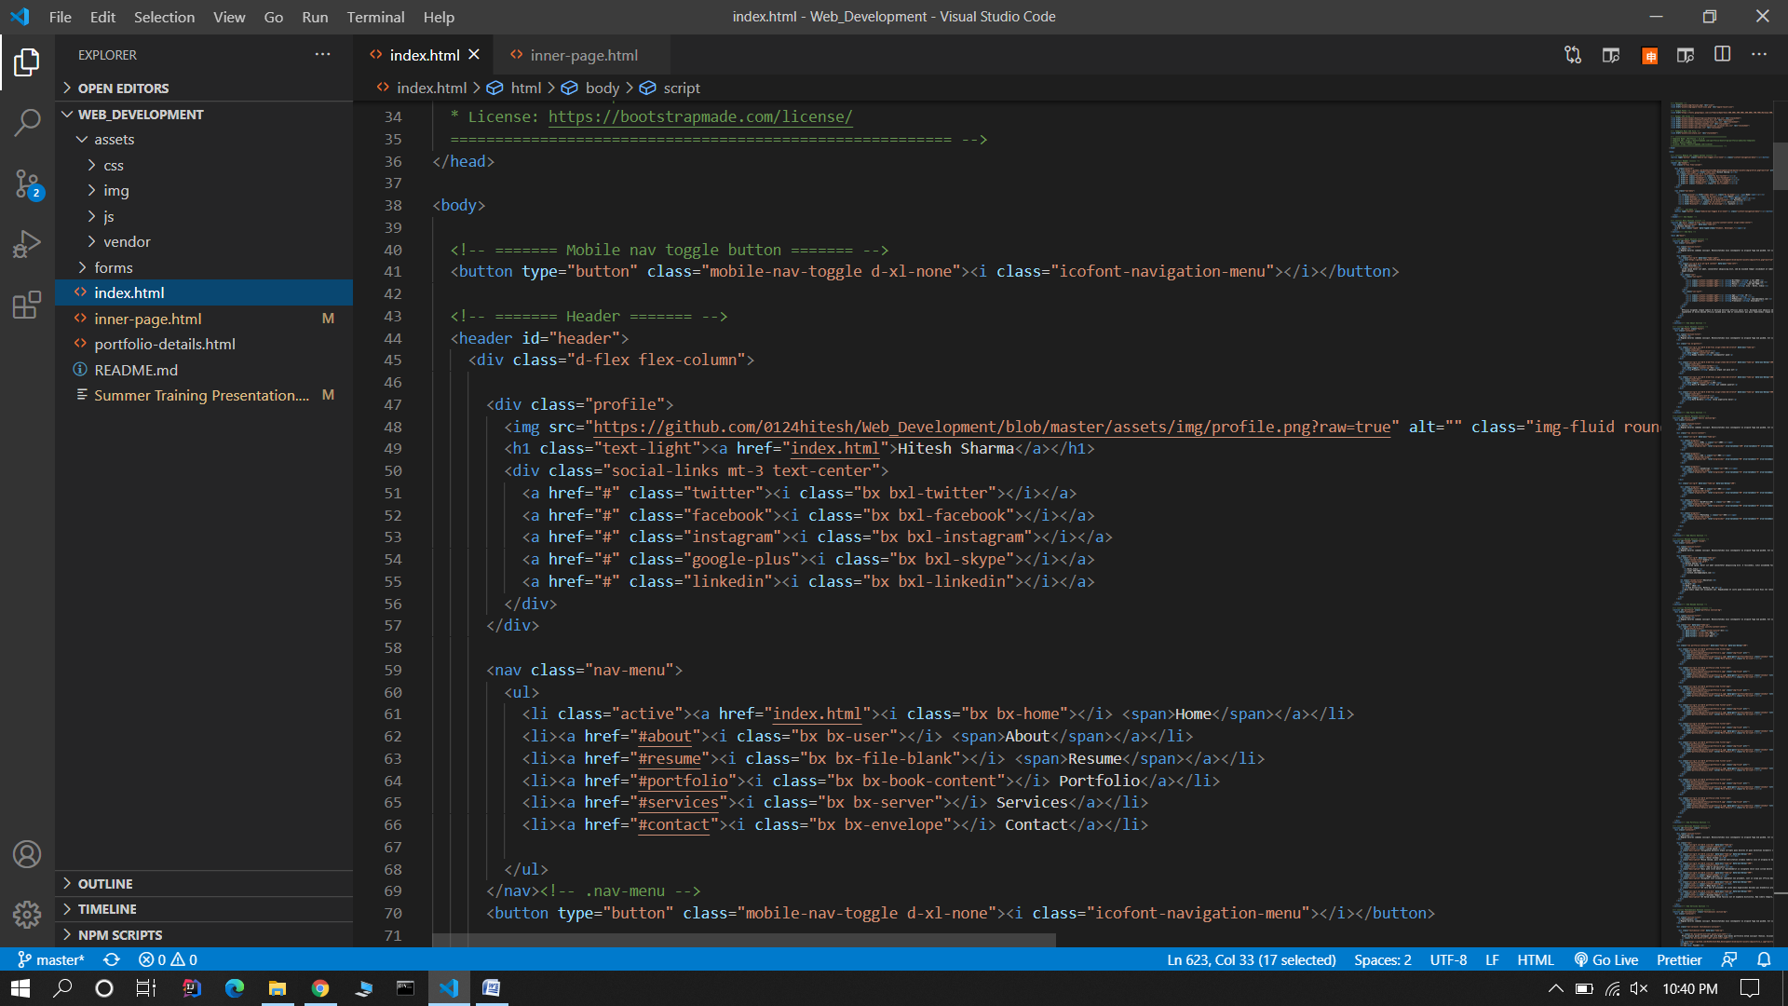

**About**

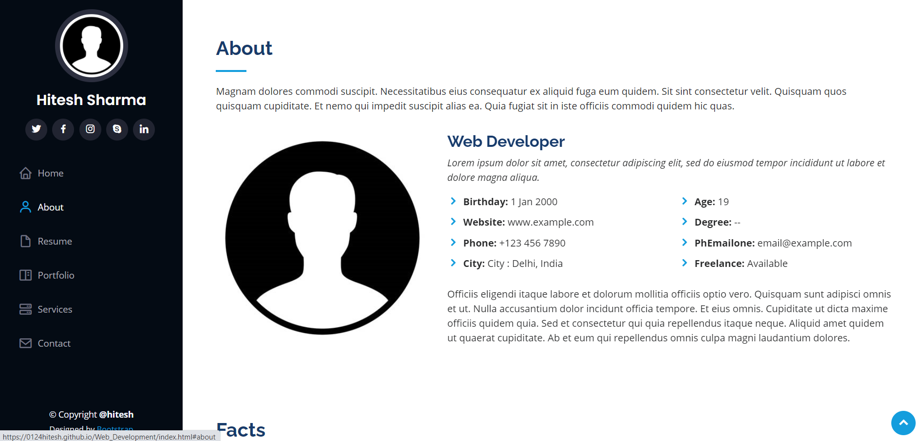

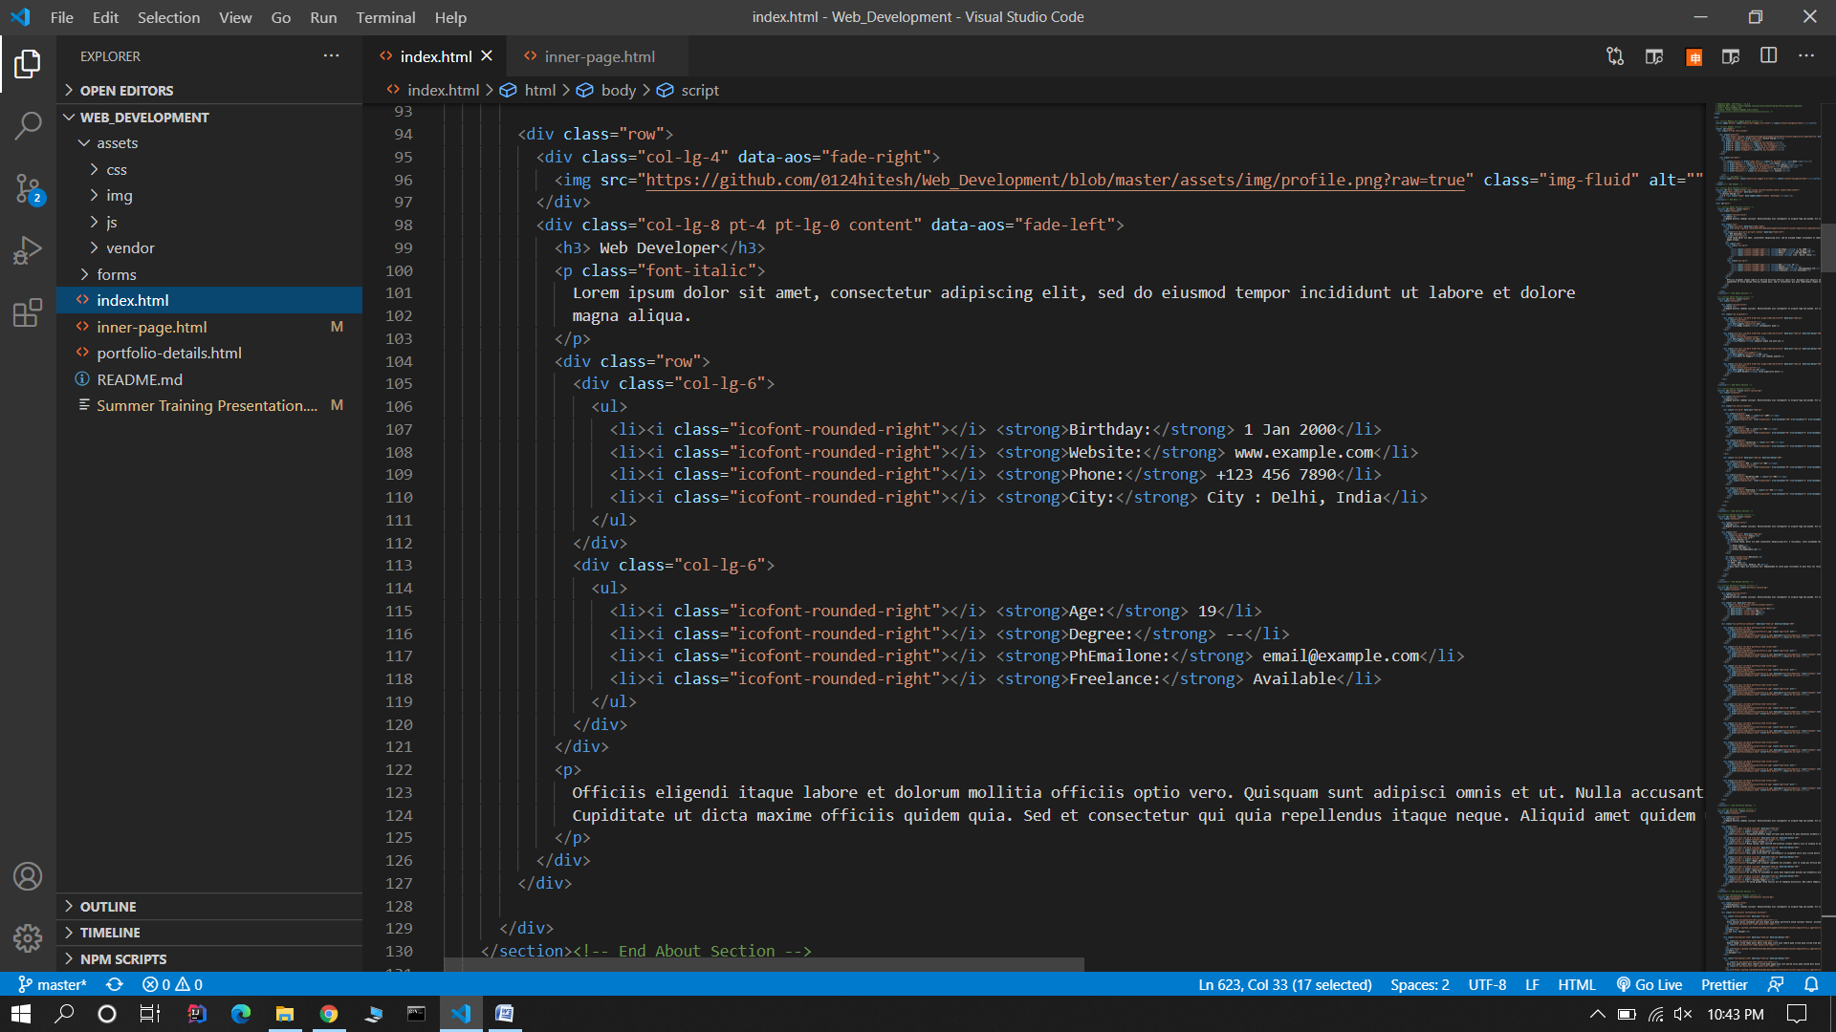

**Resume**

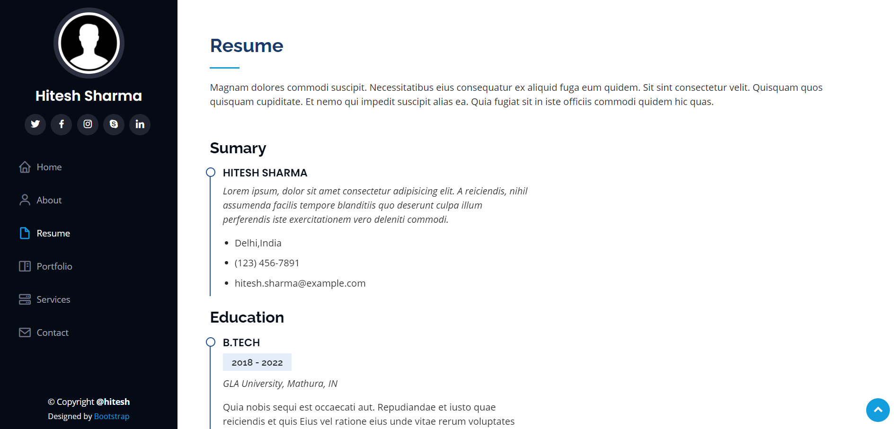

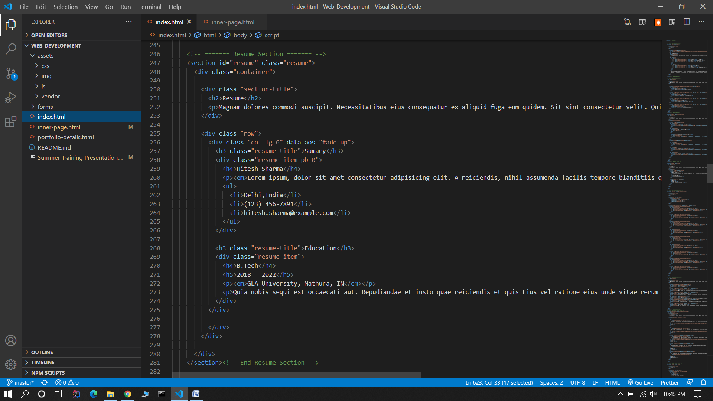

**Portfolio**

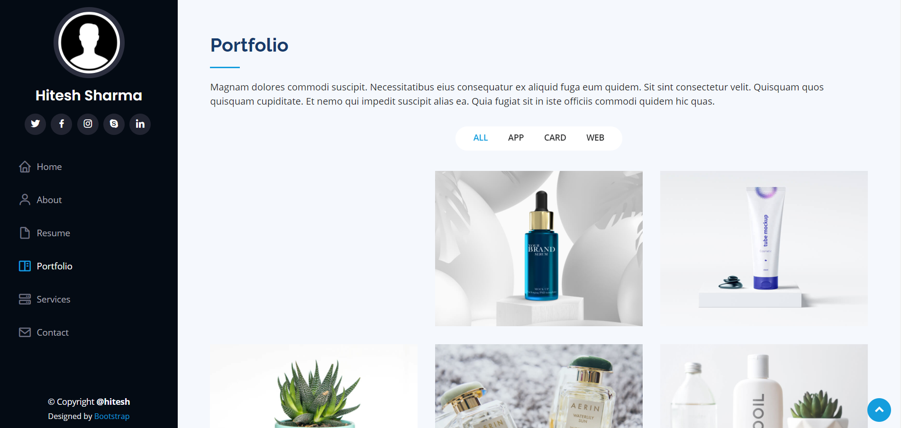

**Services**

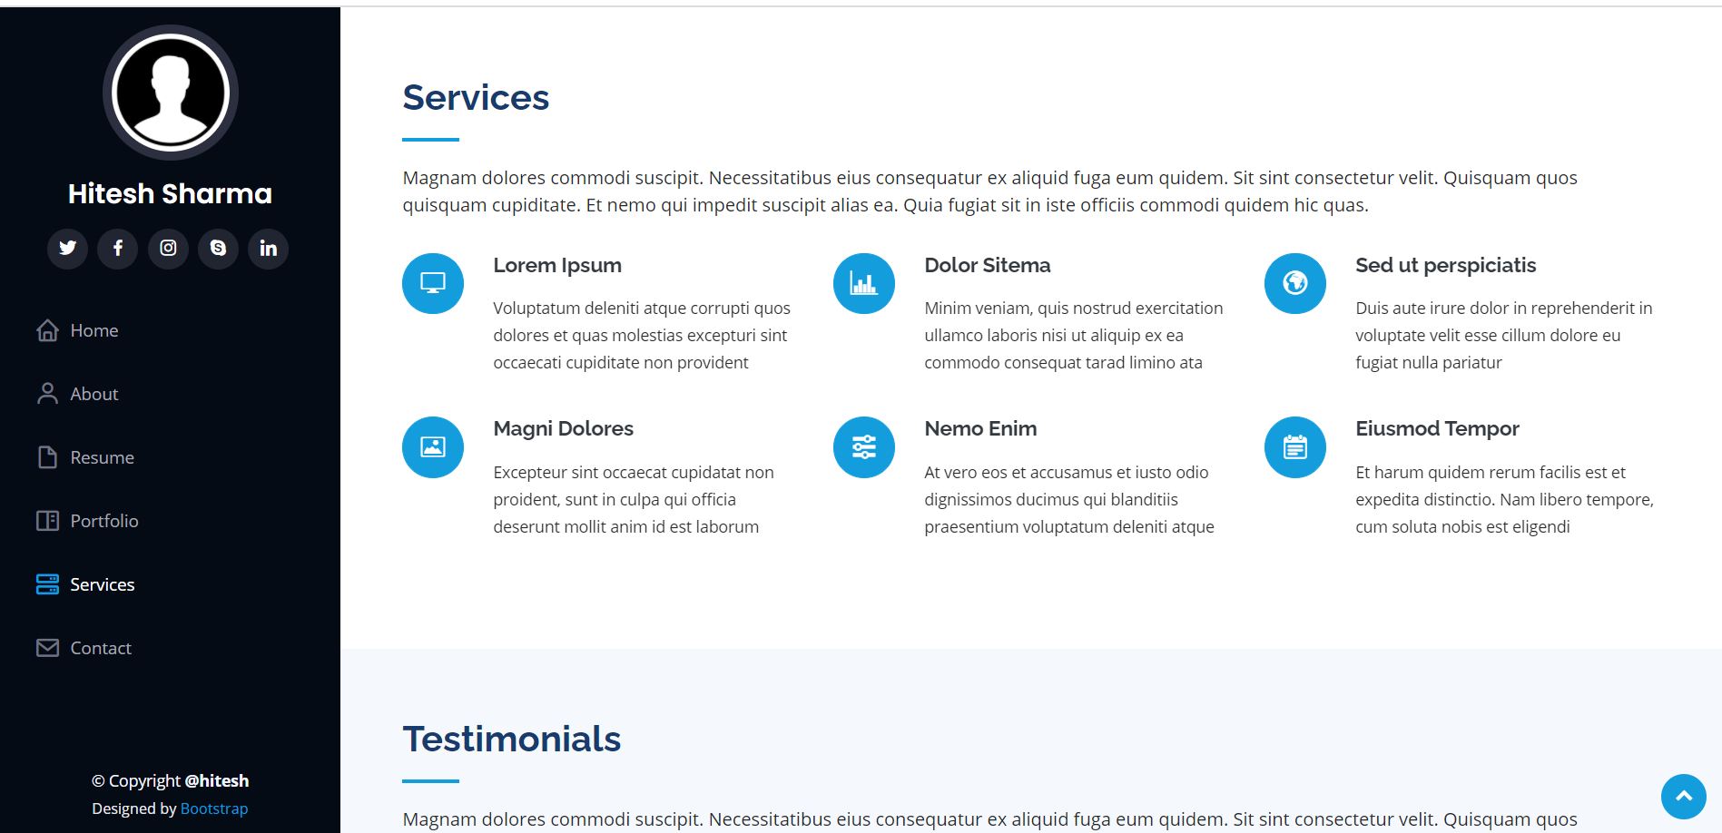

**Contact**

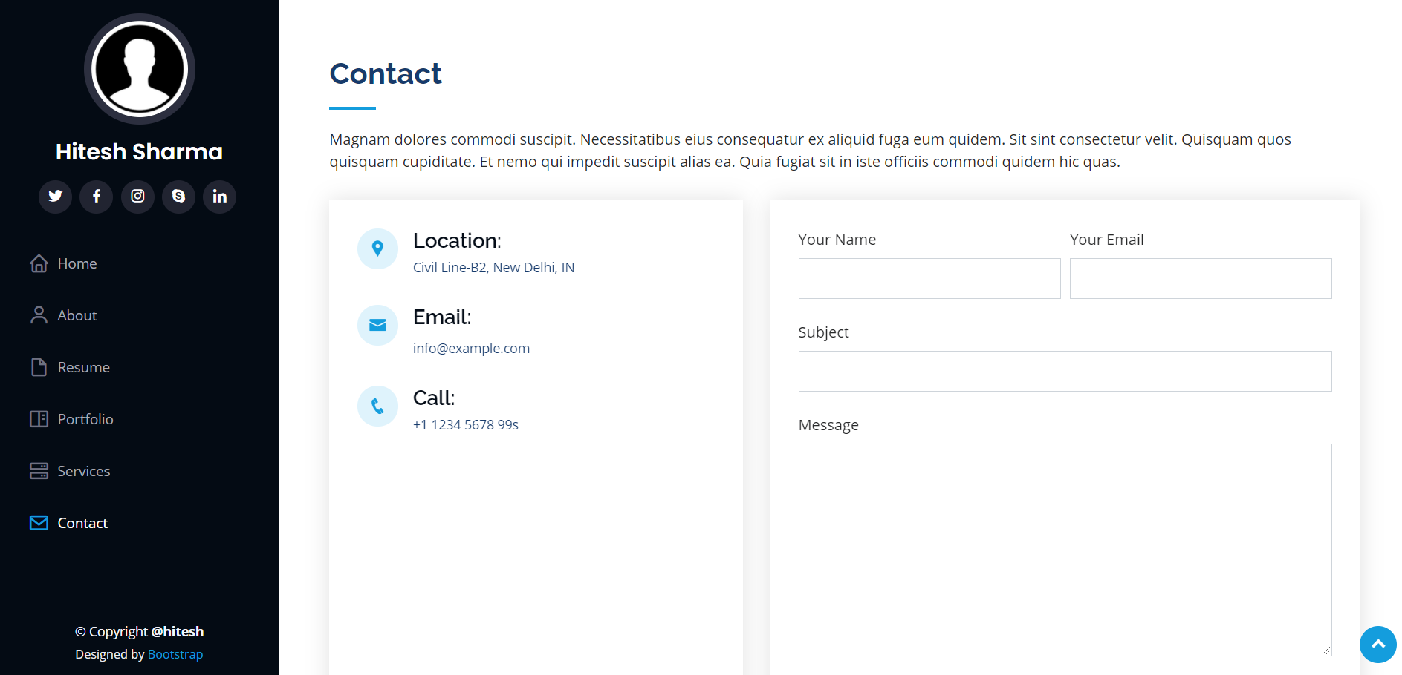

**5.2 CONCLUSION**

The above implementation resulted in a basic portfolio website which is compilation of material that exemplifies user skills, qualification, education. The project is a classic example, that learning of concepts needs to be supplemented with application of that knowledge, without which knowledge remains incomplete.

It was an experience that changed the way I perceived project development. The project is a classic example, that learning of concepts needs to be supplemented with application of that knowledge, without which knowledge remains incomplete.

**5.3 Limitation**

1. One of the most important limitations was the time period. Due to limited duration of this course, some of the topics weren’t studied in detail.
2. It doesn’t actually consider all the points that are required in real for a website.
3. Message option in contact section is not a part of this website.

**5.4 Experience**

Overall experience of working on this project was good. It was quite interesting to see the things appearing on the front-end of the website with several validation codes running at the back-end. It was a project totally created by me, therefore I was able to develop my skills. Although I found it a bit challenging but exploring this domain was equally amazing.

The experience of working on Udemy was nice too. The course was so properly arranged into modules that learning part was made easier. The instructor responded timely on to all the queries. Also, there were frequently asked questions along with instructor’s solution posted on Udemy which were very helpful as a reference. The quizes, code challenges and exercises provided at the end of each section was helpful in testing my learning and correct the mistakes.

I am really looking forward to higher learning in this field and apply my skills for the benefit of the organization I’ll be working for.

**BIBLIOGRAPHY**

The coding part was implemented majorly with the help of Udemy training course only.  
<https://udemy.com/>

Other links referred were :  
<https://www.w3schools.com/html>  
<https://www.w3schools.com/css>  
  
CSS Link:

assets/vendor/bootstrap/css/bootstrap.min.css

assets/vendor/icofont/icofont.min.css

assets/vendor/boxicons/css/boxicons.min.css

assets/vendor/venobox/venobox.css

assets/vendor/owl.carousel/assets/owl.carousel.min.css

assets/vendor/aos/aos.css

 Template Link:   
<https://bootstrapmade.com/iportfolio-bootstrap-portfolio-websites-template/>

JS Link:

assets/js/main.js

**6. Appendices**

<!DOCTYPE html>

<html lang="en">

<head>

  <meta charset="utf-8">

  <meta content="width=device-width, initial-scale=1.0" name="viewport">

  <title>Inner Page - iPortfolio Bootstrap Template</title>

  <meta content="" name="descriptison">

  <meta content="" name="keywords">

  <!-- Favicons -->

  <link href="assets/img/favicon.png" rel="icon">

  <link href="assets/img/apple-touch-icon.png" rel="apple-touch-icon">

  <!-- Google Fonts -->

  <link href="https://fonts.googleapis.com/css?family=Open+Sans:300,300i,400,400i,600,600i,700,700i|Raleway:300,300i,400,400i,500,500i,600,600i,700,700i|Poppins:300,300i,400,400i,500,500i,600,600i,700,700i" rel="stylesheet">

  <!-- Vendor CSS Files -->

  <link href="assets/vendor/bootstrap/css/bootstrap.min.css" rel="stylesheet">

  <link href="assets/vendor/icofont/icofont.min.css" rel="stylesheet">

  <link href="assets/vendor/boxicons/css/boxicons.min.css" rel="stylesheet">

  <link href="assets/vendor/venobox/venobox.css" rel="stylesheet">

  <link href="assets/vendor/owl.carousel/assets/owl.carousel.min.css" rel="stylesheet">

  <link href="assets/vendor/aos/aos.css" rel="stylesheet">

  <!-- Template Main CSS File -->

  <link href="assets/css/style.css" rel="stylesheet">

  <!-- =======================================================

  * Template Name: iPortfolio - v1.3.0

  * Template URL: https://bootstrapmade.com/iportfolio-bootstrap-portfolio-websites-template/

  * Author: BootstrapMade.com

  * License: https://bootstrapmade.com/license/

  ======================================================== -->

</head>

<body>

  <!-- ======= Mobile nav toggle button ======= -->

  <button type="button" class="mobile-nav-toggle d-xl-none"><i class="icofont-navigation-menu"></i></button>

  <!-- ======= Header ======= -->

  <header id="header">

    <div class="d-flex flex-column">

      <div class="profile">

        <img src="assets/img/profile-img.jpg" alt="" class="img-fluid rounded-circle">

        <h1 class="text-light"><a href="index.html">Hitesh Sharma</a></h1>

        <div class="social-links mt-3 text-center">

          <a href="#" class="twitter"><i class="bx bxl-twitter"></i></a>

          <a href="#" class="facebook"><i class="bx bxl-facebook"></i></a>

          <a href="#" class="instagram"><i class="bx bxl-instagram"></i></a>

          <a href="#" class="google-plus"><i class="bx bxl-skype"></i></a>

          <a href="#" class="linkedin"><i class="bx bxl-linkedin"></i></a>

        </div>

      </div>

      <nav class="nav-menu">

        <ul>

          <li><a href="index.html"><i class="bx bx-home"></i> <span>Home</span></a></li>

          <li><a href="#about"><i class="bx bx-user"></i> <span>About</span></a></li>

          <li><a href="#resume"><i class="bx bx-file-blank"></i> <span>Resume</span></a></li>

          <li><a href="#portfolio"><i class="bx bx-book-content"></i> Portfolio</a></li>

          <li><a href="#services"><i class="bx bx-server"></i> Services</a></li>

          <li><a href="#contact"><i class="bx bx-envelope"></i> Contact</a></li>

        </ul>

      </nav><!-- .nav-menu -->

      <button type="button" class="mobile-nav-toggle d-xl-none"><i class="icofont-navigation-menu"></i></button>

    </div>

  </header><!-- End Header -->

  <main id="main">

    <!-- ======= Breadcrumbs ======= -->

    <section class="breadcrumbs">

      <div class="container">

        <div class="d-flex justify-content-between align-items-center">

          <h2>Inner Page</h2>

          <ol>

            <li><a href="index.html">Home</a></li>

            <li>Inner Page</li>

          </ol>

        </div>

      </div>

    </section><!-- End Breadcrumbs -->

    <section class="inner-page">

      <div class="container">

        <p>

          Example inner page template

        </p>

      </div>

    </section>

  </main><!-- End #main -->

  <!-- ======= Footer ======= -->

  <footer id="footer">

    <div class="container">

      <div class="copyright">

        &copy; Copyright <strong><span>iPortfolio</span></strong>

      </div>

      <div class="credits">

        <!-- All the links in the footer should remain intact. -->

        <!-- You can delete the links only if you purchased the pro version. -->

        <!-- Licensing information: https://bootstrapmade.com/license/ -->

        <!-- Purchase the pro version with working PHP/AJAX contact form: https://bootstrapmade.com/iportfolio-bootstrap-portfolio-websites-template/ -->

        Designed by <a href="https://bootstrapmade.com/">BootstrapMade</a>

      </div>

    </div>

  </footer><!-- End  Footer -->

  <a href="#" class="back-to-top"><i class="icofont-simple-up"></i></a>

  <!-- Vendor JS Files -->

  <script src="assets/vendor/jquery/jquery.min.js"></script>

  <script src="assets/vendor/bootstrap/js/bootstrap.bundle.min.js"></script>

  <script src="assets/vendor/jquery.easing/jquery.easing.min.js"></script>

  <script src="assets/vendor/php-email-form/validate.js"></script>

  <script src="assets/vendor/waypoints/jquery.waypoints.min.js"></script>

  <script src="assets/vendor/counterup/counterup.min.js"></script>

  <script src="assets/vendor/isotope-layout/isotope.pkgd.min.js"></script>

  <script src="assets/vendor/venobox/venobox.min.js"></script>

  <script src="assets/vendor/owl.carousel/owl.carousel.min.js"></script>

  <script src="assets/vendor/typed.js/typed.min.js"></script>

  <script src="assets/vendor/aos/aos.js"></script>

  <!-- Template Main JS File -->

  <script src="assets/js/main.js"></script>

</body>

</html>