Q.1)

a) Create student table having( STUD_ID, FNAME, LNAME, BRANCH) entity.

b) Insert 5 records into student table.

c) Write a query to update branch from CS to IT for stud_id 102.

d) Write a query to remove record of stud_id 103 from student table.

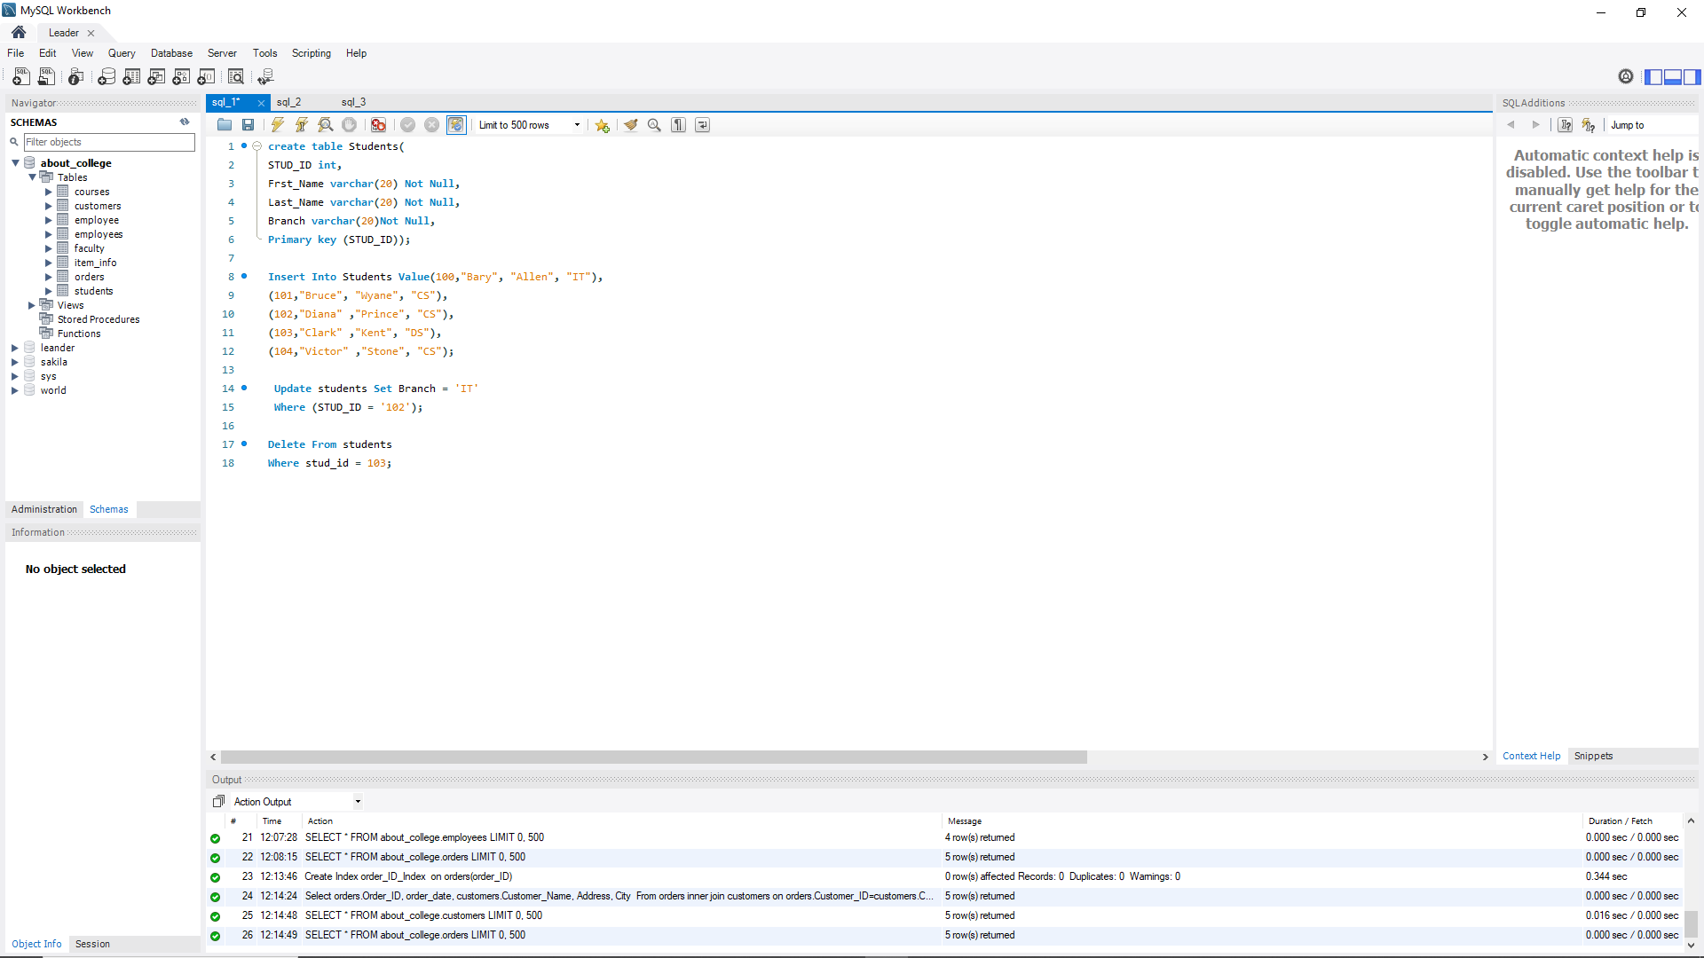

Q.2)

a) Create employee table having( EMP_ID,EMP_NAME,, SALARY).

b) Insert 5 records into employee table.

c) write a query to update salary Rs. 50,000 for EMP_ID 104.

d) write a query to remove record of EMP_ID 103 from employee table.

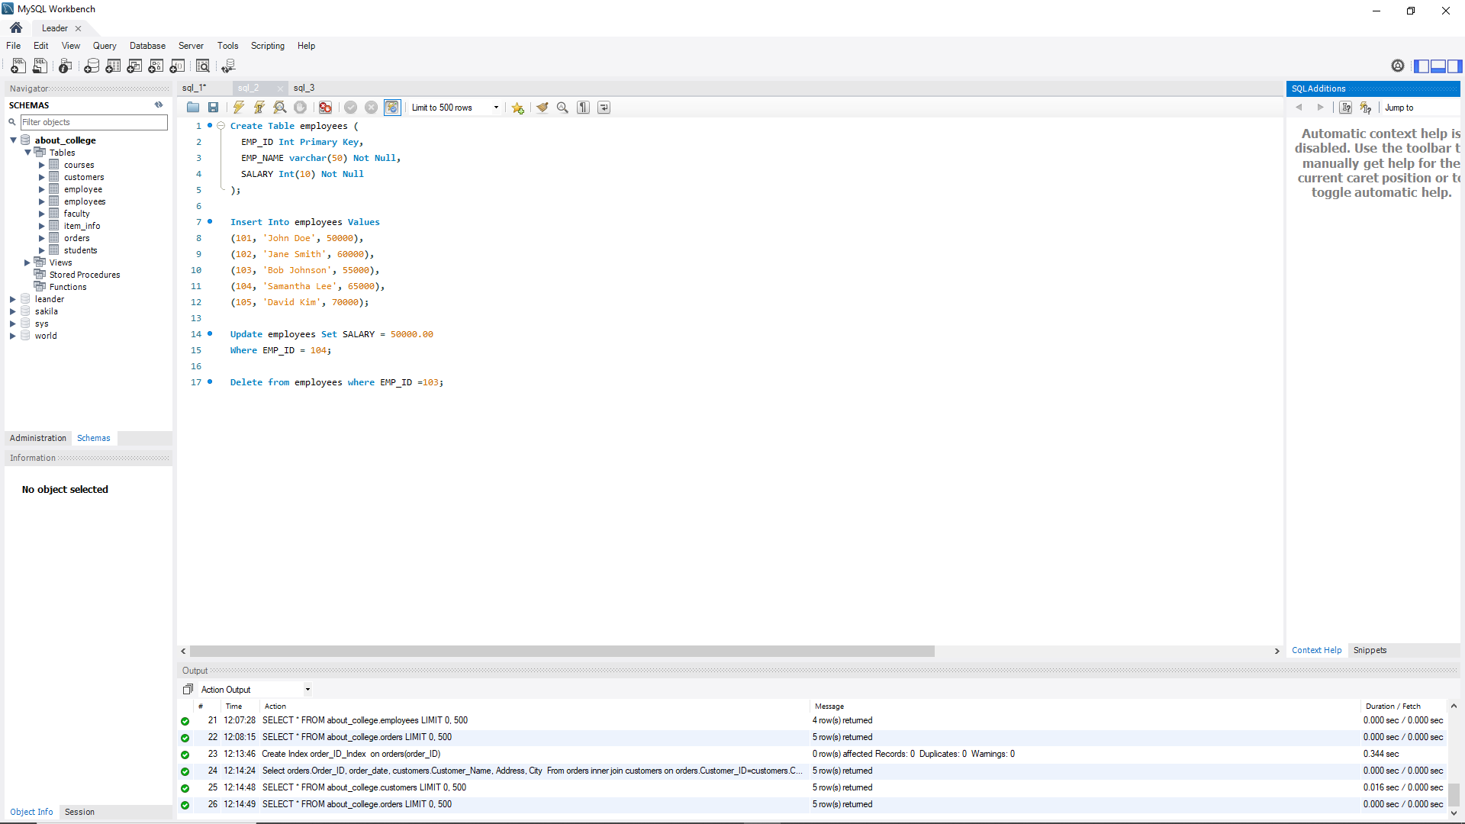

Q.3)

a) Create orders table which having( ORDERID, CUSTOMERID, EMPLOYEEID, ORDERDATE) entity and create customers table having (CUSTOMERID, CUSTOMERNAME, CONTACTNAME, ADDRESS, CITY.)

b) Insert 5 records into both tables.

c) create index for the table.

d) Perform inner join operation on above table.

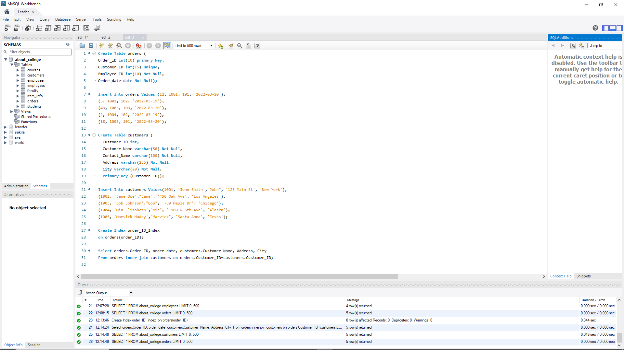

Q.4)

a) Create student table, and every student must have an associated student name. student_id should not be NULL.

b) Create Table With Customer Entity Having Name, Cid And Gender In Which Cid Is Primary Key.

c) Table With Student Entity Having Gender Which Can Be M Or F.

d) List only female students from the above table.

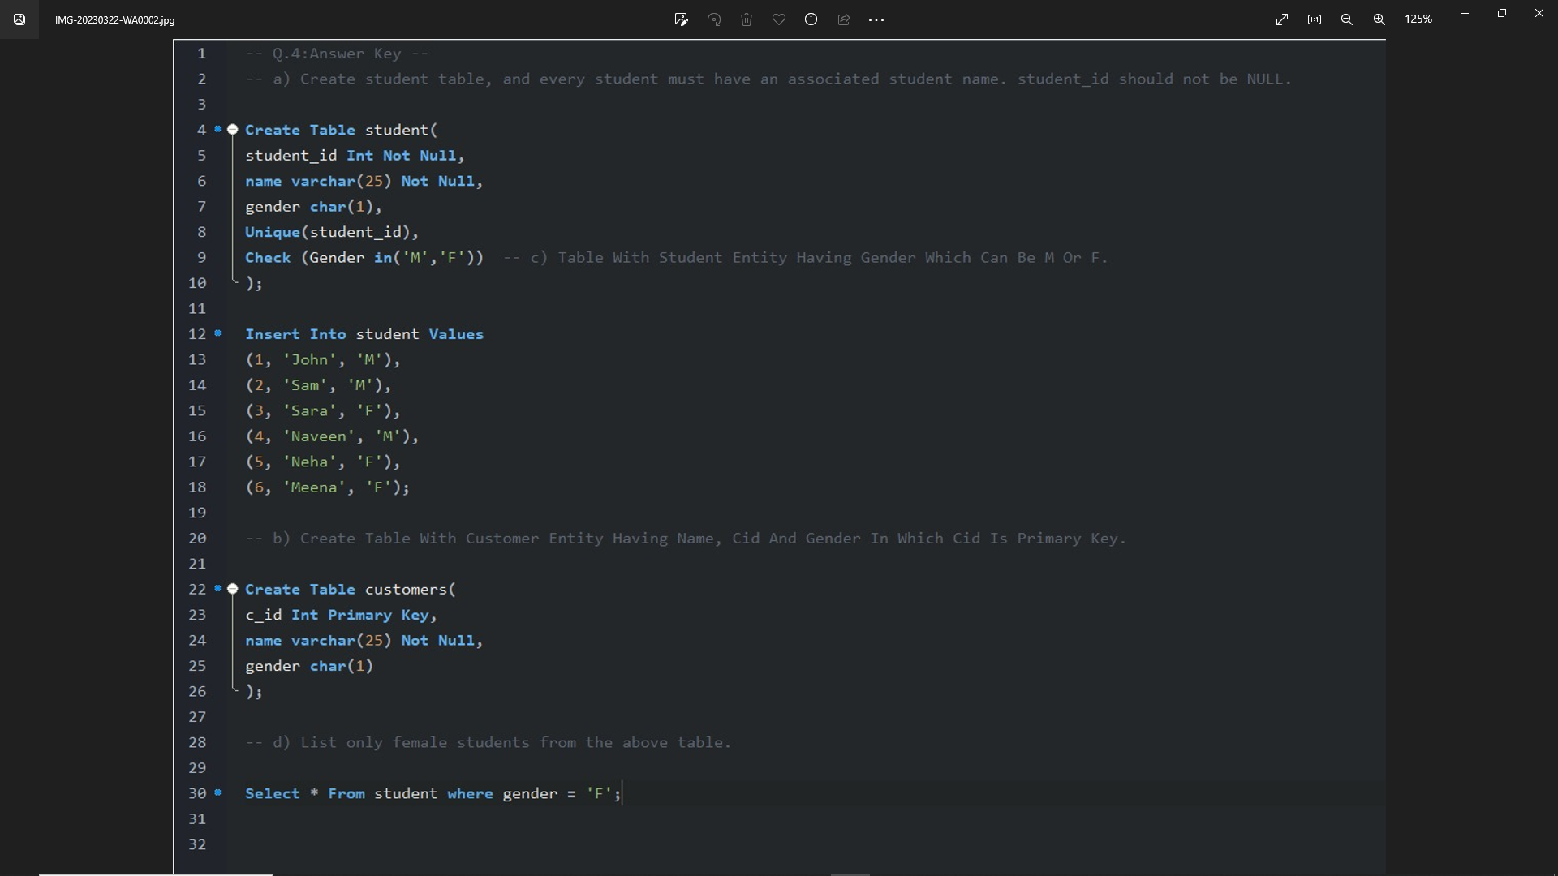

Q.5)

a)create a table name faculty of different dept(F_ID,FNAME,DEPT)

b) create a view for ‘IT_Faculty’

c) Rename the existing view name.

d) Remove the IT_Faculty view from the database.

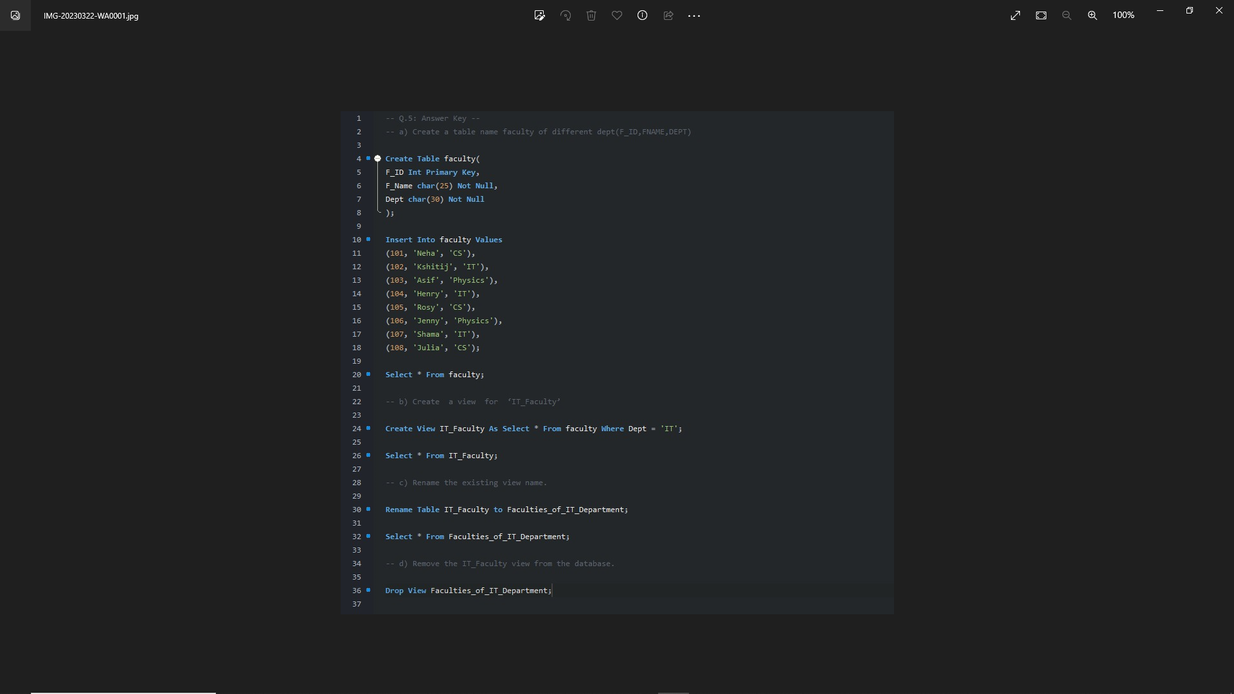

Q.6)

a) Create a table for storing Student information( STUD_ID, STUD_NAME, BRANCH etc.)of a particular College.

b) In Student table, we want to add a new column for AGE

c)Display the records in ascending order on basis of AGE

d) The College Authority wants to remove the details of all students for new batches but wants to keep the table structure.

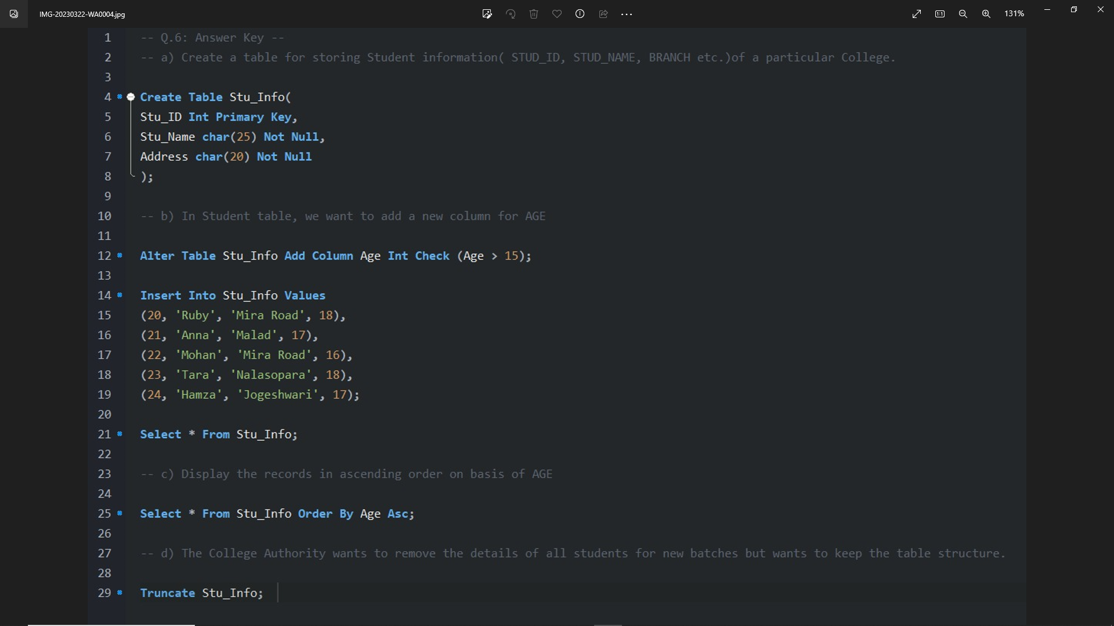

Q.7)

a) Create student table having ID, NAME, MARKS, DEPARTMENT, SUBJECT entity. Find number of students in the table.

b) find number of departments present in the student table.

d)find average marks scored by IT department.

e) find minimum marks scored by IT department.

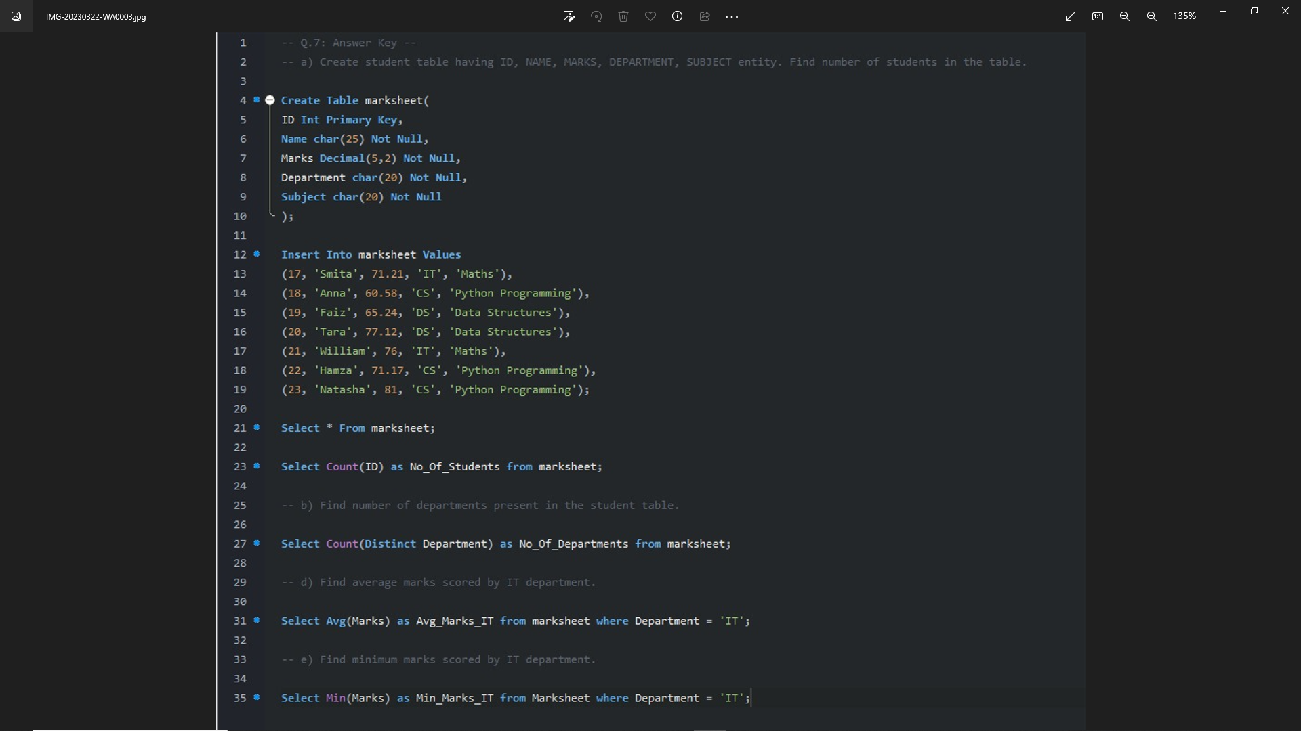

Q.8)

a) create table employee having ID, NAME, AGE, ADDRESS, SALARY entity. Find all employee with salary between 2000 and 10000.

b) Find all employee with having MAX salary

c) Find all employee whose age is >30

d) Find sum of salary of all the employees.

e) Concat the name of each employees with ‘MM’

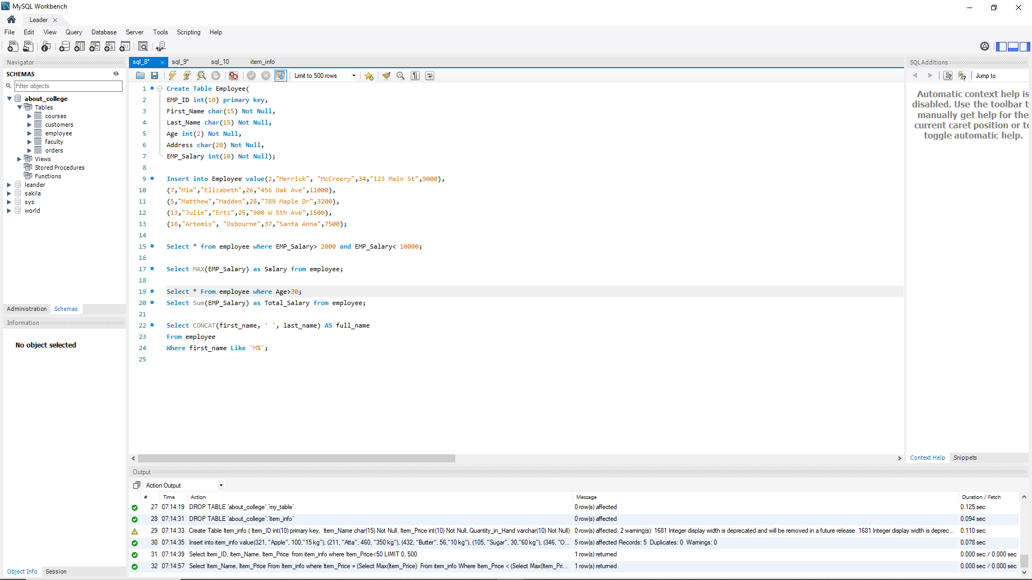

Q.9)

A supermarket manager likes to keep records about all the items in his store these records should hold the following information about each item (the item identifier ITEM_ID, THE ITEM NAME, THE ITEM PRICE, QUANTITY IN HAND)

a. ) Create the appropriate table with a primary key.

b)Display the item id and item name of item which are less than 50.

c) Name the second most expensive item(using subquery)

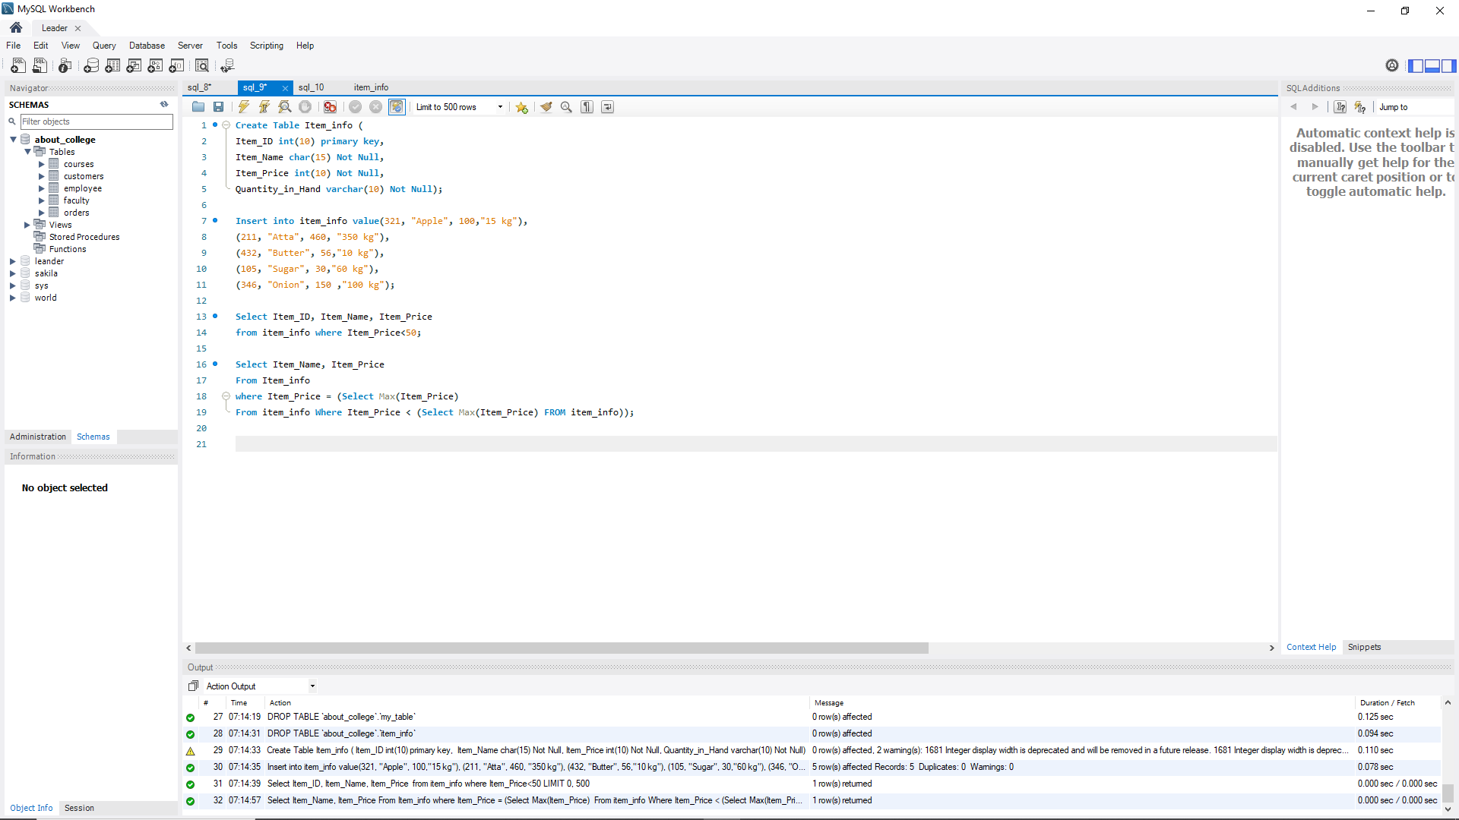

Q.10)

a) create orders table which having (OrderID, CustomerID, EmployeeID, OrderDate) entity and create customers table having (CustomerID, CustomerName, ContactName, Address, City.)

b) insert 5 records into both tables.

c) Perform inner join operation on above table.

d) Perform left outer join operation on above table.

