Processing For Packets Routed By The Firewall
Queue Type | Queue Function | Packet Transformation Chain in Queue | Chain Function
Filter | Packet filtering | FORWARD | Filters packets to servers accessible by another NIC on the firewall.
Filter | Packet filtering | INPUT | Filters packets destined to the firewall.
Filter | Packet filtering | OUTPUT | Filters packets originating from the firewall
Nat | Network Address Translation | PREROUTING | Address translation occurs before routing. Facilitates the transformation of the destination IP address to be compatible with the firewall's routing table. Used with NAT of the destination IP address, also known as destination NAT or DNAT.
Nat | Network Address Translation | POSTROUTING | Address translation occurs after routing. This implies that there was no need to modify the destination IP address of the packet as in pre-routing. Used with NAT of the source IP address using either one-to-one or many-to-one NAT. This is known as source NAT, or SNAT.
Nat | Network Address Translation | OUTPUT | Network address translation for packets generated by the firewall. (Rarely used in SOHO environments)
Mangle | TCP header modification | PREROUTING  POSTROUTING  OUTPUT  INPUT  FORWARD | Modification of the TCP packet quality of service bits before routing occurs. (Rarely used in SOHO environments)
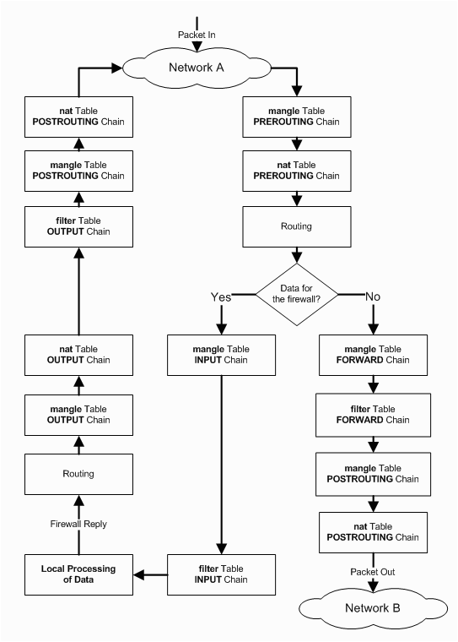

Descriptions Of The Most Commonly Used Targets
target | Desciption | Most Common Options
ACCEPT | - iptables stops further processing.  - The packet is handed over to the end application or the operating system for processing | N/A
DROP | - iptables stops further processing.  - The packet is blocked | N/A
LOG | - The packet information is sent to the syslog daemon for logging  - iptables continues processing with the next rule in the table  - As you can't log and drop at the same time, it is common to have two similar rules in sequence. The first will log the packet, the second will drop it. | --log-prefix "string"  Tells iptables to prefix all log messages with a user defined string. Frequently used to tell why the logged packet was dropped
REJECT | - Works like the DROP target, but will also return an error message to the host sending the packet that the packet was blocked | --reject-with qualifier  The qualifier tells what type of reject message is returned. Qualifiers include:  icmp-port-unreachable (default)  icmp-net-unreachable  icmp-host-unreachable  icmp-proto-unreachable  icmp-net-prohibited  icmp-host-prohibited  tcp-reset  echo-reply
DNAT | - Used to do destination network address translation. ie. rewriting the destination IP address of the packet | --to-destination ipaddress  Tells iptables what the destination IP address should be
SNAT | - Used to do source network address translation rewriting the source IP address of the packet  - The source IP address is user defined | --to-source <address>[-<address>][:<port>-<port>]  Specifies the source IP address and ports to be used by SNAT.
MASQUERADE | - Used to do Source Network Address Translation.  - By default the source IP address is the same as that used by the firewall's interface | [--to-ports <port>[-<port>]]  Specifies the range of source ports to which the original source port can be mapped.

General Iptables Match Criteria
iptables command Switch | Desciption
-t <-table-> | If you don't specify a table, then the filter table is assumed. As discussed before, the possible built-in tables include: filter, nat, mangle
-j <target> | Jump to the specified target chain when the packet matches the current rule.
-A | Append rule to end of a chain
-F | Flush. Deletes all the rules in the selected table
-p <protocol-type> | Match protocol. Types include, icmp, tcp, udp, and all
-s <ip-address> | Match source IP address
-d <ip-address> | Match destination IP address
-i <interface-name> | Match "input" interface on which the packet enters.
-o <interface-name> | Match "output" interface on which the packet exits

iptables -A INPUT -s 0/0 -i eth0 -d 192.168.1.1 -p TCP -j ACCEPT

Common TCP and UDP Match Criteria
Switch | Desciption
-p tcp --sport <port> | TCP source port. Can be a single value or a range in the format: start-port-number:end-port-number
-p tcp --dport <port> | TCP destination port. Can be a single value or a range in the format: starting-port:ending-port
-p tcp --syn | Used to identify a new TCP connection request. ! --syn means, not a new connection request
-p udp --sport <port> | UDP source port. Can be a single value or a range in the format: starting-port:ending-port
-p udp --dport <port> | UDP destination port. Can be a single value or a range in the format: starting-port:ending-port

iptables -A FORWARD -s 0/0 -i eth0 -d 192.168.1.58 -o eth1 -p TCP --sport 1024:65535 --dport 80 -j ACCEPT

iptables -A OUTPUT -p icmp --icmp-type echo-request -j ACCEPT

iptables -A INPUT -p icmp --icmp-type echo-reply -j ACCEPT

iptables -A INPUT -p icmp --icmp-type echo-request -m limit --limit 1/s -i eth0 -j ACCEPT
iptables -A INPUT -p tcp --syn -m limit --limit 5/s -i eth0 -j ACCEPT

iptables -t nat -A POSTROUTING -s 192.168.1.100 -o eth0 \
-j SNAT --to-source 97.158.253.26
iptables -t nat -A PREROUTING -d 97.158.253.26 -i eth0 \
-j DNAT --to-destination 192.168.1.10

