Scientist’s Mission(0153B052, 盧梓瑤)
Who Stole TP53’s Superpower? Searching for the Key to Unlock Cancer
Using AI to Uncover the Secrets of TP53–DNA Interactions
1. 【The LEGO Assembly Line】
What type of bond links amino acids together to form a protein? Which amino acids form hydrogen bonds with each other?
Answer:
Peptide bonds link amino acids together to form a protein's polypeptide backbone. Hydrogen bonds can form between amino acid side chains or between backbone groups. Examples of amino acids that can participate in hydrogen bonding include serine, threonine, asparagine, glutamine, aspartate, glutamate, histidine, and tyrosine. The specific interactions depend on the positions and chemical properties of the amino acids.

2. 【The Double-Track Highway of Life’s Blueprint】
How do nucleotides assemble to form double-stranded DNA? What are the basic structural components of DNA? Is DNA right-handed or left-handed? List the names of the four DNA bases. Which bases form hydrogen bonds with each other?
Answer:
DNA is made of nucleotides, each consisting of a phosphate group, a deoxyribose sugar, and a nitrogenous base. Nucleotides are joined by phosphodiester bonds to form each DNA strand. Two strands run in opposite directions and are held together by hydrogen bonds between complementary bases. The common B-form of DNA is a right-handed double helix.
The four DNA bases are adenine (A), thymine (T), guanine (G), and cytosine (C). Adenine pairs with thymine through two hydrogen bonds, while guanine pairs with cytosine through three hydrogen bonds.

3. 【Searching for My One-and-Only Soulmate in the Universe: A 20-Base-Pair Love Code Hidden Among 3 Billion DNA Base Pairs】
The source of molecular stability and specificity: hydrogen bonding — How do TP53 and DNA recognize each other?
Using the structure 3KMD, identify one pair of an amino acid and a DNA base that interact with each other.
Answer:
One amino acid to investigate is arginine 280 (Arg280) in the p53 DNA-binding domain. It participates in DNA recognition near the major groove. Using the 3KMD structure, I would examine the nearby DNA bases and identify a specific amino-acid–base interaction from the displayed structure. The interaction should be confirmed by checking the contacting atoms and their distances in ChimeraX.

4. 【Return to the Crime Scene】
Why can a mutation (change) in just one amino acid of a protein sometimes lead to a serious human disease? Give one specific example of such a disease.
Answer:
A mutation in just one amino acid can cause a serious disease because it may change a protein's three-dimensional structure, stability, or interactions with other molecules. For example, certain mutations in TP53 can impair the tumor-suppressor function of p53, allowing damaged cells to continue dividing and contributing to cancer development. Another example is sickle cell disease, which is caused by a Glu6Val substitution in the beta-globin protein.

5. 【Return to the Crime Scene: Searching for Clues】
Using the TP53–DNA structure (3KMD), identify one TP53 amino acid mutation that can lead to uncontrolled cell division and contribute to the development of cancer.
Then examine this amino acid in ChimeraX. Based on its three-dimensional position, determine whether the mutated amino acid is located directly at the protein–DNA interface or somewhere else in the protein.
Answer:
One cancer-associated TP53 mutation is R248W, in which arginine at position 248 is replaced by tryptophan. Arg248 is a DNA-contact residue in the p53 DNA-binding domain. In the three-dimensional structure, residue 248 is located at the protein–DNA interface, where it helps p53 interact with DNA. Replacing arginine with tryptophan can disrupt these interactions and impair p53's tumor-suppressor function.

a. Paste a screenshot of your ChimeraX visualization here.
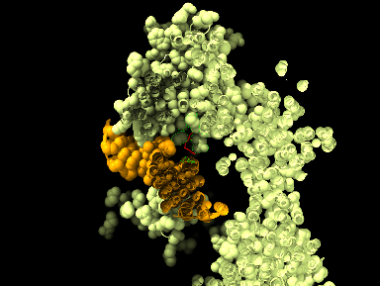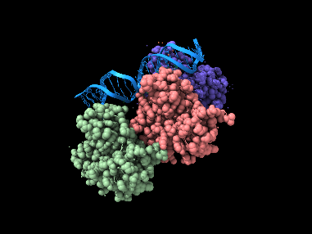

b. Save your ChimeraX session file as StudentID.cxs.


