总结：对不同内存2g,1g,256m,128m,64m 作为gateway-server-0.0.1-SNAPSHOT.jar 参数进行压测8088端口，发现在并发数为15左右都能达到最大的RPS：3400 左右，

最终发现该端口返回如下页面，基本没有业务处理，所以内存的选择与具体的业务是强关联的

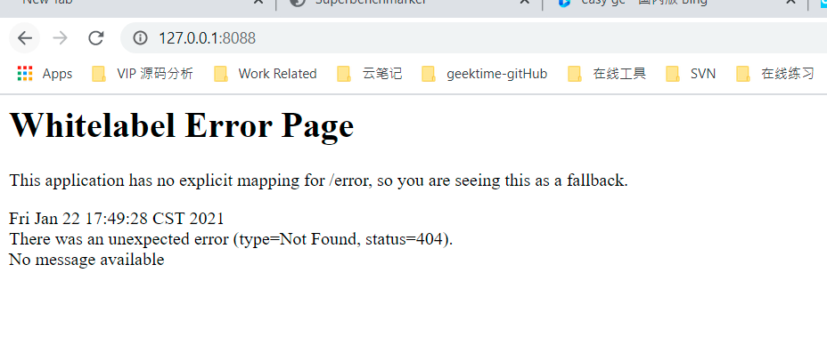

如下为详细压测数据：

java -Xms2g -Xmx2g -Xloggc:gc.log -XX:-UseAdaptiveSizePolicy -XX:+PrintGCDetails -XX:+PrintGCDateStamps -jar gateway-server-0.0.1-SNAPSHOT.jar

Requests: 100000

RPS: 3188

90th Percentile: 2ms

95th Percentile: 3ms

99th Percentile: 4ms

Average: 1.6ms

Min: 0ms

Max: 45ms

Status: finished

Start time: 2021-01-22T15:01:37.163+08:00

Finish time: 2021-01-22T15:02:08.531+08:00

Command: sb -u http://127.0.0.1:8088 -c 10 -n 100000

equests: 100000

RPS: 3314.5

90th Percentile: 3ms

95th Percentile: 3ms

99th Percentile: 4ms

Average: 2ms

Min: 1ms

Max: 44ms

Status: finished

Start time: 2021-01-22T15:00:29.971+08:00

Finish time: 2021-01-22T15:01:00.141+08:00

Command: sb -u http://127.0.0.1:8088 -c 12 -n 100000

Requests: 100000

RPS: 3430.4

90th Percentile: 3ms

95th Percentile: 4ms

99th Percentile: 5ms

Average: 2.4ms

Min: 1ms

Max: 58ms

Status: finished

Start time: 2021-01-22T14:57:27.298+08:00

Finish time: 2021-01-22T14:57:56.450+08:00

Command: sb -u http://127.0.0.1:8088 -c 15 -n 100000

Requests: 100000

RPS: 3427.8

90th Percentile: 4ms

95th Percentile: 4ms

99th Percentile: 6ms

Average: 2.8ms

Min: 0ms

Max: 52ms

Status: finished

Start time: 2021-01-22T14:55:16.886+08:00

Finish time: 2021-01-22T14:55:46.060+08:00

Command: sb -u http://127.0.0.1:8088 -c 18 -n 100000

Requests: 100000

RPS: 3290.7

90th Percentile: 4ms

95th Percentile: 5ms

99th Percentile: 7ms

Average: 3.2ms

Min: 1ms

Max: 52ms

Status: finished

Start time: 2021-01-22T14:49:45.355+08:00

Finish time: 2021-01-22T14:50:15.744+08:00

Command: sb -u http://127.0.0.1:8088 -c 20 -n 100000

Requests: 100000

RPS: 2993.8

90th Percentile: 5ms

95th Percentile: 6ms

99th Percentile: 9ms

Average: 3ms

Min: 0ms

Max: 66ms

Status: finished

Start time: 2021-01-22T14:53:27.927+08:00

Finish time: 2021-01-22T14:54:01.330+08:00

Command: sb -u http://127.0.0.1:8088 -c 25 -n 100000

Requests: 100000

RPS: 2683

90th Percentile: 6ms

95th Percentile: 8ms

99th Percentile: 12ms

Average: 3.3ms

Min: 0ms

Max: 63ms

Status: finished

Start time: 2021-01-22T14:51:11.755+08:00

Finish time: 2021-01-22T14:51:49.026+08:00

Command: sb -u http://127.0.0.1:8088 -c 30 -n 100000

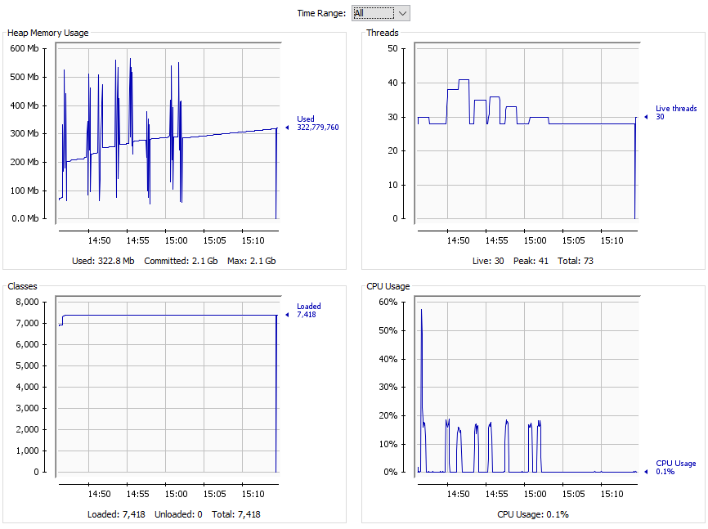

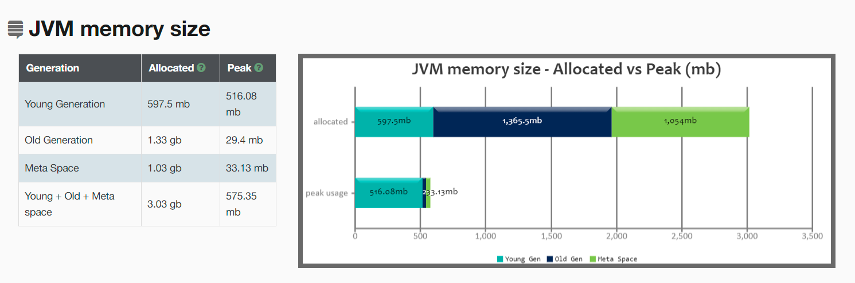

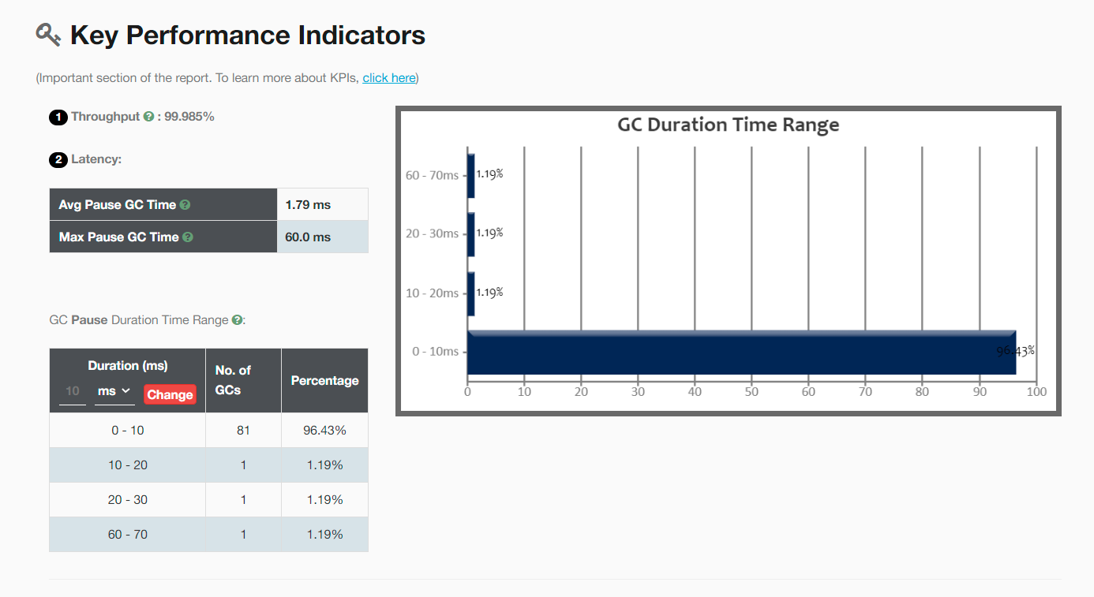

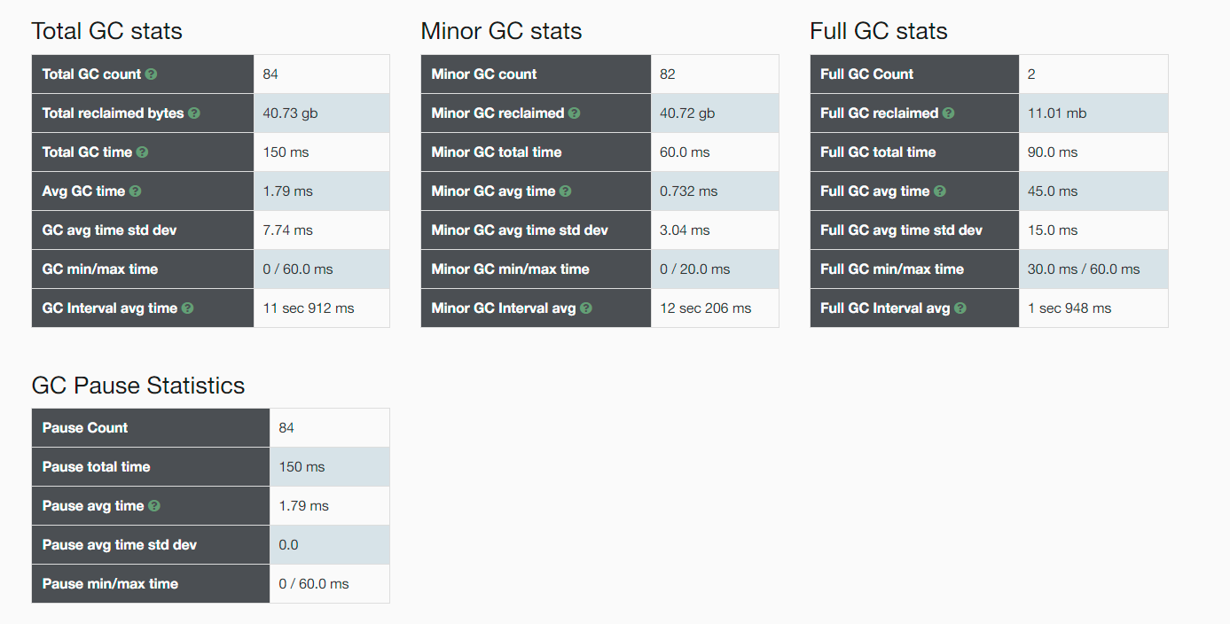

java -Xms1g -Xmx1g -Xloggc:gc.log -XX:-UseAdaptiveSizePolicy -XX:+PrintGCDetails -XX:+PrintGCDateStamps -jar gateway-server-0.0.1-SNAPSHOT.jar

|  |  |
| --- | --- |
| **Requests:**100000  **RPS:**3167.4  **90th Percentile:**2ms  **95th Percentile:**3ms  **99th Percentile:**4ms  **Average:**1.7ms  **Min:**0ms  **Max:**41ms | **Status:**finished  **Start time:**2021-01-22T15:20:55.846+08:00  **Finish time:**2021-01-22T15:21:27.417+08:00  **Command:**sb -u http://127.0.0.1:8088 -c 10 -n 100000 |

|  |  |
| --- | --- |
| **Requests:**100000  **RPS:**3292.5  **90th Percentile:**3ms  **95th Percentile:**3ms  **99th Percentile:**4ms  **Average:**2ms  **Min:**1ms  **Max:**47ms | **Status:**finished  **Start time:**2021-01-22T15:35:24.893+08:00  **Finish time:**2021-01-22T15:35:55.265+08:00  **Command:**sb -u http://127.0.0.1:8088 -c 12 -n 100000 |

|  |  |
| --- | --- |
| **Requests:**100000  **RPS:**3452.9  **90th Percentile:**3ms  **95th Percentile:**4ms  **99th Percentile:**5ms  **Average:**2.4ms  **Min:**0ms  **Max:**50ms | **Status:**finished  **Start time:**2021-01-22T15:36:55.331+08:00  **Finish time:**2021-01-22T15:37:24.292+08:00  **Command:**sb -u http://127.0.0.1:8088 -c 15 -n 100000 |

|  |  |
| --- | --- |
| **Requests:**100000  **RPS:**3403.9  **90th Percentile:**4ms  **95th Percentile:**4ms  **99th Percentile:**6ms  **Average:**2.8ms  **Min:**0ms  **Max:**52ms | **Status:**finished  **Start time:**2021-01-22T15:40:25.442+08:00  **Finish time:**2021-01-22T15:40:54.820+08:00  **Command:**sb -u http://127.0.0.1:8088 -c 18 -n 100000 |

|  |  |
| --- | --- |
| **Requests:**100000  **RPS:**3403.5  **90th Percentile:**4ms  **95th Percentile:**5ms  **99th Percentile:**7ms  **Average:**3ms  **Min:**0ms  **Max:**56ms | **Status:**finished  **Start time:**2021-01-22T15:41:45.391+08:00  **Finish time:**2021-01-22T15:42:14.773+08:00  **Command:**sb -u http://127.0.0.1:8088 -c 20 -n 100000 |

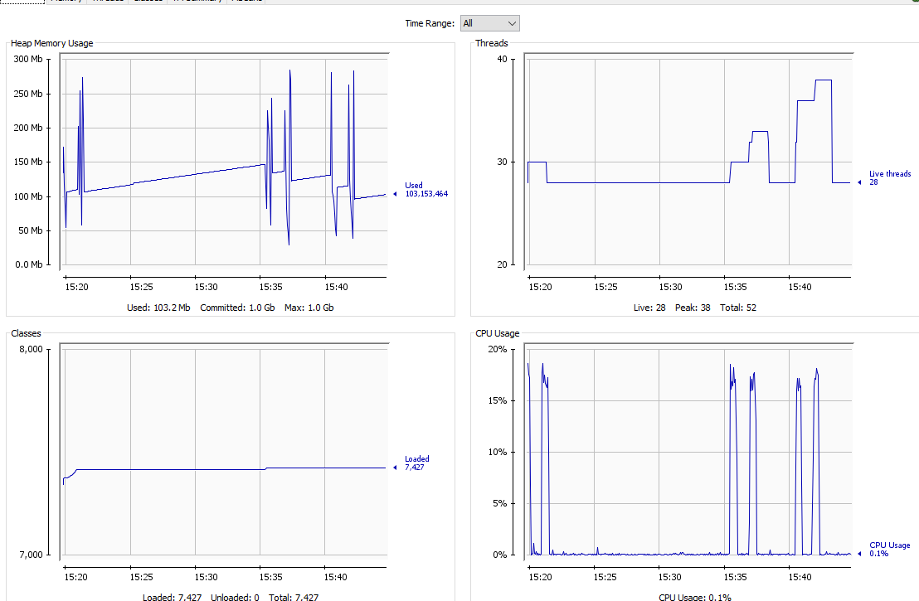

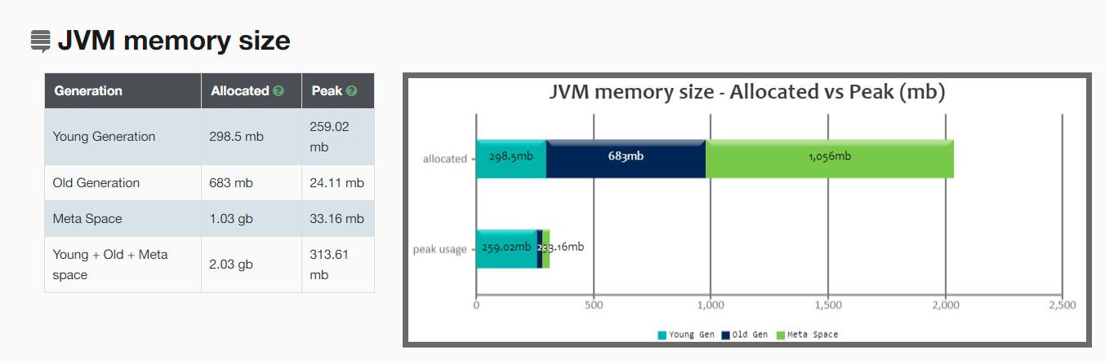

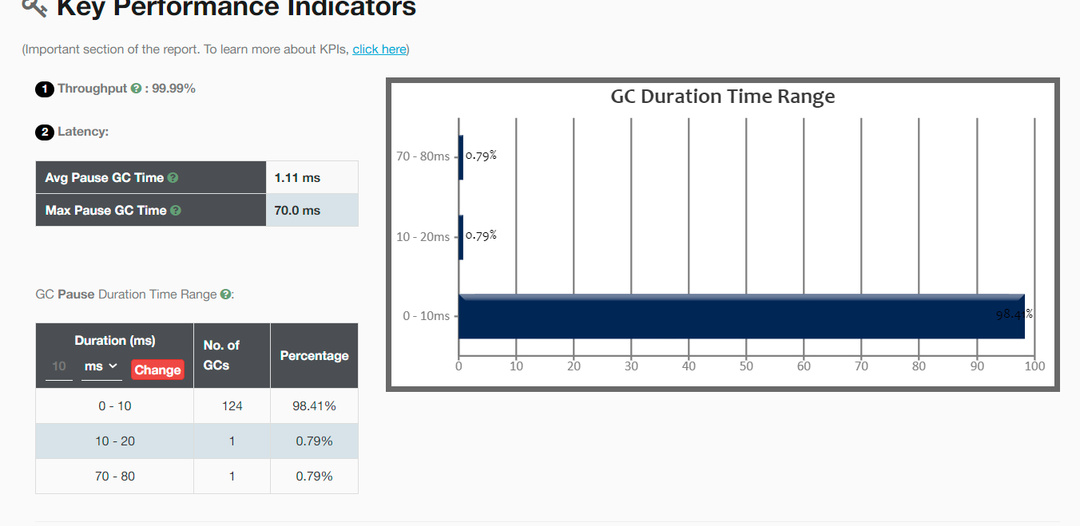

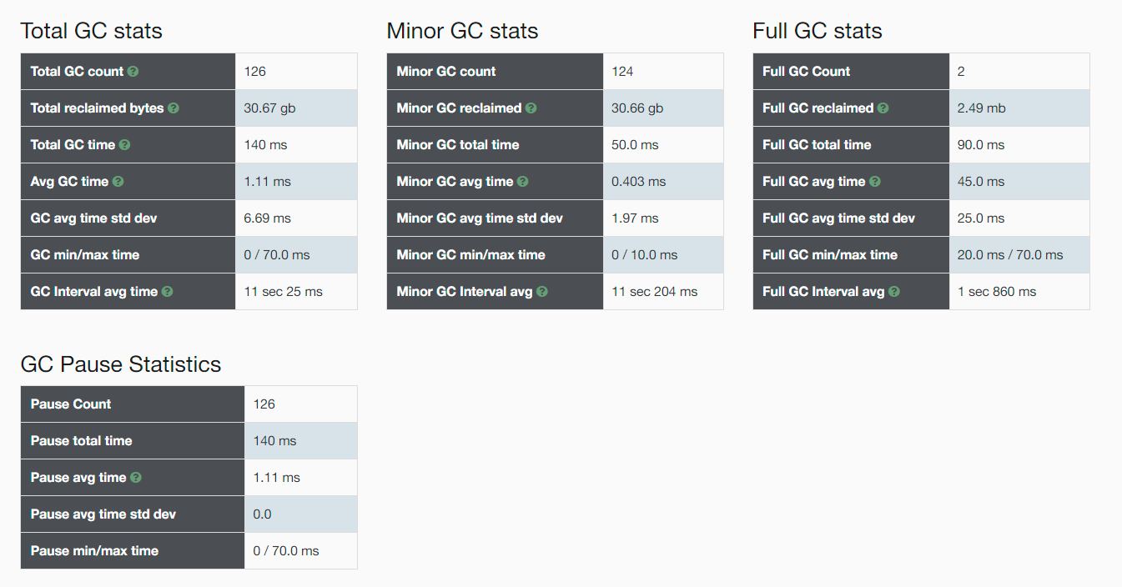

-----------------------------------------------------------------------------------------------------------------------------------------

java -Xms512m -Xmx512m -Xloggc:gc.log -XX:-UseAdaptiveSizePolicy -XX:+PrintGCDetails -XX:+PrintGCDateStamps -jar gateway-server-0.0.1-SNAPSHOT.jar

|  |  |
| --- | --- |
| **Requests:**100000  **RPS:**2792  **90th Percentile:**3ms  **95th Percentile:**3ms  **99th Percentile:**5ms  **Average:**1.8ms  **Min:**0ms  **Max:**211ms | **Status:**finished  **Start time:**2021-01-22T15:55:51.441+08:00  **Finish time:**2021-01-22T15:56:27.258+08:00  **Command:**sb -u http://127.0.0.1:8088 -c 10 -n 100000 |

|  |  |
| --- | --- |
| **Requests:**100000  **RPS:**3337.4  **90th Percentile:**3ms  **95th Percentile:**3ms  **99th Percentile:**4ms  **Average:**2ms  **Min:**0ms  **Max:**48ms | **Status:**finished  **Start time:**2021-01-22T15:56:58.363+08:00  **Finish time:**2021-01-22T15:57:28.327+08:00  **Command:**sb -u http://127.0.0.1:8088 -c 12 -n 100000 |

|  |  |
| --- | --- |
| **Requests:**100000  **RPS:**3430.1  **90th Percentile:**3ms  **95th Percentile:**4ms  **99th Percentile:**5ms  **Average:**2.4ms  **Min:**0ms  **Max:**47ms | **Status:**finished  **Start time:**2021-01-22T15:59:08.562+08:00  **Finish time:**2021-01-22T15:59:37.716+08:00  **Command:**sb -u http://127.0.0.1:8088 -c 15 -n 100000 |

|  |  |
| --- | --- |
| **Requests:**100000  **RPS:**3427.2  **90th Percentile:**4ms  **95th Percentile:**5ms  **99th Percentile:**6ms  **Average:**2.9ms  **Min:**0ms  **Max:**53ms | **Status:**finished  **Start time:**2021-01-22T16:00:41.481+08:00  **Finish time:**2021-01-22T16:01:10.659+08:00  **Command:**sb -u http://127.0.0.1:8088 -c 18 -n 100000 |

|  |  |
| --- | --- |
| **Requests:**100000  **RPS:**3356.5  **90th Percentile:**4ms  **95th Percentile:**5ms  **99th Percentile:**7ms  **Average:**3ms  **Min:**0ms  **Max:**60ms | **Status:**finished  **Start time:**2021-01-22T16:01:56.070+08:00  **Finish time:**2021-01-22T16:02:25.863+08:00  **Command:**sb -u http://127.0.0.1:8088 -c 20 -n 100000 |

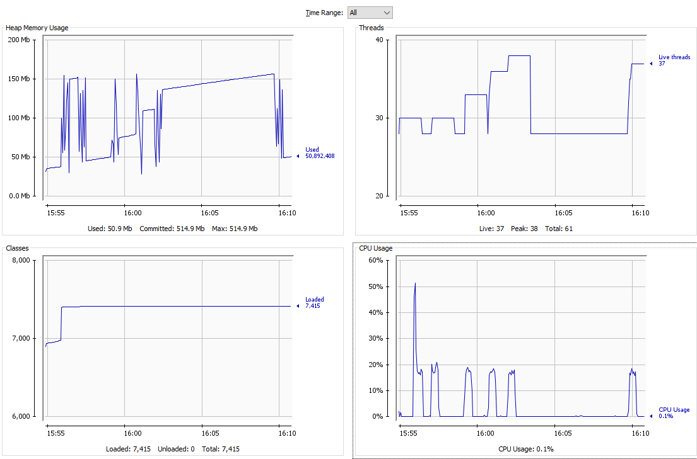

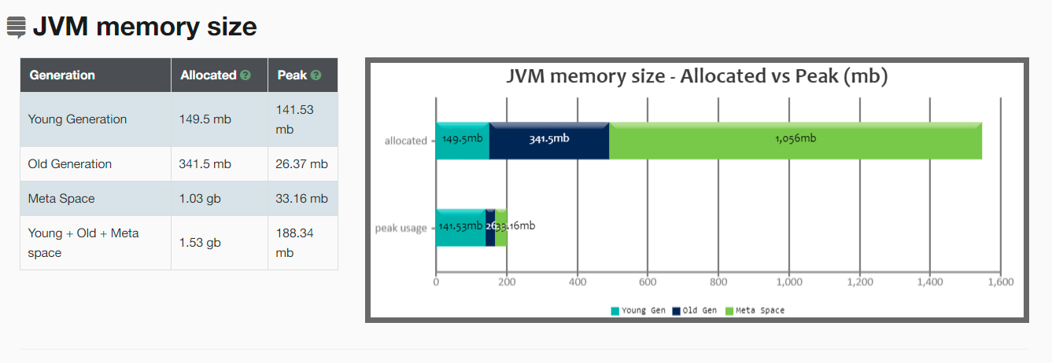

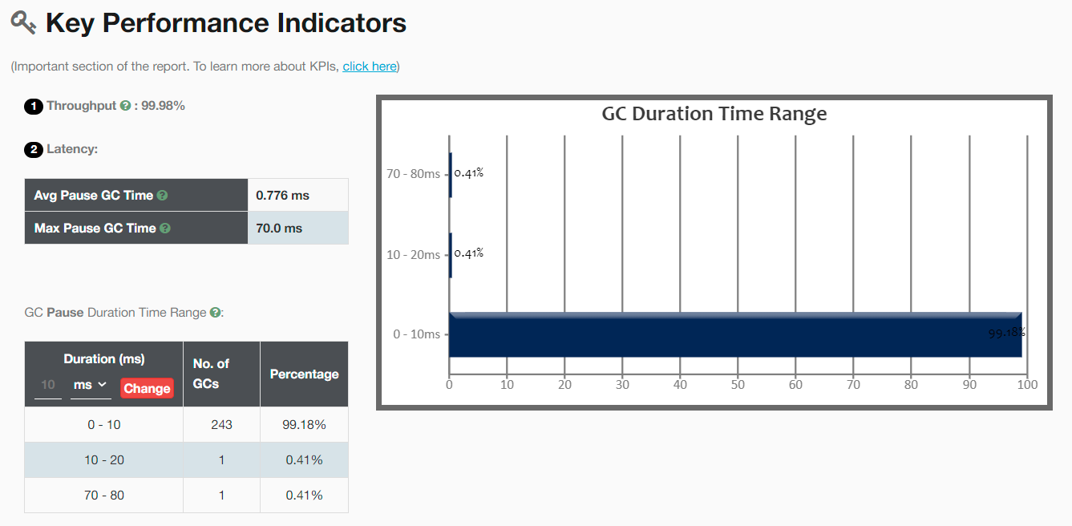

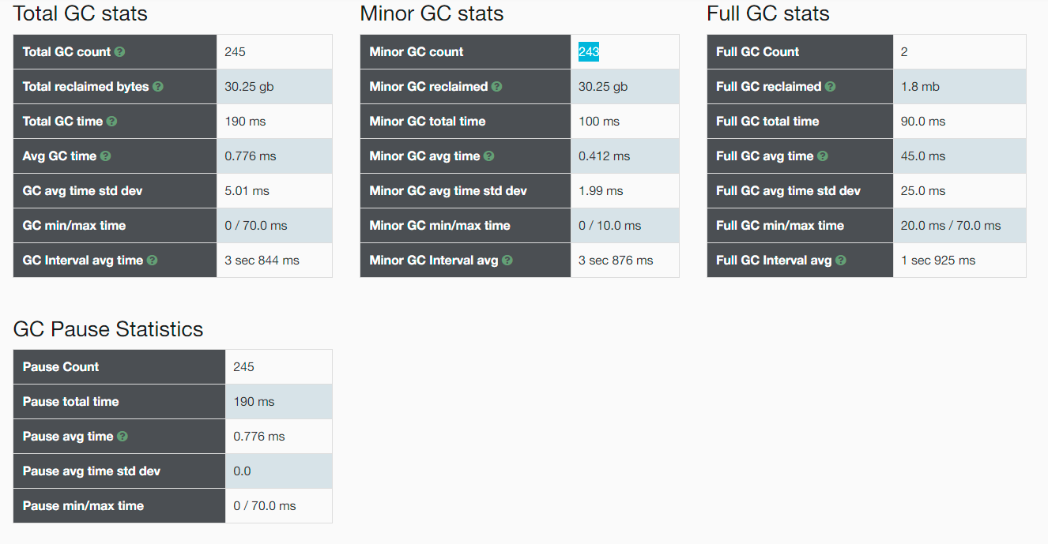

java -Xms256m -Xmx256m -Xloggc:gc.log -XX:-UseAdaptiveSizePolicy -XX:+PrintGCDetails -XX:+PrintGCDateStamps -jar gateway-server-0.0.1-SNAPSHOT.jar

|  |  |
| --- | --- |
| **Requests:**100000  **RPS:**2855.2  **90th Percentile:**3ms  **95th Percentile:**3ms  **99th Percentile:**5ms  **Average:**1.9ms  **Min:**1ms  **Max:**208ms | **Status:**finished  **Start time:**2021-01-22T16:20:40.577+08:00  **Finish time:**2021-01-22T16:21:15.602+08:00  **Command:**sb -u http://127.0.0.1:8088 -c 10 -n 100000 |

|  |  |
| --- | --- |
| **Requests:**100000  **RPS:**3337.2  **90th Percentile:**3ms  **95th Percentile:**3ms  **99th Percentile:**4ms  **Average:**2ms  **Min:**0ms  **Max:**43ms | **Status:**finished  **Start time:**2021-01-22T16:22:43.885+08:00  **Finish time:**2021-01-22T16:23:13.850+08:00  **Command:**sb -u http://127.0.0.1:8088 -c 12 -n 100000 |

|  |  |
| --- | --- |
| **Requests:**100000  **RPS:**3358.3  **90th Percentile:**3ms  **95th Percentile:**4ms  **99th Percentile:**5ms  **Average:**2.4ms  **Min:**0ms  **Max:**50ms | **Status:**finished  **Start time:**2021-01-22T16:23:50.560+08:00  **Finish time:**2021-01-22T16:24:20.336+08:00  **Command:**sb -u http://127.0.0.1:8088 -c 15 -n 100000 |

|  |  |
| --- | --- |
| **Requests:**100000  **RPS:**2923.1  **90th Percentile:**4ms  **95th Percentile:**4ms  **99th Percentile:**6ms  **Average:**2.3ms  **Min:**0ms  **Max:**54ms | **Status:**finished  **Start time:**2021-01-22T16:25:15.869+08:00  **Finish time:**2021-01-22T16:25:50.079+08:00  **Command:**sb -u http://127.0.0.1:8088 -c 18 -n 100000 |

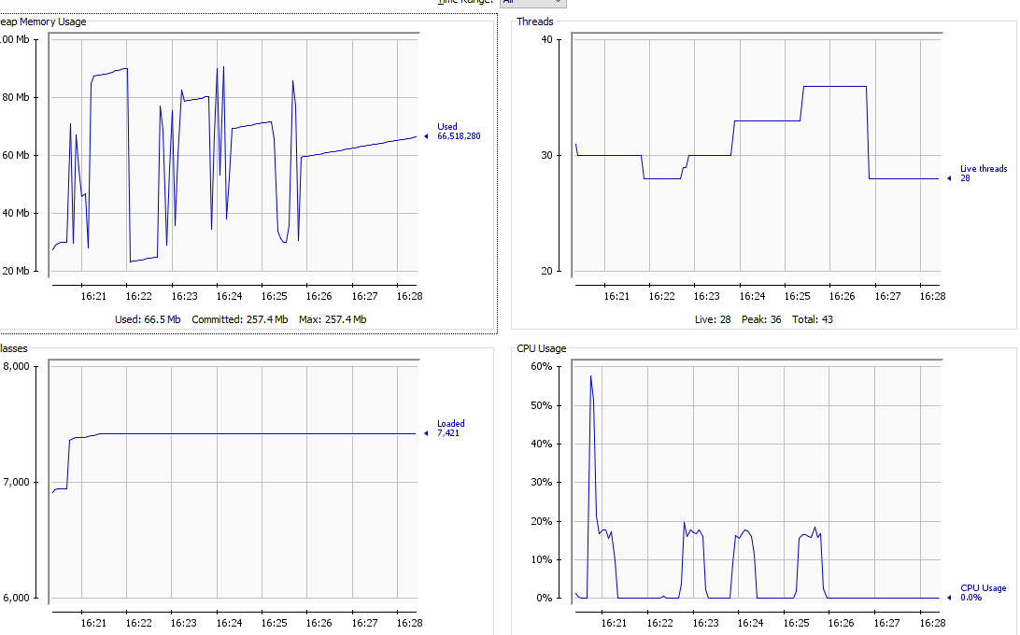

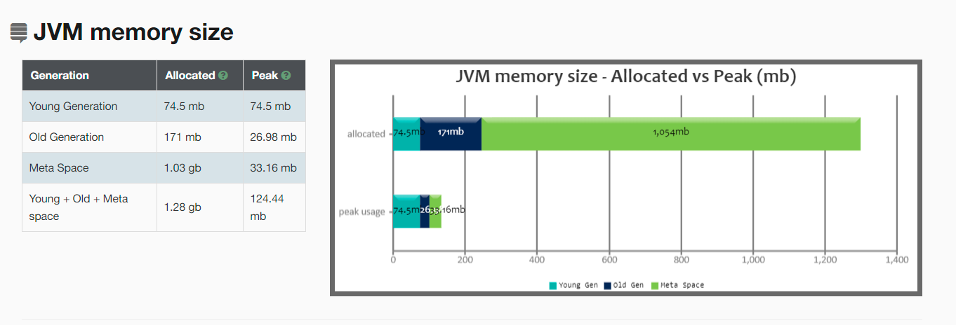

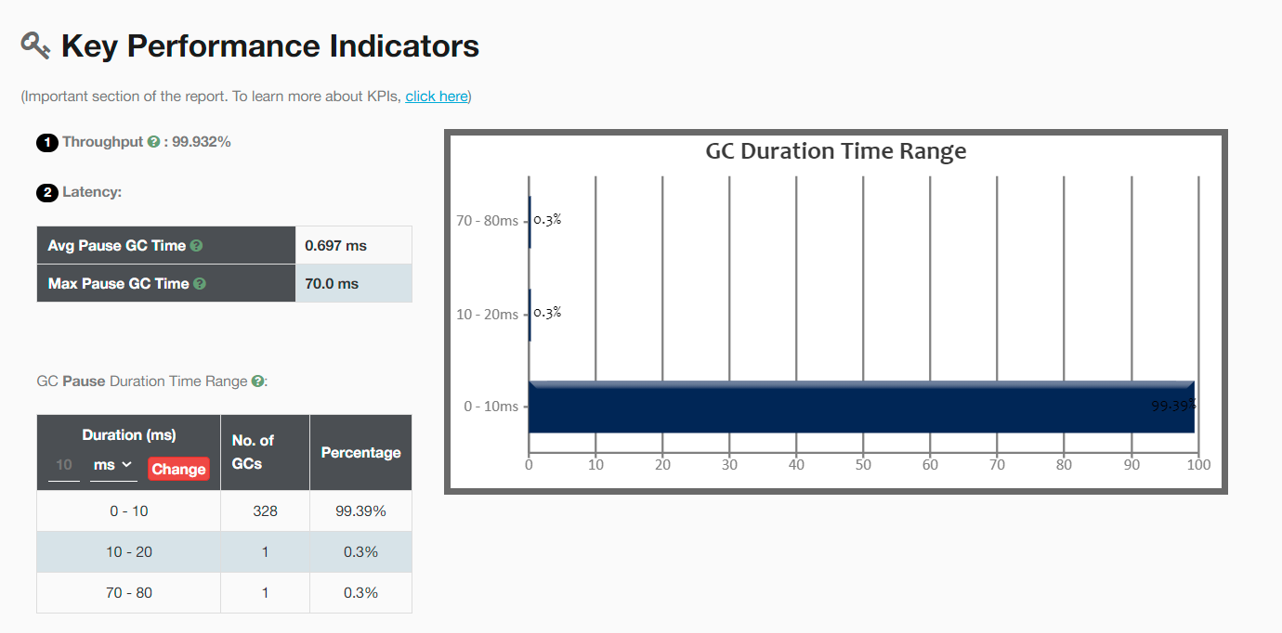

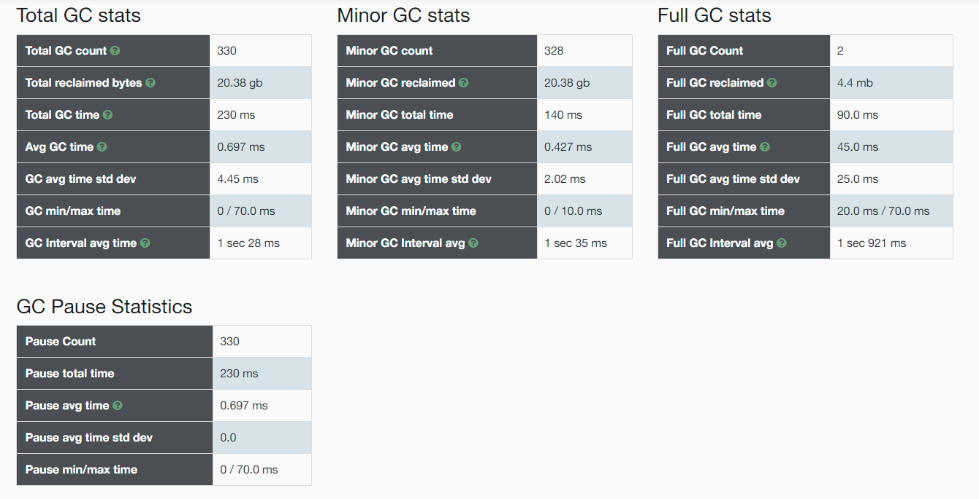

java -Xms128m -Xmx128m -Xloggc:gc.log -XX:-UseAdaptiveSizePolicy -XX:+PrintGCDetails -XX:+PrintGCDateStamps -jar gateway-server-0.0.1-SNAPSHOT.jar

|  |  |
| --- | --- |
| **Requests:**100000  **RPS:**3314  **90th Percentile:**3ms  **95th Percentile:**4ms  **99th Percentile:**5ms  **Average:**2.4ms  **Min:**0ms  **Max:**47ms | **Status:**finished  **Start time:**2021-01-22T16:38:30.193+08:00  **Finish time:**2021-01-22T16:39:00.369+08:00  **Command:**sb -u http://127.0.0.1:8088 -c 15 -n 100000 |

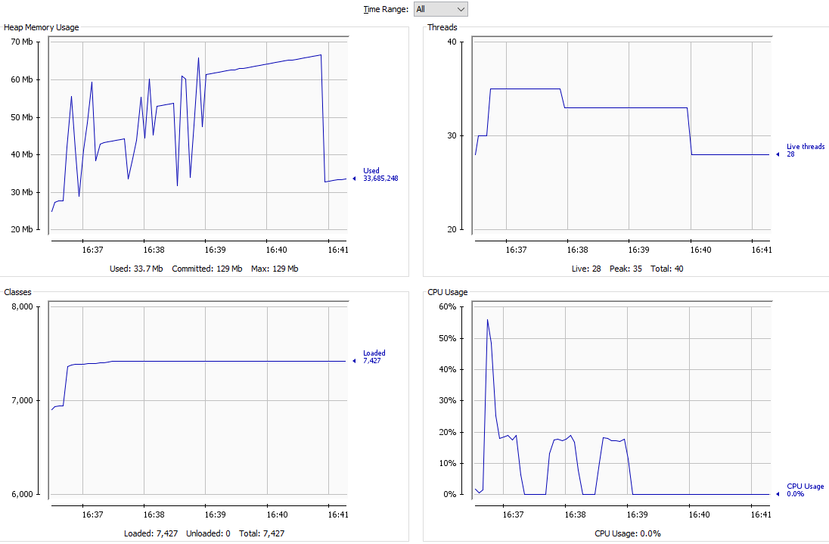

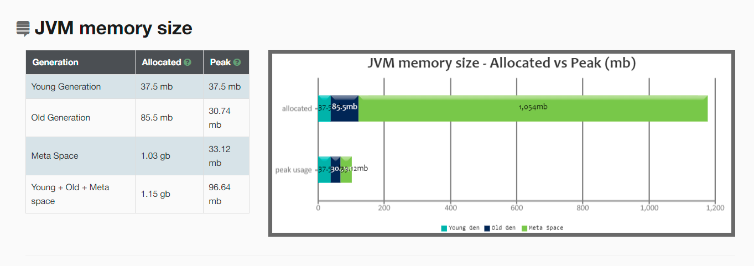

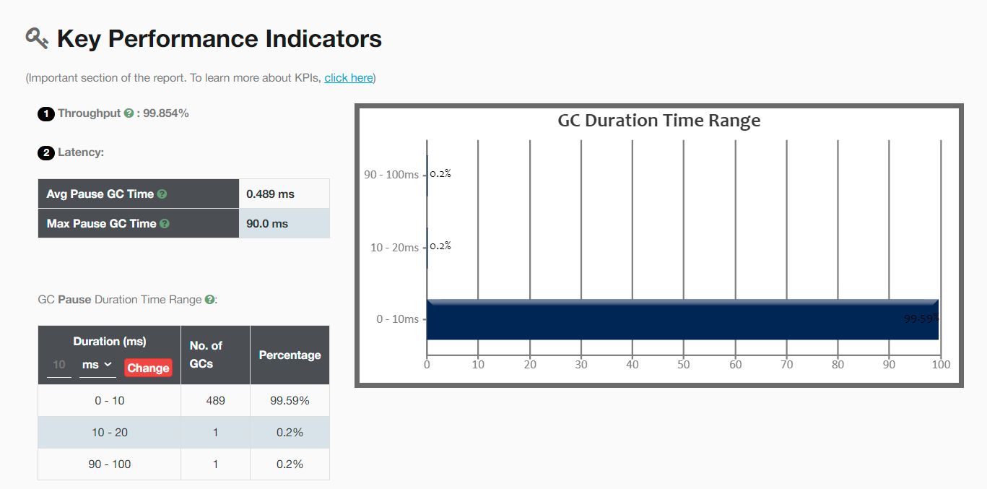

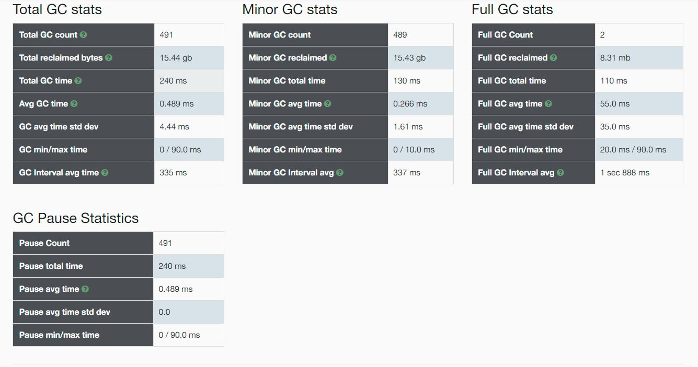

java -Xms64m -Xmx64m -Xloggc:gc.log -XX:-UseAdaptiveSizePolicy -XX:+PrintGCDetails -XX:+PrintGCDateStamps -jar gateway-server-0.0.1-SNAPSHOT.jar