**🔱 BIG HOME 3**



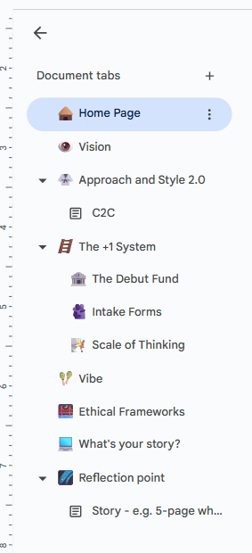

Home Page

By Aaron Abrams

**🛖 Home Page (Software Version)**

### Investment Prospectus Draft

Community, Family, Luxury

Concept: (UK Ltd. Company, whose IP the US Inc. Licences)

Invoiced as Strategic Partnership Contract

To Delaware Listed Entity

We Are: trusted referral partners to help expand your capital base. 🪨

Drip Capital is a hedge fund registered in Delaware under Regulation D exemption, 506(c)

focused on NFT-collateralized lending. We offer ETH and USDC investors access to short-term,

overcollateralized loans across top platforms (Blend, NFTfi, Gondi, etc.).

With 12,500 ETH ($23M) in total loan volume and an expansive network of borrowers across 6 different platforms, they represent the very cutting edge of a new type of finance.



Aaron Abrams,

Forty Two Degrees Publishing

4²°

The Dinosaur Dragon Investment Company Limited.

“There IS a difference”™

May, 2025. All Rights Reserved.

This IS a piece of software.

👁

(MIT OPEN LICENCE)

Basic Terms.

AI Overview

Learn more

The MIT License is a permissive open-source license that grants permission to use, copy, modify, merge, publish, distribute, sublicense, and sell the software without restriction. The only requirement is that the original copyright notice and the MIT License text are included in all copies or substantial portions of the software.

Here's a breakdown of the key aspects of the MIT License's wording:

Key Permissions:

Use: You can use the software in any way you choose.

Copy: You can make copies of the software.

Modify: You can change the software to your liking.

Merge: You can combine the software with other software.

Publish: You can release the software to the public.

Distribute: You can share the software with others.

Sublicense: You can allow others to use the software under your conditions.

Sell: You can sell copies of the software (including modified versions).

Conditions (Attribution):

Copyright Notice:

.

You must include the original copyright notice in all copies or substantial portions of the software.

License Text:

.

You must include the full text of the MIT License in all copies or substantial portions of the software.

🦕🐉🪙

(I am harvesting a trace)

##### 

##### 

##### 

##### 

##### 

##### 

##### 

##### 

##### 

##### 

##### 

##### Stablecoins, the big picture.

This year, at Stripe Sessions, the annual internet economy conference held for X consecutive years in San Francisco, California, the mood was tense and excitable.

Who had let the cat out of the bag? Little did you know it, but Crypto was making a recovery.

Beyond the temporary surges of the past quarter century, cryptographic technology has lulled significantly since the last brilliant computer inventions such as discovering the power of programmable LLMs.

But this year, alongside AI as the most important theme for the “GDP of the Internet” company at their annual conference, was the subject of Stablecoins.

Very little had been known about Stablecoins until human invention required them. Since the market for Bitcoin “BTC” grew rapidly and exceeded Billions of dollars of value storage, substantial progress has been made in the endeavour of connecting up the old banking system to the newer, more fit-for-purpose technology systems we know can deliver reliable banking services, at scale, not just in the central hubs.

Increasingly, these systems are not just theoretical or speculative—they are being put to work in real-world contexts. Across Africa, stablecoins like USDC have become essential tools for cross-border trade, remittances, and business-to-business settlements in countries where local currencies are volatile or payment infrastructure is weak (Chainalysis, 2023). In Southeast Asia, blockchain-based savings and lending platforms are providing unbanked populations access to capital, using stablecoins as the default medium of exchange (Nguyen et al., 2022). And in parts of the Middle East, stablecoins are quietly facilitating diaspora remittances and merchant transactions with far greater transparency and efficiency than traditional banks allow (GDFI, 2024). These global use cases point not just to the resilience of stablecoin adoption, but to a shift in how communities think about sovereignty, trust, and participation in financial systems—marking a profound change in the world’s relationship to money itself.

Aaron Abrams, Chair of Board, DDI

🦕🐉🪙

**Merlin**

**🛖 Home Page**

### Investment Prospectus Draft

Community, Family, Luxury

Concept: (UK Ltd. Company, whose IP the US Inc. Licences)

Invoiced as Strategic Partnership Contract

To Delaware Listed Entity

We Are: trusted referral partners to deep capital bases (Hedge Funds) 🦔

Drip Capital is a hedge fund registered in Delaware under Regulation D exemption, 506(c)

focused on NFT-collateralized lending. We offer ETH and USDC investors access to short-term,

overcollateralized loans across top platforms (Blend, NFTfi, Gondi, etc.).

With 12,500 ETH ($23M) in total loan volume and an expansive network of borrowers across 6 different platforms, they represent the very cutting edge of a new type of finance.



Aaron Abrams, Chair of The Board

The Dinosaur Dragon Investment Company Limited.

May, 2025.

All Rights Reserved.

🦕🐉🪙

##### 

##### 

##### 

##### 

##### Stablecoins, the big picture.

This year, at Stripe Sessions, the annual internet economy conference held for X consecutive years in San Francisco, California, the mood was tense and excitable.

Who had let the cat out of the bag? Little did you know it, but Crypto was making a recovery.

Beyond the temporary surges of the past quarter century, cryptographic technology has lulled significantly since the last brilliant computer inventions such as discovering the power of programmable LLMs.

But this year, alongside AI as the most important theme for the “GDP of the Internet” company at their annual conference, was the subject of Stablecoins.

Very little had been known about Stablecoins until human invention required them. Since the market for Bitcoin “BTC” grew rapidly and exceeded Billions of dollars of value storage, substantial progress has been made in the endeavour of connecting up the old banking system to the newer, more fit-for-purpose technology systems we know can deliver reliable banking services, at scale, not just in the central hubs.

Increasingly, these systems are not just theoretical or speculative—they are being put to work in real-world contexts. Across Africa, stablecoins like USDC have become essential tools for cross-border trade, remittances, and business-to-business settlements in countries where local currencies are volatile or payment infrastructure is weak (Chainalysis, 2023). In Southeast Asia, blockchain-based savings and lending platforms are providing unbanked populations access to capital, using stablecoins as the default medium of exchange (Nguyen et al., 2022). And in parts of the Middle East, stablecoins are quietly facilitating diaspora remittances and merchant transactions with far greater transparency and efficiency than traditional banks allow (GDFI, 2024). These global use cases point not just to the resilience of stablecoin adoption, but to a shift in how communities think about sovereignty, trust, and participation in financial systems—marking a profound change in the world’s relationship to money itself.

Aaron Abrams, Chair of Board, DDI

🦕🐉🪙

**👁️ Vision**

🦕🐉🪙

**Why I am trying to build.**

Since my time at Cambridge, my academic journey has been shaped by a strong belief in the value of interdisciplinary research. I’ve found that integrating ideas across disciplines can lead to richer insights and more relevant solutions to complex problems, as it encourages the blending of diverse perspectives and methods (Mahringer et al., 2023; Gohar et al., 2019). This approach has broadened how I think and allowed me to connect better with others in collaborative settings, leading to a deeper and more well-rounded grasp of the issues I’ve explored.(Szostak, 2024). At the same time, I’ve come to understand the practical challenges involved—whether it's navigating communication across disciplinary boundaries, institutional resistance, or the lack of clear benchmarks for evaluating interdisciplinary work (Roy et al., 2013; Du, 2023). These tensions can make it harder to build recognition or advance within traditional academic frameworks. Even so, I remain committed to this path, knowing that its complexity is also where its potential lies.

**…**

At the core of this community company, is a commitment to transparency and accountability—not just as buzzwords, but as operational principles that shape how we build trust and perform. From my past work with government agencies, I've seen firsthand how these values can drive organizational performance. Empirical studies back this up, showing that transparency and accountability correlate with significant improvements in effectiveness—explaining nearly half the variation in agency outcomes in some cases (Marismiati & Hardiyanti, 2025; Salihi & Hasnarika, 2023).

In rural development settings in India, these principles are essential for ensuring policies are implemented fairly and outcomes are trackable (Rao, 2010). That said, I recognize that transparency is not always straightforward. In sensitive policy areas—those involving life-and-death trade-offs, for example—transparency only builds legitimacy when paired with honest justification (Licht, 2014).

✴️AI Overview of Licht’s work:

The concept of legitimacy being strengthened by honest justification is explored in the research, particularly by de Fine Licht et al. in 2014. Providing a rationale or explanation for a decision can be more effective in building legitimacy than simply providing information. This "reasoned transparency" goes beyond mere disclosure, requiring interpretation and explanation.  
  
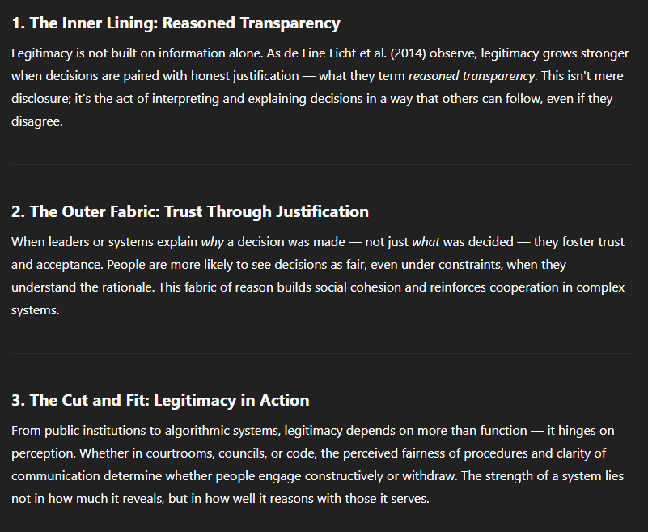

Strategic discretion in how information is shared can sometimes better serve the public, especially when it allows stakeholders to make informed judgments without being overwhelmed (Heo, 2024). **My company’s ethical foundation is built on this nuance: we commit to openness where it builds trust and actionability, while being thoughtful about context and clarity.**

Looking ahead, my current focus intersects the structure of modern finance, the mathematical science of cryptography, and the evolving logic of programmable economic systems. Delaware hedge fund structures remain a powerful, flexible legal vehicle—often used due to their investor-friendly governance, pass-through taxation, and compatibility with global capital markets. These structures provide a stable foundation for experimenting with new financial models while meeting institutional-grade regulatory standards.

In parallel, cryptography offers the mathematical rigor necessary to secure financial systems at scale. It is not just a technical tool but a theoretical framework for designing systems that can enforce trust, privacy, and verification without central intermediaries. From zero-knowledge proofs to elliptic curve signatures, cryptographic methods underlie everything from secure transactions to decentralized governance.

One of the most radical reconfigurations of finance comes from blockchain protocols like Ethereum, where money itself becomes a programmable file—defined not only by balances but by code. On Ethereum, digital assets are expressed as smart contracts—self-executing programs stored on a decentralized ledger. This redefines money from a static object into an active agent: a file that carries not just value, but embedded logic, permissions, and time-sensitive rules (Buterin, 2014; Wood, 2021). This architecture opens the door for community-owned financial primitives, automated compliance, and new forms of capital coordination.

I see this convergence—of traditional structures, mathematical formalism, and open protocols—as a frontier worth building on, carefully and ethically.



Aaron Abrams, Chair of The Board, The Dinosaur Dragon Investment Company Limited

### 2.

**🛶 Community-2-Community Sharing (C2C)**

Community-2-Community Sharing (C2C)

When someone invests your money well for you, they send you the profits they have made for you. As it concerns your tax position, there are two ways that you can receive these dividends:

1. **In a Tax Domicile:** This is how regular cash, stock, and ISA investments work. It means that the Government of the ruling tax domicile reserves its right to look at your financial position and tax you on what you own.
2. **As a file:** If you share the dividend as a file, the recipient will be able to add the dividend to their own Drive, USB Stick, or Cloud. Only they will be able to edit the file and make changes to it, so the money is truly theirs. This is a simplified explanation of how Cryptocurrency works. 🪙

#### 

#### 

#### 

#### 

#### 

#### 

#### 

#### 

#### 

#### 

#### 

#### 

#### The Inherent Risks and Rewards of Cryptocurrency Networks

The implications of receiving investment profits through traditional banking channels versus blockchain-based systems on financial privacy and control are multifaceted. Traditional banking relies heavily on centralized intermediaries, such as banks and payment processors, which can compromise financial privacy due to the need for trust in these entities and their susceptibility to failures and breaches, as highlighted by the Global Financial Crisis and subsequent events(Varma, 2019). In contrast, blockchain-based systems, particularly those utilizing Decentralized Finance (DeFi), offer enhanced privacy and control by eliminating intermediaries and enabling peer-to-peer transactions through decentralized networks(Bakare et al., 2024). Blockchain's inherent features, such as immutability and cryptographic security, ensure more secure and transparent transactions, reducing the risk of fraud and errors(Bakare et al., 2024). However, the implementation of privacy-enhancing technologies (PETs) like Zero-Knowledge Proofs (ZKPs) and multiparty computations (MPCs) in blockchain systems can introduce trade-offs, such as increased transaction times and computational loads, which may affect scalability and efficiency(Joseph, 2024). Despite these challenges, blockchain's potential to disrupt traditional banking by offering more efficient and inclusive financial services is significant, though it requires careful navigation of regulatory uncertainties and technological risks(Bakare et al., 2024) (Ibrahim, 2023). Ultimately, while blockchain-based systems provide greater financial privacy and control, they also necessitate advancements in privacy technologies and regulatory frameworks to fully realize their benefits (Joseph, 2024).

#### 

#### 

#### 

#### 



#### The Importance of the Stablecoin Innovation

Stablecoins, particularly those pegged to fiat currencies like the U.S. dollar (e.g., USDC, USDT), play a critical role in bridging traditional finance and blockchain-based systems by offering the stability of conventional currencies with the programmability and autonomy of crypto assets (Zetzsche et al., 2020). They enable users to engage in decentralized financial activities—such as investing, lending, or profit-sharing—without exposure to the volatility typically associated with cryptocurrencies. Unlike fiat deposits held in banks, which are subject to capital controls, withdrawal limits, and third-party oversight, stablecoins are user-controlled assets stored in private wallets or smart contracts, facilitating immediate, borderless transfers with minimal interference. This structure enhances individual financial sovereignty, particularly for users in jurisdictions with weak institutions or unstable monetary regimes (Chen & Bellavitis, 2020). However, stablecoins also introduce unique governance challenges, including reliance on centralized issuers, reserve transparency, and regulatory compliance, all of which are evolving under global scrutiny. Even so, their ability to maintain value while offering the benefits of blockchain technology marks them as a foundational tool for more inclusive and autonomous financial systems.

**🥋 Approach and Style 2.0**

## This is my 2nd Company, but not my first investment.

Here are two examples from my professional history that demonstrate my experience, and now offer me chances to implement lessons learned as I build my second company..

**🐋Jonah Ocean Systems Ltd:** This was my first UK Limited Company Directorship. We did a series of consecutive Government funded research contacts into seaweed biology, seaweed aquaculture, and the seaweed business ecosystem. We also won a £10k pitching competition in Wales. Get in touch if you would like to know more!

**🔮Mystic AI Ltd:** This was the first AI Startup I invested in on a SEIS Scheme in 2019. They built and ran software pipelines for Cloud-based Machine-Learning Clients. They participated in YCombinator in 2021, and have subsequently raised over $4 million.

**🪜 The +1 System**

It begins with a Google Form

You are invited to fill out the Investment Interest Form linked below. Anyone with access to the internet can receive and fill out a shared Google Form, they do not need a Google Account to do so. This simple accessibility protocol is essential for what we are building.

### How to Share the Google Form Correctly

Sending and submitting forms the right way is essential to maintain clarity, control, and data integrity. When shared via hyperlink, forms allow recipients to respond securely without risking unwanted edits to the structure—ideal for broad distribution and confidentiality. Sharing as a file, on the other hand, should be reserved for trusted collaborators involved in building or editing the form. Choosing the appropriate method ensures the form reaches the right audience in the right format, protects the intent of the questions, and preserves the quality of responses collected.

### 

### 

### 

### 

### 

### The Link

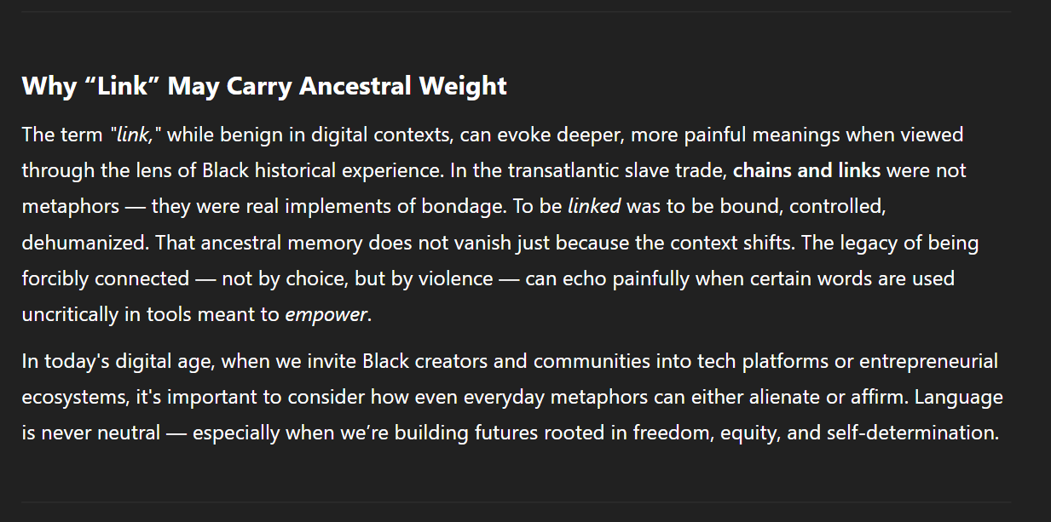

Instead of “Share the Link” we say, “Extend the thread" – evoking continuity, not constraint.

QR +[🔗](https://docs.google.com/forms/d/e/1FAIpQLSehD2pc7g1j5fRnS8l5d64xUhKfRYZVdTFXMDR8hcRuUsFj4w/viewform?usp=header)

We warmly invite you to distribute this link to any of your friends, family, or other interested parties.



**🏦 The Debut Fund**

Initial Contributors & History of Debut Fund

This is the debut (fund). Whilst you’re not setting up your own hedge fund, the mechanics feel the same. You are launching a vehicle that will allow UK residents to send and receive money from a company.

We let them know that they will have the ongoing choice of whether to receive payouts into a managed USDC wallet or just an address. (This is not fund mechanics but more exploring how do people want it. For instance, some may be used to a single platform like Hargreaves Lansdowne, so this will feel riskier and more fake compared to that unless there is an interface that works well on web.

* That’s where your unity building skills come into play, you get all the expressions of interest, set up the company, and fund the first development app with the pre-contributions. Or you go into credit on the mounting appreciation for this venture and once you have hit a certain threshold of committed capital, you invest deeper into the initiative and get that windsurf account.

( intro to the market, start off slow, use visuals)

**🫂 Intake Forms**

Investment Intake Forms 101

### Forms are on Google Drive

* As a link: If you share the form with someone as a link, they will be able to access the form by clicking on the link. They will not be able to edit the form, but they will be able to view it and submit responses.
  + Please note, you can also share Google Forms as a file. If you share the form as a file, the recipient will be able to add the form to their own Drive. They will be able to edit the form and make changes to it. Edited forms will take 2 weeks longer to process but will always be reviewed.

### 

#### A note on this approach to intake

Sending and submitting forms the right way is essential to maintain clarity, control, and data integrity. When shared via hyperlink, forms allow recipients to respond securely without risking unwanted edits to the structure—ideal for broad distribution and confidentiality. Sharing as a file, on the other hand, should be reserved for trusted collaborators involved in building or editing the form. Choosing the appropriate method ensures the form reaches the right audience in the right format, protects the intent of the questions, and preserves the quality of responses collected.

#### Feedback

Feedback on how we can improve this service is valuable to us, so we pay you for it. We are working to add programmable benefits to this rewards program, but for now we can offer fee discounts for any feedback which you implement on your personal application. This is a core part of the trust framework of the initiative, that work always gets compensated.

**🧗 Scale of Thinking**

Utilizing Conglomerate-Scale Thinking

### Using AI to make Investor Screening Simple and Scalable in Low-compute, Internet-accessible contexts

I have found it much more effective to hand off simple compute tasks to AI-enhanced web-based Macro-Platforms such as Google’s Work Suite, rather than rely on the latest local setup. This not only means the system is fungible in more contexts around the globe, but that the mechanics of actually running collective investment schemes on stablecoin platforms are currently cheap compared to the cost of running them on legacy policy systems, such as Delaware Fund Licensing and Incorporation.

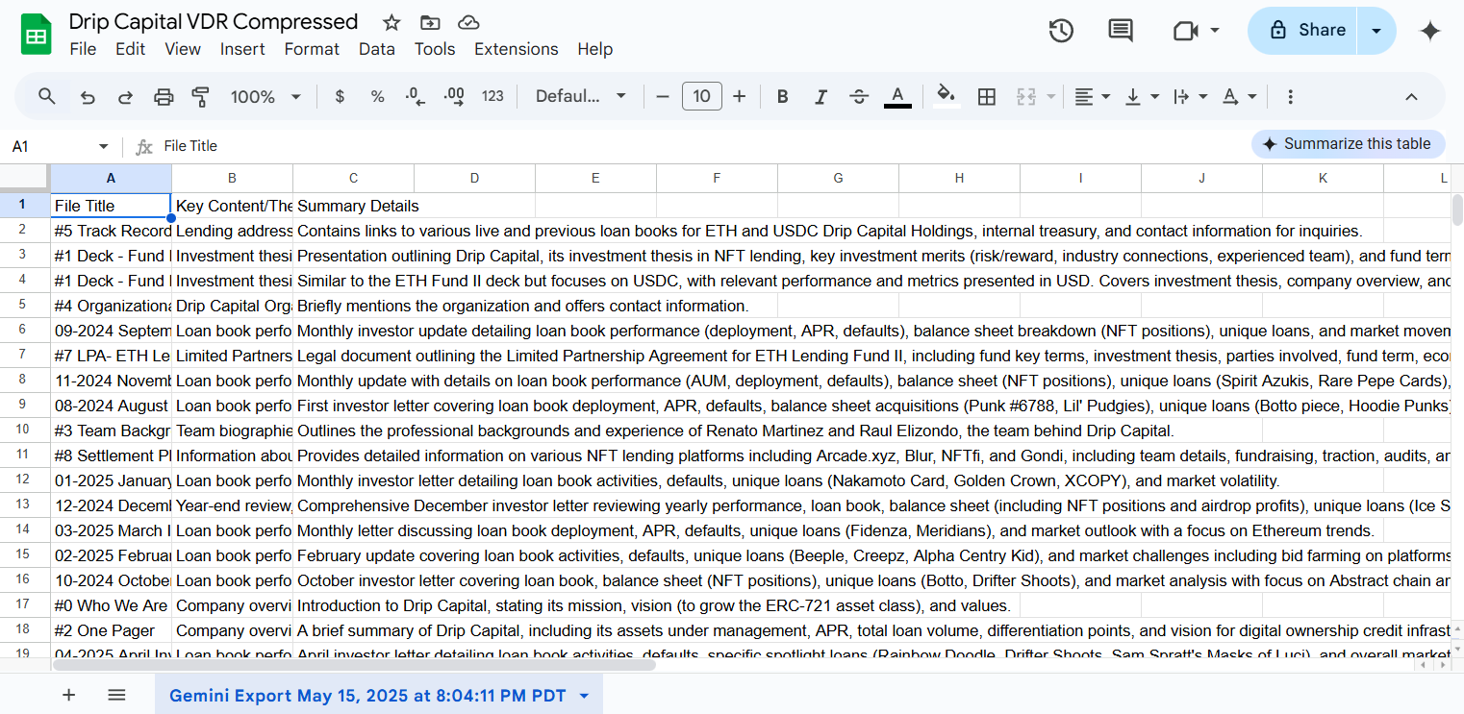

*Figure 1. Using data compression techniques to standardize input data from different styles of funds with content in different languages.*

* As a Stablecoin-Native Fund Management Platform, we are pleased to offer our investing community flexible exposure to under-democratised markets in blockchain and cryptocurrency investment vehicles.
  + Please note, as a funds holding company, we do not offer financial advice, and nothing in this presentation amounts to sales material. We just value clear and open data-flow, just like the blockchain networks which we are building on.

What we Offer

### 

#### State-of-the-Art Fund Activity Minutiae

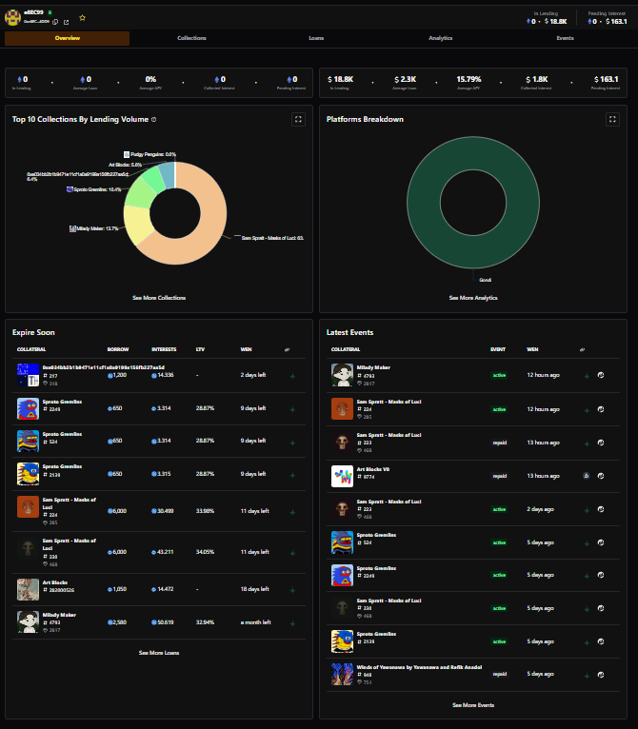

On-demand visibility of key active accounts and loan books, with curated manager notes for you to reason with and consider.

#### Clear and Customisable Manager’s Dashboard Viewpoints to Follow In Real-Time

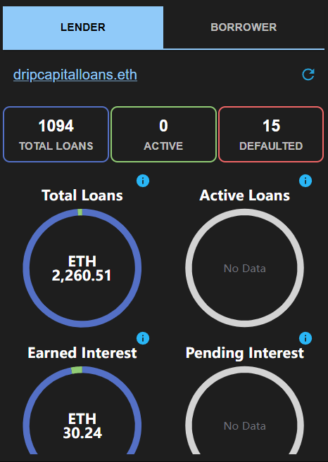

They are managing your money. So why wouldn’t you look at what they look at? 🥽

#### Accessibility

As of 2024, an estimated 5.5 billion people had access to the internet, which encompasses around 68% of the population by at-the-time estimates. We are building this company to be an investment vehicle for anyone with access to the internet, so Plus 1’s are definitely invited!

#### Thoughtful Branding with Personal Meaning



**🪇 Vibe**

**🌉 Ethical Frameworks**

**💻 What's your story?**

# Stories

# 

Out and Back 🌰

Delivered Gently 🌰

In and Out 🌰

Out and Back

This is a creative writing aid, and is not intended to be factual. [Learn more](https://support.google.com/docs/?p=before-using-ai)

**🌌 Reflection point**

Formula for Increasing

As with any “new” investment vehicle forged in the fires of late stage global capitalism, the principles of engagement must be set out clearly from the outset for a smooth, and long-running application of socio-economic theory.

**🕰️ Story - e.g. 5-page white paper**

Academic Starting Point

(Intentionally Made Up[1] Research title)

**Impact of Principles of Engagement on Long-Term Sustainability of Socio-Economic Theories in the Context of Building at Giga Scale with Emerging Investment Vehicles**

**Introductions:**

* Writing as Intervention – Science, Medicine, and Ethics in Today’s World
  + Prof. Duana Fullwiley - Department of Anthropology, Stanford University

Final Piece:

Here is a description of the poem:

The poem uses a coded writing metaphor that, once activated in the reader’s own mind, searches and consumes information in a somewhat indiscriminate or unexpected way, like a hungry rabbit. This search focuses on flaws or uncertainties within the United States economy during the early 21st century. 🕳️

* + - so the writing was code, and once implemented

It can run ahead 01100011 01101111 01100100 01100101

Jittery it sticks to the arm like glue, the horror

* + - 01100111 01101100 01110101 01100101, if it touched a new line, it still ran back past all the ones it missed in so doing never missing one.

Infusion glue, 01101100 01101001 01101110 01100101

* + - With commas, separating.

01100011 01101111 01101101 01101101 01100001 01110011

Get it, got it?[2]

* + - If you don’t get it don’t worry, the structure of this information can essentially go on
* holding weight forever.

**·**

**·**

**·**

See.

(jump, time dimension)

**·**

**·**

**·**

(Man’s Voice Through The Crappy Telephone Headset)   
“Now go to the following webpage on your browser…” <https://apps1.cdfa.ca.gov/weighmasterpublic/newapplication>

* $25 Credit and I can sign anyone up to be a Deputy Weighmaster on my new team I am forming. May cost more next time to add people (it will) so initial formation is important.
* This is SUPER CASUAL! I am putting down money against the first 10 sign ups, to make it just $5, and - how low do you want the ticket price to go?
* And then how high? - Pianos, private sales event, not an auction, selling 10 pianos at $16,000 - $48,000 is a lot of cash on entry. We collect those payments on a stripe terminal we own. If that stripe terminal can be a phone in a case then perfect. If it should look like an iPad we got this. Keep office for office. Close off back, get moving. Keep front open highly VIP. Driving force now.
* How much ‘private credit note’ can greg give me to get moving? In escrow with the financial advisor to keep it above board. If he loans me 100k, I cash a 5000 cheque, with the contract stating i will pay him back 5000 then i am only 5k deep.
* If i can sell one piano on my terminal, i am back in the green, and i can return the 5k, and we write another contract. This time it is 25k in the bank, the next step up. He writes me a 10k cheque to cash, which i quickly return once the sale of my piano goes through again, landing me 60,000 in the green. I hand greg back his 10k and now I stake a 40. Greg doesn’t want to put up a 40, so he signs 10 more pianos over to me in escrow with his financial advisors business. And so we go on.

(ledgered closed loop system, first you can display your own licence application and say, pay $75 and get it for real). Then once you gain a sponsor you can offer them to pay every time someone wants to claim a licence, on the offer that they get put through to a 10 minute advertising window, where a live media dj displays them a omni-channel tv/media stream that can jump into any advert online at once. Just to view only. Who wouldn’t want piggyback ads?)

* Role of Emerging Investment Vehicles in Sustainability, a New Blueprint for Financing Community Development.
  + Nancy Andrews - Fellow, Distinguished Careers Institute, Stanford University
* Principles of Engagement in Building at Giga Scale. Lessons from Real Estate Investment Trusts.
  + Dr. Kanak Patel, Magdalene College, Cambridge
* Case Studies and Examples of Financial Innovation Working on the Ground
  + Dr. Shailaja Fennell, Jesus College, Cambridge
* Conclusion

*This is a co-project so invite collaborators to co-create this part with you. Be thoughtful about the writers.*

*Impact of Principles of Engagement on Long-Term Sustainability of Socio-Economic Theories in the Context of Building at Giga Scale with Emerging Investment Vehicles. By Aaron Abrams.* 🪙

### Abstract

The integration of emerging investment vehicles such as cryptocurrencies, green bonds, and peer-to-peer lending into large-scale socio-economic projects presents both opportunities and challenges for long-term sustainability. This response explores the role of these vehicles in fostering sustainable socio-economic theories, focusing on their impact, challenges, and the principles of engagement that guide their effective implementation.

#### 1. Introduction

The global economy is undergoing a significant transformation, driven by the need for sustainable development and the integration of innovative financial technologies. Emerging investment vehicles, such as cryptocurrencies, green bonds, and peer-to-peer lending, are playing a pivotal role in reshaping the financial landscape, particularly in the context of building at giga scale. These vehicles not only provide new avenues for capital mobilization but also offer innovative solutions to address environmental and social challenges. However, their long-term sustainability and impact on socio-economic theories require careful examination.

#### 2. Role of Emerging Investment Vehicles in Sustainability

##### 2.1. Cryptocurrencies

Cryptocurrencies, such as Bitcoin and Ethereum, have emerged as a transformative force in the financial sector. Their decentralized nature and the use of blockchain technology offer enhanced transparency, security, and efficiency in financial transactions. However, the environmental impact of cryptocurrencies, particularly their high energy consumption, has raised concerns about their sustainability (Pham et al., 2023) (Rani et al., 2024).

Despite these challenges, cryptocurrencies can contribute to sustainability by enabling decentralized financing models that promote financial inclusion and reduce reliance on traditional intermediaries. For instance, decentralized finance (DeFi) platforms have the potential to democratize access to capital, thereby supporting sustainable development goals (SDGs) (Fatima & Carè, 2024) (Zhao, 2024).

##### 2.2. Green Bonds

Green bonds are specifically designed to finance projects that promote environmental sustainability. These bonds are instrumental in mobilizing capital for green infrastructure, renewable energy projects, and other environmentally friendly initiatives. The growth of the green bond market has been significant, with issuances reaching record levels in recent years (Hehanussa, 2024) (Chen, 2022).

The role of green bonds in sustainability is further enhanced by their alignment with global climate goals, such as the Paris Agreement. By providing a dedicated funding mechanism for green projects, these bonds help reduce the environmental footprint of large-scale developments and promote a low-carbon economy (Abramova et al., 2024) (Chen, 2022).

##### 2.3. Peer-to-Peer Lending

Peer-to-peer (P2P) lending platforms have emerged as an alternative to traditional banking, offering a direct connection between borrowers and investors. These platforms have the potential to enhance financial inclusion and provide access to capital for small and medium-sized enterprises (SMEs) and individuals who may not have access to traditional credit channels (Jovović & Vuković, 2024) (Khalegi et al., 2024).

In the context of sustainability, P2P lending can support green projects by connecting investors with projects that promote environmental sustainability. The transparency and efficiency of these platforms can also contribute to better governance and accountability in the financing of large-scale projects (Khalegi et al., 2024) (Udeh et al., 2024).

#### 3. Principles of Engagement in Building at Giga Scale

The principles of engagement play a crucial role in ensuring the long-term sustainability of socio-economic theories in the context of building at giga scale. These principles include transparency, accountability, inclusivity, and stakeholder participation.

##### 3.1. Transparency and Accountability

Transparency is a cornerstone of sustainable finance. Emerging investment vehicles, such as blockchain-based systems, offer enhanced transparency by providing a secure and immutable record of transactions. This transparency can build trust among stakeholders and ensure that funds are used for their intended purposes (Mhlanga, 2024) (Udeh et al., 2024).

Accountability is another critical principle. It ensures that all stakeholders, including investors, project developers, and beneficiaries, are held responsible for their actions. The use of smart contracts in blockchain technology can automate accountability by enforcing compliance with predefined rules and regulations (Mhlanga, 2024) (Zhao, 2024).

##### 3.2. Inclusivity and Stakeholder Participation

Inclusivity is essential for ensuring that the benefits of large-scale projects are shared equitably among all stakeholders. Emerging investment vehicles, such as P2P lending and green bonds, can promote inclusivity by providing access to capital for underserved communities and SMEs (Jovović & Vuković, 2024) (Khalegi et al., 2024).

Stakeholder participation is also vital for the success of large-scale projects. It ensures that the needs and concerns of all stakeholders are taken into account, leading to more sustainable and equitable outcomes. Blockchain technology can facilitate stakeholder participation by enabling decentralized decision-making and governance (Fatima & Carè, 2024) (Zhao, 2024).

#### 4. Challenges and Limitations

Despite their potential, emerging investment vehicles face several challenges that could hinder their effectiveness in promoting sustainability.

##### 4.1. Regulatory and Governance Challenges

The regulatory landscape for emerging investment vehicles is often fragmented and uncertain. This lack of clarity can create barriers to adoption and hinder the growth of sustainable finance. For instance, the lack of standardized regulations for cryptocurrencies and blockchain technology can lead to legal and compliance challenges (Mhlanga, 2024) (Udeh et al., 2024).

Effective governance is also critical for ensuring the sustainability of large-scale projects. Weak governance structures can lead to mismanagement of funds and a lack of accountability, undermining the effectiveness of emerging investment vehicles (Jovović & Vuković, 2024) (Khalegi et al., 2024).

##### 4.2. Technological Limitations

While blockchain technology offers significant advantages, it is not without its limitations. Issues such as scalability, interoperability, and energy consumption can hinder the widespread adoption of blockchain-based systems. For example, the high energy consumption of certain blockchain networks, such as Bitcoin, has raised concerns about their environmental sustainability (Pham et al., 2023) (Rani et al., 2024).

##### 4.3. Environmental Impact

The environmental impact of emerging investment vehicles is a critical consideration. While green bonds and P2P lending are designed to promote sustainability, the environmental footprint of cryptocurrencies has been a subject of debate. The high energy consumption of certain blockchain networks has raised concerns about their long-term sustainability (Pham et al., 2023) (Rani et al., 2024).

#### 5. Comparative Analysis of Emerging Investment Vehicles

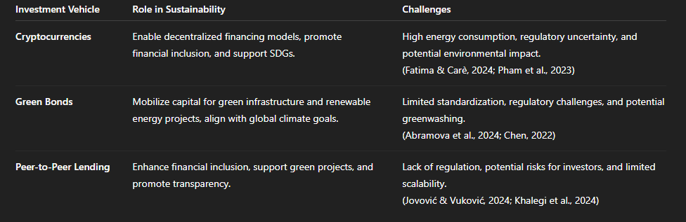

*A Table Image detailing emerging investment vehicles that are becoming accessible to anyone who can utilise a working internet connection twice – once to fund, and once to withdraw.*

#### 6. Case Studies and Examples

##### 6.1. Blockchain for Green Financing

The use of blockchain technology in green financing has been explored in various case studies. For example, blockchain-based platforms have been used to track the issuance and trading of green bonds, ensuring transparency and accountability (Mhlanga, 2024) (Udeh et al., 2024). Similarly, blockchain has been used to facilitate the trading of carbon credits, providing a secure and efficient mechanism for reducing greenhouse gas emissions (Zhao, 2024) (Udeh et al., 2024).

##### 6.2. Green Bonds for Renewable Energy

Green bonds have been instrumental in financing renewable energy projects. For instance, the issuance of green bonds has supported the development of wind farms, solar power plants, and other renewable energy initiatives. These bonds have not only mobilized capital for green projects but also promoted a low-carbon economy (Abramova et al., 2024) (Chen, 2022).

##### 6.3. Peer-to-Peer Lending for SMEs

P2P lending platforms have provided access to capital for SMEs, enabling them to invest in green technologies and sustainable practices. For example, platforms have been used to finance energy-efficient equipment and renewable energy projects for small businesses, promoting sustainability and reducing environmental impact (Jovović & Vuković, 2024) (Khalegi et al., 2024).

#### 7. Conclusion

The integration of emerging investment vehicles into large-scale socio-economic projects offers significant potential for promoting sustainability. Cryptocurrencies, green bonds, and peer-to-peer lending each have unique roles to play in mobilizing capital, enhancing transparency, and supporting sustainable development. However, their effectiveness depends on addressing challenges such as regulatory uncertainty, technological limitations, and environmental impact.

By adhering to principles of engagement such as transparency, accountability, inclusivity, and stakeholder participation, these vehicles can contribute to the long-term sustainability of socio-economic theories. Policymakers, financial institutions, and other stakeholders must work together to create an enabling environment that fosters innovation and promotes sustainable development.

Equally important is the emergence of bridging vehicles — community-driven financial entities capable of gathering and allocating capital in ways that represent local interests within the global digital investment market. These structures help ensure that participation in the internet economy remains equitable and grounded in the real needs of diverse populations, amplifying voices that might otherwise be excluded from traditional capital flows.

Aaron Abrams, Chair of the Board, The Dinosaur Dragon Investment Company Limited

🦕🐉🪙

1. https://occupationallicensing.com/occupation/weigher/?utm_source=chatgpt.com
2. https://open.spotify.com/artist/78hQVwWn8ocEqFXEbhqE1V