- Unit Impulse Signal
  - Continuous-Time
t = -5:0.01:5;
plot(t, zeros(size(t)), 'r', "LineWidth", 2.5)
hold on
line([0, 0], [0, 1], 'color', 'r', "LineWidth", 2.5)
hold off
xlabel('t')
ylabel('x(t)')
title('Continous-time unit impulse signal')
  - Discrete-Time
hold on
for(n=-5:5)
if(n==0)
stem(n,1,'r')
else
stem(n,0,'r')
end
end
hold off
xlabel('n')
ylabel('x[n]')
title('Discrete-time unit impulse signal')
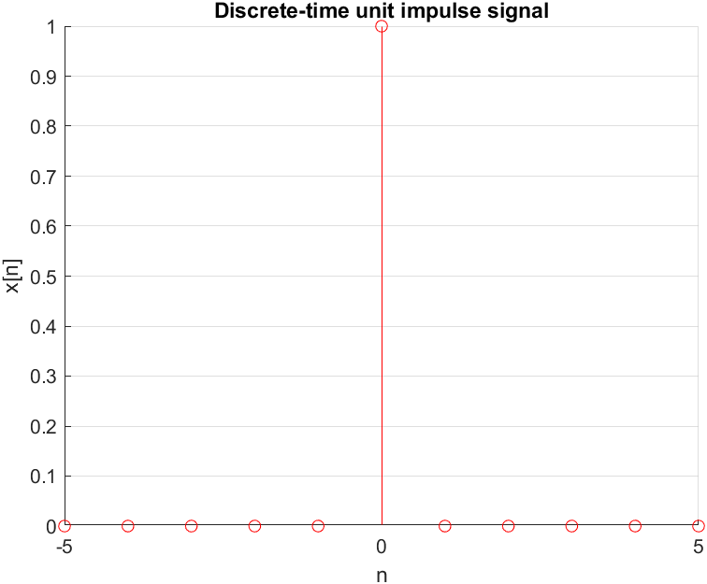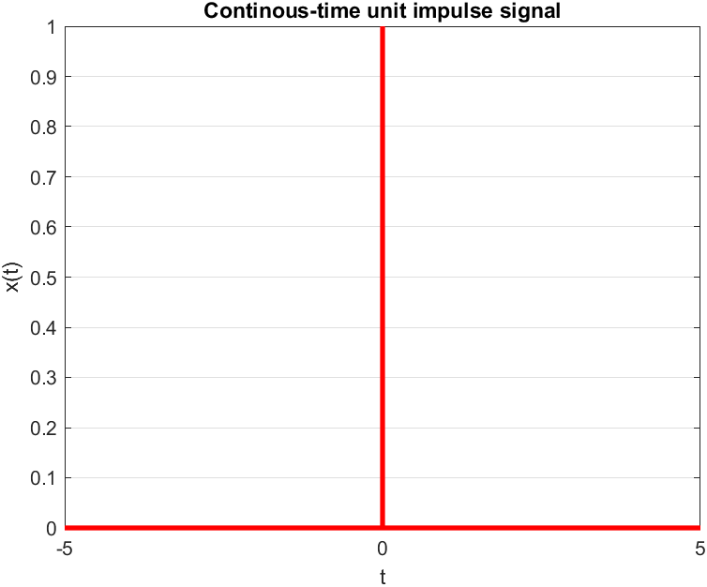
- Unit Step Signal
  - Continous-Time
t = -5:0.01:5;
x = double(t>=0);
plot(t, x, 'r', "LineWidth", 2.5)
xlabel('t')
ylabel('x(t)')
title('Continous-time unit step signal')
  - Discrete-Time
hold on
for(n=-5:5)
if(n<0)
stem(n, 0)
else
stem(n, 1, "LineWidth", 2.5)
end
end
hold off
xlabel('n')
ylabel('x[n]')
title('Discrete-time unit step signal')
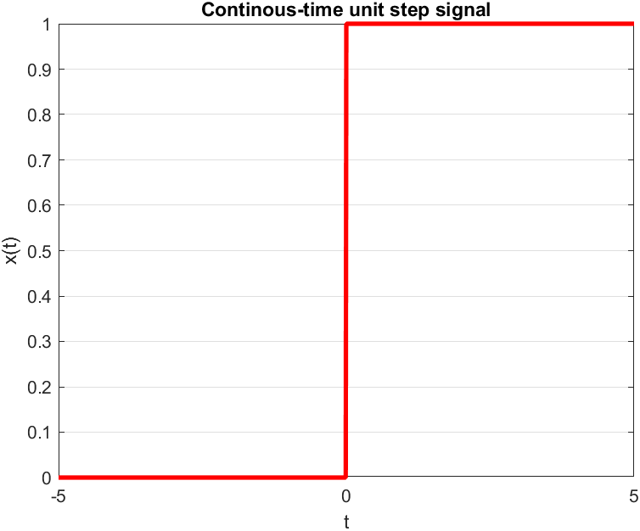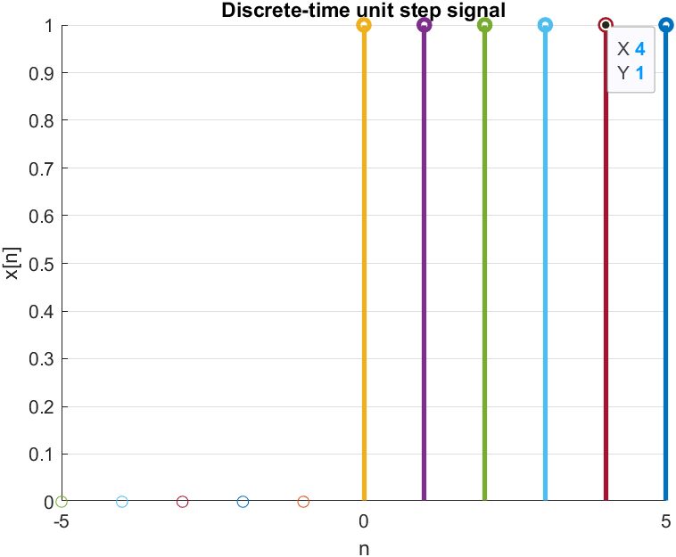

- Ramp Signal
  - Continuous-Time
% m=1 and c=2
t = -5:0.01:5;
m = input('m=');
c = input('c=');
y = m*t + c;
plot(t, y, "LineWidth", 2.5)
xlabel('t')
ylabel('x(t)')
title('Continous-time ramp signal')
  - Discrete-Time
% m = 2 and c = -1
n = -5:5;
m = input('m=');
c = input('c=');
y = m*n + c;
stem(n, y, "LineWidth", 2.5)
xlabel('n')
ylabel('x[n]')
title('Discrete-time ramp signal')
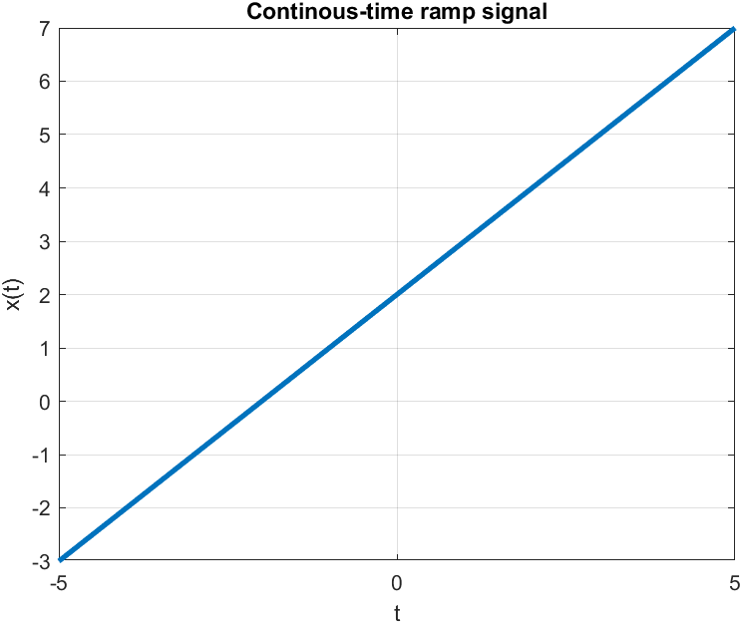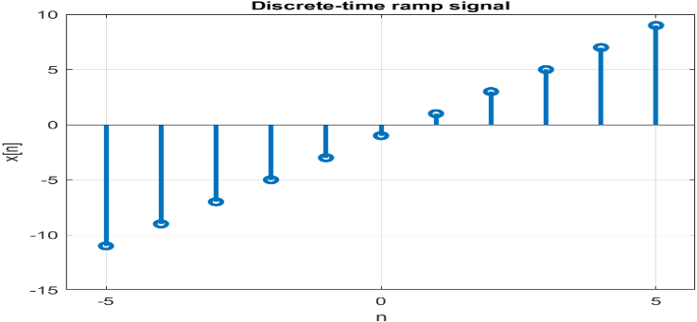
- Exponential Signal
  - Continuous-Time
% a = 1 and c = 2
% a = -1 and c = 2
t = -5:0.01:5;
a = input('a=');
c = input('c=');
y = c*exp(a*t);
plot(t, y, "LineWidth", 2.5)
xlabel('t')
ylabel('x(t)')
title('Continous-time exponential signal')
  - Discrete-Time
% a = 0.3 and c = 1
% a = -0.5 and c = 1
n = -5:5;
c = input('c=');
a = input('a=');
y = c*exp(a*n);
stem(n, y, "LineWidth", 2.5)
xlabel('n')
ylabel('x[n]')
title('Discrete-time exponential signal')
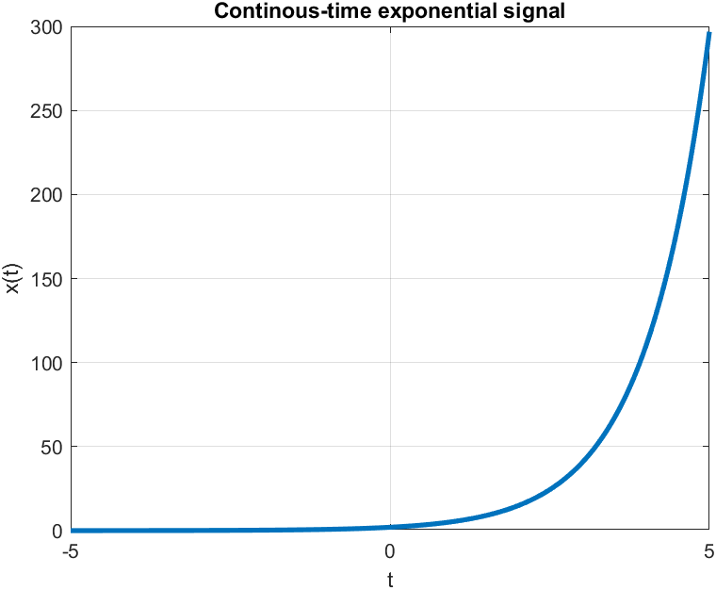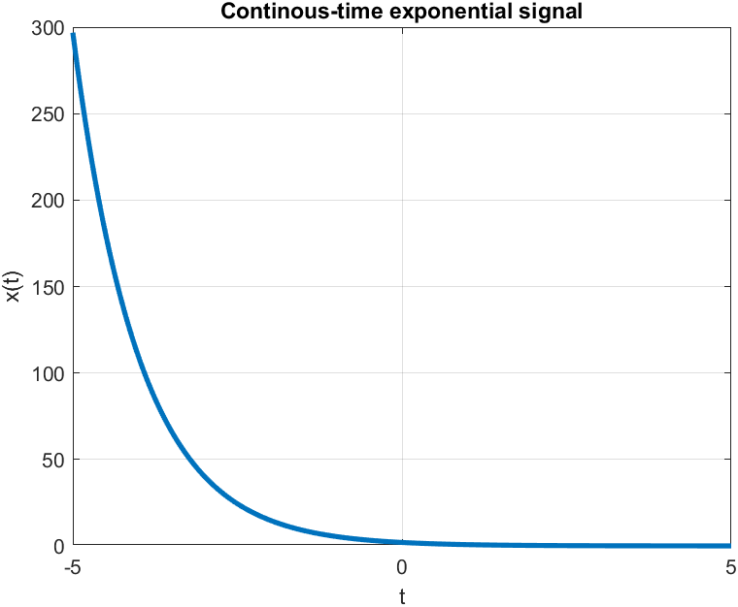
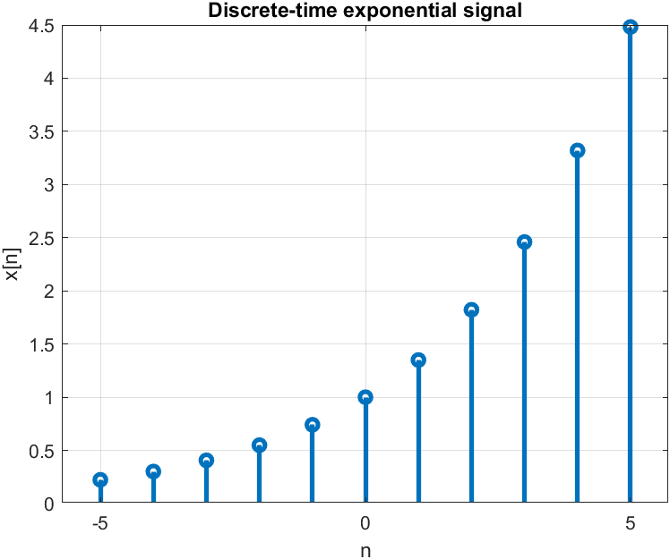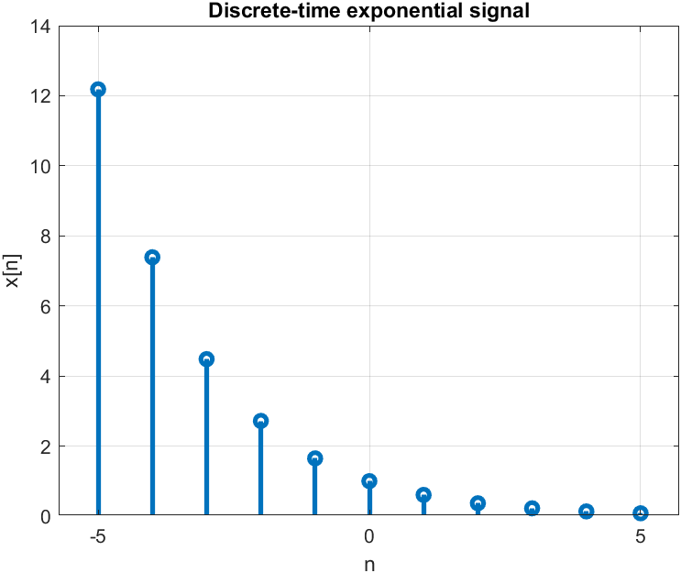
- Sinusoidal Signal
  - Continuous-Time
hold on
t = -5:0.01:5;
x = sin(t);
y = cos(t);
plot(t, x, "LineWidth", 2.5)
plot(t, y, "LineWidth", 2.5)
xlabel('t')
ylabel('x(t) and y(t)')
title('Continous-time sinusoidal signal')
hold off
  - Discrete-Time
n = -5:1:5;
x = sin(n);
stem(n, x, "LineWidth", 2.5)
xlabel('n')
ylabel('x[n]')
title('Discrete-time exponential signal')


