
Tribhuvan University
Institute of Engineering
Central Campus, Pulchowk

Lab No. : 3
TITLE:
Study of Z-Transform, Frequency response, FIR Filter, IIR Filters and FFT

Submitted To: Department of Electronics and Computer Engineering
Submitted By: Aaryan Adhikari
Roll no: 080bel003
Submission Date:

Title: Study of Z-Transform, Frequency response, FIR Filter, IIR Filters and FFT

Objective:
- To find z transform and it’s inverse for a given system
- To find frequency response
- To design FIR filter
- To design IIR filter
- To find FFT

Theory:
Z-Transform:
The Z-transform is a mathematical tool used to convert discrete-time signals into a complex-frequency domain representation. It is the discrete-time equivalent of the Laplace transform.
Definition: For a sequence $x\left[n\right],$ the Z-transform $X\left(z\right)$ is defined as:
$$X\left(z\right)=\sum_{n=-∞}^{∞}{x\left[n\right]z^{-n}}$$
A Linear Time-Invariant (LTI) system is often represented by a rational transfer function $H\left(z\right)=\frac{N\left(z\right)}{D\left(z\right)}$, where the roots of the numerator are zeros and the roots of the denominator are poles.
A causal LTI system is stable if and only if all poles of the transfer function $H(z)$ lie inside the unit circle in the z-plane.
The Region of Convergence (ROC) is the set of values of z for which the Z-transform converges. It determines system stability and causality.
Frequency Response:
The frequency response describes how a system affects the magnitude and phase of an input signal across different frequencies. It is obtained by evaluating the transfer function $H\left(z\right)$ on the unit circle, where $z=e^{jω}$. This yields the complex function $H\left(e^{jω}\right)$. If the system impulse response is $h\left[n\right],$the frequency response $H\left(e^{jω}\right)$is:
$$H\left(e^{jω}\right)=\sum_{n=-∞}^{∞}{h\left[n\right]e^{-jωn}}$$
The frequency response consists of two parts:
- Magnitude Response $\left|H\left(e^{jω}\right)\right|:$ Indicates how the system scales the input amplitude.
- Phase Response $∠H\left(e^{jω}\right):$ Indicates the phase shift introduced by the system.
Finite Impulse Response (FIR) Filter:
FIR filters are systems where the impulse response $h\left[n\right]$ settles to zero in finite time. They are inherently stable because they do not use feedback. The output $y\left[n\right]$ is a weighted sum of the current and past input values:
$$y\left[n\right]=\sum_{k=0}^{M}{b_{k}x\left[n-k\right]}$$
It is always stable since there are no poles (except at $z=0).$
It can be easily designed to have a linear phase, which prevents signal distortion in the time domain.
It usually requires a higher order (more coefficients) than IIR filters to achieve the same sharp cutoff.
An ideal impulse response $h_{d}\left[n\right]$ is usually infinite. We multiply it by a function called window to make it finite:
$$h\left[n\right]=h_{d}\left[n\right]⋅w\left[n\right]$$
Typical Windows used:
Window Name | Formulas | Main lobe width | Minimum stopband attenuation dB
Rectangular | $$1$$ | $4π/ N$ | -13
Bartlett | $$1-\frac{2n}{M - 1}$$ | $$8π/ N$$ | -26
Hanning | $$0.5-0.5\cos\left(\frac{2πn}{M}\right)$$ | $$8π/ N$$ | -31
Hamming | $$0.5-0.46\cos\left(\frac{2πn}{M}\right)$$ | $$8π/ N$$ | -41
Blackman | $$0.42-0.5\cos\left(\frac{2πn}{M}\right)+0.08\cos\left(\frac{4πn}{M}\right)$$ | $$12π/ N$$ | -57
Kaiser | $$\frac{I_{0}\left[β\sqrt{1-{\left(\frac{2n}{M}-1\right)}^{2}}\right]}{I_{0}\left(β\right)}$$ | Variable | Variable

Infinite Impulse Response (IIR) Filter:
IIR filters are recursive systems where the output depends on current and past input values as well as past output values. This feedback loop allows the impulse response to theoretically continue indefinitely.
The relationship between input $x\left[n\right]$ and output $y\left[n\right]$ is:
$$y\left[n\right]=\sum_{k=0}^{M}{b_{k}x\left[n-k\right]}-\sum_{k=1}^{N}{a_{k}y\left[n-k\right]}$$
We mainly use Butterworth filter design. This filter type is characterized by a maximally flat magnitude response in the passband.
Order Estimation $\left(N\right)$:
$$N≥\frac{\log_{10}\left(\frac{{10}^{0.1R_{s}}-1}{{10}^{0.1R_{p}}-1}\right)}{2\log_{10}\left(\frac{Ω_{s}}{Ω_{p}}\right)}$$
Where, Rs = stopband attenuation
Rp = passband ripple
$Ω_{s}$ = stopband analog frequency, and
$Ω_{p}$ = passband analog frequency
The mathematical definition of the Butterworth response is:
$${\left|H\left(jΩ\right)\right|}^{2}=\frac{1}{1+{\left(\frac{Ω}{Ω_{c}}\right)}^{2N}}$$
FFT (Fast Fourier Transform):
The FFT is not a different transform; it is an efficient algorithm to compute the Discrete Fourier Transform (DFT). While a standard DFT takes $O\left(N^{2}\right)$ operations, the FFT reduces this to $O\left(N\log_{2}{N}\right).$
The DFT Formula$:$
$$X\left[k\right]=\sum_{n=0}^{N-1}{x\left[n\right]e^{-j\frac{2π}{N}kn}}, k=0,1,…,N-1$$
To return to the time domain, we use the Inverse DFT (IDFT):
$$x\left[n\right]=\frac{1}{N}\sum_{k=0}^{N-1}{X\left[k\right]e^{j\frac{2π}{N}kn}}, n=0,1,…,N-1$$
The most common method is the Cooley-Tukey Radix-2 Decimation-in-Time (DIT) algorithm. This approach recursively divides the sequence into even-indexed and odd-indexed subsequences:
$$X\left[k\right]=\sum_{m=0}^{N/2-1}{x\left[2m\right]e^{-j\frac{2π}{N}\left(2m\right)k}}+e^{-j\frac{2π}{N}k}\sum_{m=0}^{N/2-1}{x\left[2m+1\right]e^{-j\frac{2π}{N}\left(2m\right)k}}$$
This decomposition leads to the butterfly structure, which significantly cuts down on redundant calculations.
Spectral Analysis Formulas
Once the complex sequence $X\left[k\right]$ is obtained, we extract meaningful data using the following formulas:
- Magnitude Spectrum: $\left|X\left[k\right]\right|=\sqrt{\text{Re}{\left(X\left[k\right]\right)}^{2}+\text{Im}{\left(X\left[k\right]\right)}^{2}}$
- Phase Spectrum: $∠X\left[k\right]=\tan^{-1}\left(\frac{\text{Im}\left(X\left[k\right]\right)}{\text{Re}\left(X\left[k\right]\right)}\right)$
- Power Spectrum: ${\left|X\left[k\right]\right|}^{2}$

Code:
- Z – Transform:
% z-transform
num=[1,2,1.3,0,4,1];
den=[0.65,0,2.3,3,2,1];
[z,p,k]=tf2zp(num,den);
zplane(z,p)

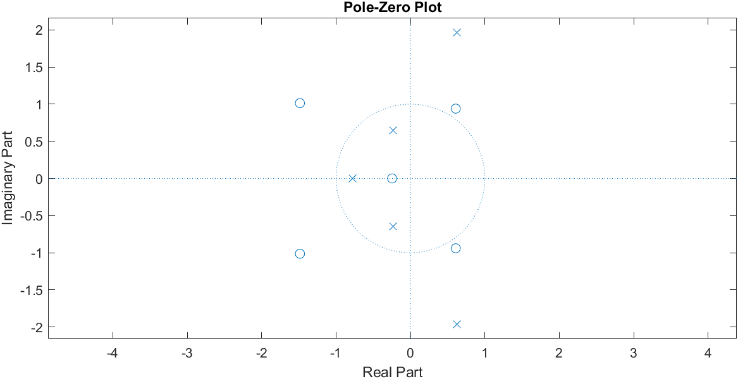
%z-transform
z =[
-1.4857 + 1.0130i
-1.4857 - 1.0130i
0.6090 + 0.9394i
0.6090 - 0.9394i
-0.2467 + 0.0000i
]; % zeros
p =[
0.6212 + 1.9665i
0.6212 - 1.9665i
-0.7748 + 0.0000i
-0.2338 + 0.6420i
-0.2338 - 0.6420i
]; % poles
k =1.5385; % gain
[num,den]=zp2tf(z,p,k);
% Normalize
num = num / den(1);
den = den / den(1);
% Display H(z)
Hz = tf(num, den, -1)

Output:
Hz =

1.538 z^5 + 3.077 z^4 + 2 z^3 - 0.0001606 z^2 + 6.154 z + 1.538
---------------------------------------------------------------
z^5 + 1.11e-16 z^4 + 3.539 z^3 + 4.616 z^2 + 3.077 z + 1.538

- Frequency Response:
% frequency response
num=[0.008,-0.033,0.05,-0.033,0.008]
den=[1,2.37,2.7,1.6,0.4]
w=20 % range of frequency
x=freqz(num,den,w)
subplot(211)
plot(abs(x))
grid on
subplot(212)
plot(angle(x))
grid on
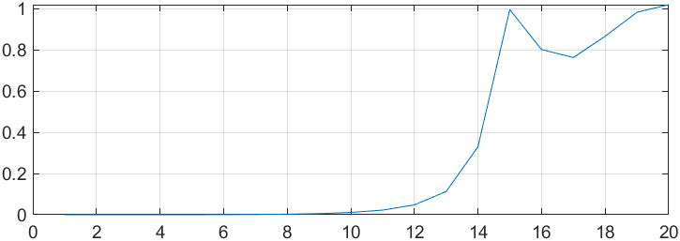
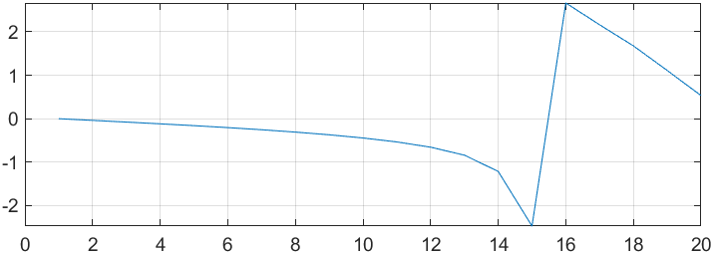

- FIR filter design:
For low pass filter
Using Rectangle window:
%FIR filter design
N=input('enter the length of the filter')
wc=input('cutoff frequency=')
h=fir1(N,wc/pi,rectwin(N+1)) % response of filter
freqz(h)

Input: N = 28; wc = 0.6$π$
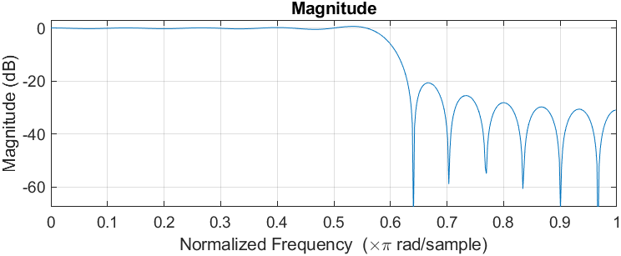
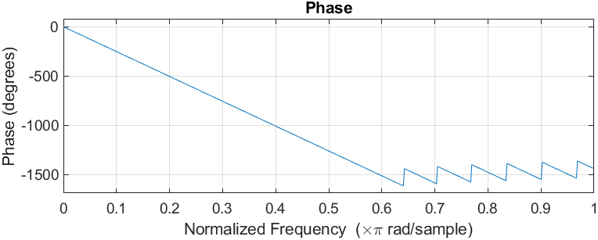
Using Blackman window
%FIR filter design
N=input('enter the length of the filter')
wc=input('cutoff frequency=')
h=fir1(N,wc/pi,blackman(N+1)) % response of filter
freqz(h)

Input: N = 28; wc = 0.6$π$
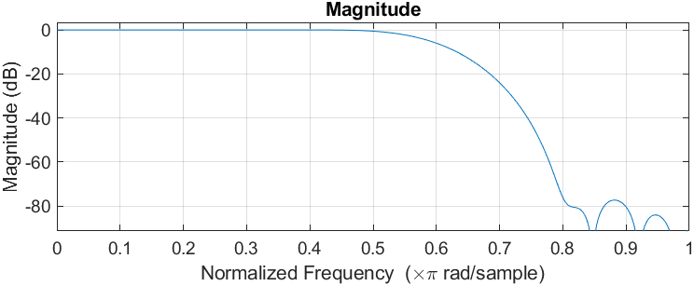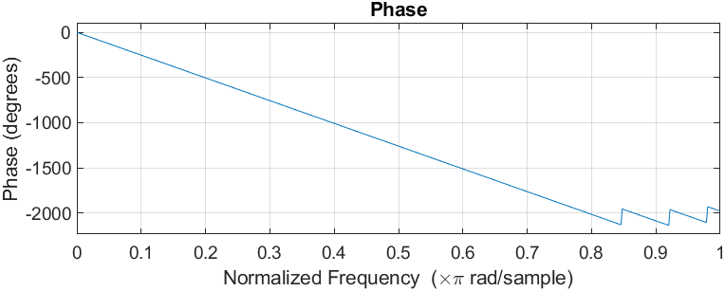
Using Kaiser window
% FIR filter design from kaiser window
N = input('Enter filter length: ');
wc = input('Cutoff frequency: ');
beta = 5; % for ~60 dB attenuation
h = fir1(N, wc/pi, kaiser(N+1, beta));
freqz(h)
Input: N = 28; wc = 0.6$π$
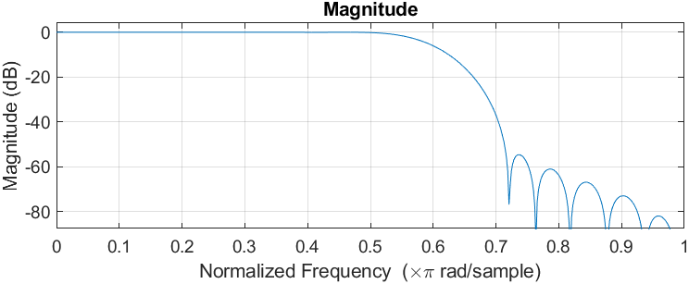

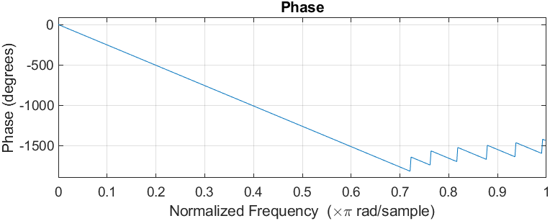
- IIR filter design:
% IIR filter design
rp=0.4 % passband ripple
rs=30 %stopband attenuation
wp=0.2*pi %passband frequency
ws=0.4*pi %stopband frequency
[N,wn]=buttord(wp/pi , ws/pi, rp, rs) %finding order of the filter
[b,a]=butter(N,wn) %low pass
freqz(b,a)

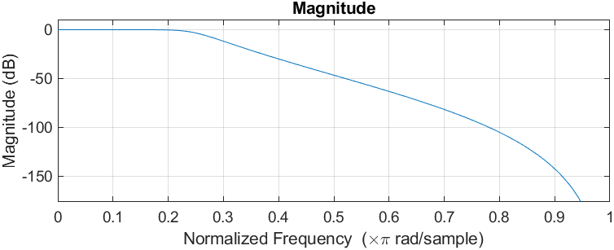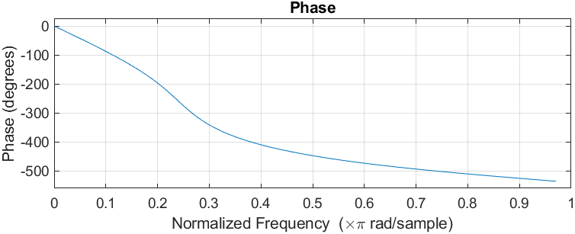

Using same order for high pass filter
[c,d]=butter(N,wn, 'high') %high pass
freqz(c,d)

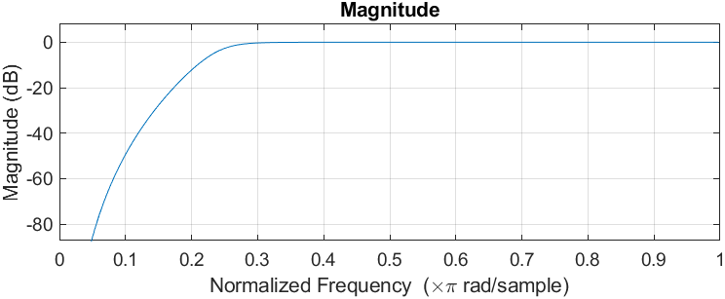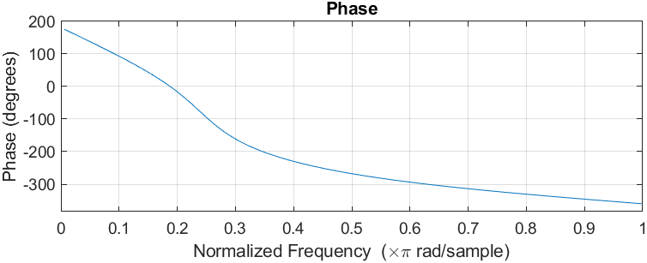

- FFT:
For signal x[n] = [0, 2, 1, 3]
x2 = [0, 2, 1, 3];
N2 = length(x2);
X2 = fft(x2, N2);
subplot(4,1,1)
stem(0:N2-1, real(X2), 'filled', 'LineWidth', 1.5)
title('Real Part'); xlabel('k'); ylabel('Re{X(k)}'); grid on;
subplot(4,1,2)
stem(0:N2-1, imag(X2), 'filled', 'LineWidth', 1.5)
title('Imaginary Part'); xlabel('k'); ylabel('Im{X(k)}'); grid on;
subplot(4,1,3)
stem(0:N2-1, abs(X2), 'filled', 'LineWidth', 1.5)
title('Magnitude'); xlabel('k'); ylabel('|X(k)|'); grid on;
subplot(4,1,4)
stem(0:N2-1, angle(X2), 'filled', 'LineWidth', 1.5)
title('Phase'); xlabel('k'); ylabel('Angle (rad)'); grid on;
disp('Input x[n] = '); disp(x2)
fprintf('\nDFT X[k]:\n');
disp(X2.')
fprintf('\n k Magnitude Phase(rad)\n');
for k = 1:N2
fprintf('%2d %8.3f %8.3f\n', k-1, abs(X2(k)), angle(X2(k)));
end

Output:
Input x[n] =
0 2 1 3
DFT X[k]:
6.0000 + 0.0000i
-1.0000 + 1.0000i
-4.0000 + 0.0000i
-1.0000 - 1.0000i
k Magnitude Phase(rad)
0 6.000 0.000
1 1.414 2.356
2 4.000 3.142
3 1.414 -2.356
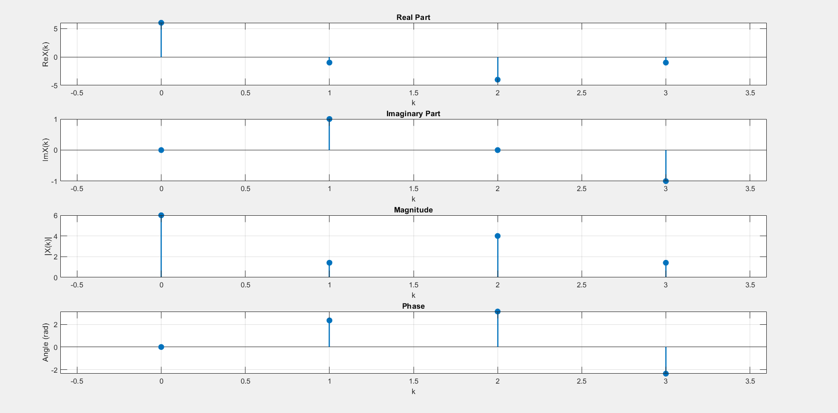

For signal x[n] = [1.2, 3.6, 2.4, -2, 1.6, 2.1]
x1 = [1.2, 3.6, 2.4, -2, 1.6, 2.1, 0, 0];
N1 = length(x1);
X1 = fft(x1, N1);
subplot(4,1,1)
stem(0:N1-1, real(X1), 'filled', 'LineWidth', 1.5)
title('Real Part'); xlabel('k'); ylabel('Re{X(k)}'); grid on;
subplot(4,1,2)
stem(0:N1-1, imag(X1), 'filled', 'LineWidth', 1.5)
title('Imaginary Part'); xlabel('k'); ylabel('Im{X(k)}'); grid on;
subplot(4,1,3)
stem(0:N1-1, abs(X1), 'filled', 'LineWidth', 1.5)
title('Magnitude'); xlabel('k'); ylabel('|X(k)|'); grid on;
subplot(4,1,4)
stem(0:N1-1, angle(X1), 'filled', 'LineWidth', 1.5)
title('Phase'); xlabel('k'); ylabel('Angle (rad)'); grid on;
disp('Input x[n] = '); disp(x1)
fprintf('\nDFT X[k]:\n');
disp(X1.')
fprintf('\n k Magnitude Phase(rad)\n');
for k = 1:N1
fprintf('%2d %8.3f %8.3f\n', k-1, abs(X1(k)), angle(X1(k)));
end

Output:
Input x[n] =
1.2000 3.6000 2.4000 -2.0000 1.6000 2.1000 0 0
DFT X[k]:
8.9000 + 0.0000i
2.0749 - 2.0464i
0.4000 - 7.7000i
-2.8749 + 2.7536i
1.5000 + 0.0000i
-2.8749 - 2.7536i
0.4000 + 7.7000i
2.0749 + 2.0464i
k Magnitude Phase(rad)
0 8.900 0.000
1 2.914 -0.779
2 7.710 -1.519
3 3.981 2.378
4 1.500 0.000
5 3.981 -2.378
6 7.710 1.519
7 2.914 0.779
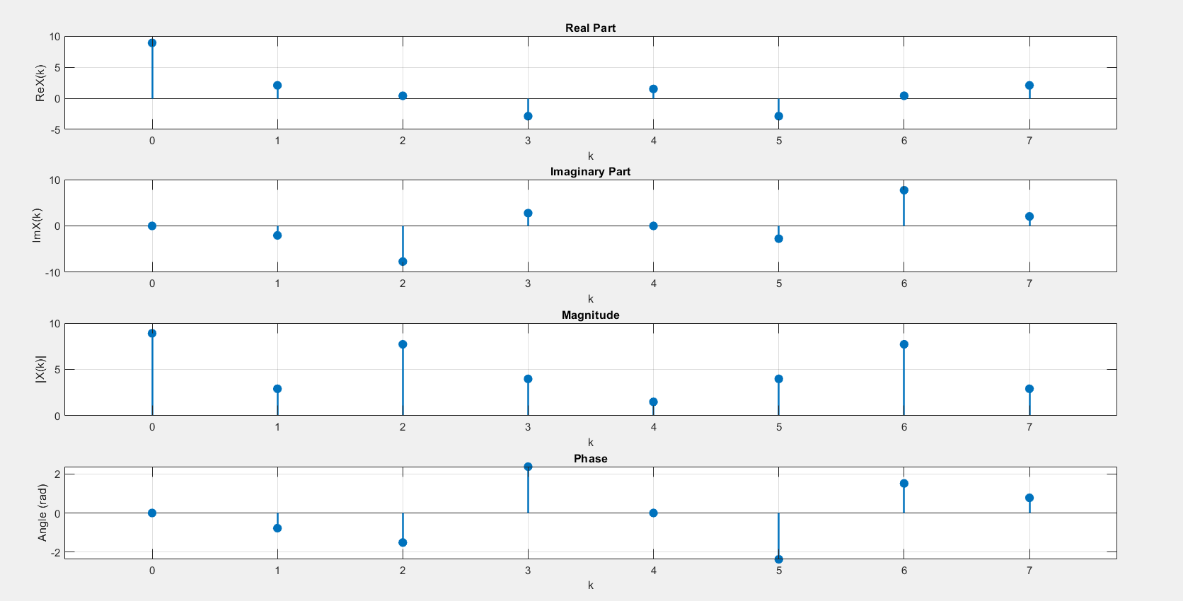

Discussion and Conclusion:
In this lab, we study the concepts of Z-Transform, Frequency response, FIR Filter, IIR Filters and FFT and verify its operation through MATLAB. In Z-Transform we look at the poles and zeros location in z-plane and also get transfer function from the values of poles and zeros. In frequency response we look at magnitude and phase response for a given transfer function. We design FIR filter using different windows and plot the magnitude and phase response. We also design IIR filter for given passband and stopband frequency, passband ripple and stopband attenuation. We use Butterworth filter design technique. And we computed the FFT of two different signals of different length and plotted its response.
In conclusion, in this lab we demonstrated the application of Z-transform, frequency response analysis, FIR and IIR filter design, and FFT using MATLAB and gain practical experience with in using them.

