**Project Design Phase-I**

**Solution Architecture**

|  |  |
| --- | --- |
| Date | 16 October 2022 |
| Team ID | PNT2022TMID38633 |
| Project Name | Fertilizers Recommendation System For Disease Prediction |
| Maximum Marks | 4 Marks |

**Solution Architecture Diagram:**

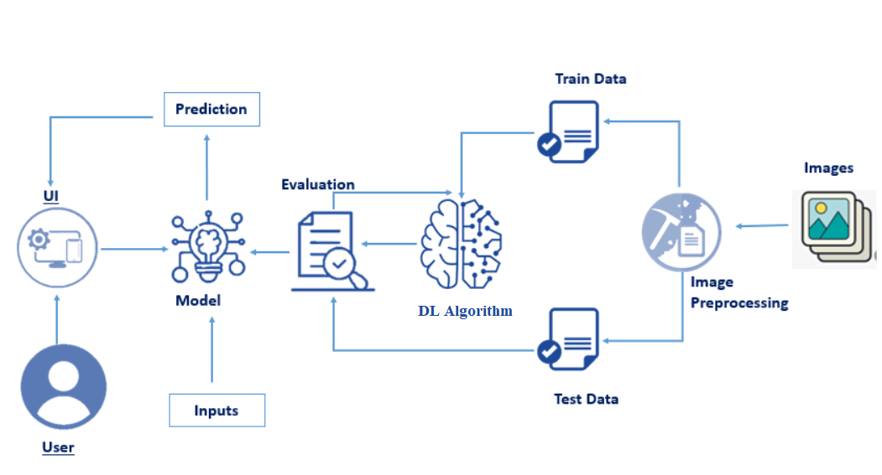

Figure 1: Architecture and data flow of The *Fertilizer Recommendation System for Disease Predection*