FY2024 Sales Performance Analysis Report
B2B Office Supplies | Analytics Division

Prepared by: Rishab (Data Analyst Intern)
Period: FY2024 (January – December 2024)
Dataset: 1,000 transactions | 8 Cities | 3 Categories

1. Executive Summary
This report presents a comprehensive analysis of FY2024 sales data for a B2B office supplies company operating across 8 major Indian cities. The analysis covers revenue trends, product performance, regional insights, channel effectiveness, and customer satisfaction based on 1,000 transaction records.

Key Performance Indicators
Total Revenue FY2024 | ₹5.08 Crore
Total Orders | 1,000
Average Order Value | ₹50,803
Overall Customer Rating | 3.01 / 5

2. Revenue & Sales Trends
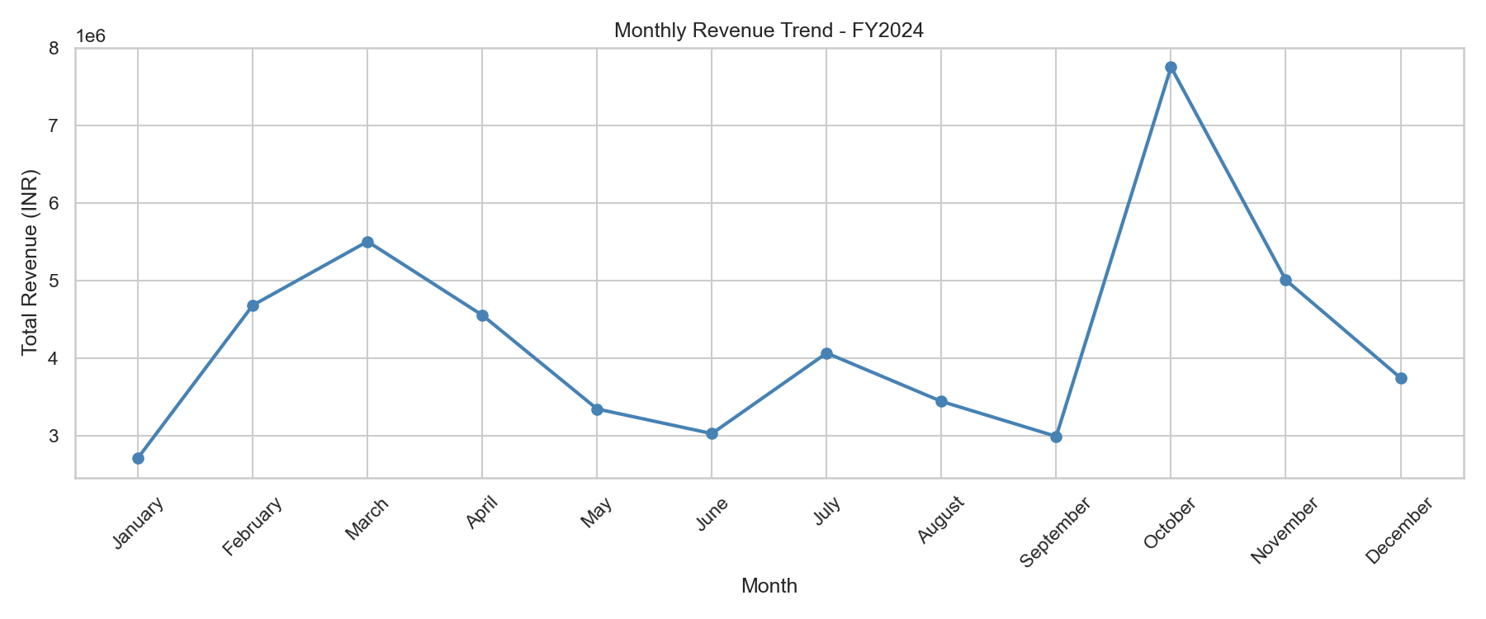
Figure 1: Monthly Revenue Trend FY2024

- Q4 is the strongest quarter at ₹1.65 crore, driven by an October spike of ₹77.5 lakh — likely festive season (Dussehra/Diwali) demand.
- Q3 is the weakest quarter at ₹1.05 crore — July to September shows a consistent dip that needs a targeted sales push next year.
- January is the weakest individual month at ₹27 lakh, suggesting slow post-holiday business activity.

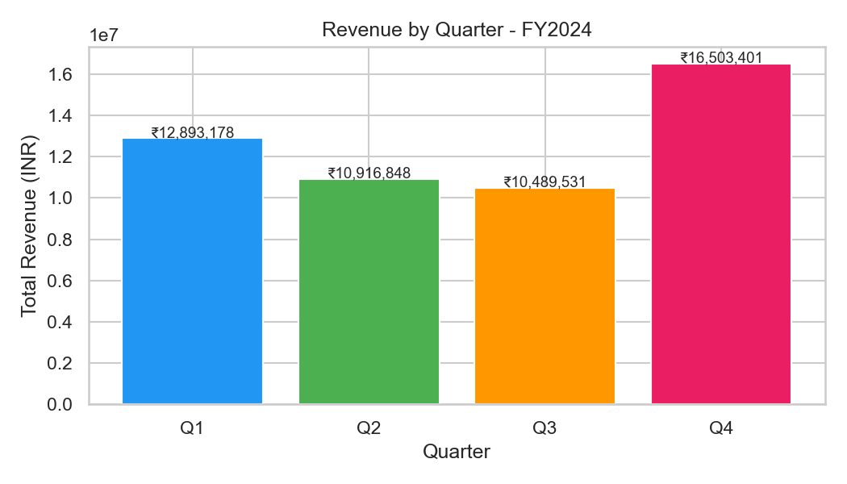
Figure 2: Revenue by Quarter

3. Product Performance
Top 5 Products by Revenue
Product | Revenue
Laptop Pro 15 | ₹23,026,250
Standing Desk | ₹8,098,200
Monitor 24 inch | ₹6,703,200
Office Chair | ₹4,214,400
Filing Cabinet | ₹2,359,175

- Laptop Pro 15 alone contributes ₹2.3 crore — 45% of total revenue from one product. This is a significant concentration risk.
- Bottom 5 products are all Stationery items with combined revenue under ₹6.5 lakh for the full year.
- Discount strategy is ineffective: orders with 0% discount generated comparable revenue to orders with 20% discount, indicating discounts are not driving proportional volume uplift.
- Stationery has the highest return rate at 7.03%, followed by Furniture at 6.77% and Electronics at 4.39%.


Figure 3: Top 5 Products by Revenue

4. Regional & City Analysis
- South region leads with ₹1.97 crore (39% of total revenue), nearly double the West region at ₹1.22 crore.
- Chennai is the top-performing city at ₹76 lakh. Delhi is the weakest major metro at ₹55 lakh despite its market size.
- Guwahati (Northeast) performs on par with Kolkata (East) at ₹66.5 lakh each — strong Tier-2 city performance.
- Northeast and East regions are nearly equal in revenue — both underperform relative to South and West.

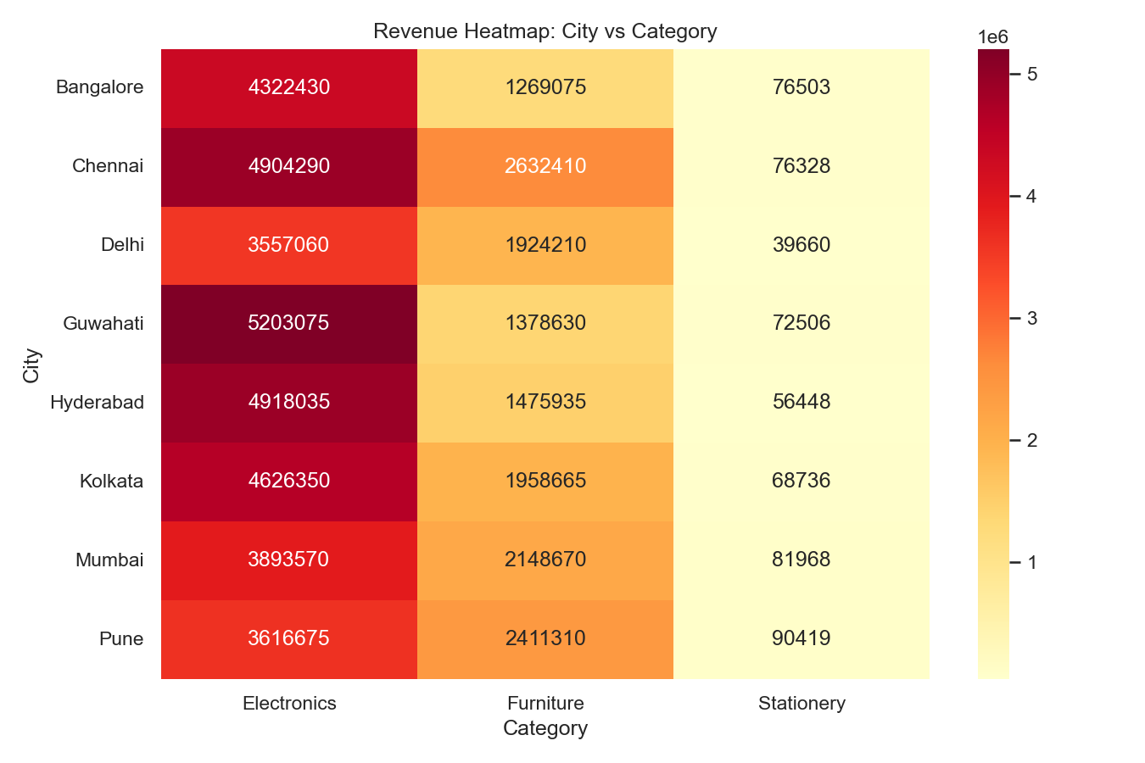
Figure 4: Revenue Heatmap — City vs Category

5. Channel & Customer Insights
- All three sales channels are nearly equal in revenue — Retail Store (₹1.74 cr), Corporate B2B (₹1.72 cr), Online (₹1.62 cr). Healthy diversification with no over-dependence on one channel.
- Individual customers have the highest average order value at ₹53,541 — higher than Enterprise (₹51,587) and SME (₹47,268). Bulk discounts in Enterprise deals likely suppress per-order value.
- Cash is the most used payment method (213 orders), followed closely by EMI (208). UPI adoption is relatively low at 193 orders for a B2B business.

6. Customer Satisfaction
- Overall average rating is 3.01/5 — mediocre. Significant room for improvement across all categories and cities.
- Bangalore has the lowest city rating at 2.85 — delivery reliability, product quality, or after-sales service issues should be investigated.
- Pune has the highest rating at 3.18, followed by Mumbai at 3.13.
- Correlation between discount percentage and customer rating is near zero (0.02) — higher discounts do not lead to better customer satisfaction.

7. Recommendations
Based on the analysis, the following actions are recommended for Q1 FY2025:

- Reduce blanket discounting. Discounts are not driving proportional revenue or satisfaction gains. Cap discounts at 10% and run targeted promotions only during Q3 (Jul–Sep) to address the seasonal dip.
- Reduce dependency on Laptop Pro 15. A single product driving 45% of revenue is a business risk. Actively promote Standing Desk and Monitor 24 inch — both are in the top 5 and have growth potential.
- Invest in the South region and investigate Delhi. South already leads — double down with dedicated sales resources. Delhi underperforms for its market size — assign a focused sales rep and run a targeted B2B outreach campaign.
- Improve customer satisfaction in Bangalore. With the lowest rating of 2.85, Bangalore needs a service quality audit — check delivery timelines, return processing speed, and product quality for that city specifically.
- Re-evaluate the Stationery category. Stationery contributes less than 2% of total revenue (₹5.6 lakh) and has the highest return rate. Consider reducing SKUs to only high-margin items and dropping slow movers like Whiteboard Marker Set.

8. Conclusion
FY2024 showed solid overall performance with ₹5.08 crore in revenue across 1,000 orders. However, the business faces key risks: over-reliance on a single product, an ineffective discount strategy, geographic revenue concentration, and below-average customer satisfaction. Addressing these through focused regional expansion, smarter pricing, and service quality improvements can meaningfully improve FY2025 performance.

Tools Used: Python (Pandas, Matplotlib, Seaborn) | Dataset: 1,000 rows, 18 columns

