1. **Product price range** and **average number of ratings**

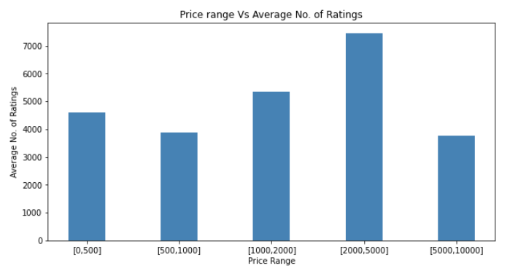

|  |  |  |  |  |
| --- | --- | --- | --- | --- |
| **price range** | **average number of ratings** | **Max number of ratings** | **Min number of ratings** | **Total no of ratings** |
| [0,500] | 4614.65 | 74057.0 | 1.0 | 466080.0 |
| [500,1000] | 3892.75 | 45625.0 | 1.0 | 241351.0 |
| [1000,2000] | 5339.13 | 33961.0 | 6.0 | 80087.0 |
| [2000,5000] | 7454.8 | 20920.0 | 1.0 | 37274.0 |
| [5000,10000] | 3769.0 | 10160.0 | 1165.0 | 15076.0 |

1. **Product price range** and **average number of 5, 4, 3, 2, 1 ratings (in %)**

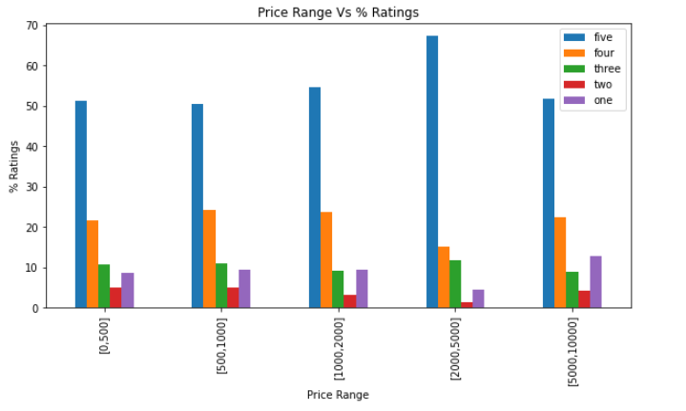

|  |  |  |  |  |  |
| --- | --- | --- | --- | --- | --- |
| **Price range** | **5 stars** | **4 stars** | **3 stars** | **2 stars** | **1 stars** |
| [0,500] | avg(51.32) | avg(21.65) | avg(10.66) | avg(5.03) | avg(8.58) |
| [500,1000] | avg(50.50) | avg(24.09) | avg(10.93) | avg(5.06) | avg(9.35) |
| [1000,2000] | avg(54.60) | avg(23.60) | avg(9.20) | avg(3.20) | avg(9.46) |
| [2000,5000] | avg(67.20) | avg(15.20) | avg(11.80) | avg(1.40) | avg(4.400) |
| [5000,10000] | avg(51.75) | avg(22.50) | avg(9.00) | avg(4.25) | avg(12.75) |

1. **Price range and average no. of reviews**

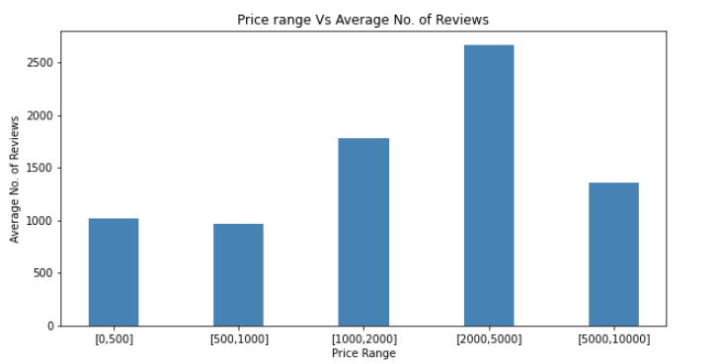

|  |  |  |  |  |
| --- | --- | --- | --- | --- |
| **price range** | **average number of reviews** | **Max number of reviews** | **Min number of reviews** | **Total no of reviews** |
| [0,500] | 1016.089 | 17541.0 | 1.0 | 102625.0 |
| [500,1000] | 965.48 | 13496.0 | 0.0 | 59860.0 |
| [1000,2000] | 1777.53 | 12475.0 | 2.0 | 26663.0 |
| [2000,5000] | 2667.0 | 8543.0 | 1.0 | 13335.0 |
| [5000,10000] | 1362.5 | 3895.0 | 352.0 | 5450.0 |

1. **Product category and avg no. of ratings**

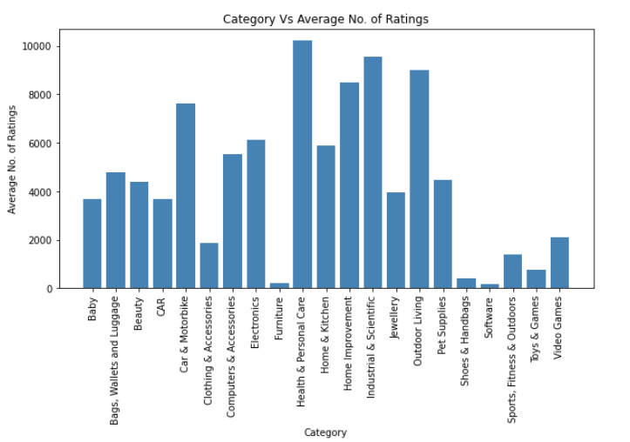

|  |  |  |  |  |
| --- | --- | --- | --- | --- |
| **Category** | **Avg no of ratings** | **max** | **min** | **total** |
| **Baby** | 3663.78 | 17154.0 | 10.0 | 51293.0 |
| **Bags, Wallets and Luggage** | 4763.5 | 4874.0 | 4653.0 | 9527.0 |
| **Beauty** | 4405.2 | 18447.0 | 42.0 | 44052.0 |
| **CAR** | 3679.55 | 13520.0 | 458.0 | 33116.0 |
| **Car & Motorbike** | 7631.0 | 13949.0 | 825.0 | 38155.0 |
| **Clothing & Accessories** | 1849.94 | 12036.0 | 6.0 | 31449.0 |
| **Computers & Accessories** | 5538.65 | 74057.0 | 9.0 | 127389.0 |
| **Electronics** | 6103.81 | 22710.0 | 45.0 | 67142.0 |
| **Furniture** | 199.0 | 450.0 | 1.0 | 1194.0 |
| **Health & Personal Care** | 10205.25 | 43591.0 | 1.0 | 122463.0 |
| **Home & Kitchen** | 5866.83 | 45625.0 | 1.0 | 217073.0 |
| **Home Improvement** | 8507.0 | 33961.0 | 9.0 | 51042.0 |
| **Industrial & Scientific** | 9535.0 | 16900.0 | 2170.0 | 19070.0 |
| **Jewellery** | 3970.0 | 3970.0 | 3970.0 | 3970.0 |
| **Outdoor Living** | 8995.0 | 10764.0 | 7226.0 | 17990.0 |
| **Pet Supplies** | 4465.0 | 13368.0 | 948.0 | 22325.0 |
| **Shoes & Handbags** | 415.125 | 1409.0 | 12.0 | 3321.0 |
| **Software** | 161.66 | 315.0 | 16.0 | 485.0 |
| **Sports, Fitness & Outdoors** | 1410.3 | 7269.0 | 13.0 | 28206.0 |
| **Toys & Games** | 759.75 | 1684.0 | 257.0 | 3039.0 |
| **Video Games** | 2119.42 | 10360.0 | 18.0 | 14836.0 |

1. **Category and Average no. of Reviews(in %)**

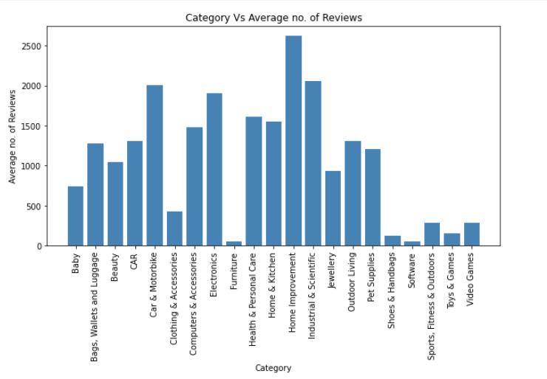

1. **Category and Average no. of 5,4,3,2,1 ratings**

|  |  |  |  |  |  |
| --- | --- | --- | --- | --- | --- |
| **Category** | **5** | **4** | **3** | **2** | **1** |
| **Baby** | 57.285714 | 20.857143 | 9.285714 | 4.857143 | 7.928571 |
| **Bags, Wallets and Luggage** | 54.0 | 24.5 | 10.5 | 3.5 | 6.5 |
| **Beauty** | 53.72 | 19.54 | 13.27 | 4.72 | 9.0 |
| **CAR** | 51.44 | 25.44 | 11.44 | 3.55 | 8.33 |
| **Car & Motorbike** | 61.60 | 22.40 | 8.60 | 3.0 | 4.40 |
| **Clothing & Accessories** | 44.11 | 26.17 | 14.11 | 6.29 | 9.41 |
| **Computers & Accessories** | 46.41 | 22.41 | 9.95 | 4.50 | 12.33 |
| **Electronics** | 55.00 | 23.27 | 9.36 | 3.45 | 9.09 |
| **Furniture** | 52.28 | 13.0 | 11.85 | 3.14 | 5.42 |
| **Health & Personal Care** | 60.50 | 20.50 | 9.16 | 2.83 | 7.0 |
| **Home & Kitchen** | 48.82 | 26.92 | 9.41 | 4.30 | 7.97 |
| **Home Improvement** | 55.66 | 19.0 | 12.16 | 5.83 | 7.8 |
| **Industrial & Scientific** | 48.0 | 24.50 | 12.0 | 5.0 | 11.0 |
| **Jewellery** | 47.0 | 25.0 | 14.0 | 5.0 | 7.0 |
| **Outdoor Living** | 53.5 | 25.5 | 12.0 | 4.0 | 5.0 |
| **Pet Supplies** | 57.2 | 21.8 | 10.6 | 3.8 | 7.0 |
| **Shoes & Handbags** | 51.75 | 21.25 | 11.87 | 4.12 | 11.12 |
| **Software** | 55.33 | 15.0 | 7.66 | 9.33 | 13.0 |
| **Sports, Fitness & Outdoors** | 45.57 | 21.42 | 11.09 | 7.0 | 10.09 |
| **Toys & Games** | 48.5 | 22.25 | 13.75 | 6.0 | 9.0 |
| **Video Games** | 60.0 | 17.0 | 8.57 | 5.0 | 9.71 |

1. **Warranty and avg no of reviews and ratings**

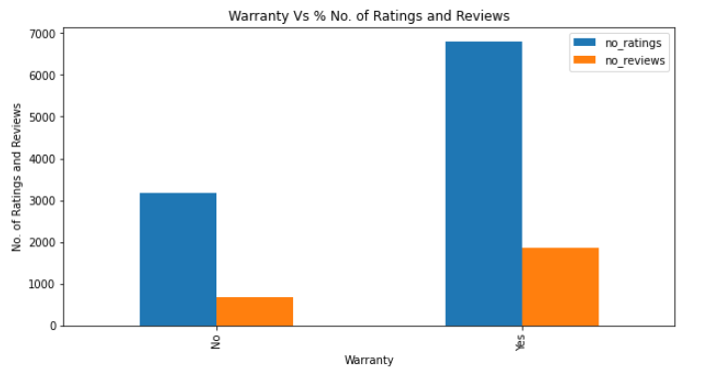

|  |  |  |
| --- | --- | --- |
| **Warranty** | **Avg no of reviews** | **Avg no of ratings** |
| **Yes** | 1855.7500 | 6801.236111 |
| **No** | 679.2196 | 3162.484848 |

1. **Return policy and avg no of reviews and ratings**

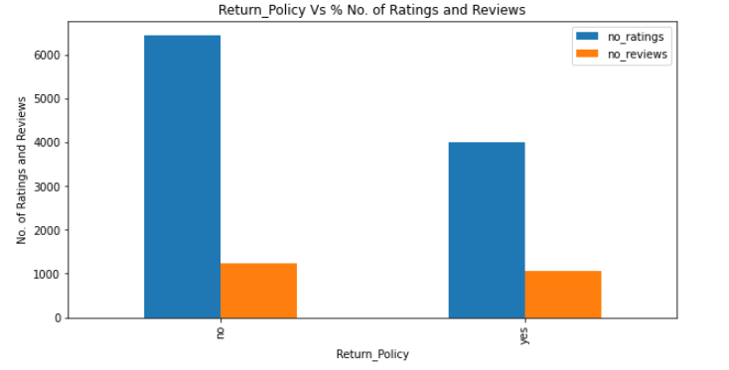

|  |  |  |
| --- | --- | --- |
| **Return policy** | **Avg no of reviews** | **Avg no of ratings** |
| **Yes** | 1065.7485 | 4003.850299 |
| **No** | 1224.0810 | 6445.783784 |