EX 4:

| A | D | G | F |
| --- | --- | --- | --- |
| 1 | 1 | 1 | 0 |
| 1 | 1 | 0 | 1 |
| 1 | 0 | 1 | 1 |
| 1 | 0 | 0 | 1 |
| 0 | 1 | 1 | 0 |
| 0 | 1 | 0 | 0 |
| 0 | 0 | 1 | 0 |
| 0 | 0 | 0 | 0 |

fonction **F(A, D, G)**:

= A . D . !G + A . !D . G + A . !D . !G

= A . ( D. !G + !D . G + !D * !G )

= A . ( D . !G + !D . ( G + !G ) )

= A . ( D . !G + !D )

= A . ( !G + !D )

= A . ( ! (G . D) )

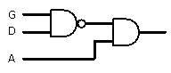

EX 6

| W | X | Y | Z | E |
| --- | --- | --- | --- | --- |
| 1 | 1 | 1 | 1 | 0 |
| 1 | 1 | 1 | 0 | 0 |
| 1 | 1 | 0 | 1 | 0 |
| 1 | 1 | 0 | 0 | 0 |
| 1 | 0 | 1 | 1 | 0 |
| 1 | 0 | 1 | 0 | 0 |
| 1 | 0 | 0 | 1 | 0 |
| 1 | 0 | 0 | 0 | 1 |
| 0 | 1 | 1 | 1 | 0 |
| 0 | 1 | 1 | 0 | 1 |
| 0 | 1 | 0 | 1 | 0 |
| 0 | 1 | 0 | 0 | 0 |
| 0 | 0 | 1 | 1 | 0 |
| 0 | 0 | 1 | 0 | 1 |
| 0 | 0 | 0 | 1 | 0 |
| 0 | 0 | 0 | 0 | 0 |

Fonction **E(W, X, Y, Z)**:

= W . !X . !Y . !Z + !W . X . Y . !Z + !W . !X . Y . !Z

= Y . !Z . ( !W . X + !W . !X ) + W . !X . !Y . !Z

= Y . !Z . !W + W . !X . !Y . !Z

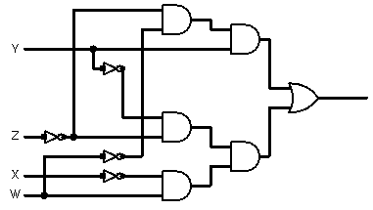

Ex Sup

EX2

| b1 | b2 | a | b | c | d |
| --- | --- | --- | --- | --- | --- |
| 1 | 1 | 1 | 0 | 0 | 1 |
| 1 | 0 | 0 | 1 | 1 | 0 |
| 0 | 1 | 0 | 1 | 1 | 0 |
| 0 | 0 | 1 | 1 | 0 | 0 |