EX 1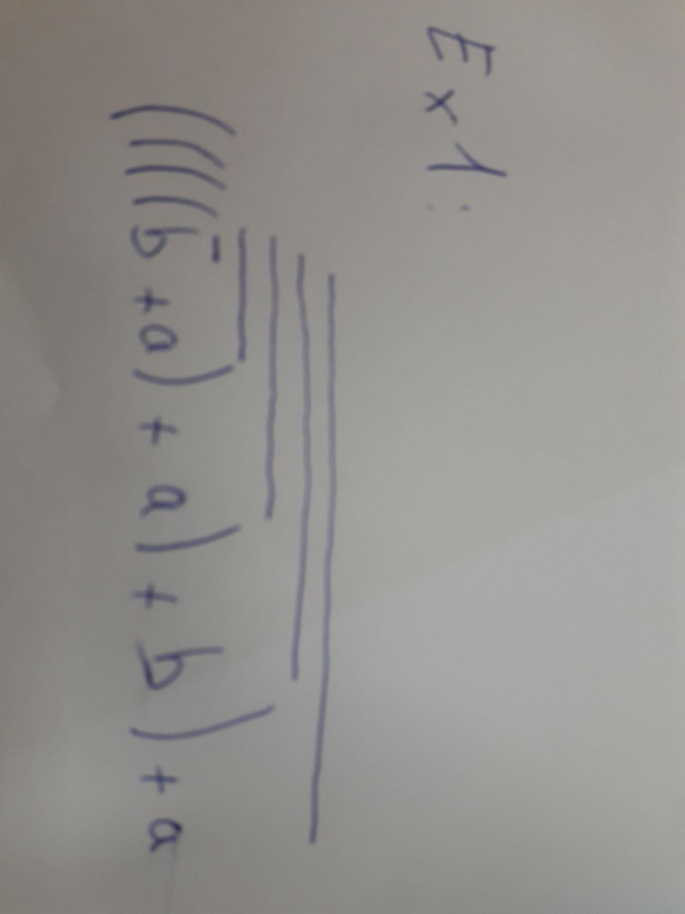

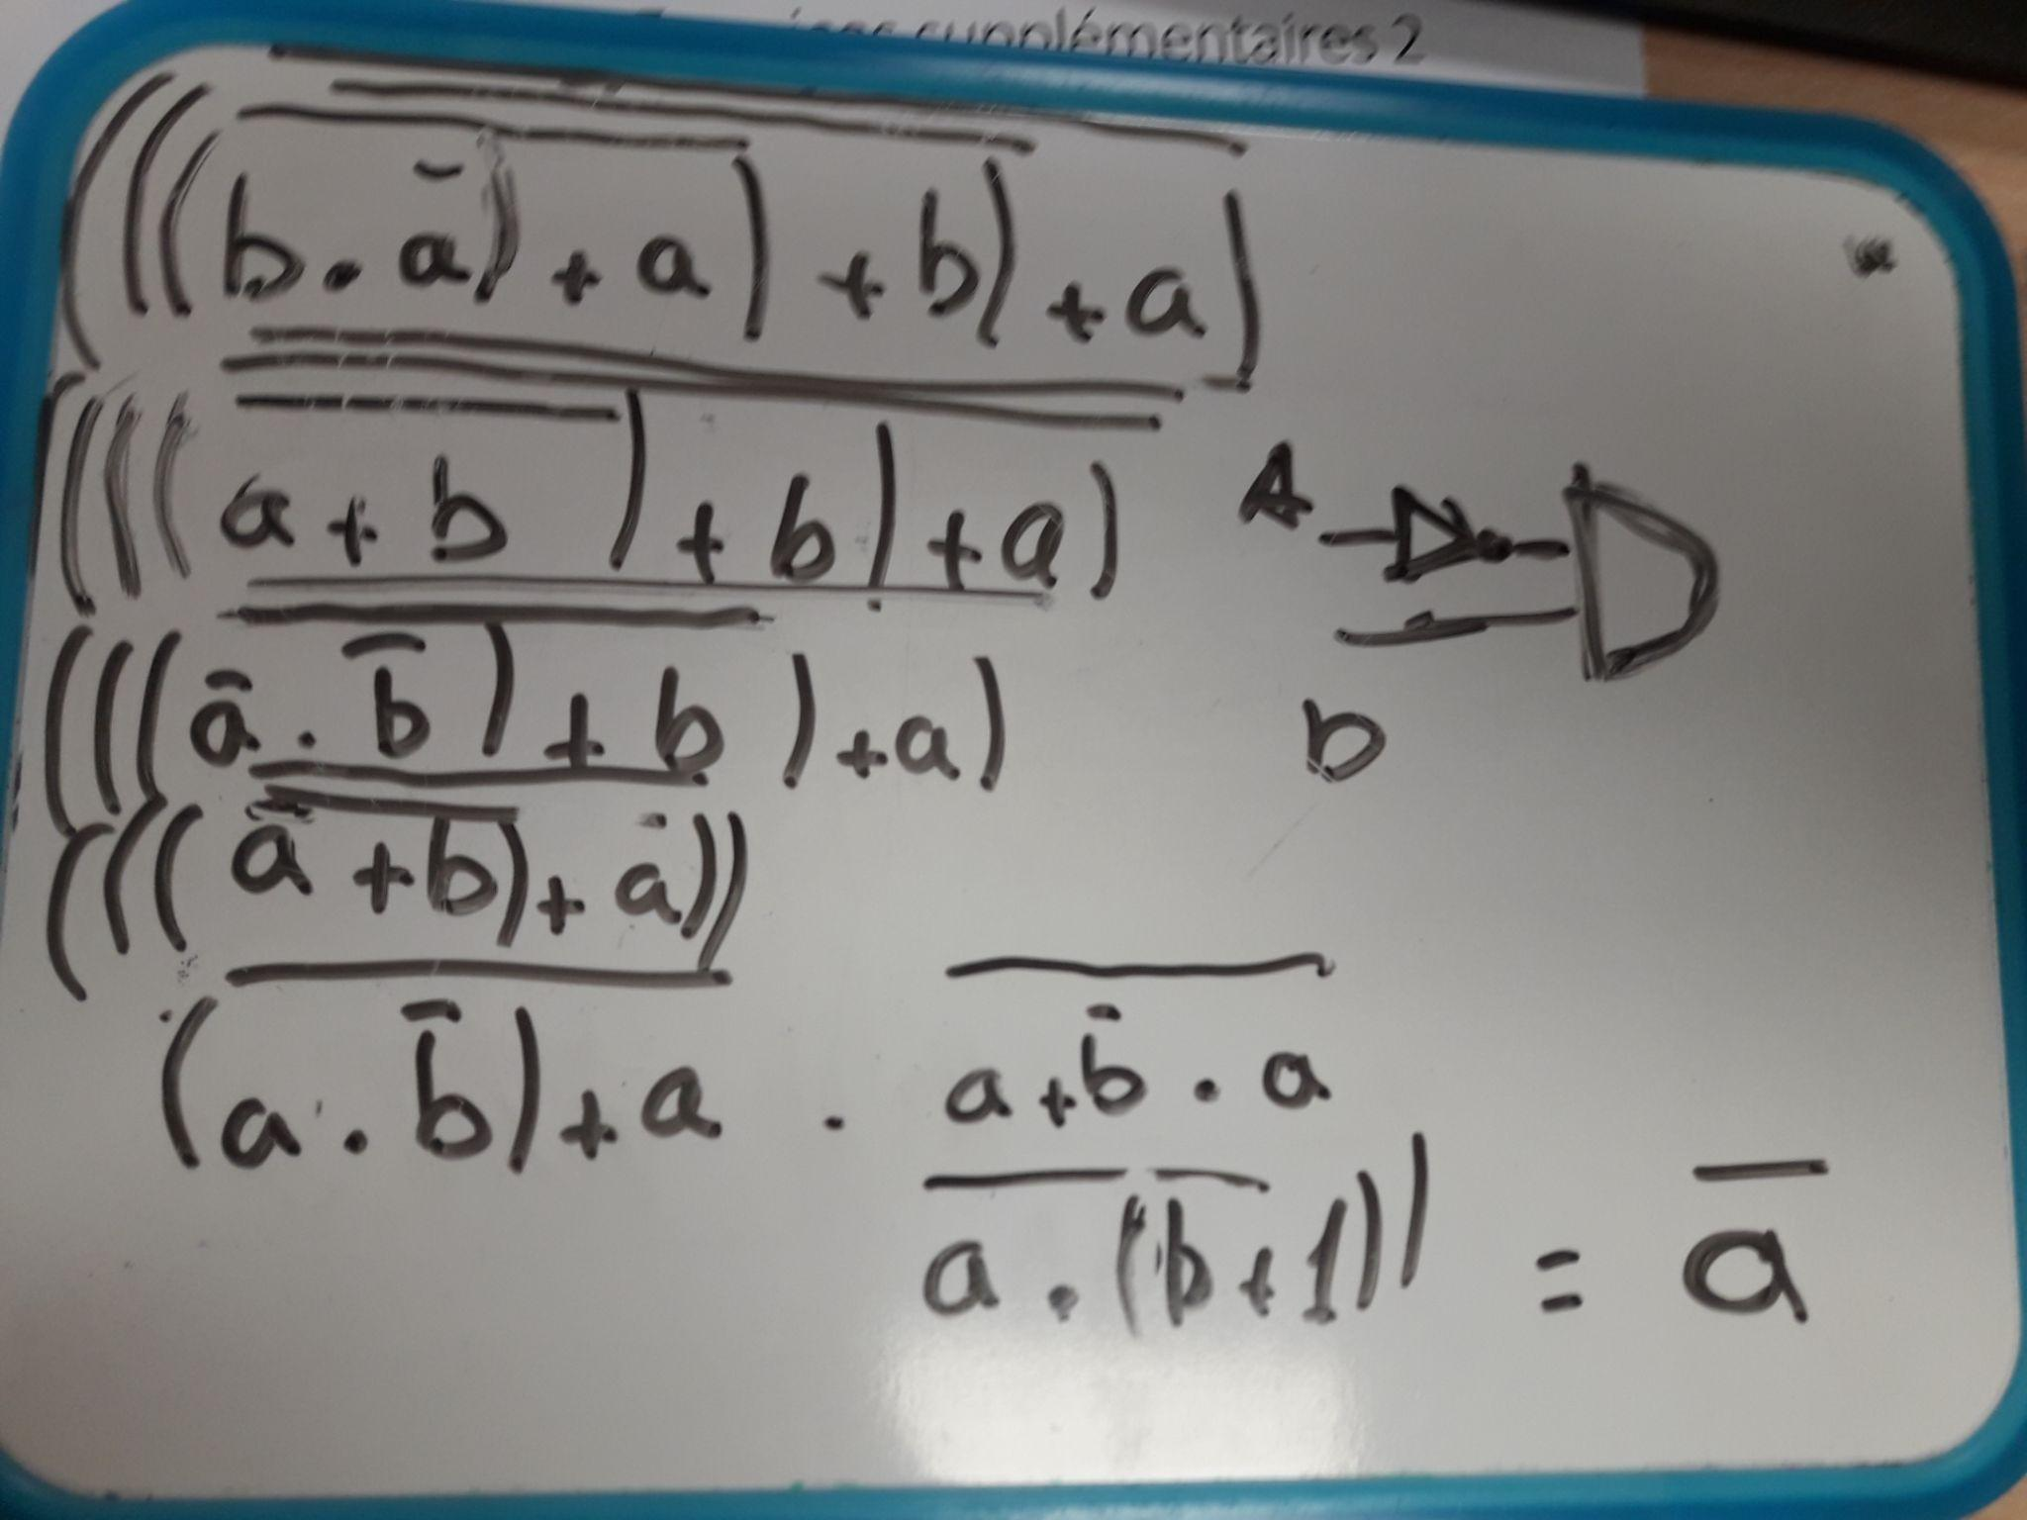

EX 2

| a | b | c | s1 | s2 | s3 |
| --- | --- | --- | --- | --- | --- |
| 1 | 1 | 1 | 1 | 0 | 0 |
| 1 | 1 | 0 | 1 | 0 | 0 |
| 1 | 0 | 1 | 0 | 1 | 1 |
| 1 | 0 | 0 | 0 | 1 | 1 |
| 0 | 1 | 1 | 0 | 1 | 0 |
| 0 | 1 | 0 | 0 | 1 | 0 |
| 0 | 0 | 1 | 0 | 0 | 1 |
| 0 | 0 | 0 | 0 | 0 | 1 |

fonction **s1(a, b, c)**:

= a . b . c + a . b . !c

= a . b

fonction **s2(a, b, c)**:

= a . !b . c + a . !b . !c + !a . b . c + !a . b . !c

= a . ( !b . c + !b . !c ) + !a . ( b . c + b . !c )

= a . ( !b . ( c + !c ) ) + !a . ( b . ( c + !c ) )

= a . !b + !a . b

= a ⊕ b

fonction **s3(a, b, c)**:

= a . !b . c + a . !b . !c + !a . !b . c + !a . !b . !c

= a . ( !b . c + !b . !c ) + !a . ( !b . c + !b . !c )

= a . ( !b . ( c + ! c) ) + !a . ( !b . ( c + !c ) )

= a . !b + !a . !b

= !b . (a + !a )

= !b