**SYNOPSIS**

**Report on**

**Food Fusion**

**By**

**Priyanshu Singh (2200290140118)**

**Parth Gupta (2200290140105)**

**Manan Sharma (2200290140084)**

**Manmeet Chauhan (2200290140085)**

**Session:2023-2024 (IV Semester)**

Under the supervision of

### Dr. Amit Kumar Gupta

**Professor**

### KIET Group of Institutions, Delhi-NCR, Ghaziabad



### Department Of Computer Applications

**KIET GROUP OF INSTITUTIONS, DELHI-NCR, GHAZIABAD-201206**

(APRIL, 2024)

**ABSTRACT**

The aim of the project was to build a responsive online application for restaurant which helps customers to order foods online. Along with this, the application needs to be responsive as the application can be accessed through devices with different size of screens. One of big problem while ordering online is trust. Social media websites play a vital role to attract customers and make trust on their mind. So, customers trust the quality and attract to order online when they see the reviews and likes of their friends and relatives who used the service earlier. To address this functionality, deep research has been made on the earlier works for automating the food ordering processes. has been used to develop the backend of the system and Bootstrap 5 used for developing the responsive frontend. After developing the system, different testing methods have been used to find bugs in the system and ensure the quality. Food Fusion is a cutting-edge food application designed to enhance culinary experiences by connecting users with diverse cuisines, recipes, and fellow enthusiasts. Through personalized recommendations and community engagement

**TABLE OF CONTENTS**

Page Number

1. Introduction 4
2. Literature Review 5
3. Project / Research Objective 6
4. Project Flow/ Research Methodology 7-9
5. Project / Research Outcome 10-11
6. Proposed Time Duration 12
7. References/ Bibliography 13

**INTRODUCTION**

Online food ordering is the process of ordering food from a website. The product can either be food that has been specially prepared for direct consumption (such as vegetables straight from a farm or garden, frozen meats, etc.) or food that has not been (such as direct from a certified home kitchen, restaurant). The effort to create an online food ordering system aims to replace the manual method of taking orders with a digital one. The ability to rapidly and correctly create order summary reports whenever necessary is a key factor in the development of this project. The potential of an online food ordering system is enormous. Any restaurant or fast-food chain can use this MERN project to keep track of customer orders. This project is simple, quick, and precise.

There is less disk space needed. It is used as the backbone by the online food ordering system, eliminating the risk of data loss and ensuring data security. Customers have the option of either having the food delivered or picked up.  
 A customer starts by selecting the restaurant of their choice, then scans the menu, picks an item, and then decides whether they want it delivered or picked up. Then, when picking up the food, you can pay with cash at the restaurant or with a credit card or debit card using the app or website. The customer is informed by the website and app about the food's quality, how long it takes to prepare, and when it will be ready for pick-up or delivery.

In today's fast-paced world, convenience and efficiency are paramount. Our food delivery app aims to seamlessly connect hungry customers with a wide array of delicious cuisines from their favourite local restaurants. With just a few taps on their smartphones, users can browse through a diverse selection of dishes, place orders, and have their meals delivered right to their doorstep in no time.

At the heart of our app lies a commitment to providing exceptional service, ensuring that every aspect of the ordering process is smooth and hassle-free. Whether it's a quick lunch break at the office, a cozy dinner at home, or a gathering with friends, our platform offers a convenient solution for all dining occasions.

**LITERATURE REVIEW**

The food and repair industry requires the preferences of the purchasers , to satisfy and identify their needs. consistent with the research, majority of the respondents were aware of the food apps and therefore the most used apps are Zomato and Swiggy. The respondents considered various factors like delivery time, convenience and good customer service because the most vital ones (Vinaik, Goel, Sahai, & Garg, 2019). This study analyses the connection between online food service and therefore the facilities provided and also the factors which influence the buying behaviour of consumers. It concludes that as social media features a great influence on customers, it helps the web service providers advertise their products for greater reach to the masses. It also says that as currently, people are within the growth stage regarding the digital world, they like cash on delivery because the most convenient option (Kumari, 2019). The research paper helps to spot the determinants of continuous use intention for food delivery software applications. The research findings stated that the users were influenced by peers, indicating that word of mouth marketing should be pursued by delivery app providers. Hence, it's important for a web service provider to supply several benefits to users in order that they are doing not switch to a different delivery app service (Lee, Sung, & Jeon, 2019). Recently, because the online food delivery business is growing, this game changing trend of a userfriendly system where orders are often easily placed through a mobile app results in many challenges that ought to not be overlooked. It results in unhealthy patterns of food consumption and features a broader influence on the social environment. Unhealthy low-priced nutriment has become a trend because it is definitely available (Maimaiti, Zhao, Jia, Ru, & Zhu, 2018). Most of the businesses nowadays are altering their traditional business strategies into online marketing to satisfy the stress and wishes of the consumers. it's shown that folks prefer food delivery apps which provides them offers and promotions.

**Project objectives**

The project objective of a food delivery app can vary depending on specific goals and target audiences, but generally, it revolves around enhancing convenience, accessibility, and efficiency in food ordering and delivery processes. Here are some common objectives:

1. **Convenience**: Provide users with a convenient way to order food from a variety of restaurants or eateries without the hassle of physically visiting them.

2. **Accessibility:** Make food ordering accessible to a wide range of users, including those with busy schedules, limited mobility, or living in areas with limited dining options.

3. **Efficiency:** Streamline the food ordering process, reducing wait times for both customers and restaurants, and ensuring timely delivery of orders.

4. **Real-Time Tracking:** Provide real-time tracking of orders, allowing users to monitor the status of their delivery and estimated time of arrival.

5.**Feedback Mechanism:** Incorporate a feedback mechanism where users can rate their overall experience, providing valuable insights for restaurants and helping to maintain service quality.

6. **Scalability:** Design the app with scalability in mind, allowing for future expansion into new markets or the addition of new features.

**Process Flow**

Complete Visualization of Online Food Ordering System An easy-to-use table management system will also be included in a good restaurant reservation setup. This enables restaurants to see their restaurant hour by hour and receive reservations through a variety of ways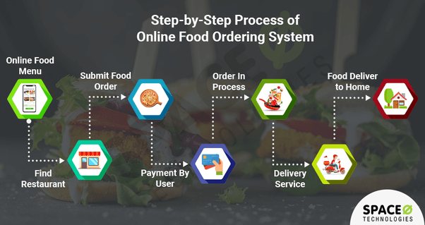

**Admin workflow**

Process User goes to home page of the domain. If he/she has an account then he/she can login in restaurant management system otherwise he/she need to register an account after successful registration, they can login in home page.

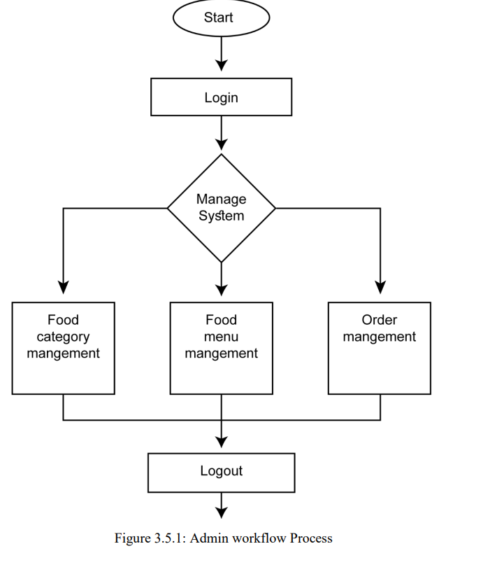

**Customer Workflow**

Process Initially to visit the food categories or food menu, users don’t need to login/register an account. After checking out the categories and menu items, if the user finds his/her desired menu and if they want to order that particular item they can go to order page. During placing any order the customer needs to provide his/her required information mentioned the order section.

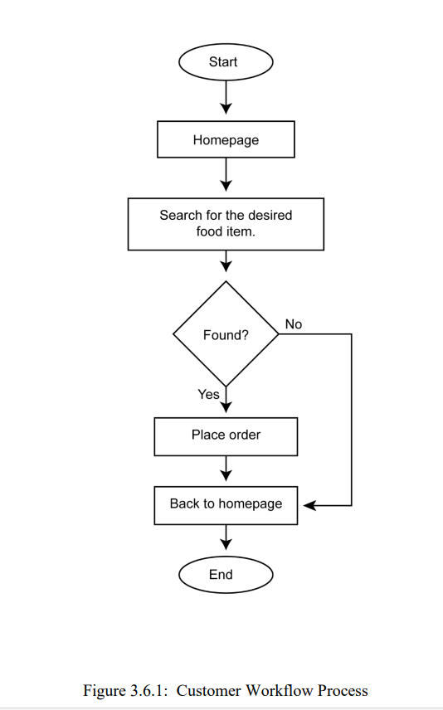

**Project Outcome**

1. **Increased Convenience:**

Users can conveniently browse through various restaurants, cuisines, and menu items, and place orders from the comfort of their homes or workplaces.

1. **Enhanced Accessibility:**

The app provides access to a wide range of dining options, catering to diverse tastes and dietary preferences. It also facilitates food ordering for individuals with limited mobility or those residing in areas with limited dining options.

1. **Improved Efficiency:**

Both customers and restaurants benefit from streamlined order processing, reducing wait times and enhancing overall operational efficiency. Delivery partners can optimize routes for timely order deliveries.

1. **Expanded Market Reach:**

Restaurants and eateries can expand their customer base beyond their physical locations, tapping into a larger market of app users seeking diverse dining experiences.

1. **Customer Satisfaction:**

Providing a seamless and user-friendly ordering experience, along with timely delivery and quality service, leads to increased customer satisfaction and loyalty.

1. **Increased Employment Opportunities:**

The app creates job opportunities for delivery partners and support staff, contributing to economic growth and employment in the delivery industry.

1. **Continuous Improvement:**

The app's development team can iteratively improve the platform based on user feedback, technological advancements, and market trends, ensuring its relevance and competitiveness in the long term

**Project Duration**

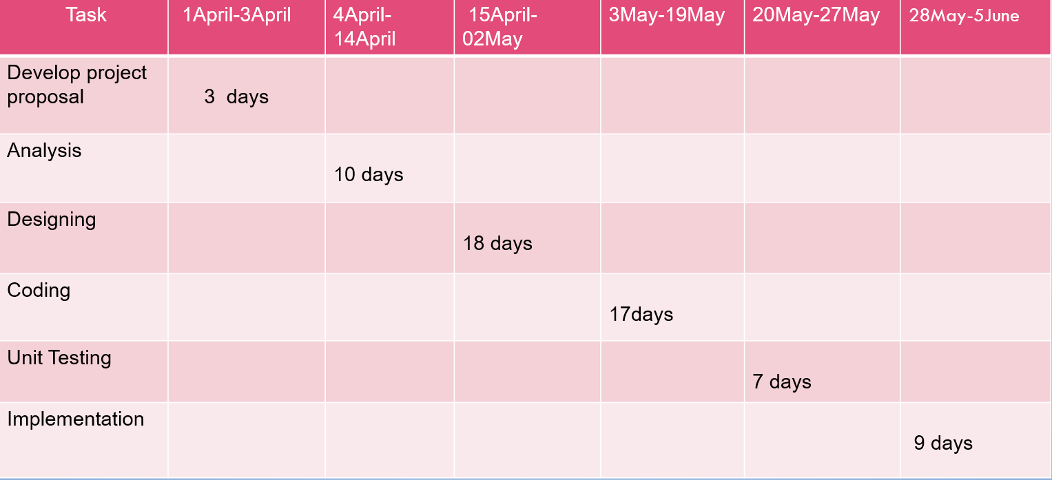

**REFERENCES**

[1] Kirti Bhandge, Tejas Shinde, Dheeraj Ingale, Neeraj Solanki, Reshma Totare,”A Proposed System for Touchpad Based Food Ordering System Using Android Application”, International Journal of Advanced Research in Computer Science Technology (IJARCST 2015).

[2] Varsha Chavan, Priya Jadhav,Snehal Korade,Priyanka Teli, ”Implementing Customizable Online Food Ordering System Using Web Based Application”, International Journal of Innovative Science, Engineering Technology(IJISET) 2015.

[3] Resham Shinde, Priyanka Thakare, Neha Dhomne, Sushmita Sarkar, ”Design and Implementation of Digital dining in Restaurants using Android”, International Journal of Advance Research in Computer Science and Management Studies 2014.

[4] Ashutosh Bhargave, Niranjan Jadhav, Apurva Joshi, Prachi Oke, S. R Lahane,“Digital Ordering System for Restaurant Using Android”, International Journal of Scientific and Research Publications 2013.

[5] Khairunnisa K., Ayob J., Mohd. Helmy A. Wahab, M. Erdi Ayob, M. Izwan Ayob, M. Afif Ayob, ”The Application of Wireless Food Ordering System” MASAUM Journal of Computing 2009.

[6] Noor Azah Samsudin, Shamsul Kamal Ahmad Khalid, Mohd Fikry Akmal Mohd Kohar, Zulkifli Senin, Mohd Nor Ihkasan,” A customizable wireless food ordering system with real time customer feedback”, IEEE Symposium on Wireless Technology and Applications.