**SYNOPSIS**

**Report on**

### E-Commerce WebSite

**by**

Radhika Gupta 2200290140119

**Session:2023-2024 (4th Semester)**

Under the supervision of

### Associate Prof. Mr. Prashant Aggarwal

**KIET Group of Institutions, Delhi-NCR, Ghaziabad**



**DEPARTMENT OF COMPUTER APPLICATIONS**

**KIET GROUP OF INSTITUTIONS, DELHI-NCR, GHAZIABAD-201206**

(APRIL- 2024)

### ABSTRACT

The purpose of Online E-commerce System is to automate the existing manual system by the help of computerized equipment’s and full-fledged computer software, fulfilling their requirements, so that their valuable data/information can be stored for a longer period with easy accessing and manipulation of the same. The required software and hardware are easily available and easy to work with. Online E-commerce System, as described above, can lead to error free, secure, reliable and fast management system. It can assist the user to concentrate on their other activities rather to concentrate on the record keeping. Thus it will help organization in better utilization of resources.

The organization can maintain computerized records without redundant entries. That means that one need not be distracted by information that is not relevant, while being able to reach the information. The aim is to automate its existing manual system by the help of computerized equipment’s and full-fledged computer software, fulfilling their requirements, so that their valuable data/information can be stored for a longer period with easy accessing and manipulation of the same. Basically the project describes how to manage for good performance and better services for the clients.

### TABLE OF CONTENTS

1. Introduction 4

2.Abstract 5

3.Objective of Project 6

4.Scope of Porject 7

5.Report of Project 9

6.Module of Project 9

7.Input Data and Validation of Project 11

8.Features of Project 12

9. Software Requirement Specification 13

10. Identification of need 14

11.Feasibility Study 15

12. System design of the project 16

13. User Interface Design 17

14. Preliminary Product Descriptions 18

15. Project Category 19

16. Implementation Methodology 20

17. Tools and Platform — Software Requirements 21

18. Tools and Platform — Hardware Requirements 22

19. System Analysis 23

20. Conclusion of the Project 24

21. Future scope of the Project 25

22. Bibliography and references 26

User Interface Design

15 Preliminary Product Descriptions

User Interface Design

15 Preliminary Product Descriptions

User Interface Design

15 Preliminary Product Descriptions

User Interface Design

15 Preliminary Product De

# Introduction

The "Online E-commerce System" has been developed to override the

problems prevailing in the practicing manual system. This software is

supported to eliminate and in some cases reduce the hardships faced by

this existing system. Moreover this system is designed for the particular

need of the company to carry out operations in a smooth and effective

manner.

The application is reduced as much as possible to avoid errors while

entering the data. It also provides error message while entering invalid

data. No formal knowledge is needed for the user to use this system. Thus

by this all it proves it is user-friendly. Online E-commerce System, as

described above, can lead to error free, secure, reliable and fast

management system. It can assist the user to concentrate on their other

activities rather to concentrate on the record keeping. Thus it will help

organization in better utilization of resources.

Every organization, whether big or small, has challenges to overcome and

managing the information of Item Category, Men, Woman, Child, Delivery

Address, Order. Every Online E-commerce System has different Food

needs, therefore we design exclusive employee management systems that

are adapted to your managerial requirements. This is designed to assist in

strategic planning, and will help you ensure that your organization is

equipped with the right level of information and details for your future goals.

Also, for those busy executive who are always on the go, our systems

come with remote access features, which will allow you to manage your

workforce anytime, at all times. These systems will ultimately allow you to

better manage resources.

The "Online E-commerce System" has been developed to override the

problems prevailing in the practicing manual system. This software is

supported to eliminate and in some cases reduce the hardships faced by

this existing system. Moreover this system is designed for the particular

need of the company to carry out operations in a smooth and effective

manner.

The application is reduced as much as possible to avoid errors while

entering the data. It also provides error message while entering invalid

data. No formal knowledge is needed for the user to use this system. Thus

by this all it proves it is user-friendly. Online E-commerce System, as

described above, can lead to error free, secure, reliable and fast

management system. It can assist the user to concentrate on their other

activities rather to concentrate on the record keeping. Thus it will help

organization in better utilization of resources.

Every organization, whether big or small, has challenges to overcome and

managing the information of Item Category, Men, Woman, Child, Delivery

Address, Order. Every Online E-commerce System has different Food

needs, therefore we design exclusive employee management systems that

are adapted to your managerial requirements. This is designed to assist in

strategic planning, and will help you ensure that your organization is

equipped with the right level of information and details for your future goals.

Also, for those busy executive who are always on the go, our systems

come with remote access features, which will allow you to manage your

workforce anytime, at all times. These systems will ultimately allow you to

better manage resources.

The "Online E-commerce System" has been developed to override the

problems prevailing in the practicing manual system. This software is

supported to eliminate and in some cases reduce the hardships faced by

this existing system. Moreover this system is designed for the particular

need of the company to carry out operations in a smooth and effective

manner.

The application is reduced as much as possible to avoid errors while

entering the data. It also provides error message while entering invalid

data. No formal knowledge is needed for the user to use this system. Thus

by this all it proves it is user-friendly. Online E-commerce System, as

described above, can lead to error free, secure, reliable and fast

management system. It can assist the user to concentrate on their other

activities rather to concentrate on the record keeping. Thus it will help

organization in better utilization of resources.

Every organization, whether big or small, has challenges to overcome and

managing the information of Item Category, Men, Woman, Child, Delivery

Address, Order. Every Online E-commerce System has different Food

needs, therefore we design exclusive employee management systems that

are adapted to your managerial requirements. This is designed to assist in

strategic planning, and will help you ensure that your organization is

equipped with the right level of information and details for your future goals.

Also, for those busy executive who are always on the go, our systems

come with remote access features, which will allow you to manage your

workforce anytime, at all times. These systems will ultimately allow you to

better manage resources.

The "Online E-commerce System" has been developed to override the problems prevailing in the practicing manual system. This software is supported to eliminate and in some cases reduce the hardships faced by this existing system. Moreover this system is designed for the particular need of the company to carry out operations in a smooth and effective manner. The application is reduced as much as possible to avoid errors while entering the data. It also provides error message while entering invalid data. No formal knowledge is needed for the user to use this system. Thus by this all it proves it is user-friendly. Online E-commerce System, as described above, can lead to error free, secure, reliable and fast management system. It can assist the user to concentrate on their other activities rather to concentrate on the record keeping. Thus it will help organization in better utilization of resources. Every organization, whether big or small, has challenges to overcome and managing the information of Item Category, Men, Woman, Child, Delivery Address, Order. Every Online E-commerce System has different Food needs, therefore we design exclusive employee management systems that are adapted to your managerial requirements. This is designed to assist in strategic planning, and will help you ensure that your organization is equipped with the right level of information and details for your future goals. Also, for those busy executive who are always on the go, our systems come with remote access features, which will allow you to manage your workforce anytime, at all times. These systems will ultimately allow you to better manage resources.

# Project Objective

The main objective of the Project on Online E-commerce System is to manage the details of Clothes, Item Category, Shopping Cart, Customer, Order. It manages all the information about Clothes, Delivery Address, Order. The project is totally built at administrative end and thus only the administrator is guaranteed the access. The purpose of the project is to build an application program to reduce the manual work for managing the Clothes, Item Category, Delivery Address, and Shopping Cart. It tracks all the details about the Shopping Cart, Customer, Order.

# Functionalities

Provides the searching facilities based on various factors. Such as

Clothes, Shopping Cart, Customer, Order.

* Provides the searching facilities based on various factors. Such as Clothes, Shopping Cart, Customer, Order.
* Manage the information of Item Category
* Shows the information and description of the Clothes, Shopping Cart.
* To increase efficiency of managing the Clothes, Item Category.
* It deals with monitoring the information and transactions of Customer.
* Manage the information of Clothes.
* Editing, adding and updating of Records is improved which results in proper resource management of Clothes data.
* Manage the information of Customer
* Online E-commerce System also manage the Delivery Address details online for Customer details, Order details, Clothes.It tracks all the information of Item Category, Delivery Address, Customer etc. Manage the information of Item Category

• Shows the information and description of the Clothes, Shopping Cart

• To increase efficiency of managing the Clothes, Item Category

• It deals with monitoring the information and transactions of Customer.

• Manage the information of Clothes.

• Editing, adding and updating of Records is improved which results in

proper resource management of Clothes data.

• Manage the information of Customer

• Integration of all records of Order.

# Scope

It may help collecting perfect management in details. In a very short time, the collection will be obvious, simple and sensible. It will help a person to know the management of passed year perfectly and vividly. It also helps in current all works relative to Online E-commerce System. It will be also reduced the cost of collecting the management & collection procedure will go on smoothly. Our project aims at Business process automation, i.e. we have tried to computerize various processes of Online E-commerce System.

* In computer system the person has to fill the various forms & number of copies of the forms can be easily generated at a time.
* In computer system, it is not necessary to create the manifest but we can directly print it, which saves our time.
* To assist the staff in capturing the effort spent on their respective working areas.
* To utilize resources in an efficient manner by increasing their productivity through automation.
* The system generates types of information that can be used for various purposes.
* It satisfy the user requirement
* Be easy to understand by the user and operator
* Be easy to operate
* Have a good user interface
* Be expandable
* Delivered on schedule within the budget.

# Features

* Product and Component based
* Creating & Changing Issues at ease
* Query Issue List to any depth
* Reporting & Charting in more comprehensive way
* User Accounts to control the access and maintain security
* Simple Status & Resolutions
* Multi-level Priorities & Severities.
* Targets & Milestones for guiding the programmers
* Attachments & Additional Comments for more information
* Robust database back-end
* Various level of reports available with a lot of filter criteria's • It contain better storage capacity.
* Accuracy in work.
* Easy & fast retrieval of information.
* Well-designed reports.
* Decrease the load of the person involve in existing manual system.
* Access of any information individually.
* Work becomes very speedy.
* Easy to update information

# Proposed time duration

# 

|  |  |
| --- | --- |
| **Week Number** | **Tasks** |
| **Week 1-2:**  **Project Initiation and Planning** | 1. Define project objectives and goals. 2. Assemble the project team. 3. Establish communication and collaboration tools. 4. Identify user requirements and technical specifications. |
| **Week 3-4:**  **System Design and Front-end Development** | 1. Develop the system architecture. 2. Design the database structure. 3. Create wireframes for the user interface. 4. Build the user interface using ReactJS. |
| **Week 5-6:**  **Backend Integration and Core Development** | 1. Integrate external APIs for question retrieval. 2. Ensure seamless data flow between the front-end and back-end. 3. Develop the AI-driven virtual interviewer. 4. Create initial question/response logic. |
| **Week 7-8:**  **Testing, Refinement, and Deployment** | 1. Conduct thorough system testing. 2. Gather initial user feedback. 3. Identify and address issues and bugs. 4. Continue testing and refinement based on user feedback. 5. Finalize the project codebase and configurations. 6. Prepare a presentation and demonstration for the project's final submission. |

**Software And Hardware Requirement**

**Software Requirements :-**

# Name of component Specification

**Operating system** Windows XP , Windows 7,8,8.1,10 Linux

**Browser** Any of Mozilla, Opera. Chrome etc.

**Hardware Requirements :-**

**Name of component** **Specification**

**Processor** Minimum Pentium III 630MHz

**RAM** 2 GB

**Hard disk** 20 GB

**Monitor** 15 colour monitor

**Software Requirement Specification**

The Software Requirements Specification is produced at the culmination of the analysis task. The function and performance allocated to software as part of system engineering are refined by establishing a complete information description, a detailed functional and behavioral description, an indication of performance requirements and design constraints, appropriate validation criteria, and other data pertinent to requirements.

# System Design of Online E-commerce System

In this phase, a logical system is built which fulfils the given requirements. Design phase of software development deals with transforming the clients requirements into a logically working system. Normally, design is performed in the following in the following two steps:

* Primary Design Phase: In this phase, the system is designed at block level. The blocks are created on the basis of analysis done in the problem identification phase. Different blocks are created for different functions emphasis is put on minimizing the information flow between blocks. Thus, all activities which require more interaction are kept in one block.
* Secondary Design Phase: In the secondary phase the detailed design of every block is performed.

# The general tasks involved in the design process are the following:

* + Design various blocks for overall system processes.
  + Design smaller, compact and workable modules in each block.
  + Design various database structures.
  + Specify details of programs to achieve desired functionality.
  + Design the form of inputs, and outputs of the system.
  + Perform documentation of the design.
  + System reviews.

**ER Diagram**

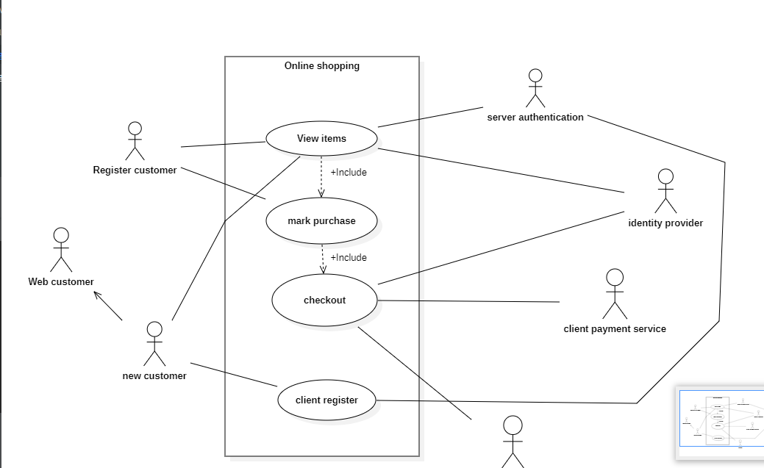

The Software Requirements Specification is produced at the culmination of

the analysis task. The function and performance allocated to software as

part of system engineering are refined by establishing a complete

information description, a detailed functional and behavioral description, an

indication of performance requirements and design constraints, appropriate

validation criteria, and other data pertinent to requirements.

The Software Requirements Specification is produced at the culmination of

the analysis task. The function and performance allocated to software as

part of system engineering are refined by establishing a complete

information description, a detailed functional and behavioral description, an

indication of performance requirements and design constraints, appropriate

validation criteria, and other data pertinent to requirements.

The Software Requirements Specification is produced at the culmination of

the analysis task. The function and performance allocated to software as

part of system engineering are refined by establishing a complete

information description, a detailed functional and behavioral description, an

indication of performance requirements and design constraints, appropriate

validation criteria, and other data pertinent to requirements.

The Software Requirements Specification is produced at the culmination of

the analysis task. The function and performance allocated to software as

part of system engineering are refined by establishing a complete

information description, a detailed functional and behavioral description, an

indication of performance requirements and design constraints, appropriate

validation criteria, and other data pertinent to requirements.

The Software Requirements Specification is produced at the culmination of

the analysis task. The function and performance allocated to software as

part of system engineering are refined by establishing a complete

information description, a detailed functional and behavioral description, an

indication of performance requirements and design constraints, appropriate

validation criteria, and other data pertinent to requirements.

The Software Requirements Specification is produced at the culmination of

the analysis task. The function and performance allocated to software as

part of system engineering are refined by establishing a complete

information description, a detailed functional and behavioral description, an

indication of performance requirements and design constraints, appropriate

validation criteria, and other data pertinent to requirements.

The Software Requirements Specification is produced at the culmination of

the analysis task. The function and performance allocated to software as

part of system engineering are refined by establishing a complete

information description, a detailed functional and behavioral description, an

indication of performance requirements and design constraints, appropriate

validation criteria, and other data pertinent to requirements.

The Software Requirements Specification is produced at the culmination of

the analysis task. The function and performance allocated to software as

part of system engineering are refined by establishing a complete

information description, a detailed functional and behavioral description, an

indication of performance requirements and design constraints, appropriate

validation criteria, and other data pertinent to requirements.

The Software Requirements Specification is produced at the culmination of

the analysis task. The function and performance allocated to software as

part of system engineering are refined by establishing a complete

information description, a detailed functional and behavioral description, an

indication of performance requirements and design constraints, appropriate

validation criteria, and other data pertinent to requirements.

**0 Level DFD Diagram**

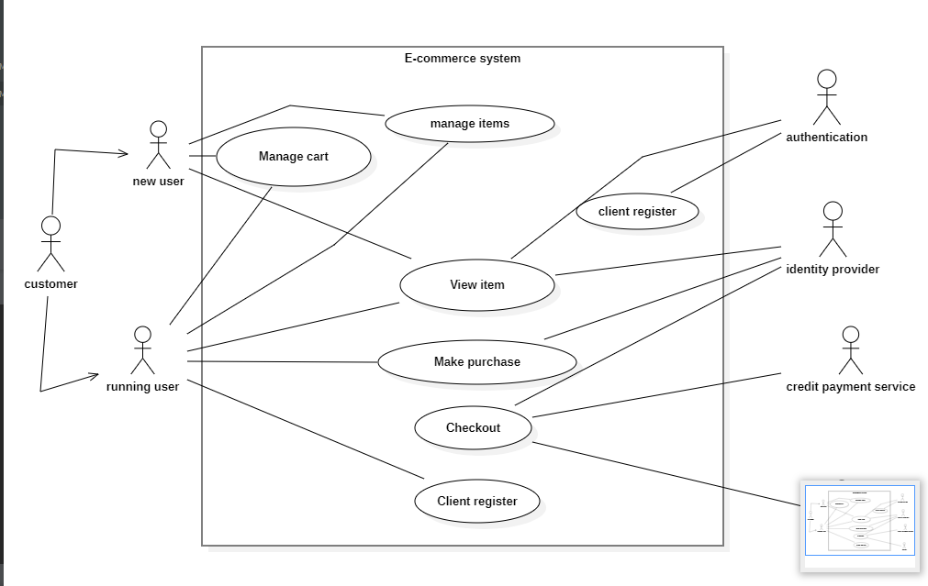

**1 Level DFD Diagram**

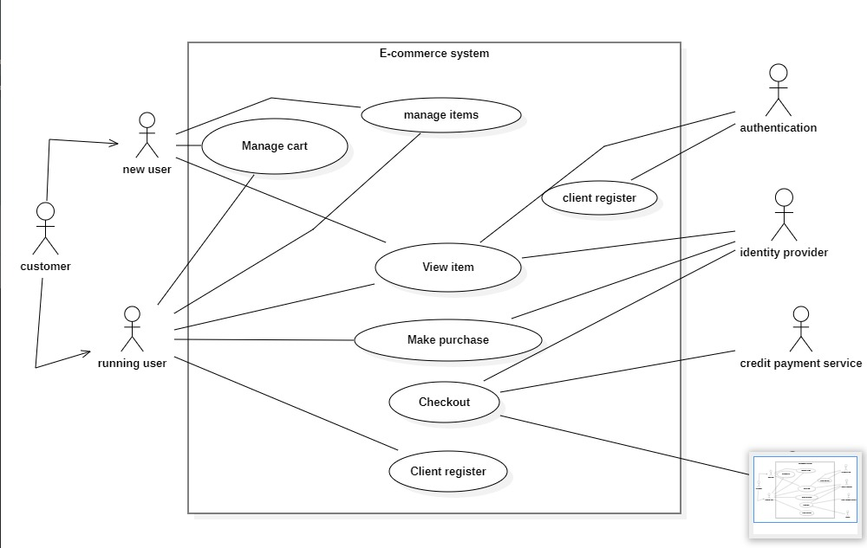

**Use Case Diagram**

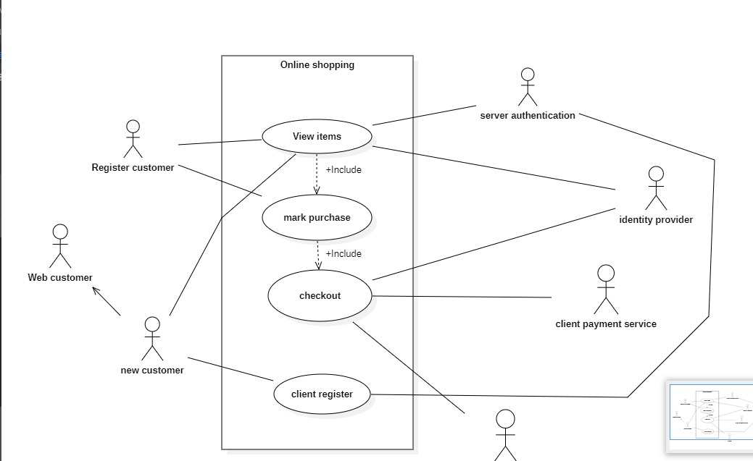

# Conclusion of the Project Online E-commerce System:

Our project is only a humble venture to satisfy the needs to manage their project work. Several user friendly coding have also adopted. This package shall prove to be a powerful package in satisfying all the requirements of the school. The objective of software planning is to provide a frame work that enables the manger to make reasonable estimates made within a limited time frame at the beginning of the software project and should be updated regularly as the project progresses.