**SYNOPSIS**

**Report on**

**FOOD WASTAGES MANAGEMENT SYSTEM**

**by**

Vikas Kumar Gupta (2200290140176)

Tanuj Tayal (2200290140176)

**Session:2023-2024 (IV Semester)**

Under the supervision of

**Dr. Ankit Verma (Assistant Professor)**

### KIET Group of Institutions, Delhi-NCR, Ghaziabad

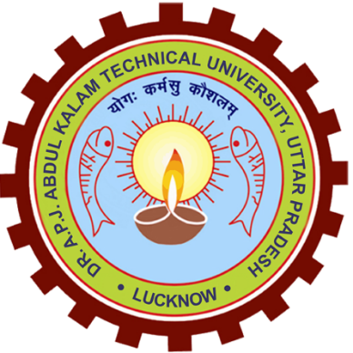

### Department Of Computer Applications

**KIET GROUP OF INSTITUTIONS, DELHI-NCR,**

**GHAZIABAD-201206**

(2023-24)

**ABSTRACT**

“Get useful out of your daily waste” - Our purpose of creating this project is to provide humans useful out of waste that would actually be a part of Clean India, Green India. Waste like plastic packets, chips packets, electronic items, etc., that is usually thrown on public places, would be part of our website. Global users would be asked to submit the waste items to our team, which could be reused and recycled and on the basis of that, we would provide them with shopping coupons.

In this we would provide a service in which the people can register with essential details and can login after that. After that they can select the categories of wastage and submit it.

**TABLE OF CONTENTS**

Page Number

1. Introduction 4
2. Literature Review 5
3. Project / Research Objective 6
4. Project Flow/ Research Methodology 7
5. Project / Research Outcome 9
6. Proposed Time Duration 10
7. References/ Bibliography 12

**INTRODUCTION**

In a world where abundance often coincides with deprivation, “Food Wastages Management System” emerges as a beacon of compassion and efficiency, dedicated to minimizing food waste and addressing hunger. Our innovative web-based platform serves as a conduit for collecting details about excess food left over from functions or events, and seamlessly connecting donors with individuals and organizations in need.

At the heart of “Food Wastages Management System” lies a profound recognition of the inefficiencies inherent in our current food distribution systems. Every day, countless events and gatherings produce surplus food that is left uneaten, destined for disposal. Simultaneously, there are communities and individuals struggling with food insecurity, lacking access to nutritious meals. “Food Wastages Management System” is the solution to this disconnect, harnessing technology to redistribute surplus food where it is most needed.

Our platform offers a user-friendly interface designed to streamline the process of food donation and distribution. Event organizers can easily register excess food on our platform, providing details such as type, quantity, and location. Through our sophisticated algorithm, we match this surplus with nearby Non-Governmental Organizations (NGOs) and other entities dedicated to addressing food insecurity. By facilitating this connection, “Food Wastage Management System” ensures that surplus food finds its way to those who need it most, efficiently and effectively.

But “Food Wastages Management System” is more than just a matching service; it is a catalyst for social change. By redirecting surplus food from waste bins to dinner tables, we not only alleviate hunger but also reduce the environmental impact of food waste. Our platform empowers individuals and organizations to make a tangible difference in their communities, fostering a sense of collective responsibility and solidarity.

As we embark on this journey, we invite you to join us in our mission to create a world where no one goes hungry and where surplus food becomes a valuable resource rather than a liability. Together, let's harness the power of technology and human compassion to build a more equitable and sustainable future. Welcome to “Food Wastages Management System”, where surplus meets need, and together, we make a difference, one meal at a time.

LITERATURE REVIEW

In recent years, the issue of food waste and its environmental and social implications has garnered increasing attention from researchers and policymakers worldwide. As societies grapple with the paradox of surplus amidst scarcity, a growing body of literature has emerged exploring various strategies for mitigating food waste and redistributing surplus food to those in need.

One prominent avenue of research focuses on the quantification and characterization of food waste. Studies by Parfitt et al. (2010) and Gustavsson et al. (2011) have provided comprehensive assessments of food waste at different stages of the supply chain, shedding light on the magnitude of the problem and identifying key drivers of waste generation. These findings underscore the urgent need for interventions to address food waste at its source.

In response to this imperative, a burgeoning field of research has emerged around surplus food redistribution initiatives. The work of Mourad et al. (2017) and Evans et al. (2013) has explored the effectiveness of various models for rescuing surplus food from events and redistributing it to food-insecure populations. These studies have highlighted the potential of technology-driven platforms to facilitate efficient and scalable surplus food redistribution, while also emphasizing the importance of stakeholder engagement and collaboration.

Indeed, the role of technology in addressing food surplus and redistribution has been a focal point of scholarly inquiry. Research by Stancu et al. (2016) and Qian et al. (2018) has examined the potential of digital platforms and mobile applications to connect food donors with recipients, enabling real-time communication and coordination. These studies have underscored the importance of user-friendly interfaces and robust algorithms in optimizing the matching process and maximizing the impact of surplus food redistribution efforts.

Furthermore, the literature has explored the broader implications of surplus food redistribution for food security, environmental sustainability, and social equity. Studies by Vittore et al. (2019) and Silvennoinen et al. (2019) have highlighted the multifaceted benefits of surplus food redistribution, including reduced greenhouse gas emissions, enhanced community resilience, and improved nutritional outcomes for vulnerable populations.

In summary, the literature on surplus food redistribution underscores the urgency of addressing food waste and the potential of technology-driven solutions to facilitate more efficient and equitable food systems. By leveraging insights from existing research and building upon proven models and best practices, initiatives like “Food Wastage Management System” are poised to make a meaningful contribution to this critical endeavour, connecting surplus with need and fostering a more sustainable and just food system for all.

PROJECT / RESEARCH OBJECTIVE

The primary objective of “Food Wastage Management System” is to develop and implement a web-based platform aimed at minimizing food waste generated from functions or events, while simultaneously addressing the issue of food insecurity. The project endeavours to create a seamless and efficient system for collecting details about excess food and connecting donors with Non-Governmental Organizations (NGOs) and other entities that work to alleviate hunger.

**1. Minimize Food Waste:** The foremost goal of “Food Wastage Management System” is to reduce food waste by providing a platform where event organizers can easily register and donate excess food. By capturing surplus food that would otherwise be discarded, the project aims to minimize the environmental impact associated with food waste and promote sustainable consumption practices.

**2. Address Food Insecurity:** “Food Wastage Management System” seeks to address the pressing issue of food insecurity by facilitating the redistribution of surplus food to individuals and communities in need. Through strategic partnerships with NGOs and other charitable organizations, the project aims to ensure that surplus food reaches those who are most vulnerable and lacking access to nutritious meals.

**3. Efficient Matching System:** A key objective of the project is to develop an efficient matching system that connects donors with recipients in a timely and effective manner. By leveraging technology, “Food Wastage Management System” aims to streamline the process of food donation and distribution, optimizing resource allocation and enhancing the overall impact of surplus food redistribution efforts.

**4. User-Friendly Interface:** “Food Wastage Management System” aims to develop a user-friendly interface that is accessible to both donors and recipients. The platform will be designed to facilitate easy registration and donation of excess food, as well as seamless browsing and selection of available food items for recipients. By prioritizing usability and accessibility, the project aims to maximize participation and engagement from all stakeholders.

**5. Promote Community Engagement:** In addition to facilitating food donation and distribution, “Food Wastage Management System” aims to promote community engagement and awareness around issues of food waste and food insecurity. Through educational initiatives and outreach efforts, the project seeks to foster a sense of collective responsibility and empower individuals to take action in addressing these critical issues.

Overall, the objective of “Food Wastage Management System” is to harness the power of technology and community collaboration to create a more sustainable and equitable food system, where surplus food is utilized to its fullest potential in alleviating hunger and reducing waste. Through these efforts, the project aims to make a meaningful impact in the fight against food insecurity and contribute to building a brighter future for all.

PROJECT FLOW/ RESEARCH METHODOLOGY

**1. Research and Analysis:**

The project begins with comprehensive research and analysis to understand the dynamics of food surplus at functions and events, as well as the existing systems for food donation and distribution. This involves studying patterns of food waste, identifying key stakeholders (event organizers, food donors, NGOs, etc.), and assessing the effectiveness of current solutions.

**2. Platform Development:**

Based on the insights gathered, the development of the “Food Wastage Management System” platform commences. This involves designing a user-friendly interface for event organizers to register surplus food details, as well as for NGOs and individuals to search for and request surplus food. The platform is built to ensure seamless communication and transaction between donors and recipients.

**3. Testing and Iteration:**

Once the initial platform is developed, rigorous testing is conducted to identify and address any bugs or usability issues. Feedback from beta testers, including event organizers and NGOs, is crucial in refining the platform to ensure optimal functionality and user experience.

**4. Outreach and Partnerships:**

Simultaneously, outreach efforts are initiated to engage with potential partners, including event organizers, NGOs, and other stakeholders in the food industry. Building strong partnerships is essential for the success of “Food Wastage Management System”, as it expands the network of food donors and recipients, and enhances the reach and impact of the platform.

**5. Launch and Implementation:**

With the platform fully developed and tested, “Food Wastage Management System” is officially launched to the public. A comprehensive marketing and promotional campaign is rolled out to raise awareness and encourage participation from both donors and recipients. The platform is implemented across various events and functions, and efforts are made to ensure smooth adoption and integration into existing workflows.

**6. Data Monitoring and Evaluation:**

Throughout the implementation phase, continuous monitoring and evaluation of data are conducted to track the flow of surplus food, measure impact, and identify areas for improvement. Insights gathered from data analysis inform decision-making and strategic planning to optimize the efficiency and effectiveness of “Food Wastage Management System”.

**7. Scaling and Expansion:**

As “Food Wastage Management System” gains traction and proves its efficacy, efforts are made to scale the project and expand its reach to new regions and communities. This involves replicating successful models, establishing partnerships in new areas, and adapting the platform to meet the unique needs of different contexts.

In summary, the project flow and research methodology for “Food Wastage Management System” involve a systematic approach from research and development to implementation and scaling, guided by a commitment to reducing food waste and addressing food insecurity through technology-driven solutions.

PROJECT / RESEARCH OUTCOME

Addressing Food Waste and Hunger through “Food Wastage Management System”:

The culmination of our web-based project, “Food Wastage Management System”, marks a significant milestone in the ongoing battle against food waste and hunger. Through meticulous planning, innovative technology, and unwavering dedication, our platform has successfully revolutionized the way surplus food from functions or events is collected, redistributed, and utilized to alleviate food insecurity.

One of the primary outcomes of “Food Wastage Management System” is the effective collection and dissemination of details about excess food. By providing event organizers with a streamlined platform to register surplus food, we have facilitated the efficient identification and categorization of available resources. This process not only minimizes the logistical challenges associated with food donation but also ensures that no edible surplus goes unnoticed or unutilized.

Furthermore, “Food Wastage Management System” has emerged as a vital connector, bridging the gap between donors and recipients. Through our platform, Non-Governmental Organizations (NGOs), community groups, and individuals in need can easily access information about surplus food available in their vicinity. This seamless connection facilitates swift and targeted distribution, ensuring that surplus food reaches those who need it most in a timely manner.

Moreover, the impact of “Food Wastage Management System” extends beyond immediate relief, as evidenced by its potential to foster long-term behavioural change. By raising awareness about the environmental and social implications of food waste, our platform encourages individuals and organizations to adopt more sustainable practices. Through education and advocacy, “Food Wastage Management System” contributes to a broader cultural shift towards mindful consumption and responsible stewardship of resources.

Ultimately, the success of “Food Wastage Management System” lies in its ability to make a tangible difference in the lives of both donors and recipients. For event organizers, our platform offers a convenient solution for managing surplus food responsibly, while for recipients, it provides much-needed access to nutritious meals. By harnessing the power of technology and community collaboration, “Food Wastage Management System” embodies the transformative potential of collective action in addressing pressing social and environmental challenges.

As we reflect on the outcomes of our project, we are reminded of the immense potential for positive change when individuals and organizations come together with a shared vision and purpose. Through “Food Wastage Management System”, we have demonstrated that even the simplest of actions, such as redistributing surplus food, can have a profound and lasting impact on society.

PROPOSED TIME DURATION

Proposed Time Duration for “Food Wastage Management System”: A Web-Based Solution

Embarking on a journey to develop and implement a web-based platform like “Food Wastage Management System”, dedicated to collecting surplus food from functions or events and redistributing it to those in need, requires careful consideration of various factors that influence project timelines. From inception to deployment, each phase demands meticulous planning and execution to ensure the platform's success. Here, we propose a comprehensive timeline for the development and launch of “Food Wastage Management System”:

**1. Conceptualization (1-2 days):** During this initial phase, the project team conducts market research, stakeholder consultations, and feasibility studies to refine the project's scope and objectives. Key activities include defining target user groups, identifying technological requirements, and outlining the platform's features and functionalities.

**2. Design and Planning (1-2 weeks):** With a clear understanding of project goals and requirements, the focus shifts to designing the platform's architecture, user interface, and user experience. This phase involves creating wireframes, mock-ups, and prototypes, as well as developing a comprehensive project plan outlining timelines, milestones, and resource allocation.

**3. Development (1-3 weeks):** The development phase entails the actual coding and programming of the “Food Wastage Management System” platform, including frontend and backend development, database design, and integration of third-party services (if applicable). Agile development methodologies may be employed to facilitate iterative development and accommodate evolving requirements.

**4. Testing and Quality Assurance (1-2 days):** Rigorous testing is essential to ensure the reliability, security, and usability of the “Food Wastage Management System” platform. This phase involves various types of testing, including functional testing, performance testing, security testing, and user acceptance testing. Feedback from beta testers and stakeholders is collected and incorporated into the platform's refinement.

**5. Deployment and Launch (1 day):** Upon successful completion of testing and quality assurance, the “Food Wastage Management System” platform is prepared for deployment to production environments. This involves configuring servers, deploying code, and setting up monitoring and analytics tools. A comprehensive launch plan is executed to promote the platform, onboard users, and garner initial traction.

**6. Post-launch Optimization and Support (Ongoing):** Following the platform's launch, continuous monitoring, optimization, and support are essential to address any issues, gather user feedback, and implement enhancements. Regular updates and feature releases ensure the platform remains relevant, efficient, and user-friendly over time.

In summary, the proposed time duration for the development and launch of “Food Wastage Management System” spans approximately 1 to 1.5 months, encompassing phases such as conceptualization, design and planning, development, testing and quality assurance, deployment and launch, and post-launch optimization and support. However, it's important to note that actual timelines may vary depending on factors such as project complexity, resource availability, and unforeseen challenges.

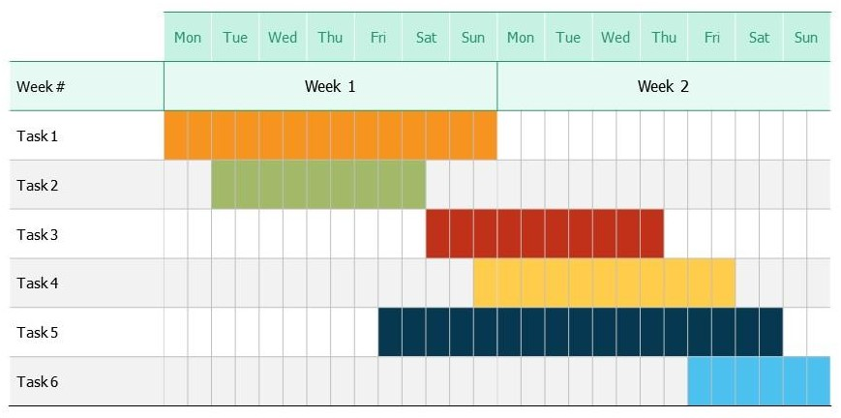

Gantt Chart

REFERENCES/ BIBLIOGRAPHY

* 1. MongoDB Official Documentation: https://docs.mongodb.com/
  2. Express.js Official Documentation: https://expressjs.com/
  3. React.js Official Documentation: https://reactjs.org/
  4. Node.js Official Documentation: https://nodejs.org/
  5. Redux Toolkit Official Documentation: https://redux-toolkit.js.org/
  6. JSON Web Token (JWT) Official Website: https://jwt.io/