**SYNOPSIS**

**Report on**

**BANK ACCOUNT MANAGEMENT SYSTEM**

**by**

MANSI PANWAR

ROLL NUMBER: 2200290140087

**Session:2023-2024 (IV Semester)**

Under the supervision of

**DR. AMIT KUMAR**

**(ASSISTANT PROFESSOR)**

**KIET Group of Institutions, Delhi-NCR, Ghaziabad**



**DEPARTMENT OF COMPUTER APPLICATIONS**

**KIET GROUP OF INSTITUTIONS, DELHI-NCR,**

**GHAZIABAD-201206**

(2023-2024)

# ABSTRACT

The Bank Account Management System is an application for maintaining a person's account in a bank. In this project I tried to show the working of a banking account system and cover the basic functionality of a Bank Account Management System. To develop a project for solving financial applications of a customer in banking environment in order to nurture the needs of an end banking user by providing various ways to perform banking tasks. Also, to enable the user’s work space to have additional functionalities which are not provided under a conventional banking project.

The Bank Account Management System undertaken as a project is based on relevant technologies. The main aim of this project is to develop software for Bank Account Management System. This project has been developed to carry out the processes easily and quickly, which is not possible with the manuals systems, which are overcome by this software. This project is developed using Java language. Creating and managing requirements is a challenge of IT, systems and product development projects or indeed for any activity where you have to manage a contractual relationship. Organization need to effectively define and manage requirements to ensure they are meeting needs of the customer, while proving compliance and staying on the schedule and within budget.

The impact of a poorly expressed requirement can bring a business out of compliance or even cause injury or death. Requirements definition and management is an activity that can deliver a high, fast return on investment. The project analyzes the system requirements and then comes up with the requirements specifications. It studies other related systems and then come up with system specifications. The system is then designed in accordance with specifications to satisfy the requirements. The system design is then implemented with Java. The system is designed as an interactive and content management system. The content management system deals with data entry, validation confirm and updating whiles the interactive system deals with system interaction with the administration and users. Thus, above features of this project will save transaction time and therefore increase the efficiency of the system

# TABLE OF CONTENTS

* Introduction
* Project Objective
* Research Methodology
* Project Outcome
* Proposed Time Duration
* References

# INTRODUCTION

The “Bank Account Management System” project is a model Internet Banking Site. This site enables the customers to perform the basic banking transactions by sitting at their office or at homes through PC or laptop. The system provides the access to the customer to create an account, deposit/withdraw the cash from his account, also to view reports of all accounts present. The customers can access the banks website for viewing their Account details and perform the transactions on account as per their requirements. With Internet Banking, the brick and mortar structure of the traditional banking gets converted into a click and portal model, thereby giving a concept of virtual banking a real shape. Thus, today's banking is no longer confined to branches. E-banking facilitates banking transactions by customers round the clock globally.

The primary aim of this “Bank Account Management System” is to provide an improved design methodology, which envisages the future expansion, and modification, which is necessary for a core sector like banking. This necessitates the design to be expandable and modifiable and so a modular approach is used in developing the application software.

Anybody who is an Account holder in this bank can become a member of Bank Account Management System. He has to fill a form with his personal details and Account Number. Bank is the place where customers feel the sense of safety for their property. In the bank, customers deposit and withdraw their money. Transaction of money also is a part where customer takes shelter of the bank. Now to keep the belief and trust of customers, there is the positive need for management of the bank, which can handle all this with comfort and ease. Smooth and efficient management affects the satisfaction of the customers and staff members, indirectly. And of course, it encourages management committee in taking some needed decision for future enhancement of the bank.

Now a day’s, managing a bank is tedious job up to certain limit. So software that reduces the work is essential. Also, today’s world is a genuine computer world and is getting faster and faster day-by-day. Thus, considering above necessities, the software for bank management has become necessary which would be useful in managing the bank more efficiently.

All transactions are carried out online by transferring from accounts in the same Bank or international bank. The software is meant to overcome the drawbacks of the manual system

## PROJECT OBJECTIVE

**Account Creation and Maintenance:**

* Facilitate the creation of new accounts.
* Manage account details, such as account holder information, account type, opening date, etc.
* Handle account modifications, such as updating personal details or changing account types.

**Transaction Processing**:

* Record deposits, withdrawals, transfers, and other financial transactions.
* Ensure accuracy and maintain transaction histories for audit and reference purposes.
* Generate periodic statements and reports for account holders.

**Balance Management**:

* Display current account balances.
* Implement overdraft protection and manage associated fees.
* Provide alerts for low balances or unusual account activities.

**Security and Authentication**:

* Implement robust security measures, such as encryption, to protect sensitive customer data.
* Authenticate users through secure login processes, multi-factor authentication, etc.
* Monitor and detect suspicious activities to prevent fraud.

**Interest and Fee Calculation**:

* Calculate and apply interest on savings or other interest-bearing accounts.
* Compute fees for services, such as overdrafts, insufficient funds, or maintenance.
* Ensure transparency in fee structures and interest rates.

**Customer Service and Support**:

* Provide account holders with access to customer support, FAQs, and self-service options.
* Handle inquiries, complaints, and requests related to accounts.
* Streamline communication between the bank and its customers.

**Integration and Scalability**:

* Integrate with other banking systems, such as payment gateways, loan management systems, or credit scoring platforms.
* Ensure the system can handle growth in terms of new accounts, increased transaction volumes, and evolving regulatory requirements.

**Compliance and Reporting**:

* Adhere to banking regulations and standards relevant to account management.
* Generate reports required for regulatory compliance, audits, and internal reviews.
* Maintain transparency and accuracy in financial reporting.

**Accessibility and Usability**:

* Ensure the system is user-friendly for both bank staff and account holders.
* Provide accessibility features to accommodate users with disabilities.
* Offer mobile and online banking capabilities for convenient account management.

**Backup and Recovery**:

* Implement backup solutions to protect against data loss.
* Ensure rapid recovery capabilities in the event of system failures, disasters, or security breaches.

## RESEARCH METHODOLOGY

The methodology of developing of project will be a step-by-step sequence to design, develop and deliver the application. In software engineering this methodology called ‘waterfall model’ which one portion of work follows after another in a linear sequence. Following steps will be followed in this methodology:

* Initiation (Requirement Specification);
* Planning and design;
* Execution (construction and coding);
* Validation (Testing);
* Closure (Installation and Maintenance).

By project requirements specifications we can analyze the tasks which going to be done by the system. The function and performance of allocated to software as part of system engineering are refined by establishing a complete information description. A detailed functional and behavioural description of the project and concentrating on requirements and constraints of that will provide and good product. The proposed system should follow these requirements:

SYSTEM REQUIREMENT:

HARDWARE REQUIREMENTS:

* 1. Windows 7 or higher;
  2. I3 processor or higher;
  3. 8GB RAM or higher;
  4. 100 ROM or higher;

SOFTWARE REQUIREMENTS:

* 1. IDE- NETBEANS;
  2. JAVA (CONCEPTS: AWT, SWING).
  3. MySQL

# DATA FLOW DIAGRAM(DFD)

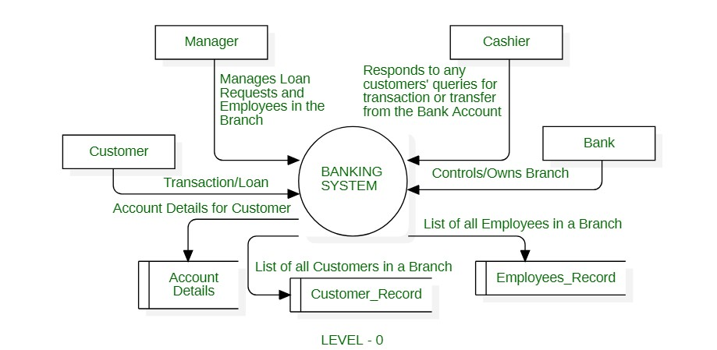

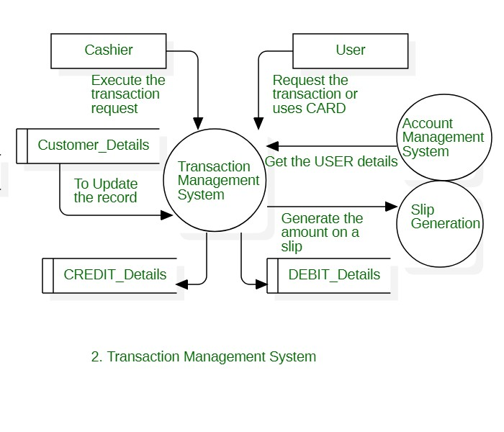

## PROJECT OUTCOMES

The implementation and effective operation of a Bank Account Management System (BAMS) can lead to several beneficial outcomes for both the bank and its customers. Here are some of the key outcomes:

1. **Improved Operational Efficiency**:
   * Streamlined account creation, maintenance, and transaction processing reduce manual errors and processing times.
   * Automated workflows and integration with other banking systems enhance overall efficiency.
2. **Enhanced Customer Experience**:
   * Faster and more accurate transaction processing.
   * Convenient self-service options, such as online and mobile banking.
   * Prompt customer support and timely resolution of inquiries or issues.
3. **Increased Security and Fraud Prevention**:
   * Robust security measures protect against unauthorized access, fraud, and data breaches.
   * Monitoring tools and alerts help detect and prevent suspicious activities in realtime.
4. **Transparent and Accurate Financial Management**:
   * Clear visibility of account balances, transactions, fees, and interest calculations.
   * Regular and accessible financial statements and reports for account holders.
5. **Cost Savings**:
   * Reduced manual processes and errors lead to cost savings in operations.
   * Efficient fee and interest calculations optimize revenue streams for the bank.
6. **Scalability and Adaptability**:
   * The system can easily adapt to changes in banking regulations, technological advancements, and growing customer demands.
   * Scalable infrastructure supports the bank's growth without significant additional investments.
7. **Regulatory Compliance**:
   * Automated compliance checks and reporting ensure adherence to banking regulations and standards.
   * Simplified audit processes and reduced risks of non-compliance penalties.
8. **Data-Driven Insights**:
   * Access to comprehensive data analytics and reporting capabilities.
   * Insights into customer behavior, preferences, and trends to inform strategic decisions and personalized services.
9. **Integration with Digital Banking Solutions**:
   * Seamless integration with online, mobile, and digital banking platforms enhances the overall digital banking experience for customers.
   * Enables the delivery of innovative banking products and services.
10. **Building Trust and Reputation**:

* Reliable and secure banking services foster trust among customers.
* Positive customer experiences and efficient services enhance the bank's reputation in the market.

In summary, the outcomes of a well-implemented Bank Account Management System include improved operational effectiveness, enhanced customer satisfaction, strengthened security measures, regulatory compliance, and the ability to leverage data for strategic decision-making. These outcomes contribute to the bank's success, competitiveness, and long-term growth in the financial industry.

## 

## REFERENCES

1. [Introduction to Java Swing - GeeksforGeeks](https://www.geeksforgeeks.org/introduction-to-java-swing/)
2. [Java AWT Tutorial (geeksforgeeks.org)](https://www.geeksforgeeks.org/java-awt-tutorial/)
3. Java: The Complete Reference, Twelfth Edition, 12th Edition by Herbert Schildt.

PROPOSED TIME DURATION: 1-1.5 MONTH