**SYNOPSIS**

**Report on**

**E-LEARNING PLATFORM**

**By**

**Prachi Sharma (**2200290140110)

**Prajjwal Yadav** (2200290140)

**Priyanka Pandey** (2200290140117)

**Session:2023-2024 (IV Semester)**

Under the supervision of

**Dr. Shashank Bhardwaj**

### KIET Group of Institutions, Delhi-NCR, Ghaziabad



### Department Of Computer Applications

**KIET GROUP OF INSTITUTIONS, DELHI-NCR, GHAZIABAD-201206**

(April 2024)

**ABSTRACT**

In the contemporary era of digital education, e-learning platforms have emerged as transformative tools reshaping the landscape of learning and instruction. This abstract delves into the core features and benefits of an innovative e-learning platform designed to cater to diverse educational needs.

The e-learning platform provides a comprehensive and flexible framework for individuals and institutions to engage in dynamic learning experiences. Leveraging state-of-the-art technologies, including artificial intelligence and machine learning algorithms, the platform offers personalized learning paths tailored to the unique preferences and proficiency levels of learners. Through interactive multimedia content, including videos, simulations, and gamified modules, users are immersed in immersive learning environments that foster engagement and retention.

Moreover, the platform integrates social learning features, enabling collaborative interactions among learners, instructors, and peers. Discussion forums, live chats, and virtual classrooms facilitate knowledge sharing and peer-to-peer support, enhancing the overall learning experience. Additionally, robust assessment tools and analytics empower instructors to track progress, identify learning gaps, and provide targeted interventions to optimize learning outcomes.

Accessibility and inclusivity are prioritized through responsive design and compatibility with multiple devices, ensuring seamless access for users across various demographics and geographic locations. Furthermore, the platform emphasizes continuous improvement through feedback mechanisms and data-driven insights, fostering a culture of lifelong learning and professional development.

In conclusion, the e-learning platform represents a paradigm shift in education delivery, offering a transformative learning ecosystem that empowers learners, educators, and organizations to thrive in the digital age.

**TABLE OF CONTENTS**

Page Number

1. Introduction 4
2. Literature Review 5,6
3. Project / Research Objective 7
4. Project Flow/ Research Methodology 8,9
5. Project / Research Outcome 10
6. Proposed Time Duration 11

References/ Bibliography 12

**INTRODUCTION**

E-Learning is learning utilizing electronic technologies to access educational curriculum outside of a traditional classroom. In most cases, it refers to a course, or program delivered completely online. We define eLearning as courses that are specifically delivered via the internet to somewhere other than the classroom where the professor is teaching. E-learning platform designed to revolutionize the way individuals and institutions engage with education. In today's fast-paced world, traditional learning methods often struggle to keep pace with evolving needs and technological advancements. However, with our e-learning platform, learners are empowered to access high-quality educational content anytime, anywhere, and at their own pace.

A Person/Student/Learner has to fill up registration form which is absolutely Free. Once Learner registers successfully, they will get UserID/Email and Password for login into Student/Learner Panel. After login they can buy any course as per their choice or requirement which is available in iSchool. They can watch purchased video courses online and can submit their feedback. As well they can update their profile and can change password. Admin of this system will upload new courses which will be available for everyone. Admin can delete or edit student/learner details. Admin can modify course details and can check sells report.

**LITERATURE REVIEW**

The proliferation of e-learning platforms has garnered significant attention in educational research, reflecting the growing interest in technology-mediated learning environments. This review synthesizes key findings from recent studies on e-learning platforms, highlighting their impact on pedagogy, learner engagement, and educational outcomes.

Studies indicate that e-learning platforms offer diverse instructional approaches, including multimedia content, interactive simulations, and gamified activities, which cater to different learning styles and preferences. By providing personalized learning experiences, these platforms promote learner autonomy and self-directed learning, leading to increased motivation and engagement.

Furthermore, research suggests that social learning features embedded within e-learning platforms facilitate collaboration and knowledge sharing among learners, fostering a sense of community and collective intelligence. Discussion forums, peer-to-peer feedback mechanisms, and collaborative projects enhance interaction and promote deeper understanding of course materials.

Assessment tools integrated into e-learning platforms enable instructors to evaluate learner performance effectively and provide timely feedback for improvement. Adaptive learning algorithms analyze learner data to identify areas of weakness and recommend targeted interventions, thereby enhancing learning efficacy and retention.

Accessibility and inclusivity emerge as critical themes in the literature, with studies emphasizing the importance of designing e-learning platforms that accommodate diverse learners, including those with disabilities and varying technological proficiencies. Responsive design, multi-modal content delivery, and localization efforts contribute to ensuring equitable access to educational opportunities.

Despite the myriad benefits of e-learning platforms, challenges such as digital literacy gaps, technological barriers, and concerns regarding the quality of online instruction persist. Future research should focus on addressing these challenges while exploring innovative strategies to enhance the effectiveness and scalability of e-learning platforms in diverse educational contexts.

In conclusion, the literature underscores the transformative potential of e-learning platforms in revolutionizing educational practices and advancing learning outcomes. By leveraging technology to create engaging, inclusive, and adaptive learning environments, e-learning platforms hold promise for shaping the future of education in the digital age.

**OBJECTIVE**

* **Ability to recall previously learned material** – Students/learners can watch video courses as many times as they need. If they forgot something during the course they can come back and watch that specific part anytime.
* **Creative way to present lesson** – It is very creative way to present lectures. It will surely enhance teaching ability of tutor.
* **Low Cost** – As nobody needs to travel or rent anything so it’s very cost efficient.
* **High Quality** – As tutor do not has time boundation so he can teach in his own comfort time.
* **Learn anytime from anywhere** – Students/Learners can start learning anytime from anywhere they just required internet connection with a compatible device.
* **Improve course quality according to learner’s feedback** – Tutor can improve their course as per student’s feedback. It will help tutor to improve their ability to teach.
* **Earn Money Online**– As courses are paid so we can say it’s an online teaching business which has no boundaries means students/learners can join from across the world so this system can make good business with good quality.

**PROJECT FLOW**

**1. Needs Assessment:** Identify target audience, learning objectives, and technological requirements.

**2. Content Creation:** Develop or curate educational content, including multimedia resources, assessments, and supplementary materials.

**3. Platform Development:** Design and build the e-learning platform, ensuring usability, accessibility, and compatibility across devices.

**4. Integration of Features**: Incorporate interactive elements, social learning tools, assessment mechanisms, and analytics capabilities into the platform.

**5. Testing and Quality Assurance**: Conduct thorough testing to identify and address any technical issues or usability concerns.

**6. Launch and Promotion:** Roll out the e-learning platform to users, and implement marketing strategies to increase awareness and user adoption.

**7. User Support and Training:** Provide ongoing support to users, including technical assistance and training sessions on platform usage.

**8. Monitoring and Evaluation:** Track user engagement, assess learning outcomes, and gather feedback to continually improve the platform.

**9. Iterative Development**: Implement updates and enhancements based on user feedback and emerging trends in e-learning technology.

**10. Scaling and Sustainability**: Expand the reach of the e-learning platform to new audiences and ensure long-term viability through funding, partnerships, and strategic planning.

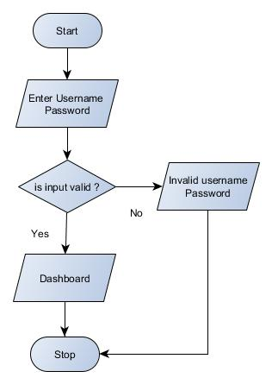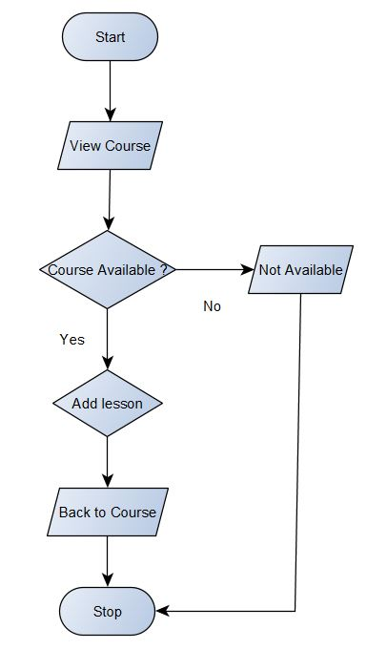

LOGIN ADD LESSON

**PROJECT OUTCOME**

**1. Increased Accessibility:** Learners can access educational resources anytime, anywhere, and overcoming geographical barriers.

**2. Enhanced Learning Experience:** Interactive multimedia content, personalized learning paths, and social collaboration tools enrich the learning process, leading to improved engagement and retention.

**3. Improved Learning Outcomes:** Effective assessment mechanisms and data-driven insights enable instructors to monitor learner progress and provide targeted interventions, resulting in better academic performance.

**4. Expanded Reach:** The scalability of the e-learning platform allows for the dissemination of educational content to a wider audience, including remote or underserved communities.

**5. Cost-effectiveness:** By reducing the need for physical infrastructure and travel expenses,e-learning platforms offer a cost-effective alternative to traditional education delivery methods.

**6. Lifelong Learning Culture:** The flexibility and convenience of e-learning promote a culture of continuous learning, empowering individuals to pursue personal and professional development goals throughout their lives.

7**. Collaboration and Knowledge Sharing:** The social learning features of the platform facilitate collaboration among learners, educators, and experts, creating a vibrant community of knowledge exchange and peer support.

**PROPOSED TIME DURATION**

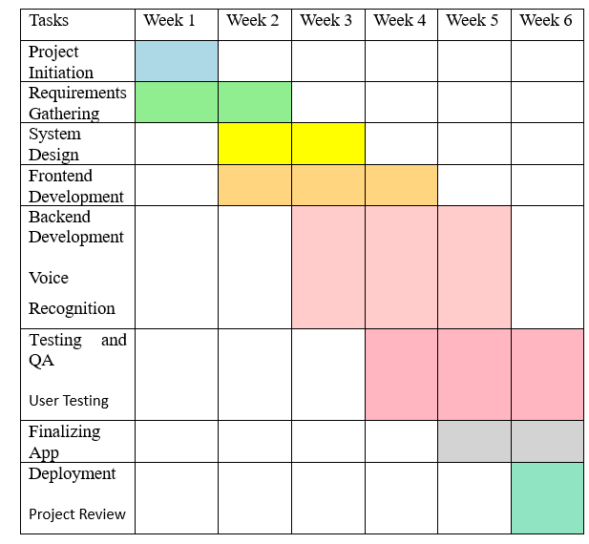

**REFERENCES**

<https://www.emerald.com/insight/content/doi/10.1108/AAOUJ-09-2020-0078/full/html>

<https://creately.com/diagram/example/ii8w6rkf1/e-learning-development-process-flow>

<https://www.indeed.com/career-advice/career-development/research-methodology>

<https://www.behance.net/gallery/123664145/eStudy-A-Complete-Case-Study-of-eLearning-Platform>

<https://www.ispringsolutions.com/blog/elearning-project-management>