{ } |   Valeriy Novytskyy |   1400 NW Irving St    Portland OR 97209 | valeriy.novytskyy@outlook.com  (503) 421-3906

Experienced full stack developer with a passion for creating compelling user interfaces and connected cloud services.


Senior Software Development Engineer Sep 2016 – Present

SoftSource / WebMD vendor Portland OR
1+ years
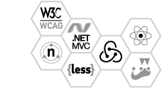
Developed server-rendered React/Redux applications served with expess.js and driven by ASP.NET WebAPI back-end.
Implemented page designs using accessible HTML5 and object oriented LESS styles, tested with Jest, Enzyme, and Mocha.
Software Development Engineer July 2011 – Sep 2016
Experis IT / Microsoft vendor Tigard OR
5+ years
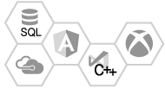
Developed continuous integration and quality assurance tools.
Maintained a cloud-based crash reporting system integrated with Jira, Team Foundation Server and Xbox One platform.
Web and Print Designer Nov 2006 – Jul 2011
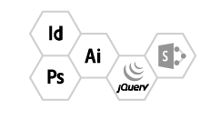
Unisource Manufacturing Portland OR
4+ years
Used SharePoint and jQuery to create content-driven sites, designed marketing materials in Adobe Creative Suite.

Associate of Applied Science in IT & Multimedia Aug 2006 - Mar 2008

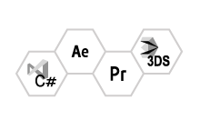
ITT Technical Institute Portland OR
Studied software development, graphic design, illustration, video production, 3D modeling and animation.
Continued Education in IT & Multimedia Sep 2005 - Aug 2006
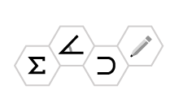
Clark Community College Vancouver, WA
Studied mathematics, logic, C programming, drawing, 3D design.
 | Certifications  70-486: ASP.NET MVC Web Applications. |  | Interests  Industrial design, robotics, music production.

