***The Business Model Canvas***

No.

***Iteration:***

Day

***On:***

Year

Month

***Designed by:***

***Designed for:***

|  |  |  |  |  |  |
| --- | --- | --- | --- | --- | --- |
| *Key Partners*  Our key partners are our teachers and our school.  And of course the others group members. | *Key Activities*  Main activity: development of a client or a chat which follows the client-server method. Software maintenance, and product assembling, testing and packaging. | *Value Propositions*  A simple chat client that send and receives messages, and interpret them to offer the best service for every type of message | | *Customer Relationships*  Of course our hypothetical customers expect from us a friendly but respectful relationship, and in fact this is exactly the relationship we offer, and to maintain this attitude is completely free! | *Customer Segments*  We are creating our project for us, to improve our development skills, and learn how to work well together. |
|  | *Key Resources*  Of course for our project the software development skills are essentials.  Another important resource we need is the time, essentials to conclude a functional product.  And, of course, group members who work well together. |  | | *Channels*  How are we integrating them with customer routines?  We can contact our customers on the following channels: GitHub, Marconi’s campus and of course email services. |  |
|  |  |  | |  |  |
|  |  |  | |  |  |
|  |  |  | |  |  |
|  |  |  | |  |  |
|  |  |  | |  |  |
|  |  |  | | *+* |  |
| *Cost Structure* | | |  | | |
| We don’t have much costs, the most important price we have is the time we sped working on the project. | | |  | | |
|  | | |  | | |

[***www.businessmodelgeneration.com***](http://www.businessmodelgeneration.com/)

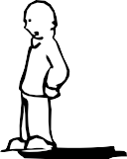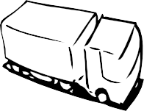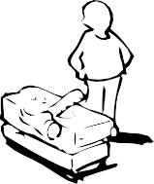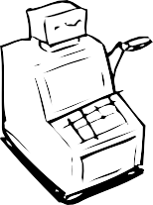

This work is licensed under the Creative Commons Attribution-Share Alike 3.0 Unported License.

To view a copy of this license, visit <http://creativecommons.org/licenses/by-sa/3.0/> or send a letter to Creative Commons, 171 Second Street, Suite 300, San Francisco, California, 94105, USA.