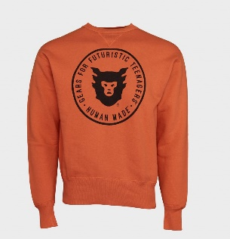 **ALOHA GATES**

|  |  |  |  |  |  |  |
| --- | --- | --- | --- | --- | --- | --- |
| **Address** | [agates@gmail.com](mailto:agates@gmail.com)  (234) 345 - 0000 |  | | | | |
| 1st University |  | | | | |
| Washington, DC 9999 |  | | | | |
|  | | | | | | |
| **EDUCATION** | | | | | | |
| **MS. in Computer Science. GPA: 3.9/4.0** | | | 05/2018 | |  |
| Johns Hopkins University, Baltimore, Maryland | | |  | |  |
|  | | |  | |  |
| **B.S. in Electrical Engineering. GPA: 3.8/4.0** | | | 05/2012 | |  |
| Catholic University of America (CUA), Washington, District of Columbia | | |  | |  |
|  | | | | | | |
| **COMPUTER SKILLS** | | | | | | |
| * Programming: C++, Java, LabVIEW, C#, Python. * Modelling: ZEMAX, COMSOL, SolidWorks, ImageJ, FEKO. | | | | | | |
|  | | | | | | |
| **PROJECTS** | | | | | | |
| Surgical navigators – control robot to pick up the object Using deep convolutional neural network to reconstruct | | | 2018 |  | | |
|  | | | | | | |
| Real-Time Cell Monitoring - wide field of view and super-resolution An 3D imaging endoscope integrated with a Kuka robot for anastomosis surgery. | | | 2016 |  | | |
| Self-driving car navigator A road prediction map for self-driving vehicle. | | | 2015 |  | | |
|  | | | | | | |
| **HONOR & AWARDS** | | | | | | |
| **Joseph E. Robert Jr. Award**  Children’s National Health System, USA | | | 09/2015 – present | | | |
|  | | |  | | | |
| **Vatican Hackathon – 2nd prize**  Vatican, Italy | | | 2018 | | | |
|  | | |  | | | |
| **Table-tennis tournament – 1st prize**  Catholic University, USA | | | 2016 | | | |
|  | | | | | | |
| **LEADERSHIP** | | | | | | |
| **Graduate Student Representative**  ECEDepartment, JHU General Council | | | 09/2016 – 09/2017 | | |
|  | | |  | | |
| **President**  Optical Society of America, JHU Student Chapter | | | 05/2015 – 09/2016 | | |