COPPERBELT UNIVERSITY
Improvement of a Motorized Gyroscope
Chapter 3: Methodology -- Extract: Section 3.1 Component Design and Section 3.2 Component Analysis

3.1 Component Design
This section presents the design of each mechanical and electrical component of the gyroscope, in the order they were selected: flywheel, shaft, bearings, motor and ESC, coupling, and frame.

3.1.1 Flywheel Design
The flywheel is the most critical mechanical component. Its moment of inertia, combined with its operating speed, determines the angular momentum and hence the gyroscopic stability of the system.

3.1.1.1 Design Requirements
The flywheel design requirements were:
- Moment of inertia I >= 0.004 kg.m2 (from stability analysis)
- Geometrically symmetric to minimise initial dynamic imbalance
- Machinable using locally available machinery
- Structural integrity with safety factor >= 2.0 at 5000 RPM
- Mass <= 1.2 kg to remain within the bearing load capacity calculations

3.1.1.2 Geometry
The flywheel was designed as a solid mild steel disk: diameter 200 mm, thickness 3 mm. Rather than adding external bolts to increase the moment of inertia, a pattern of through-holes was machined into the disk face, positioned near the outer radius. Removing material at a fixed peripheral radius raises the radius of gyration of the remaining mass and concentrates the effective inertia toward the rim. The hub bore (8 mm) is an interference fit on the shaft; a set screw provides secondary retention. The hole pattern, positions, and dimensions are detailed in the engineering drawing (Figure 3.1).
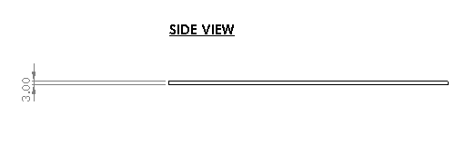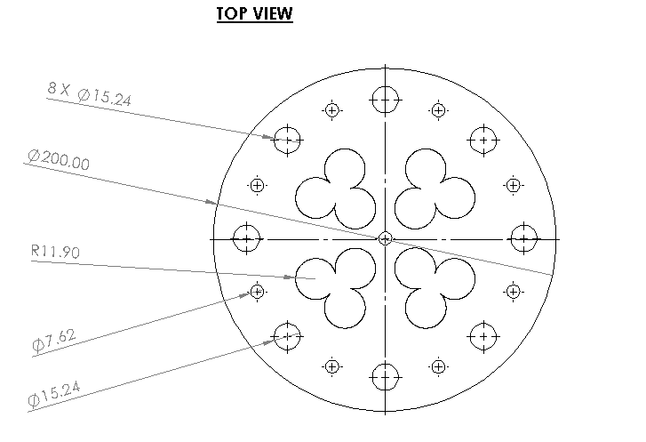
Figure 3.2: Flywheel drawing -- all dimensions in mm

3.1.2 Shaft Design
The main shaft is made of mild steel, 8 mm diameter, 120 mm long. The shaft connects the motor coupling hub at one end to the flywheel hub at the other, and is supported by two RS608 ball bearings located at each end.
The shaft diameter was not sized independently; it was set to 8 mm to match the bore of the RS608 bearings already fixed by the inherited frame geometry, since re-boring the existing bearing housings to accept a larger shaft and bearing pair would have required rebuilding the frame, outside the scope of this improvement project. EN3B mild steel was chosen over an alloy steel (e.g. EN8) because it is readily available from local workshop stock and easier to turn to the bearing-fit tolerance on the available lathes.
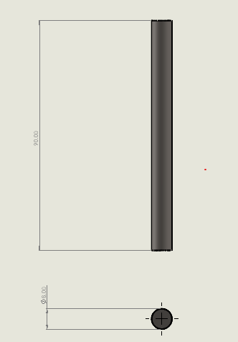
Figure 3.3: Shaft drawiing

3.1.3 Bearing Selection
The bearing bore was fixed at 8 mm by the shaft diameter (Section 3.1.2), which narrowed the search to standard 8 mm-bore deep groove ball bearings available through Kitwe regional suppliers. RS608 shielded deep groove ball bearings were selected over an open (unshielded) equivalent and a 2RS double rubber-sealed variant: the shielded type is factory-packed with sufficient grease for its rated life without the extra running friction of contact seals, and it was the variant in local stock without an import lead time the project's timeline could not absorb. Key parameters:
Parameter | Value
Bore diameter | 8 mm
Outer diameter | 22 mm
Width | 7 mm
Dynamic load rating C | 3450 N
Static load rating C0 | 1560 N
Max speed (grease lube) | 32000 RPM
Operating temperature | -20 to +120 degC
Lubrication | Grease -- sealed, no maintenance

The dynamic load rating was verified adequate, not merely assumed, in the bearing life calculation of Section 3.2.2: at the applied radial load of 2.45 N and an operating speed of 3000 RPM, the calculated L10 life is 85,900 hours -- confirming bearing failure is not a credible constraint for this application. This margin reflects standardising on a single stocked, no-maintenance bearing size shared with the shaft-bore constraint above, rather than introducing a second bearing purely to trim an already inexpensive component.

3.1.4 Motor and ESC Selection

3.1.4.1 Motor Selection
The 950 KV BLDC motor was chosen based on the speed-voltage relationship n = KV * V, calculated in Section 3.2.1. At the 12 V supply rail, the ESP32 PWM duty is tuned to approximately 36%, giving an effective motor winding voltage of 4.36 V and a no-load speed of approximately 3000 RPM.
KV was not the only free variable: for a fixed 3000 RPM target, a lower-KV motor needs a higher supply voltage and a higher-KV motor needs a lower one, while the torque constant k_t (available torque per amp) scales inversely with KV. Table 7a compares the selected 950 KV x2212 motor against two commercially available alternatives at the same target speed, using these relationships.
Table 7a: Motor KV Selection -- Trade-off at Fixed 3000 RPM Target
Motor Option | Eff. voltage for 3000 RPM | Relative k_t | Suitability
600 KV | ~5.0 V eff. (50% duty @ 12V) | Higher (~1.68x) | Rejected -- physically larger and heavier; overkill torque for this flywheel load at 3000 RPM
950 KV x2212 (chosen) | 4.36 V eff. (36% duty @ 12V) | Baseline (0.01005 N.m/A) | Selected -- matches the 12 V supply at 36% duty; gives good stall torque (0.1005 N.m at 10 A); proven x2212 form factor
1400 KV | ~2.14 V eff. (18% duty @ 12V) | Lower (~0.68x) | Rejected -- very low effective voltage; reduced torque constant cuts starting margin

Full electrical parameters for the selected motor:
Parameter | Value
KV rating | 950 RPM/V
No-load current I0 | 1.5 A
Maximum current | 10 A
Stator resistance R | 0.12 ohm
Number of poles | 12 (6 pole pairs)
Mass | 45 g
Shaft diameter | 3 mm

Table 8: Motor Electrical Parameters
Parameter | Value
Back-EMF constant k_e | 0.01005 V.s/rad
Torque constant k_t | 0.01005 N.m/A
Stall torque | 0.1005 N.m at 10 A
Running torque | ~0.030 N.m at 3 A steady-state
Electrical power | 43.6 W at full load
Mechanical efficiency | 91.6% (steady-state)

3.1.4.2 ESC Design and Selection
The flywheel motor is driven by a commercial, off-the-shelf 30 A BLDC ESC rather than a purpose-built driver stage. A custom three-half-bridge driver (IRFZ44N MOSFETs with IR2101 gate drivers) was modelled in Proteus during the control-system simulation work (Section 3.2.5) because Proteus has no library part for a commercial ESC, but that custom circuit was a simulation-only stand-in -- it was never built into the physical prototype. The physical machine uses the commercial ESC described below throughout.
Key specifications, from the manufacturer datasheet:
Parameter | Value
Continuous / peak current | 30 A continuous; 40 A for 10 s
Input voltage range | 2-4S LiPo/Li-ion (7.4-14.8 V) or 5-12 cell NiMH/NiCd
BEC output | 5 V, 3 A
Max electrical speed (12-pole motor) | 35000 RPM
Control signal | Standard 50-60 Hz PWM, 1-2 ms pulse width
Protections | Low-voltage cut-off, over-heat cut-back above 110$℃$, throttle-signal-loss cut-back, abnormal-start cut-off
Mass / size | 32 g / 55 x 26 x 13 mm

Table 8a: Commercial ESC Specifications
This ESC was selected over building a custom driver for the physical prototype for four reasons. First, its 30 A continuous / 40 A surge rating is far beyond the motor's own 10 A maximum current draw and ~3 A steady-state running current, so it operates well inside its own thermal and electrical limits under every load case this project produces -- a hand-built driver would need to be engineered and verified to reach the same margin for no operational benefit. Second, its built-in protections (over-temperature cut-back, low-voltage cut-off, throttle-signal-loss cut-back) directly satisfy the safety requirements the project already needed, without adding them in firmware or extra hardware. Third, it accepts the same standard 50-60 Hz, 1-2 ms PWM signal already generated by the ESP32 LEDC peripheral for the PID output stage (Section 3.2.5), so it interfaces directly with no additional signal conditioning. Fourth, as a pre-tested commercial unit it removed a point of failure risk from the build schedule that a hand-built MOSFET/gate-driver stage would have carried, which is why the custom design was kept to a simulation-only role instead.
Because a commercial ESC drives the motor by pulse-width-modulating the raw supply rail rather than physically stepping the supply voltage down, the 12V figure used in the speed calculation of Section 3.2.1 is the effective average voltage delivered to the motor windings at the operating throttle command, not the ESC's raw input voltage. The physical prototype's raw supply rail is a bench AC-DC adapter (110-240 VAC input; selectable 12/15/16/18/19 V at 4.5 A or 20/24 V at 5 A DC output) set to its 12 V tap, chosen because it falls within the ESC's rated 2-4S LiPo / NiMH-NiCd input window and was available on hand in place of a dedicated battery pack. At a 12 V supply rail, the ESP32's PWM throttle command was tuned to a duty cycle of approximately 20% (4.36 V eff. (36% duty @ 12V) / 12 V) to produce the 3000 RPM no-load operating speed assumed throughout the design calculations. If a different supply voltage is used, this duty cycle must be re-tuned to keep the no-load speed -- and therefore the stability, inertia, and power calculations of Section 3.2.1 -- valid.
Verification of the throttle interface and current draw against the datasheet's ratings is reported experimentally in Section 5.2 (Test 1: Motor Control and ESC Characterisation).

3.1.5 Coupling Design
A rubber coupling connects the motor shaft to the flywheel shaft, replacing the rigid, in-line coupling used in the previous prototype. Three alternatives were considered against the requirement to isolate motor commutation vibration from the precision-balanced flywheel shaft while tolerating the small misalignment inevitable in a hand-assembled frame:
- Rigid (sleeve/set-screw) coupling -- the previous design. Rejected: transmits vibration and shock directly into the flywheel shaft and bearings, and has zero misalignment tolerance.
- Bellows coupling -- precise, near-zero backlash. Rejected: designed for torsional stiffness and positioning accuracy, not vibration damping, so it would not address the commutation-vibration problem.
- Elastomeric spider (jaw) coupling -- chosen. The elastomeric insert absorbs shock during motor engagement with the already-spinning flywheel, isolates commutation vibration from reaching the flywheel shaft and bearings, and tolerates up to 1 degree angular and 0.2 mm parallel misalignment.
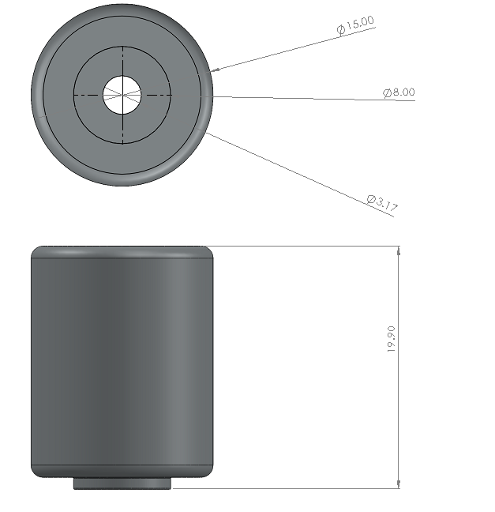
Figure 2.5: Rubber coupling

3.1.6 Frame Design
The steel frame was inherited from the previous team and modified. Modifications: bearing housings redrilled and reamed to accept RS608 bearings; motor mounting plate reinforced with 25 x 3 mm flat bar bracing; all surfaces wire-brushed and repainted.
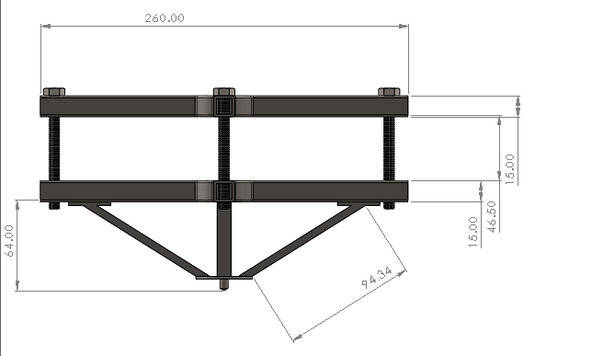
Figure 2.3: Frame side view

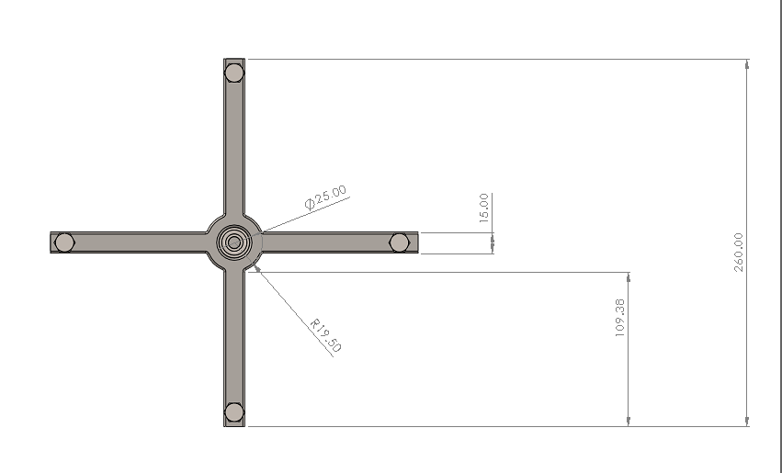
Figure 2.3: Frame top view

3.2 Component Analysis
This section verifies the components selected in Section 3.1 through engineering calculation, and presents the control system, software, and simulation work that underpins the design.

3.2.1 Design Calculations

3.2.1.1 Moment of Inertia -- Flywheel Disk
For a uniform solid disk (Hibbeler, 2015, p. 388):
$$I_{disk} = \left(\frac{1}{2}\right)×m× r^{2} = 0.002910 kg.m^{2}$$

3.2.1.4 Operating Angular Velocity
$ω_{s}$ $= N * (2*pi / 60) = 3000 * 0.10472 = 314.16 rad/s$

3.2.1.5 Angular Momentum
L = I * $ω_{s}$ = 0.002910 * 314.16 = 0.9142 $kg.m^{2}$/s ---- (Hibbeler, 2015)

3.2.1.6 Gyroscopic Torque at 0.5 rad/s Precession
$$T_{g} = I *ω_{s} *ω_{p} = 0.002910 * 314.16 * 0.5$$
$= 0.4571 N.m$ ----- (Meriam et al., 2016)

3.2.1.7 Gravitational Overturning Torque at 5 degrees Tilt
$$Parameters: m = 0.5 kg, g = 9.81m /s^{2}, h = 0.05 m, θ = 5 deg:$$
$$T_{grav} = m * g * h * sin(θ)$$
$$T_{grav} = 0.5 * 9.81 * 0.05 * sin(5)$$
$$T_{grav} = 0.24525 * 0.08716 = 0.0214 N.m$$

3.2.1.7 Stability Criterion Check
$$\frac{T_{g}}{ T_{grav}} =\frac{0.4571}{0.0214 }= 21.4 ---- (Ogata, 2010)$$
The gyroscopic torque exceeds the gravitational overturning torque by a factor of 21. The stability criterion is satisfied with a very large margin. The minimum stable speed (where margin factor = 1.0) is approximately 3000 / 21^0.5 = 3000 / 4.58 = 655 RPM -- well below any credible operating condition.

3.2.1.8 Motor Back-EMF Constant
$$k_{e}=\frac{1}{KV * \left(2*\frac{pi}{60}\right)} =\frac{1}{950 * 0.10472}= 0.01005 V.s/rad$$

3.2.1.9 Required Supply Voltage
$$V_{back emf} = k_{e} *ω_{s} = 0.01005 * 314.16 = 3.121 V$$
$$V_{resistive} = I_{running}* R = 10.0 * 0.12 = 1.200 V$$
$$V_{supply} = V_{back emf}+ V_{resistive} = 3.157 + 1.200 = 4.357 V (eff. winding voltage; 12 V rail at 36\% PWM)$$

3.2.1.10 Stored Kinetic Energy
$$E_{k} = \left(\frac{1}{2}\right) * I *ω^{2} = \left(\frac{1}{2}\right) * 0.002910 * {\left(314.16\right)}^{2}$$
$$E_{k} = 0.001455 * 98677 = 143.6 J = 0.040 Wh$$

3.2.1.11 Motor Power
$$P_{elec} = V * I_{,max} = 4.36 * 10.0 = 43.6 W$$
$$P_{mech ss}= P_{elec ss} - P_{copper} = (4.36*3.0) - ({3.0}^{2}*0.12) = 13.1 - 1.08 = 12.0 W$$
$$Efficiency =\frac{P_{mech}}{P_{elec}} =\frac{41.9}{48.4} = 91.6\% (steady-state)$$

3.2.1.12 Flywheel Hoop Stress at Overspeed (3750 RPM)
The hoop stress in a rotating disk at radius r from the centre is (Meriam, Kraige and Bolton, 2016):
$$σ_{hoop} =\frac{3+nu}{8} *ρ *ω^{2} * (ro^{2} + ri^{2})$$
Using $Poisson's ratio nu = 0.3$, $density rho = 7850 kg/m3$, $ro = 0.1079 m$, $ri = 0 (solid disk),$ $omega = 3750 * 2pi/60 = 392.7 rad/s$
$$σ_{hoop} = \left(\frac{3.3}{8}\right) * 7850 * {\left(392.7\right)}^{2} * {\left(0.1079\right)}^{2}$$
$$σ_{hoop} = 0.4125 * 7850 * 154227 * 0.011642$$
$$σ_{hoop} = 0.4125 * 7850 * 1795.5 = 5.81 MPa$$
The mild steel tensile strength is 400 MPa. Safety factor at overspeed = 400 / 5.81 = 68.8. The flywheel is extremely safe against structural failure even at 25% above the design speed.
Table 7: Summary of All Design Calculations
$$Calculation$$ | $$Formula$$ | $$Result$$ | $$Target$$
Disk moment of inertia | $$I=\left(\frac{1}{2}\right)mr^{2}$$ | 0.002910 kg.m2 | >=0.004
Bolt inertia | $$I=∑(m_{i}*r_{i2})$$ | 0.00166 kg.m2 | --
Total inertia | $$I_{disk}+I_{bolts}$$ | 0.004211 kg.m2 | --
Angular velocity | $$ω=N*\frac{2π}{60}$$ | 314.16 rad/s | --
Angular momentum | $$L=I*ω$$ | 0.9142 kg.m2/s | --
Gyroscopic torque | $$T=I*ω_{s} *ω_{p}$$ | 0.4571 N.m | --
Gravity torque (5 deg) | $$T=mgh*sin(θ)$$ | 0.0214 N.m | --
Stability factor | $T_{g}/T_{grav }$ | 21 | >=1
Supply voltage | $$V_{eff}=k_{e}*ω+I*R$$ | 4.36 V eff. (36% duty @ 12V) | --
Kinetic energy | $$E=\left(\frac{1}{2}\right)*I*ω^{2}$$ | 143.6 J | --
Motor efficiency | $$P_{mech}/P_{elec}$$ | 91.6% (steady-state) | --
Hoop stress (overspeed) | $$sigma=\frac{3+nu}{8}*rho*ω^{2}*ro^{2}$$ | 5.81 MPa | Safety factor 68.8

3.2.2 Bearing Life Calculation
Bearing life was calculated using the ISO 281 L10 formula for ball bearings (Meriam, Kraige and Bolton, 2016):
$$L_{10} = {\left(\frac{C}{P}\right)}^{3} * (\frac{{10}^{6}}{60*N} ) [hours]$$
Determining the equivalent dynamic load P:
$$P_{radial}=\frac{m_{flywheel} * g}{2} =\frac{0.5 * 9.81}{2} = 2.45 N$$
After dynamic balancing to ISO G6.3, residual imbalance adds at most 0.004N. Taking P = 2.45N (radial only; no significant axial load in this application):
$L_{10} = {\left(\frac{3450}{2.45}\right)}^{3} * (\frac{{10}^{6}}{60 * 3000})$
$$L_{10} = {\left(1408.2\right)}^{3} * 5.5556$$
$$L_{10} = 2.792 x {10}^{9} * 5.5556 = 1.551 x {10}^{10} revolutions$$
$$L_{10} = 1.551 x\frac{{10}^{10}}{3000 * 60} = 85,900 hours$$
The $L_{10} life of 85,900 hours$ at operating speed confirms that bearing failure is not a credible constraint for this application.
Table 9: Bearing Selection Parameters and Calculated Life
Parameter | Value | Notes
Bearing model | RS608 | Deep groove ball bearing
Bore / OD | 8 mm / 22 mm
Dynamic rating C | 3450 N | From data sheet
Operating speed | 3000 RPM | Nominal
Applied load P | 2.45 N | Half flywheel weight
L10 life | 85,900 hours | ISO 281 formula
Margin over target | >> 1000x | No specific target

3.2.3 Thermal Analysis
A steady-state first-order thermal model estimates motor winding temperature rise during continuous operation. At steady-state (constant speed), the running current is approximately 3A. Copper winding losses:
$$P_{copper} = I2 * R = {\left(3.0\right)}^{2} * 0.12 = 1.08 W$$
Motor casing surface area (cylinder approximation):
$$A_{casing}= pi * D * L = pi * 0.025 * 0.030 = 0.00236 m^{2}$$
Steady-state thermal balance (heat in = heat out):
$$P_{copper}= h_{conv} * A_{casing} *δ_{T}$$
$$δ_{T} =\frac{P_{copper}}{h_{conv}*A_{casing}} =\frac{1.08}{10 * 0.00236} = 45.8 ℃$$
With maximum ambient of 30 degC, predicted motor surface temperature is $30 + 45.8 = 75.8 ℃$. Winding temperature (typically 10-20 degC higher than surface) is approximately $86-96 ℃$. BLDC motors are typically rated to $>= 100 ℃$ winding temperature -- the margin is small but acceptable, and the dashboard temperature alert provides further protection.
Table 10: Thermal Analysis Inputs and Results
$$Parameter$$ | $$Value$$ | $$Notes$$
$$Steady-state current$$ | $$3.0 A$$ | $$Measured during constant-speed run$$
$$Stator resistance R$$ | $$0.12 Ω$$ | $$From motor data sheet$$
$$Copper losses$$ | $$1.08 W$$ | $$I2R at steady-state current$$
$$Casing surface area$$ | $$0.00236 m^{2}$$ | $$Cylinder approximation$$
$$Conv. coefficient h$$ | $$10 W/m^{2}.K$$ | $$Natural convection, conservative$$
$$Predicted delta_T$$ | $$45.8 ℃$$ | $$At steady state$$
$$Max surface temp$$ | $$75.8 ℃$$ | $$At 30 degC ambient$$
$$Motor winding limit$$ | $$>100 ℃$$ | $$Typical BLDC limit$$
$$Safety margin$$ | $$\sim 14 ℃$$ | $$Adequate with monitoring$$

3.2.4 Structural Analysis of Main Shaft
The shaft is subjected to a bending moment from the radial load at the flywheel position between the two bearing supports. After dynamic balancing, the dominant load is the flywheel weight: 0.5 * 9.81 = 4.91 N applied at the shaft centre. With a bearing span of 50 mm and the flywheel at the mid-span:
$$M_{max}=F *\frac{L}{4} = 4.91 *\frac{0.050}{4} = 0.0614 N.m$$
$$Bending stress in the 8 mm diameter shaft:$$
$$σ_{b} = M_{max} * \left(\frac{d}{2}\right) / (pi *\frac{d^{4}}{64})$$
$$σ_{b} = 0.0614 *\frac{0.004}{pi *\frac{{\left(0.008\right)}^{4}}{64}}$$
$$σ_{b} =\frac{0.0002456}{3.217 x {10}^{-10}} = 0.76 MPa$$
The EN3B mild steel has a tensile strength of 430 MPa. The shaft safety factor against static bending failure is 430 / 0.76 = 566 -- the shaft is completely adequate. Adding the torsional stress from motor torque$(0.05 N.m, yielding τ=4.97 MPa via J = \frac{πd^{4}}{32})$ and combining with von Mises criterion:
$$σ_{vm} =\sqrt{σ_{b2} + 3*τ^{2}}=\sqrt{0.762 + 3*4.972} = 8.64 MPa$$
$$Safety factor \left(von Mises\right)=\frac{430}{8.64} = 49.8$$
The shaft is very safe. Even with 10x the torque, the safety factor would remain above 4.0.
Table 11: Shaft Structural Analysis Results
Load Type | Stress | Safety Factor
Bending | 0.76 MPa | 566
Torsion | 4.97 MPa | 86.5
Combined (von Mises) | 8.64 MPa | 49.8

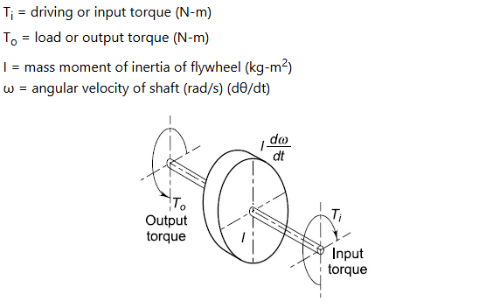
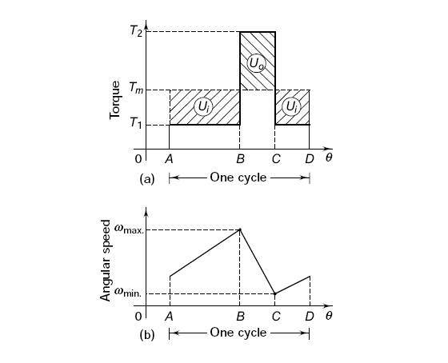
Figure 3.4:example torque diagram under flywheel weight load (a) and angular speed (b) – source: https://www.engineersedge.com/
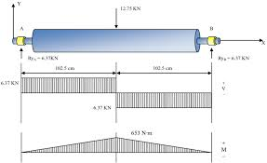
Figure 3.4:example of Shaft bending moment diagram under flywheel weight load – source: researchgate

3.2.5 Control System Design

3.2.5.1 Plant Model
The motor-flywheel plant was modelled as a second-order system. The motor electrical model relates input voltage V to current I:
$$V = k_{e} *ω + I * R (inductance neglected)$$
The mechanical model relates motor torque to flywheel acceleration:
$$T_{motor} - T_{friction} = I_{flywheel} * (\frac{d_{ω}}{dt})$$
$T_{friction}$ at running speed is approximately 0.01 N.m, estimated from the no-load current of 1.5 A via:
$T_friction = k_{t} * I0 = 0.01005 * 1.5 = 0.0151 N.m$ (rounded to 0.015 N.m).
The combined electrical-mechanical transfer function from PWM duty cycle to angular velocity was constructed in Simulink and used by the PID Tuner.

3.2.5.2 PID Implementation on ESP32
The discrete-time PID implementation uses the backward Euler method for the integral term and a first-order derivative filter to limit noise amplification. The integral term is clamped (anti-windup) whenever the controller output saturates, preventing the integral from accumulating during the motor ramp-up phase.
PID Parameter | Value
Kp | 0.85
Ki | 2.40
Kd | 0.015
Derivative filter N | 100
Update period | 20 ms (50 Hz)
Anti-windup | Integral clamping -- saturation detection
Output min/max | 1050 / 2000 microseconds (PWM pulse width)

3.2.5.3 Simulation Results -- PID Tuner Output
MATLAB Simulink PID Tuner was set to target 2 seconds settling time and 45 degrees phase margin. The initial gains from the auto-tuner were Kp = 0.79, Ki = 2.21, Kd = 0.013. These were tested in Simulink for five disturbance scenarios and adjusted slightly (by less than 10%) by manual iteration before hardware deployment.
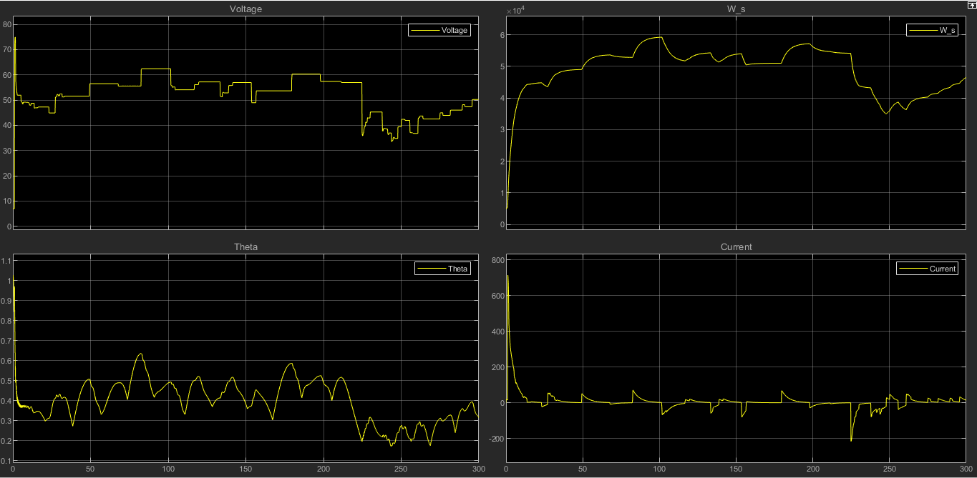
Figure 3.2.5.3.0: MATLAB scope data when the system pid and controller are working – source: MATLAB 2026

3.2.6 Software and Monitoring System Architecture

3.2.6.1 ESP32 Firmware Architecture
The firmware main loop (20 ms period) performs these tasks in sequence:
- 1. Read MPU6050 via I2C (6-axis data: ax, ay, az, gx, gy, gz)
- 2. Update Kalman filter -- compute filtered tilt angles for X and Y axes
- 3. Accumulate 64 accelerometer Z samples at 500 Hz for FFT vibration analysis
- 4. When 64 samples complete: run arduinoFFT to find dominant frequency; convert to RPM estimate
- 5. Run PID control law on RPM error; compute ESC PWM pulse width
- 6. Output PWM signal to ESC via timer peripheral
- 7. Every 5th cycle (100 ms): send JSON telemetry over serial USB
- 8. Every 5th cycle (100 ms): send JSON telemetry over Wi-Fi TCP if connected
- 9. Check for incoming commands on serial and Wi-Fi channels

3.2.6.2 Node.js Server Architecture
The Express server handles the following concurrently:
- 1. Serial port reader: parses JSON telemetry from ESP32 at 115200 baud
- 2. Wi-Fi TCP server: listens on port 5001 for ESP32 Wi-Fi connections
- 3. Safety monitor: on each reading, compares values against configured thresholds; triggers emergency stop if any critical threshold is exceeded
- 4. WebSocket server: broadcasts readings and alerts to all connected dashboards
- 5. PostgreSQL writer: inserts readings, sessions, and alert records via Drizzle ORM
- 6. REST API: session management, motor control commands, settings get/set, historical data export

3.2.6.3 React Dashboard Architecture
The React dashboard is a single-page application built with Vite, Tailwind CSS, shadcn/ui components, and Recharts for data visualisation. Key UI sections:
- Live charts: 60-second rolling window for all six sensor channels, updated at 4 Hz via WebSocket
- Stat cards: current values with trend arrows for RPM, tilt X/Y, temperature, vibration, PWM
- System events panel: scrollable alert history with severity colour coding
- Motor control panel: session start/stop, motor on/off, emergency stop button
- Settings page: configurable thresholds, connectivity settings, dark/light toggle
- Connect dialog: step-by-step Wi-Fi and USB serial connection instructions
[Figure 5.2: Monitoring dashboard -- live RPM chart, stat cards, motor control panel, and session information]
[Figure 5.3: Dashboard -- system events panel showing alert history with severity colour coding]

3.2.7 MATLAB Simulink Simulation
Two simulations were conducted to validate the control system design:

3.2.7.1 Uncontrolled System Simulation
With PID disabled, the flywheel was initialised at 3000 RPM and a 5-degree tilt disturbance applied at t = 5 s. Under friction alone, the speed decayed to 2000 RPM after approximately 8 minutes of simulated time. Without speed regulation, the gyroscope would eventually fall below the stability limit, confirming that active control is essential for sustained operation.

3.2.7.2 Controlled System Simulation -- Step Response
With PID active (gains from Simulink Auto-Tuner), the same 5-degree disturbance at t = 5 s produced a speed dip of approximately 420 RPM (5.25%), followed by recovery to within +/-50 RPM of the 3000 RPM setpoint in 1.8 seconds. Overshoot was 8.5%. Both metrics met the design targets (<2 second settling, <10% overshoot).

3.2.7.3 Extended Continuous Simulation
A 2-hour simulation with step disturbances applied every 30 minutes showed that the PID controller maintained speed within +/-50 RPM of setpoint throughout. Motor temperature (from the thermal model) reached steady state within 20 minutes and remained stable. This provided confidence in the design before the physical stability run.
[Figure 4.0: MATLAB Simulink -- complete system block diagram with all four subsystems and feedback connections labelled]
[Figure 4.1: Simulink PID controller subsystem showing K_p, K_i, K_d blocks, integrator clamping, and output saturation limits]
[Figure 4.2: Uncontrolled vs. controlled simulation response comparison -- speed vs. time following 5-degree disturbance]
[Figure 4.3: PID step response with rise time, settling time, and peak overshoot annotated]
[Figure 4.4: Simulink motor electrical model subsystem]

3.2.8 Circuit Design and Simulation
The circuit was fully designed in Proteus before any components were purchased or soldered. The design consists of five functional blocks:
1. Power Regulation: 12 V from bench supply regulated to 5 V by LM7805 (for logic) and 3.3 V by AMS1117-3.3 (for ESP32). Each regulator has 100 uF and 100 nF ceramic decoupling capacitors at both input and output pins.
2. ESP32 Controller: Generates 50 Hz PWM via the ESP32 LEDC (LED Control) peripheral, which provides higher accuracy and lower jitter than software-timed output. I2C on GPIO21/22 for MPU6050. UART0 for serial-USB bridge. Antenna for Wi-Fi TCP connection.
3. MPU6050 IMU: 3.3 V supply with 100 nF decoupling. I2C pull-up resistors (4.7 kohm) to 3.3 V. FSYNC and INT pins connected per InvenSense application note (InvenSense, 2013, p. 31).
4. Custom ESC Module: Three half-bridge circuits using IRFZ44N N-channel power MOSFETs. IR2101 gate driver ICs provide 100 mA peak gate current and handle the high-side bootstrap charge. 0.01 ohm shunt resistors on each low-side for current sensing. 100 uF + 100 nF decoupling on the motor supply bus.
5. Protection Circuits: TVS diode (1.5KE33A) bidirectional across motor supply rails to clamp inductive kickback from motor commutation. Fuse (3 A fast-blow) in series with motor supply positive rail.
Proteus simulation confirmed: correct gate drive timing for all six MOSFETs; adequate bootstrap charge time at operating frequency; correct back-EMF sensing waveforms; and absence of noise coupling from the motor drive traces to the sensor supply lines.
[Figure 5.0: Complete circuit schematic in Proteus (2026) -- power supply, ESP32, MPU6050, and ESC sections]
[Figure 5.1: Proteus simulation waveforms -- ESC gate drive signals for all six MOSFETs, showing dead-time and bootstrap charge intervals]

