Requirement Deliverable 3: Update 1
1. Document Control Information
Field | Details
Project Title | Arbiter Coffee Hub: A Smart Coffee Shop Management & Ordering System
System Name | Arbiter Coffee Hub
Version (Current) | 1.0.0
New Version (After Update) | 1.0.1
Patch ID | PATCH-2026-001
Release Date | April 24, 2026
Prepared By | Eil John Kerby Aguilar
Reviewed By
Approved By

2. Update Overview
2.1 Type of Update (you can check multiple boxes if applicable)
/ Bug Fix
☐ Security Patch
☐ Feature Enhancement
☐ Performance Optimization
☐ UI/UX Improvement
☐ Database Modification
☐ Other: ___________
2.2 Purpose of the Update
Provide a concise explanation of why this update was necessary.
Fixing/updating the SSL configuration is required to restore trust, enable API communication, and make the web app function properly.
3. Scope of Changes
3.1 Modules Affected (red text is just a sample)
Module Name | Type of Change | Description
HTTP | Bug Fix | Refactor code structure for improved readability & maintainability
API | Bug Fix | Refactor code structure for improved readability & maintainability

3.2 Files Modified (red text is just a sample)
File Name | File Path | Description of Change
AdminController.php | backend/app/Http/Controller/Api | API hostname checks
api.js | frontend/src/config | Enhance service worker logic
serviceWorker.js | frontend/src/utils | Enhance service worker logic

3.3 Database Changes (you can check multiple boxes if applicable)
/ No database changes
☐ Schema Modified
☐ New Table Added
☐ Column Updated
If yes, provide the description below (e.g., a short paragraph or an updated ERD).
4. Proof of Update (Provide either a screenshot of major interface changes, an updated database schema, or a narrative explanation if the changes cannot be visually represented.)
Before | After
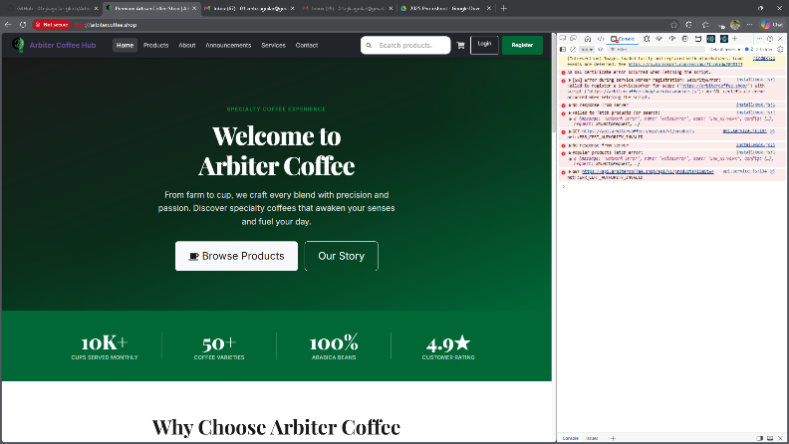 | 