**Title:** Integrating Atomic Force Microscopy and Machine Learning: Advancements and Applications

**Abstract:** Atomic Force Microscopy (AFM) is a powerful tool for high-resolution imaging and characterization of nanoscale structures. In recent years, the integration of AFM with machine learning techniques has opened up new possibilities for automated data analysis, image recognition, and feature extraction. This abstract explores the synergy between AFM and machine learning, highlighting their combined potential in enhancing our understanding of nanoscale materials and biological systems. The fusion of AFM and machine learning offers a promising avenue for accelerating scientific discoveries and technological advancements in fields ranging from materials science to biology and beyond.

**Applications of the project**

The integration of AFM and machine learning has significant applications across various fields, including materials science and biology. This technology accelerates data analysis, improves image recognition, particle identification, and enhances our understanding of nanoscale structures and biological systems.

**AFM Characteristics**

Atomic Force Microscopy (AFM) is known for its high-resolution imaging capabilities, making it suitable for nanoscale structure characterization. It allows for precise topographical imaging and mechanical measurements on the nanoscale.

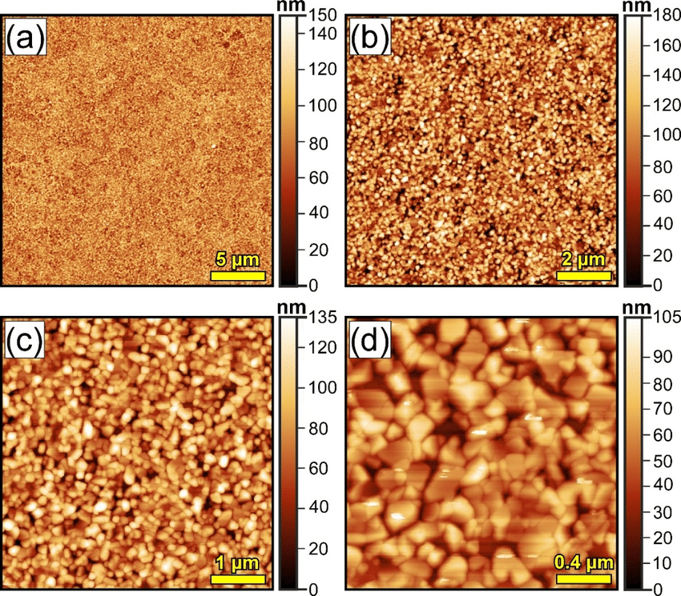

**Data set:**

Preparation guidelines

Camara specifications

Distance from which angle photo is clicked

Time at which you are clicking:

Data sets include more than 1000 images

**Existing systems**

Identify references in the literature appropriate for your project

Write the references (at leat 5)

Check git hub code