**Read a CSV file with data in multiple columns and compute mean, median, mode of each of the columns.**

**CSV FILE:**

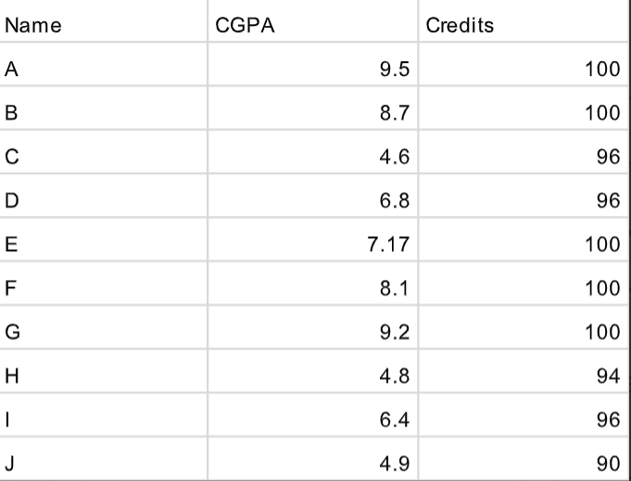

import pandas as pd

print(pd.__version__)

1.5.3

import pandas as pd

import matplotlib.pyplot as plt

import numpy as np

data = pd.read_csv("/content/drive/MyDrive/Studentdetails.csv")

print(data.to_string())

Name CGPA Credits

0 A 9.50 100

1 B 8.70 100

2 C 4.60 96

3 D 6.80 96

4 E 7.17 100

5 F 8.10 100

6 G 9.20 100

7 H 4.80 94

8 I 6.40 96

9 J 4.90 90

print("Mean:")

print(data.mean())

Mean:

CGPA 7.017

Credits 97.200

dtype: float64

print("\nMedian")

print(data.median())

Median

CGPA 6.985

Credits 98.000

dtype: float64

a=data.plot()

plt.show()

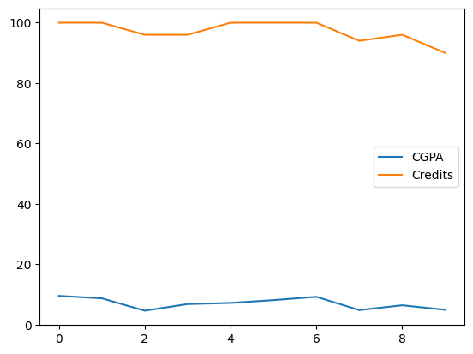

**Plot each of the columns with different colors (check what kind of graph is suitable )**

import matplotlib.pyplot as plt

import numpy as np

xpoint=(["Banglore","Hyderabad","Mumbai","Chennai"])

ypoint=([13607800,10801163,25368000,11933000])

c=(["red","blue","green","hotpink"])

plt.bar(xpoint,ypoint,color=["red","blue","hotpink","yellow"])

plt.xlabel("City")

plt.ylabel("Population")

plt.show()

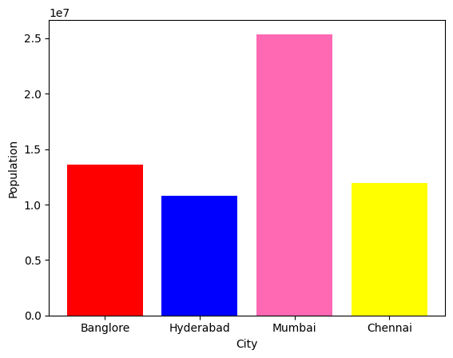

**Create a game (like lottery/ rock paper/scissors) and write a python code to record how many times the computer won and the user won. Plot the graph showing the success rate of user and computer with different colors**

import random

import matplotlib.pyplot as plt

comp_score=0

user_score=0

tie=0

for x in range(5):

  comp=random.randint(1,99)

  user=int(input(("Enter number between 1 to 99: ")))

  if (comp>user):

    comp_score+=1

  elif (user>comp):

    user_score+=1

  else:

    tie+=1

print("computer points")

print(comp_score)

print("user points")

print(user_score)

if(comp_score>user_score):

  print("Computer  won")

else:

  print("User won")

x=(["Computer","User","Tie"])

y=([comp_score,user_score,tie])

plt.bar(x,y)

plt.ylabel("Score")

plt.show()

Enter number between 1 to 99: 45

Enter number between 1 to 99: 48

Enter number between 1 to 99: 98

Enter number between 1 to 99: 57

Enter number between 1 to 99: 79

computer points

1

user points

4

User won

