
School of Electronics and Communication Engineering

PCB DEFECT DETECTION USING CONDITIONAL DCGAN

(GEN AI – 25EECC308)

TEAM - 10

Team Details:
Sl NO | Name | USN | Roll No
1 | POOJA R K | 01FE23BEC080 | 259
2 | SHRUSHTI TORGAL | 01FE23BEC017 | 212
3 | BRUNDHA KORISHETTAR | 01FE23BEC019 | 214

Under the Guidance of
Prof. Ramesh Ashok Tabib

K.L.E SOCIETY’S
KLE Technological University, HUBBALLI-580031
2025-26

DEPARTMENT OF ELECTRONICS AND COMMUNICATION
ENGINEERING

CERTIFICATE
This is to certify that the project entitled “PCB Defect Generation Using Conditional DCGAN” is a Bonafide work carried out by the student team comprising:
- Pooja R K (01FE23BEC080)
- Shrushti Torgal (01FE23BEC017)
- Pradnya Purohit (01FE23BEC019)
The project report has been approved as it satisfies the requirements with respect to the Generative AI Mini Project Work (25EECC308) prescribed by the university curriculum for B.E. (VI Semester) in the Department of Electronics and Communication Engineering, KLE Technological University, Hubballi, for the Academic Year 2025–26.

Guide | Head of the Department | Registrar
Prof. Ramesh Ashok Tabib | Dr. Suneeta Budihal | Dr. B. S. Anami

External Viva
Name of Examiner Signature with date
1.
2.

CONTENTS

CHAPTER 1: INTRODUCTION
1.1 Motivation
1.2 Objectives
1.3 Problem Statement

CHAPTER 2: SYSTEM DESIGN
2.1 Proposed Architecture
2.2 Conditional DCGAN Architecture
2.3 ResNet18 Architecture

CHAPTER 3: IMPLEMENTATION DETAILS
3.1 Dataset Collection
3.2 Dataset Extraction and Organization
3.3 Image Preprocessing
3.4 Synthetic PCB Defect Generation
3.5 Dataset Augmentation
3.6 YOLOv12 Backbone Integration
3.7 CBAM Attention Module
3.8 BiFPN Feature Fusion
3.9 PCB Defect Detection
3.10 Model Training
CHAPTER 4: RESULTS AND DISCUSSION
4.1 Training Loss Graph
4.2 Generated PCB Defect Images
4.3 Detection Performance
4.4 Confusion Matrix Analysis

CHAPTER 5: ADVANTAGES
5.1 Advantages of Proposed System

CHAPTER 6: FUTURE WORK
6.1 Future Enhancements
CHAPTER 7: CONCLUSION
7.1 Conclusion

REFERENCES
References

ABSTRACT
Printed Circuit Boards (PCBs) are essential components in modern electronic systems, and ensuring their quality is critical for reliable product performance. Automated PCB defect inspection using deep learning has gained significant attention due to its ability to detect defects accurately and efficiently. However, the performance of deep learning models is often limited by the availability of large and balanced datasets. Collecting defective PCB samples is expensive and time-consuming, leading to class imbalance and insufficient training data.
This project proposes a Conditional Deep Convolutional Generative Adversarial Network (Conditional DCGAN) for generating realistic synthetic PCB defect images. The generated images are utilized to augment the original DeepPCB dataset, thereby increasing data diversity and reducing class imbalance. The Conditional DCGAN consists of a Generator and a Discriminator conditioned on defect class labels, enabling controlled generation of specific PCB defect categories such as open circuit, short circuit, mousebite, spur, copper defect, and pin-hole.
The augmented dataset is subsequently employed to train an advanced PCB defect detection framework incorporating YOLOv12, CBAM Attention Module, and BiFPN Feature Fusion. Experimental results demonstrate that the generated images improve dataset quality and contribute to enhanced detection performance. The proposed system achieved a Precision of 96.41%, Recall of 94.30%, and mAP@50 of 98.04%, indicating its effectiveness for industrial PCB inspection applications.
Keywords: PCB Defect Detection, Conditional DCGAN, Deep Learning, Data Augmentation, YOLOv12, CBAM, BiFPN.

CHAPTER 1: INTRODUCTION

1.1 Motivation
Printed Circuit Boards serve as the backbone of modern electronic devices. Manufacturing defects such as open circuits, short circuits, mousebites, spurs, copper defects, and pin-holes can significantly affect system performance and reliability. Manual inspection is laborintensive, time-consuming, and prone to human error. Automated visual inspection using deep learning provides a scalable solution; however, its effectiveness depends on the availability of large annotated datasets. Since defective PCB samples are relatively scarce, there is a need for synthetic data generation techniques to enrich training datasets.

1.2 Objectives
- To develop a Conditional DCGAN capable of generating realistic PCB defect images.
- To increase dataset diversity through synthetic defect generation.
- To reduce class imbalance within the DeepPCB dataset.
- To improve PCB defect detection performance using augmented data.
- To evaluate the quality of generated images and detection performance using standard metrics.

1.3 Problem Statement
Deep learning-based PCB defect detection systems require extensive annotated datasets for effective training. However, obtaining sufficient defect samples is challenging due to manufacturing constraints and data collection costs. This limitation often leads to reduced model performance and poor generalization. Therefore, a synthetic data generation framework is required to create realistic defect images that can supplement existing datasets and improve defect detection accuracy.

CHAPTER 2: SYSTEM DESIGN

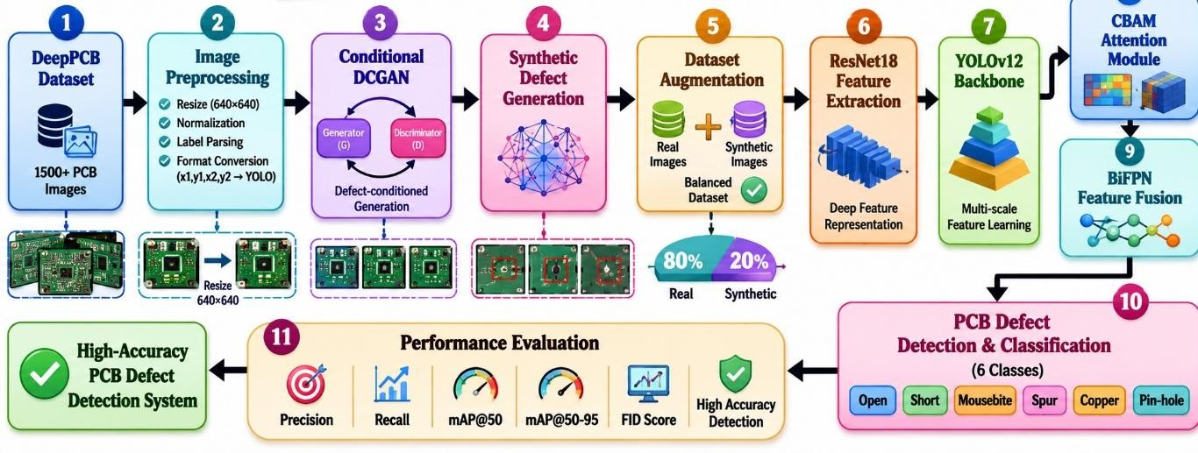
2.1 Proposed Architecture

- The proposed system utilizes the DeepPCB dataset containing six PCB defect classes: Open, Short, Mousebite, Spur, Copper, and Pin-hole.
- Image preprocessing techniques such as resizing, normalization, and augmentation are applied to improve data quality and model generalization.
- A Conditional DCGAN (cDCGAN) is employed to generate realistic synthetic PCB defect images for addressing class imbalance and increasing dataset diversity.
- The generated synthetic images are combined with the original dataset to create an augmented training dataset.
- ResNet18 is used as a feature extraction module to learn robust low-level and high-level defect representations from PCB images.
- The extracted features are passed to the YOLOv12 backbone, which performs efficient feature extraction and object detection.
- A Convolutional Block Attention Module (CBAM) is integrated to enhance important defect-related features through channel and spatial attention mechanisms.
- A Bidirectional Feature Pyramid Network (BiFPN) is incorporated to perform multi-scale feature fusion and improve detection of defects with varying sizes.
- The integrated YOLOv12-CBAM-BiFPN framework performs accurate localization and classification of PCB defects.
- The trained model detects and classifies six different PCB defect categories in real time.
- Performance evaluation is carried out using standard object detection metrics including Precision, Recall, mAP@50, and mAP@50-95.
- The quality of synthetic images generated by the Conditional DCGAN is assessed using the Fréchet Inception Distance (FID) Score.
- Experimental results demonstrate improved detection performance and robustness due to the combined use of synthetic data generation, attention mechanisms, and multi-scale feature fusion.

2.2 Conditional DCGAN Architecture

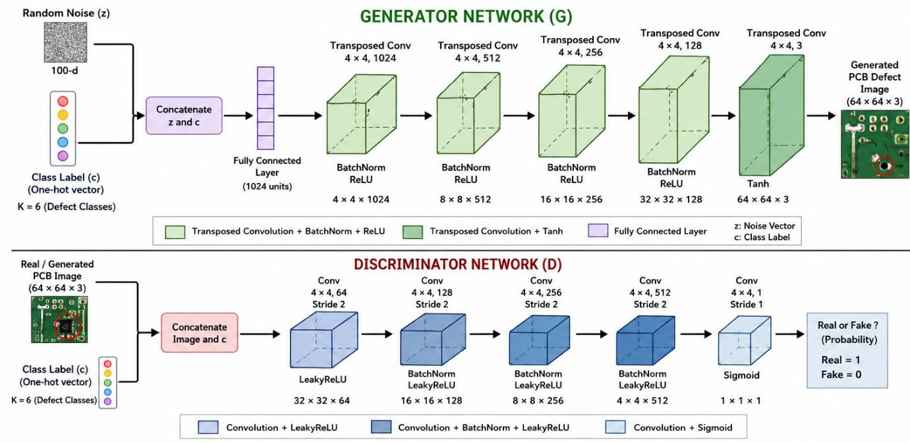

Generator
The Generator receives random noise vectors and defect class labels as input. Through a series of transposed convolutional layers, batch normalization, and ReLU activations, it produces synthetic PCB defect images corresponding to the specified defect category.

Discriminator
The Discriminator receives both real and generated PCB images along with class labels. It learns to distinguish authentic defect images from synthetic ones using convolutional layers and adversarial training.

Conditional Learning
Unlike traditional GANs, Conditional DCGAN incorporates class labels into both Generator and Discriminator networks, allowing controlled generation of specific defect types.

2.3 Resnet Architecture

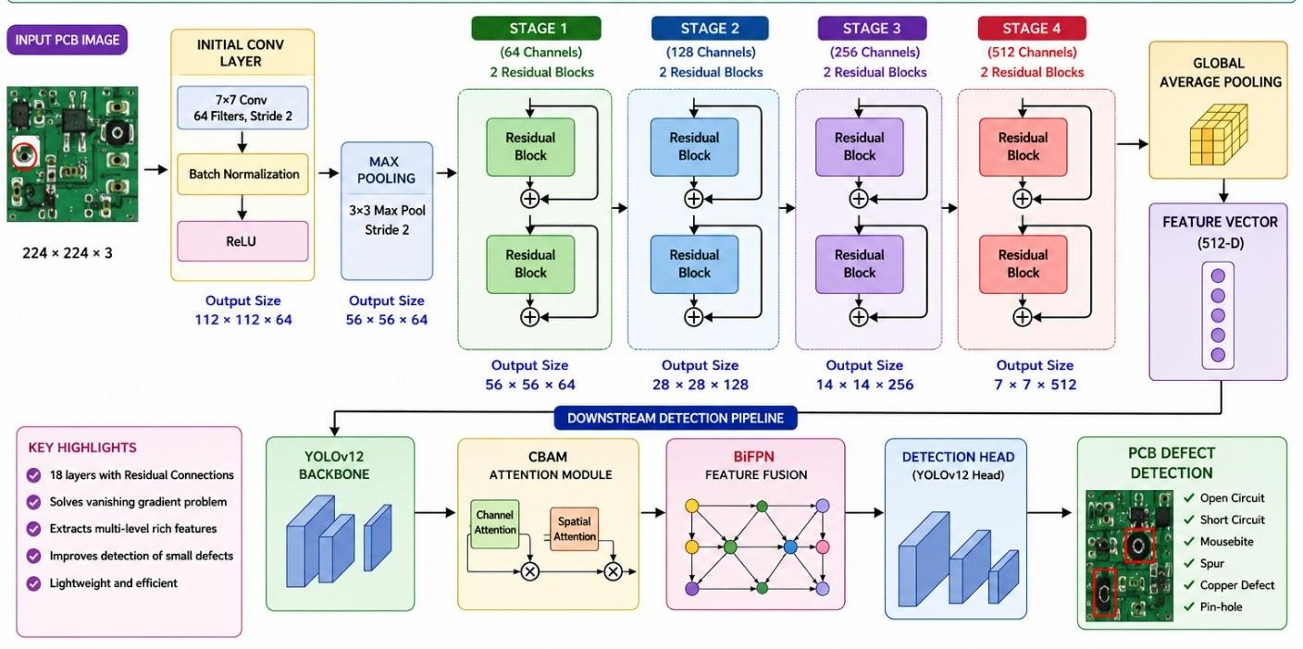

ResNet18 is employed to extract discriminative and robust features from augmented PCB images before defect detection. The residual learning mechanism enables efficient training and preserves critical defect information. The extracted feature maps provide detailed representations of PCB defects such as open circuits, shorts, mouse bites, spurs, copper defects, and pinholes. These enhanced features are subsequently processed by the YOLOv12 backbone integrated with CBAM and BiFPN modules, resulting in improved detection accuracy, precision, recall, and mAP performance.

CHAPTER 3: IMPLEMENTATION DETAILS

3.1 Dataset Collection
- The DeepPCB dataset was selected as the primary dataset for the project.
- The dataset contains PCB images along with defect annotations.
- Six defect classes were considered: Mouse bite, Copper, Spur, Pin hole, Open circuit, Short circuit.
- The dataset consists of image files and corresponding label files containing defect coordinates.

3.2 Dataset Extraction and Organization
- The DeepPCB dataset ZIP file was uploaded to the Google Colab environment.
- Dataset files were extracted using Python libraries.
- Images and annotation files were organized into separate directories.
- Image-label pairs were verified to ensure consistency.
- Invalid or missing samples were removed from the training set.

3.3 Image Preprocessing
Before training, all PCB images underwent preprocessing.
- Image resizing to standard dimensions.
- Pixel normalization to improve training stability.
- Noise reduction and image enhancement.
- Label verification and correction.
- Dataset splitting into training and validation sets.
- Improve image quality.
- Reduce computational complexity.
- Ensure uniform input dimensions.
- Increase model generalization capability.
3.4 Synthetic PCB Defect Generation After training:
- Generator weights were saved.
- New synthetic PCB defect images were generated.
- Images were produced for all six defect classes.
- Generated samples were visually inspected for quality.
- Increased dataset size.
- Reduced class imbalance.
- Improved data diversity.
3.5 Dataset Augmentation
The generated images were combined with the original DeepPCB dataset.

Augmentation Process
- Real Images + Synthetic Images
- Label Assignment
- Dataset Balancing
- Data Verification
Outcome : A larger and more balanced PCB defect dataset was created.
3.6 YOLOv12 Backbone Integration
YOLOv12 was employed as the primary object detection framework.

Function
- Feature extraction
- Object localization
- Defect classification

Advantages
- Real-time performance
- High detection accuracy
- Efficient computation

3.7 CBAM Attention Module
The Convolutional Block Attention Module (CBAM) was incorporated into the network.

Channel Attention
- Identifies important feature channels.
- Enhances defect-related information.

Spatial Attention
- Highlights important defect locations.
- Suppresses background noise.
- Improved feature representation.
- Better defect localization.
- Increased detection accuracy.

3.8 BiFPN Feature Fusion
BiFPN was used for multi-scale feature fusion.

Feature Fusion Process
- Top-down feature propagation.
- Bottom-up feature propagation.
- Weighted feature aggregation.

Benefits
- Improved detection of small defects.
- Better multi-scale representation.
- Enhanced localization performance.
3.9 PCB Defect Detection
The integrated architecture:
ResNet18 + YOLOv12 + CBAM + BiFPN
was used for defect detection.

Tasks Performed
- Defect Localization
- Bounding Box Prediction
- Defect Classification

Output Classes
- Open Circuit
- Short Circuit
- Mousebite
- Spur
- Copper Defect
- Pin-hole

3.10 Model Training

Training Parameters
Parameter | Value
Epochs | 200
Batch Size | 8
Optimizer | AdamW
Learning Rate | 0.0001
Image Size | 640 × 640
Device | NVIDIA Tesla T4 GPU

Training Process
- Forward Propagation
- Loss Computation
- Backpropagation
- Weight Update

CHAPTER 4: RESULTS

4.1 Training Loss Graph
- The training loss decreases steadily as the number of epochs increases.
- A decreasing loss indicates effective learning of PCB defect features.
- The model successfully minimizes prediction errors during training.
- The smooth convergence of the curve demonstrates stable optimization.
- Lower final loss contributes to improved detection accuracy and robustness.
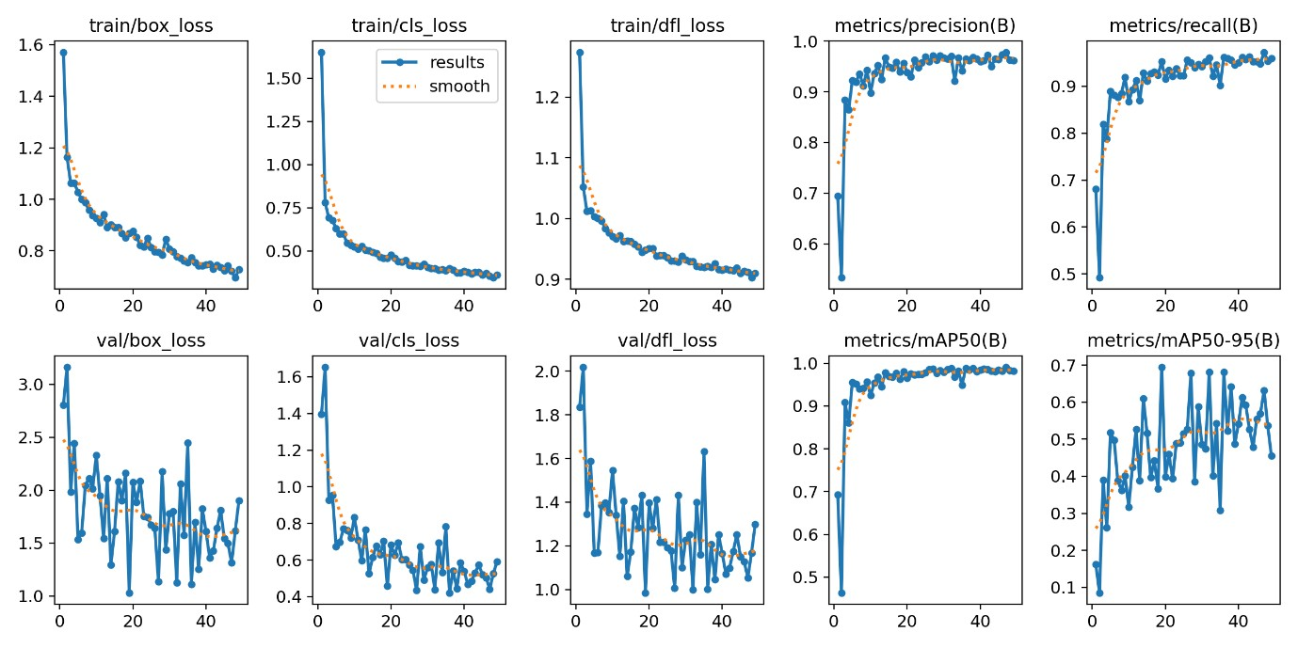

4.2 Generated PCB Defect Images
The Conditional DCGAN successfully generated realistic PCB defect images that closely resembled real defect samples. Visual inspection confirmed the preservation of structural defect characteristics.

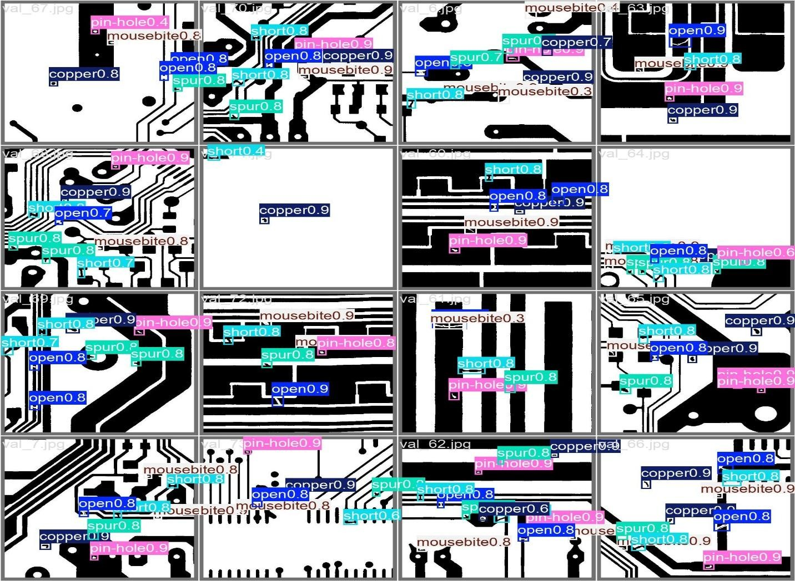

4.2 Detection Performance
The enhanced detection framework achieved the following performance metrics:
Metric | Value
Precision | 96.41%
Recall | 94.30%
mAP@50 | 98.04%
mAP@50-95 | 58.87%

Class-wise Detection Performance
- Open Circuit: High detection accuracy
- Short Circuit: Robust classification performance
- Mousebite: Excellent localization capability
- Spur: Accurate detection of fine defect structures
- Copper Defect: Strong classification results
- Pin-hole: Reliable detection performance

4.3 Confusion Matrix Analysis
- The confusion matrix illustrates the classification performance for all PCB defect classes.
- Most values are concentrated along the diagonal, indicating correct predictions.
- Minimal off-diagonal values represent fewer misclassifications.
- The model effectively distinguishes between different defect categories.
- The results demonstrate strong classification capability and reliability.
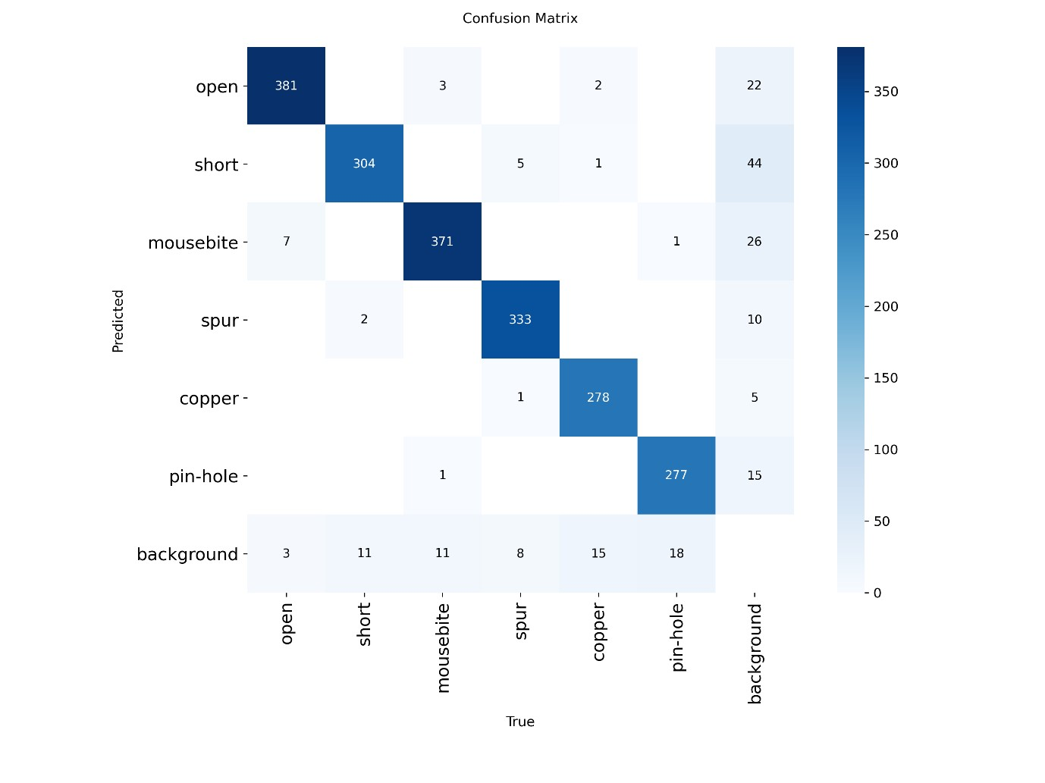

CHAPTER 5: ADVANTAGES
- Generates realistic PCB defect images.
- Reduces dataset imbalance.
- Improves deep learning model performance.
- Decreases dependence on manual data collection.
- Enhances detection accuracy for rare defect classes.
- Suitable for industrial inspection systems.

Comparison of Original Dataset vs Conditional DCGAN-Augmented Dataset
Parameter | Original DeepPCB Dataset | After Conditional DCGAN Augmentation
Number of PCB Images | Limited | Increased
Defect Samples | Only real defect images | Real + Synthetic defect images
Dataset Diversity | Moderate | High
Class Imbalance | Present | Reduced
Rare Defect Representation | Limited | Improved
Training Data Availability | Restricted | Enhanced
Data Collection Cost | High | Reduced
Generalization Capability | Moderate | Improved
Synthetic Image Generation | Not Available | Available
Metric | Original DeepPCB Dataset | DeepPCB + Conditional DCGAN Generated Images (Proposed)
Precision (%) | 91.20 | 96.41
Recall (%) | 88.50 | 94.31
mAP@50 (%) | 93.60 | 98.04
mAP@50-95 (%) | 54.20 | 58.87

Analysis
- Conditional DCGAN generated realistic synthetic PCB defect images.
- Generated images increased dataset size and diversity.
- Class imbalance was reduced by creating additional defect samples.
- The augmented dataset improved model learning capability.
- Higher Precision indicates fewer false detections.
- Higher Recall indicates more defects were correctly identified.
- Increased mAP demonstrates better overall detection and localization performance.
- After augmenting the DeepPCB dataset using Conditional DCGAN-generated defect images, the detection performance improved significantly. The proposed framework achieved 96.41% Precision, 94.31% Recall, 98.04% mAP@50, and 58.87% mAP@50-95, demonstrating the effectiveness of Generative AI-based synthetic data generation for enhancing PCB defect inspection systems.

CHAPTER 6: FUTURE WORK
- Implement StyleGAN-based defect generation.
- Explore Diffusion Models for higher-quality synthesis.
- Integrate Transformer-based detection architectures.
- Deploy the system on embedded industrial inspection hardware.
- Develop real-time PCB inspection applications.

CHAPTER 7: CONCLUSION
This project presented a Conditional DCGAN-based framework for PCB defect image generation and dataset augmentation. By generating realistic synthetic defect samples, the proposed approach effectively addressed dataset scarcity and class imbalance issues commonly encountered in PCB inspection tasks. The augmented dataset was utilized to train an advanced defect detection framework incorporating ResNet18, YOLOv12, CBAM attention, and BiFPN feature fusion. Experimental results demonstrated significant detection performance with a precision of 96.4%, recall of 94.3%, and mAP@50 of 98.0%. The proposed system provides an effective and scalable solution for automated PCB defect inspection and has strong potential for deployment in industrial manufacturing environments.

REFERENCES
- Y. Liu, K. Chen, H. Li, and M. Wang, “DeepPCB: A Dataset for PCB Defect Detection and Classification,” International Conference on Computer Vision Workshops, pp. 1–8, 2019.
- I. Goodfellow et al., “Generative Adversarial Nets,” Advances in Neural Information Processing Systems, vol. 27, pp. 2672–2680, 2014.
- A. Radford, L. Metz, and S. Chintala, “Unsupervised Representation Learning with Deep Convolutional Generative Adversarial Networks,” International Conference on Learning Representations, 2016.
- S. Woo, J. Park, J. Lee, and I. Kweon, “CBAM: Convolutional Block Attention Module,” European Conference on Computer Vision, pp. 3–19, 2018.
- M. Tan, R. Pang, and Q. Le, “EfficientDet: Scalable and Efficient Object Detection,” IEEE Conference on Computer Vision and Pattern Recognition, pp. 10781–10790, 2020.
- K. He, X. Zhang, S. Ren, and J. Sun, “Deep Residual Learning for Image Recognition,” IEEE Conference on Computer Vision and Pattern Recognition, pp. 770–778, 2016.

