
School of Electronics and Communication Engineering

Radar Obstacle Alert for UAV Scenario: Ultrasonic sensor detects obstacles for UAV; if object < safe distance, trigger warning LEDs and buzzer, log event, and adjust motor speed to avoid collision. Tasks: 1. Ultrasonic ISR 2. Motor speed adjustment. 3. LED/Buzzer alert 4. Logging Kernel Objects: ISR, event flag, message queue.
(Operating System and Embedded Systems Design - 25EECC304)

Team –7
Team Details:
Sl NO | Name | USN | Roll No
1 | POOJA R K | 01FE23BEC080 | 259
2 | ACHYUT BIDKAR | 01FE23BEC012 | 208
3 | PRADNYA PUROHIT | 01FE23BEC010 | 207
4 | BHAVANA A | 01FE23BEC087 | 265

Under the Guidance of
Dr. Basavaraj sir

CONTENTS
- Introduction
- Problem Statement
  - Objectives
- Problem Analysis
  - Features Selected
  - Assumptions Made
  - Peripherals Used for Prototyping
- System Architecture
  - Functional Block Diagram
  - RTOS Task Architecture
- Algorithm and Flowchart
- Specifications and Calculations
  - Thermistor Specifications and Temperature Calculation
  - PWM and Fan Control Calculations
  - UART Configuration
- Interfacing Diagram
- Results and Analysis
  - Hardware Results
  - Simulation Results (Proteus)
  - RTOS Memory and Timing Analysis
- Conclusion
- Future Enhancements
- References

Abstract:
Radar Obstacle Alert for UAV Scenario using RTX is a real-time embedded system designed to enhance UAV safety by detecting nearby obstacles and preventing collisions. An ultrasonic sensor continuously measures the distance between the UAV and surrounding objects. If an obstacle is detected within a predefined safe distance, the system immediately triggers visual (LED) and audible (buzzer) alerts, reduces motor speed via PWM to avoid collision, and logs the event for monitoring and analysis. The system is implemented on the LPC1768 microcontroller using RTX RTOS, enabling concurrent execution of ultrasonic sensing, motor control, alert generation, and event logging tasks. RTOS kernel objects such as Interrupt Service Routines (ISR), event flags, and message queues ensure reliable synchronization, fast response, and deterministic real-time behavior. This approach demonstrates how RTOS-based embedded systems can provide modular, scalable, and responsive solutions for safety-critical UAV applications in dynamic environments.

Radar Obstacle Alert for UAV Scenario: Ultrasonic sensor detects obstacles for UAV; if object < safe distance, trigger warning LEDs and buzzer, log event, and adjust motor speed to avoid collision.

Introduction
Obstacle detection and collision avoidance are essential for safe UAV operations, especially during low-altitude flight and indoor navigation. UAVs in dynamic environments risk colliding with walls, trees, or other obstacles, which can damage hardware or cause mission failure. To prevent this, a real-time obstacle monitoring and alert system is necessary for stable navigation. This project, “Radar Obstacle Alert for UAV Scenario using RTX,” implements such a system using an ultrasonic sensor to detect obstacles. The system is designed with an RTOS-based approach to ensure fast, reliable, and deterministic responses by dividing operations into tasks and interrupt routines.
The ultrasonic sensor continuously measures the distance between the UAV and nearby objects. When an obstacle is within the safe limit, the system triggers LED and buzzer alerts to warn the operator. Simultaneously, the motor speed is reduced to help avoid collisions. Event logging is performed using message queues for monitoring, debugging, and post-flight analysis. By using RTOS kernel objects like ISR, event flags, and message queues, the system achieves modular, responsive, and reliable obstacle alert and avoidance.
Problem Statement
The problem is to design a real-time embedded system that continuously monitors obstacles for a UAV, generates timely visual and audible alerts, logs critical events, and adjusts motor speed to avoid collisions. Delayed detection or response can lead to mission failure, UAV instability, or damage. The system must detect obstacles within a predefined safe distance and respond immediately with appropriate alerts and corrective motor control. Implementation will use the RTX RTOS on the LPC1768 microcontroller, leveraging RTOS objects such as ISR, tasks, event flags, and message queues for efficient multitasking and deterministic behavior. The design highlights the benefits of RTOS-based embedded systems over conventional polling methods in safety-critical UAV applications.
Objectives
- Design a real-time obstacle detection system using an ultrasonic sensor with LPC1768.
- Continuously measure distance and compare with a predefined safe range.
- Adjust motor speed via PWM when obstacles are detected nearby.
- Generate LED and buzzer alerts for obstacles within the safe distance.
- Log obstacle events and distance information using message queues.
- Implement concurrent ultrasonic sensing, motor control, alert handling, and logging using RTX RTOS.
- Utilize ISR, tasks, event flags, and message queues for efficient synchronization.
- Ensure deterministic real-time performance and system reliability.

3. Problem Analysis

3.1 Selected Features
- Continuous obstacle distance measurement using an ultrasonic sensor interfaced through the LPC1768 microcontroller.
- RTOS-based task decomposition using RTX, separating ultrasonic sensing, control logic, motor speed adjustment, alert generation, and UART logging.
- Multi-level obstacle classification (Safe, Warning, Critical) based on predefined safe distance thresholds.
- Visual and audible alerts (LEDs and buzzer) to indicate obstacle proximity.
- Automatic motor speed adjustment (PWM) to avoid collisions.
- UART-based logging of obstacle events, distances, and system status for monitoring and debugging.
- Inter-task communication and synchronization using event flags, message queues, and mutexes.
  - Assumptions
Table 1
Assumption | Description
Safe Distance | Predefined distance for obstacle warning and avoidance.
Sensor Accuracy | Ultrasonic sensor provides reliable distance measurements.
UAV Speed | Motor speed can be modulated via PWM without destabilizing UAV flight.
Task Timing | Sensor task executes periodically to ensure timely obstacle detection.

  - Peripherals Used
Table 2. Peripherals table
Peripheral | Purpose
Ultrasonic Sensor (HC-SR04) | Measures distance to obstacles
PWM Output | Motor speed control for obstacle avoidance
GPIO | LEDs and buzzer alerts
UART0 | System logging
RTOS Kernel | Task scheduling & inter-task communication

4. System Architecture
4.1 Functional Block Diagram
The RTOS-based obstacle detection system measures distance with the ultrasonic sensor. The Sensor Task receives distance data through an ISR and passes it to the Control Task, which determines the system state. Depending on the obstacle proximity, the Control Task triggers LED/Buzzer alerts or adjusts motor speed via PWM, while the UART Logging Task records data to a PC/monitor.
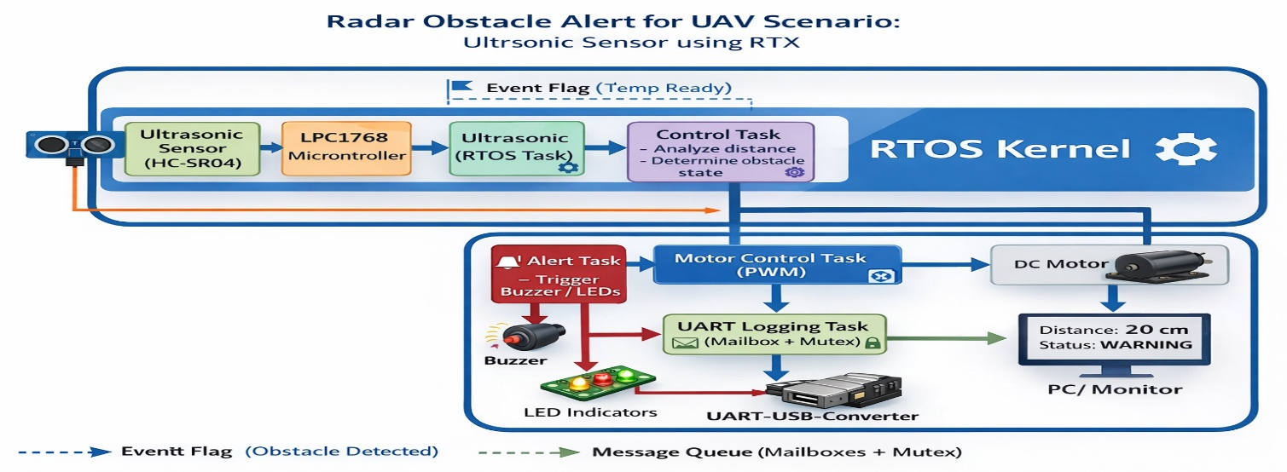

Figure 1. Functional Block Diagram of RTOS-based Radar Obstacle System

4.2 Task Architecture
Table 3. Task architecture
Task | Priority | Function
Sensor Task | Medium | Periodic obstacle distance acquisition
Control Task | High | Decision-making & alert generation
Motor Task | Medium | Adjusts motor speed via PWM
UART Task | Low | Logs obstacle events and system states

4.3 Algorithm Flow
The system begins with the initialization of LPC1768 peripherals, including GPIO for LEDs and buzzer, UART for logging, PWM for motor control, and the ultrasonic sensor for distance measurement. RTX RTOS tasks are created for sensor data acquisition, control decision-making, motor speed adjustment, and UART logging, with kernel objects like event flags, message queues, and mutexes ensuring proper task synchronization and safe communication.
The Sensor Task periodically triggers the ultrasonic sensor and measures the echo pulse to calculate the distance to nearby obstacles. The Control Task evaluates the measured distance against predefined safe, warning, and critical thresholds, triggering corresponding visual and audible alerts, adjusting the motor speed via the Motor Task, and sending system status to the UART Task for logging.
The Motor Task adjusts the UAV motor speed smoothly using PWM signals based on obstacle proximity, while the UART Task formats and sends real-time logs to a PC terminal. This task-based RTOS design ensures continuous monitoring, fast response to obstacles, deterministic real-time behavior, and safe inter-task communication. Optional safety features include emergency alerts and watchdog timers to handle sensor failures or task delays.

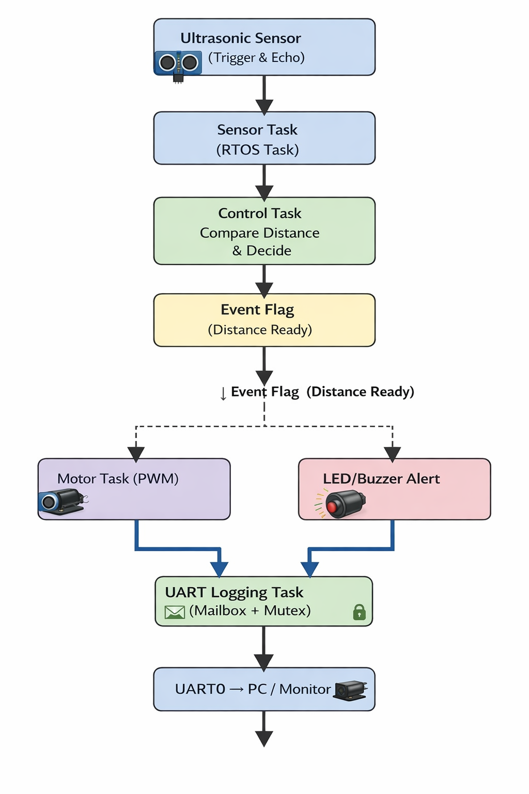
Figure 2. Data flow diagram

5. Specifications & Calculations
Parameter | Specification / Value | Calculation / Notes
Microcontroller | LPC1768 (ARM Cortex-M3) | 100 MHz, 12-bit ADC, supports RTX RTOS tasks
Ultrasonic Sensor | HC-SR04 or similar | Trigger: 10 μs pulse, Echo measures distance using Distance (cm) = EchoTime(μs)/58
Safe Distance | >30 cm | No alert, motor runs at normal speed
Warning Distance | 15–30 cm | LED blinks, buzzer intermittent, motor speed reduced 50–70%
Critical Distance | <15 cm | LED ON, buzzer continuous, motor speed reduced 0–30%
Motor PWM | 0–100% | Duty cycle adjusted dynamically based on obstacle proximity
LED Alert | Red LED | Flashes or continuous based on system state
Buzzer | Active 5V | Intermittent or continuous sound based on system state
UART Logging | 9600 baud | Message format: Distance: XX cm
RTOS Tasks | Sensor, Control, Motor, UART | Prioritized using RTX kernel objects (Event Flags, Mutex, Message Queue)
Measurement Period | 100 ms | Sensor task measures distance periodically

6. Interfacing Diagram
Figure 3 illustrates the interfacing and hardware connections of the proposed RTOS-based Radar Obstacle System. The schematic diagram shows the integration of how the LPC1768 microcontroller is connected to all the hardware components to implement the obstacle alert system. Each peripheral interacts with the MCU through dedicated pins and protocols:
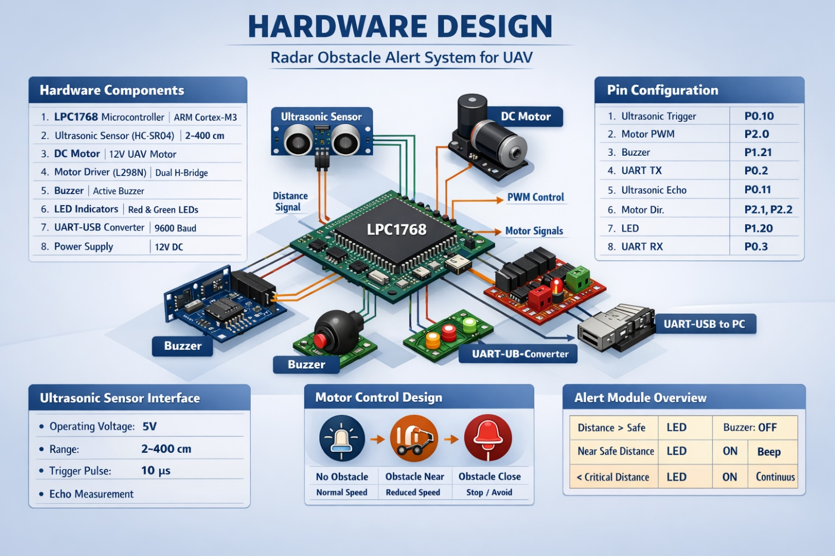
Figure 3. Interfacing diagram of the RTOS-base Radar Obstacle System

6.1Connections Overview
The interfacing details between the peripherals and the LPC1768 microcontroller are summarized below:
- Ultrasonic Sensor Trigger → P0.22
- Ultrasonic Sensor Echo → P0.21 (Interrupt for ISR)
- Buzzer → P0.23
- LED Indicators → P0.24, P0.25
- Motor PWM → P1.20
- UART TX/RX → P0.2 / P0.3 for logging

7. Results and Analysis
This section presents the functional behavior and real-time performance evaluation of the implemented RTOS-based Radar Obstacle system.
7.1 Functional Results
- Accurate real-time obstacle detection using the ultrasonic sensor.
- Motor speed adjusted smoothly according to proximity levels.
- Immediate LED/Buzzer alerts generated when obstacle thresholds crossed.
- Reliable UART logging of obstacle distance and alert status.
7.2 RTOS Performance Analysis
Memory Performance:
- Static allocation of task stacks
- Deterministic memory usage
- No heap fragmentation
Timing Performance:
- Sensor task period: 100 ms
- Control task decision latency: <5 ms
- UART logging non-blocking to avoid affecting real-time operation
7.3 Demonstration Evidence
- Hardware prototype tested with UAV motor and sensors.
- UART terminal logs showing distance measurements and alert statuses.
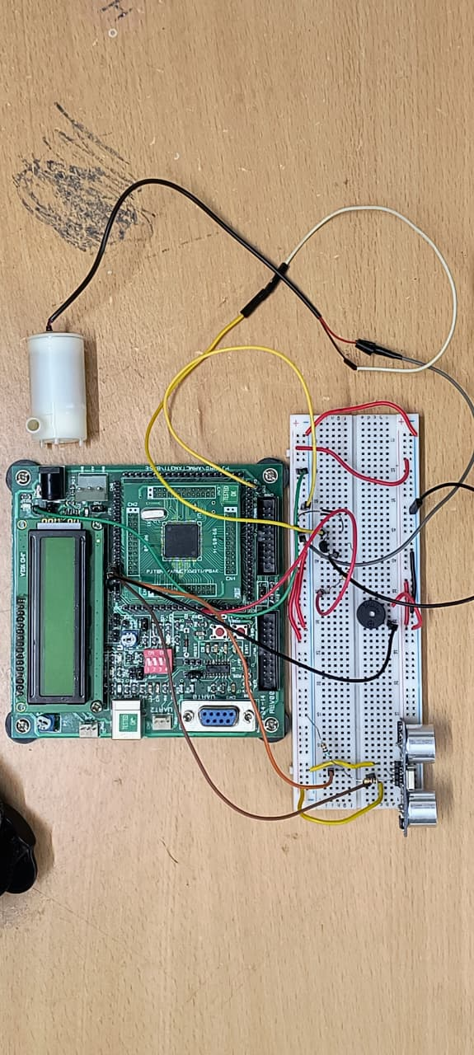

Figure 4. Hardware snapshots of the implemented prototype
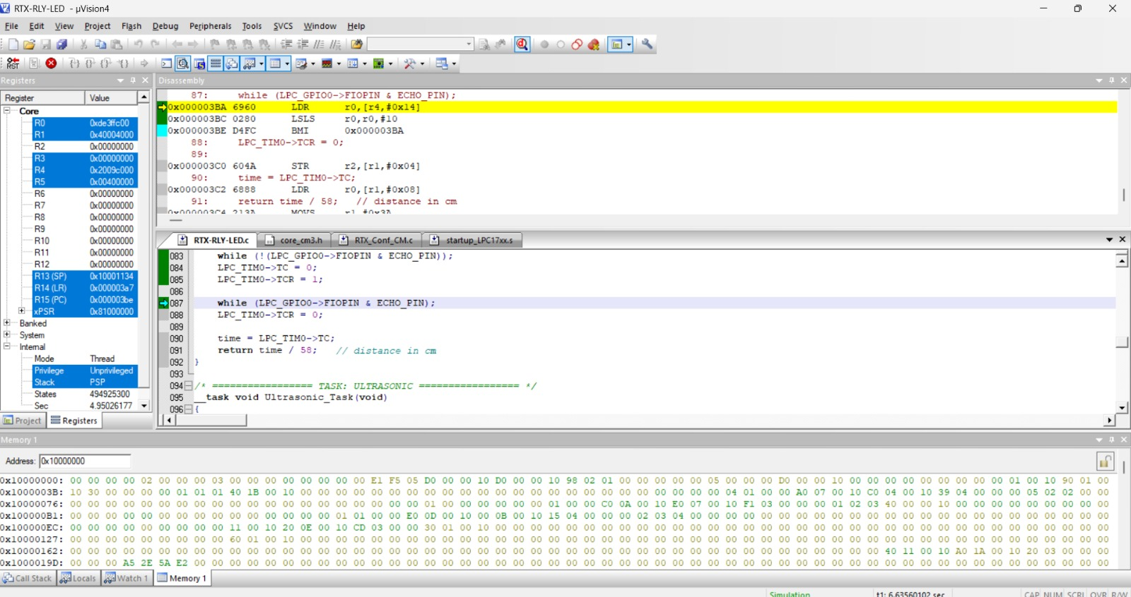
Figure 5. UART terminal logs showing temperature values and system states

8. Conclusion
This project demonstrates the design and implementation of a real-time obstacle detection and alert system for UAVs using RTX RTOS. By decomposing the application into concurrent tasks and using kernel objects (ISR, event flags, message queues, mutexes), the system achieves:
- Modular software architecture
- Deterministic real-time behavior
- Safe resource sharing
- Scalable and maintainable design
The results highlight the advantages of RTOS-based embedded design over conventional super-loop architectures in safety-critical UAV applications.

9. Future Enhancements
- Implement PID-based motor control for smoother obstacle avoidance.
- Integration of multiple ultrasonic sensors for 360° detection.
- Cloud-based data logging for post-flight analysis.
- Migration to FreeRTOS for broader industry adoption.
- Add visual display (OLED/LCD) for distance and status.

Keywords: RTOS, LPC1768, UAV, Obstacle Detection, RTX, PWM, ISR, Message Queue, Event Flag, Real-Time Control

