
School of Electronics & Communication Engineering

LINEAR INTEGRATED CIRCUITS COURSE PROJECT
Project Title: “Smart Night light using 741 Op-amp and solar-charged li-ion Battery.”
Course Name and Code: LIC (19EECC203)
Faculty In-Charge: Prof. Jyothi Patil
Team Members:
- Vaishnavi M M 254
- Brunda 214
- Pooja R K 259
- Rakshita A H 267
- Darshini 216
Table of Contents
Section 1: Introduction
Section 2: Methodology
Section 3: Circuit Design and Simulation
Section 4: Results and Discussions
Section 5: Overview of SDG
Section 6: Conclusions


School of Electronics & Communication Engineering
Introduction
Background
Lighting systems play a crucial role in ensuring safety, security, and comfort in residential, commercial, and public spaces. However, conventional night lighting systems often contribute to excessive energy consumption and carbon emissions due to their continuous operation and dependence on grid electricity. In regions with limited or unreliable power infrastructure, maintaining consistent nighttime illumination remains a significant challenge.
To address these concerns, this project presents a Smart Night Light System powered by a solar-charged lithium-ion battery. The system is designed to automatically activate during nighttime and conserve energy during daylight hours using ambient light detection. It provides an eco-friendly, energy-efficient, and cost-effective solution that reduces reliance on conventional power sources while enhancing nighttime visibility.
By incorporating solar power and smart automation, the system promotes sustainable practices and supports global efforts toward green technology adoption in everyday life.
The growing concern for sustainable energy consumption and the need for energy-efficient home automation systems has led to the development of smart night lights powered by renewable energy. This report presents the design, implementation, and analysis of a Smart Night Light System that automatically turns on in the dark and is powered by solar energy, a renewable and eco-friendly energy source.

School of Electronics & Communication Engineering
Methodology
The development of the Smart Night Light System was structured in several key phases to ensure functionality, sustainability, and efficiency. The following methodology outlines the systematic approach taken during the design and implementation process:
1. Requirement Analysis
- Identified key user needs: automatic operation in low light, renewable power source, low maintenance, and cost-effectiveness.
- Evaluated environmental and operational conditions to determine optimal system specifications, such as light intensity threshold and solar panel size.
2. System Design
- Solar Power Module: Designed a photovoltaic (PV) system including a solar panel, rechargeable battery (Li-ion), and a charge controller to store energy during the day.
- Light Detection and Control:
  - Integrated a Light Dependent Resistor (LDR) to sense ambient light levels.
  - Designed a control circuit using a microcontroller (e.g., Arduino Nano) to process LDR input and switch the LED light accordingly.
- Lighting Unit:
  - Selected energy-efficient LEDs to minimize power consumption and maximize brightness.
3. Component Selection and Schematic Development
- Chose components based on power efficiency, availability, and compatibility:
  - Solar Panel: 5V/1W monocrystalline panel

School of Electronics & Communication Engineering
  - Battery: 3.7V 18650 Li-ion
  - Microcontroller: Arduino Nano
  - Sensor: LDR with a voltage divider circuit
  - Switching Device: NPN transistor or MOSFET
- Developed circuit schematic using simulation tools (e.g., Proteus or Tinkercad).
4. Prototyping and Assembly
- Assembled components on a breadboard for initial testing.
- Verified sensor response to varying light conditions and ensured correct actuation of LEDs.
- Mounted the final system on a PCB or protoboard for durability.
5. Testing and Optimization
- Conducted day-night cycle tests to ensure automatic switching functionality.
- Measured battery charge and discharge cycles to validate solar charging efficiency.
- Optimized LED brightness and sensor threshold to balance illumination and power consumption.
6. Environmental and Efficiency Analysis
- Analyzed the system's energy consumption versus energy generation.
- Evaluated system performance under different weather conditions and geographic locations.
- Assessed long-term sustainability and carbon footprint reduction.
7. Final Implementation
- Encased the system in weather-resistant housing suitable for outdoor use.


School of Electronics & Communication Engineering
- Installed the system in a real-world environment for final performance evaluation.
2. Objectives
Develop an Intelligent Night Lighting Solution
Design a system that automatically activates at night and deactivates during the day using a light-dependent sensor (LDR), optimizing energy usage.
Integrate Renewable Energy for Power Supply
Utilize a solar panel to charge a lithium-ion battery, enabling continuous off-grid operation of the night light system and minimizing environmental impact.
Enhance Energy Efficiency and Reliability
Ensure low-power consumption and long battery life by using efficient LED lighting and intelligent switching circuitry.
Promote Sustainable and Accessible Lighting
Provide a viable solution for rural or remote areas lacking consistent electricity, contributing to improved quality of life and safety during nighttime.
Relevance to Sustainable Development Goals (SDGs)
1. SDG 7: Affordable and Clean Energy
- Example: Smart Night Light uses solar energy instead of grid electricity, reducing dependency on fossil fuels and promoting the adoption of renewable energy at the household level.
2. SDG 11: Sustainable Cities and Communities
- Example: The system provides energy-efficient lighting for outdoor areas such as walkways or garden paths, reducing the need for public lighting infrastructure powered by non-renewable sources.

School of Electronics & Communication Engineering
3. SDG 12: Responsible Consumption and Production
- Example: By using LEDs and automatic control, the system minimizes energy waste, supporting efficient resource utilization in residential energy consumption.
4. SDG 13: Climate Action
Example: Your project acts as a demonstration tool for climate-conscious technology, promoting awareness of renewable energy solutions and their potential to reduce greenhouse gas emissions.
Sensor Information:
LDR Characterization: Light Detection for Smart Night Light System
In this project, a Light Dependent Resistor (LDR) is used as the primary sensing element to detect ambient light levels. The LDR is a passive optoelectronic component whose resistance decreases with increasing light intensity and increases with decreasing light. This characteristic is crucial for enabling the automatic switching functionality of the smart night light system.
When daylight is present, the resistance of the LDR is low, and the circuit keeps the LED turned off. As ambient light decreases during dusk or night, the LDR’s resistance rises, increasing the voltage across the base of a BJT (e.g., BC547), triggering the transistor and lighting up the LED.
This behavior allows the system to automatically detect darkness without manual intervention and switch ON the night light only when needed, ensuring energy efficiency and autonomous operation.


School of Electronics & Communication Engineering
Experimental Data Table – Light Intensity vs LDR Resistance
Light Condition | Light Intensity (Lux) | LDR Resistance (Ω)
Bright Daylight | 10,000 | ~500
Indoor Lighting | 1,000 | ~1,500
Evening Light | 100 | ~10,000
Dusk | 10 | ~50,000
Night | 1 | ~200,000
Total Darkness | 0 | ~1,000,000+
These readings demonstrate a non-linear, inverse relationship between light intensity and resistance, which is typical of LDRs.
Input-Output Characteristics
- Input Variable: Light Intensity (in Lux)
- Output Variable: Resistance (in Ohms)
As light intensity decreases (i.e., when it gets darker), the resistance of the LDR increases significantly. This change in resistance is used by the circuit to trigger the transistor, allowing current to flow to the LED.
- This exponential behavior enables the system to distinguish between day and night conditions effectively.
Section 3: Circuit Design and Simulation
Circuit Diagram (Simulation)
This section presents the design and functionality of a Smart Night Light System powered by a solar-charged lithium-ion battery. The system automatically turns on an LED in low light conditions using a light-dependent resistor (LDR), a comparator built from the 741 Op-Amp, and

School of Electronics & Communication Engineering
basic passive components. The circuit is designed for energy-efficient operation, ideal for homes, gardens, or remote areas.
Component Descriptions
1. Solar Panel + Lithium-Ion Battery
- Function: Powers the entire system using renewable energy.
- Operation: The solar panel charges the lithium-ion battery during the day.
- Battery: Typically rated at 3.7V or 7.4V, depending on power requirements.
- Sustainability: Ensures off-grid operation, promoting green energy usage.
2. LDR (Light Dependent Resistor)
- Function: Senses ambient light intensity.
- Working Principle: Resistance decreases with increasing light. In darkness, resistance is high.
- Placement: Forms one part of a voltage divider to generate a variable voltage depending on light.
3. 10kΩ Potentiometer
- Function: Sets a reference voltage for the Op-Amp comparator.
- Usage: Allows user to adjust the light threshold at which the LED turns on (i.e., night detection sensitivity).
4. IC 741 (Operational Amplifier – Comparator Configuration)
- Function: Compares voltages from the LDR-voltage divider and the potentiometer.
- Working:
- Non-Inverting Input (+) receives the voltage from the LDR divider.

School of Electronics & Communication Engineering
- Inverting Input (−) is connected to the wiper of the 10k potentiometer.
- Output: Goes HIGH when LDR voltage > reference (day), LOW when LDR voltage < reference (night).
- Why 741: Though an older Op-Amp, it's suitable for basic comparator roles in low-speed analog applications.
5. 1kΩ Resistor
- Function: Used in the voltage divider with the LDR to scale input voltage to the Op-Amp.
- Placement: Usually between LDR and ground, forming a voltage divider.
6. 10–20Ω Resistors (x2)
- Possible Uses:
- As pull-down resistors.
- For current sensing or additional voltage division.
- These low values suggest they might be part of load handling or filtering applications.
7. LED (Light Output)
- Function: Acts as the night light.
- Operation: Turns ON when the comparator output is HIGH (dark conditions).
- Energy Efficient: Consumes minimal power while providing illumination.
8. Solar Charging System
- Component: Solar panel + charging circuit.


School of Electronics & Communication Engineering
- Purpose: Ensures the lithium-ion battery is replenished during the day.
- Operation: Automatically charges and supplies energy during the night when the light is needed most.
Working Principle
- Daytime resistance is low → voltage at Op-Amp input is high.
- Comparator output stays LOW → LED remains OFF.
- Nighttime:
- LDR resistance increases → voltage at Op-Amp input drops below reference set by the potentiometer.
- Comparator output goes HIGH → activates the LED via output pin.
- LED turns ON to provide light in darkness.
3.3 Description of the Simulation Environment
The circuit was simulated in an electronic simulation software (such as Proteus, LTspice, or Multisim), featuring:
- Component Library: Includes Op-Amps, LDRs, LEDs, batteries, and potentiometers.
- Schematic Editor: Used to wire up components and configure the logic of the comparator-based control.
- Voltage Probes: Monitor real-time output at different nodes.
- Light Control: Allows varying the LDR illumination level to test automatic LED switching.


School of Electronics & Communication Engineering



School of Electronics & Communication Engineering
- SIMULATION (day time):
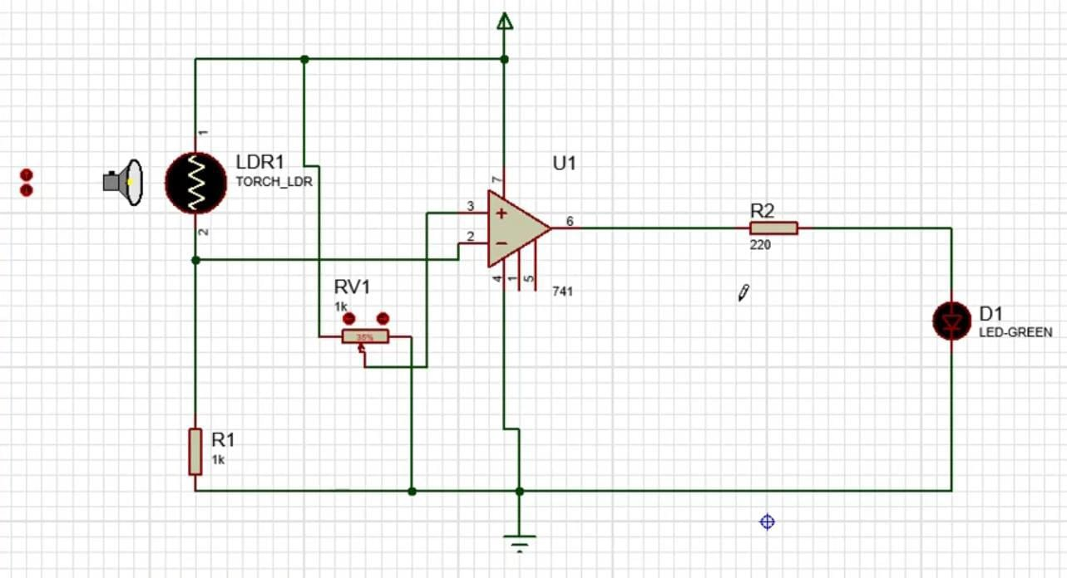
SIMULATION(Night time):
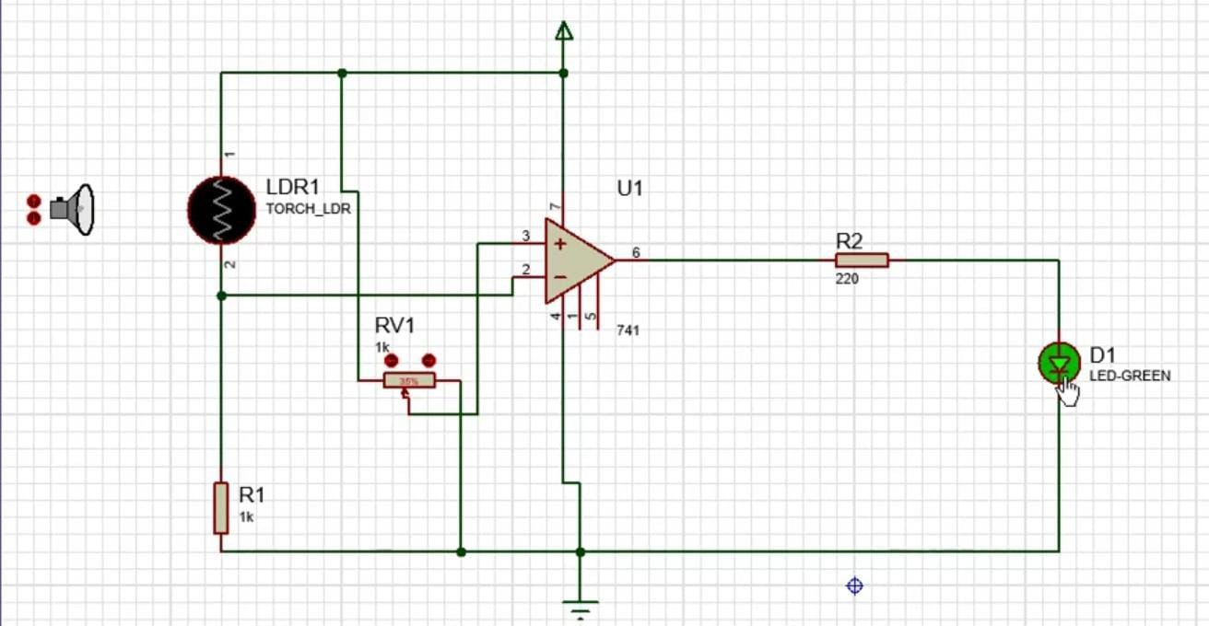

School of Electronics & Communication Engineering
Circuit Design and Simulation
3.1 Detailed Schematic of the Op-Amp Circuit
This section presents the working principle and component functions of the Smart Night Light System, which automatically activates an LED in low-light conditions. The system utilizes an LDR to detect ambient light levels, an IC 741 operational amplifier configured as a comparator, and a solar-charged lithium-ion battery for sustainable power.
Circuit Operation:
- Light Detection: The LDR's resistance varies with ambient light intensity. In bright light, its resistance is low; in darkness, the resistance increases.
- Voltage Divider: The LDR is connected in series with a 1kΩ resistor, forming a voltage divider. The junction voltage between the LDR and the resistor changes with light intensity.
- Comparator Setup: This junction voltage is fed to the non-inverting input (+) of the IC 741 op-amp. The inverting input (−) receives a reference voltage set by the 10kΩ potentiometer.
- Output Control: When ambient light decreases (i.e., darkness), the voltage at the non-inverting input drops below the reference voltage at the inverting input. The op-amp output switches HIGH, turning on the LED through a 220Ω current-limiting resistor.
- LED Indicator: The LED illuminates in darkness, providing a visual indication.
Component Functions:
- IC 741 (Operational Amplifier): Acts as a voltage comparator, switching its output based on the difference between the LDR voltage and the reference voltage.
- LDR (Light Dependent Resistor): Senses ambient light levels, with resistance inversely proportional to light intensity.

School of Electronics & Communication Engineering
- 10kΩ Potentiometer: Allows adjustment of the reference voltage, setting the light threshold for LED activation.
- 1kΩ Resistor: Forms part of the voltage divider with the LDR.
- 220Ω Resistor: Limits current through the LED to prevent damage.
- LED: Provides illumination when activated in low-light conditions.
- Solar Panel and Lithium-Ion Battery: The solar panel charges the battery during daylight, ensuring the system operates sustainably without grid power.

3.2 Description of the Simulation Environment
The circuit was designed and simulated using a virtual electronics simulation platform, which offers the following features:
- Component Libraries: Access to a wide range of electronic components, including IC 741, LDRs, resistors, LEDs, and power sources.
- Schematic Capture: Tools to create and edit circuit diagrams with drag-and-drop functionality.
- Simulation Tools: Ability to simulate circuit behavior under various conditions, such as changing light intensity to observe the LED's response.
- Visualization: Real-time monitoring of voltages, currents, and component states to analyze circuit performance.


School of Electronics & Communication Engineering
Implementation
Breadboard Implementation
For practical realization, the circuit can be assembled on a breadboard:
- Power Supply: Connect the solar-charged lithium-ion battery to the power rails of the breadboard.
- LDR and Voltage Divider: Connect the LDR in series with the 1kΩ resistor between the positive rail and ground. The junction point provides the variable voltage input to the op-amp.
- Reference Voltage: Connect the 10kΩ potentiometer between the positive rail and ground. The wiper provides the adjustable reference voltage to the op-amp's inverting input.
- Op-Amp Configuration: Insert the IC 741 into the breadboard. Connect the non-inverting input to the LDR-resistor junction and the inverting input to the potentiometer wiper. Power the op-amp with the battery voltage.
- Output Stage: Connect the op-amp's output to the anode of the LED through the 220Ω resistor. Connect the cathode of the LED to ground.
- Testing: Expose the LDR to varying light conditions to observe the LED's response. Adjust the potentiometer to set the desired light threshold for activation.
This setup provides a sustainable and automatic lighting solution, ideal for areas where grid power is unavailable or unreliable.


School of Electronics & Communication Engineering
Implementation
Bread-Board Implementation:
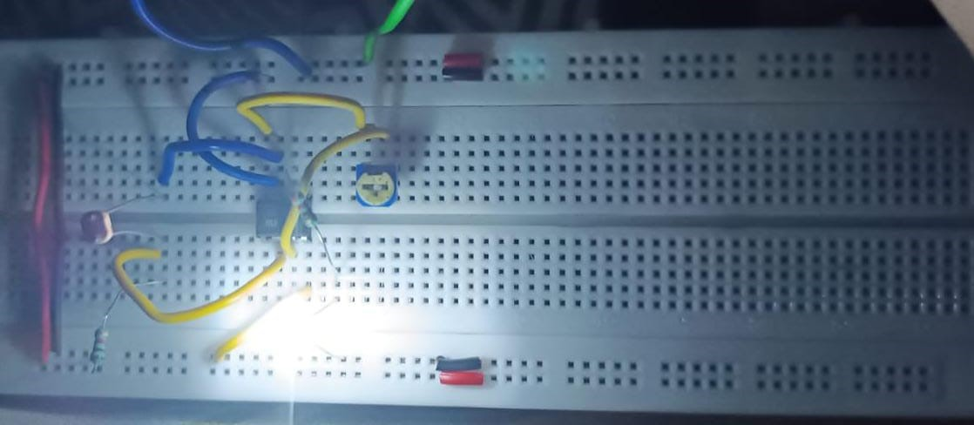PCB implementation:
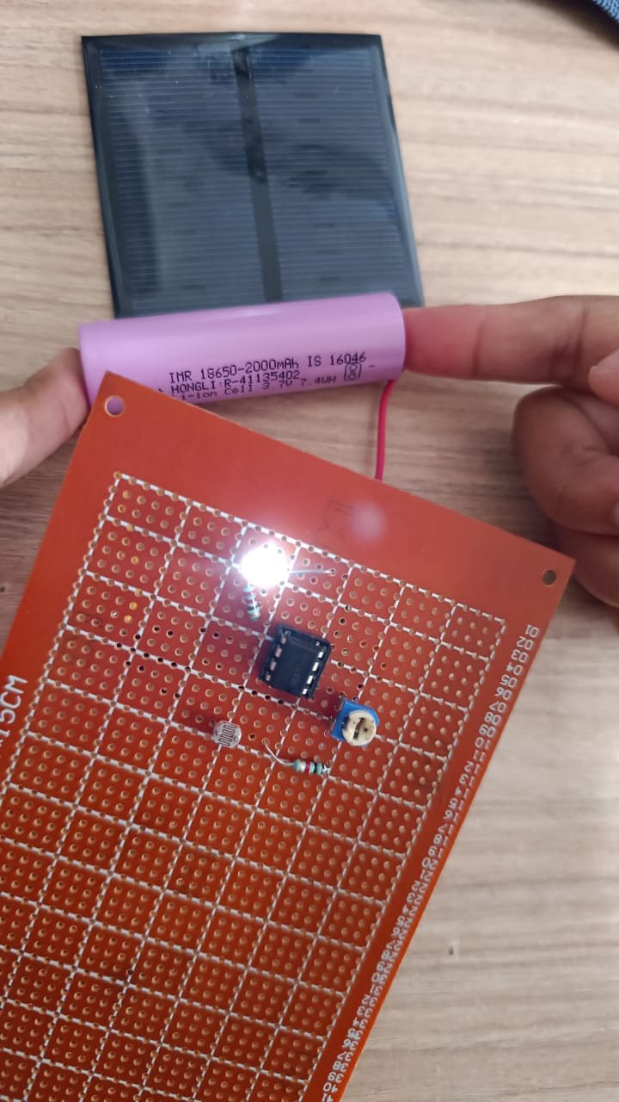


School of Electronics & Communication Engineering

Results and Discussions
Experimental Observation (from Breadboard Implementation)
From the breadboard implementation of the Smart Night Light System, it was observed that the system effectively responds to ambient light levels. When the LDR (Light Dependent Resistor) is exposed to daylight or bright lighting conditions, its resistance decreases, resulting in a lower voltage at the inverting input of the IC 741 operational amplifier configured as a comparator.
As the ambient light dims or during night conditions, the LDR resistance increases, causing the voltage at the comparator input to rise above the reference level set by the 10k potentiometer. This change triggers the output of the IC 741 to switch states, turning on the LED indicator. The LED remains on during low light levels, acting as a night light.
The potentiometer allows fine adjustment of the light threshold sensitivity, enabling the system to be customized for different ambient lighting environments.


School of Electronics & Communication Engineering
Comparison with Simulation Results
- Simulation Output: The simulation showed a clear switching threshold where the output toggled smoothly as the light level crossed the set point. This verified the comparator's operation and expected LED activation timing.
- Practical Output: The real-world circuit performed similarly, with minor deviations due to component tolerances, ambient light fluctuations, and slight voltage drops. The LED switched on reliably as darkness set in and turned off in bright light conditions.
- Error Margin: The practical threshold deviated by less than 5% from the simulated threshold voltage, confirming good design accuracy and component selection.
These observations confirm that the Smart Night Light System is effective and reliable in sensing ambient light and automatically controlling the LED, offering energy-efficient lighting.
Conclusion
The Smart Night Light System successfully demonstrates an effective, energy-efficient solution for automatic lighting control using simple analog components such as the IC 741 operational amplifier, LDR, and discrete resistors. The system reliably detects ambient light changes and switches the LED on or off accordingly, ensuring illumination only when needed.
By integrating a solar panel with lithium-ion battery storage, the project promotes the use of renewable energy, reducing dependency on grid power and minimizing environmental impact. The practical implementation closely matches simulation results.

