
DEPARTMENT OF COMPUTER APPLICATIONS
SOFTWARE REQUIREMENTS SPECIFICATION
SCHOLARSHIP ELIGIBILITY CHECK REGISTER
Submitted by
Sl. No. | Name of Student | USN
1 | Sanjana N Murthy | 01FE24ICA018
2 | Pallavi Patil | 01FE24ICA050

BCA – 5th Semester
Academic Year: 2026–2027

INDEX
Sl. No. | Particulars | Page No.
01 | Introduction | 3–5
 | 1.1 Purpose
 | 1.2 Scope
 | 1.3 Objectives
 | 1.4 Intended Audience
 | 1.5 Document Overview
 | 1.6 Foundational Concepts Used
02 | Specific Requirements | 6–8
 | 2.1 Functional Requirements
 | 2.2 Non-Functional Requirements
 | 2.3 Business Rules and System Constraints
03 | Hardware and Software Requirements | 9–10
 | 3.1 Hardware Requirements
 | 3.2 Software Requirements
04 | References | 11
05 | Future Enhancements | 12
06 | Conclusion | 13

1. INTRODUCTION

1.1 PURPOSE
The purpose of the Scholarship Eligibility Check Register is to provide a centralized system for recording student details, maintaining scholarship scheme information, checking eligibility, and keeping a register of scholarship applications and their status.
Students often find it difficult to understand the eligibility conditions of different scholarship schemes. Checking academic marks, family income, category, course details, and required documents manually can take time and may lead to mistakes. Maintaining application details in separate files also makes tracking difficult.
This system helps an authorized user enter student information and scholarship criteria, compare the details with the applicable conditions, display an eligibility result, and maintain application records. The result is intended as a preliminary check; final approval is always decided by the concerned scholarship authority.

1.2 SCOPE
The system focuses on maintaining student and scholarship records and checking whether a student matches the eligibility conditions entered for a particular scholarship scheme.
The main features include:
- Recording student details such as name, USN, course, semester, category, marks, and family income.
- Maintaining scholarship scheme details and eligibility conditions.
- Checking eligibility based on the selected scheme's configured rules.
- Displaying eligible, not eligible, or needs verification as the result.
- Showing the conditions that are satisfied or not satisfied.
- Maintaining application details, submission date, and application status.
- Recording document checklist status, such as income certificate and marks card.
- Searching and filtering student and scholarship records.
- Generating a basic eligibility and application status report.
- Allowing authorized users to add, update, and manage records.
The system may be used by students and scholarship coordinators in an educational institution. In the basic version, information and scheme rules are entered manually by an authorized user. Automatic verification with government scholarship portals is outside the basic scope.

1.3 OBJECTIVES
The main objectives of the system are:
- To maintain student scholarship details in a centralized register.
- To store scholarship scheme names and their eligibility conditions.
- To check eligibility using academic, income, category, and course-related criteria.
- To reduce errors in manual eligibility checking.
- To display the reason for an eligibility result in a simple format.
- To maintain scholarship application and document status.
- To help coordinators identify students who may be eligible for a scheme.
- To provide search, filtering, and report-generation facilities.
- To protect student information through authorized access.
- To make scholarship record management easier and more organized.

1.4 INTENDED AUDIENCE
- Students: To enter or review their details and understand preliminary eligibility.
- Scholarship Coordinators: To maintain scheme criteria and monitor application records.
- Administrators: To manage user accounts and system records.
- Project Guides: To review the requirements, design, and functionality of the project.
- Developers: To understand and implement the system requirements.
- Testers: To verify the correctness of eligibility checks and other functions.

1.5 DOCUMENT OVERVIEW
This SRS document describes the requirements of the Scholarship Eligibility Check Register.
- Section 1 introduces the project, its purpose, scope, objectives, intended audience, and foundational concepts.
- Section 2 describes the functional requirements, non-functional requirements, business rules, and system constraints.
- Section 3 specifies the hardware and software required to develop and run the application.
- Section 4 lists the references that may be used during development.
- Section 5 describes possible future enhancements.
- Section 6 presents the conclusion of the project.

1.6 FOUNDATIONAL CONCEPTS USED
- Scholarship Management: Maintaining information about scholarship schemes, applications, and their status.
- Eligibility Criteria: Conditions such as minimum marks, maximum family income, category, course, semester, and other scheme-specific rules.
- Rule-Based Eligibility Checking: Comparing student details with the conditions configured for a selected scholarship scheme.
- Student Record Management: Storing and retrieving student details in an organized manner.
- Database Management: Using a database to store student information, scheme details, and application records.
- Data Validation: Checking that entered values are complete and in the correct format.
- Report Generation: Presenting eligibility results and application status in tables or summaries.
- Authentication and Access Control: Verifying users and limiting access to records according to their permissions.
Example of a simple rule-based eligibility check:
If a scholarship scheme requires a minimum of 60% marks and a maximum family income of ₹2,50,000, a student with 65% marks and family income of ₹1,80,000 satisfies these two conditions. Other conditions, if any, must also be checked before displaying the final preliminary result.
Important: The above values are only an example to explain the checking process. Actual marks, income limits, category rules, and other conditions must be taken from the official notification of the selected scholarship scheme and updated when the rules change.

2. SPECIFIC REQUIREMENTS

2.1 FUNCTIONAL REQUIREMENTS
Functional requirements describe the operations that the system must perform.
Requirement ID | Requirement Name | Description
FR1 | User Login | The system shall allow registered users to log in using valid credentials.
FR2 | Add Student Details | The system shall allow authorized users to enter student name, USN, course, semester, category, marks, and family income.
FR3 | Update Student Details | The system shall allow authorized users to update student information when required.
FR4 | Add Scholarship Scheme | The system shall allow an authorized user to add scholarship scheme name, provider, academic year, and description.
FR5 | Set Eligibility Criteria | The system shall allow an authorized user to enter scheme-specific conditions such as minimum marks, income limit, category, course, and semester.
FR6 | Check Eligibility | The system shall compare the student's details with the criteria of the selected scholarship scheme.
FR7 | Display Eligibility Result | The system shall display a preliminary result such as Eligible, Not Eligible, or Needs Verification.
FR8 | Show Check Details | The system shall show which eligibility conditions are satisfied, not satisfied, or require verification.
FR9 | Maintain Application Register | The system shall store scholarship application details and the related student and scheme.
FR10 | Update Application Status | The system shall allow authorized users to update status such as Not Applied, Submitted, Under Review, Approved, or Rejected.
FR11 | Document Checklist | The system shall allow users to record whether required documents have been collected or verified.
FR12 | View Records | The system shall display student, scheme, eligibility, and application records to authorized users.
FR13 | Search and Filter | The system shall allow users to search by student name or USN and filter by scheme, eligibility result, or application status.
FR14 | Generate Reports | The system shall generate basic reports showing eligibility results and application status.
FR15 | Data Validation | The system shall validate required fields and reject invalid values such as negative income or marks outside the permitted range.
FR16 | Access Control | The system shall restrict protected records and operations according to user permissions.
FR17 | Delete Records | The system shall allow authorized users to delete incorrect or unnecessary records after confirmation.
FR18 | Report Export (Optional) | If implemented, the system shall allow reports to be exported in formats such as PDF or CSV.

2.2 NON-FUNCTIONAL REQUIREMENTS
Non-functional requirements describe the quality and performance expected from the system.
Requirement ID | Requirement Name | Description
NFR1 | Performance | The system should display student records and eligibility results within a reasonable time.
NFR2 | Security | The system shall protect student records and user accounts from unauthorized access.
NFR3 | Usability | The interface shall be simple, user-friendly, and easy to navigate.
NFR4 | Reliability | The system should store and retrieve student and scholarship information accurately.
NFR5 | Maintainability | The application should be structured so that it can be updated and maintained easily.
NFR6 | Compatibility | The application should work with supported modern web browsers.
NFR7 | Data Integrity | Student, scheme, eligibility, and application records shall remain consistent.
NFR8 | Accuracy | The system shall apply the configured eligibility rules consistently and correctly.
NFR9 | Privacy | Personal and financial information shall be accessible only to authorized users.
NFR10 | Backup | The database should be backed up periodically to reduce the risk of data loss.

2.3 BUSINESS RULES AND SYSTEM CONSTRAINTS

BUSINESS RULES
- Each student record must have a unique USN or another unique student identifier.
- Required student details must be entered before an eligibility check is performed.
- Marks must be within the valid range defined by the system, such as 0 to 100 for percentage marks.
- Family income must be a non-negative value.
- Each scholarship scheme must have clearly defined eligibility criteria for the relevant academic year.
- Eligibility must be checked against the criteria of the selected scheme only.
- A student must satisfy all mandatory criteria to receive an Eligible result.
- If required information is missing or unclear, the system shall display Needs Verification rather than assume eligibility.
- The system shall show the criteria that caused a Not Eligible result.
- Scholarship eligibility shown by the system is preliminary and does not guarantee approval or payment.
- Only authorized users shall add or modify scholarship scheme criteria.
- Application status shall be updated using the latest information available.

SYSTEM CONSTRAINTS
- The accuracy of the eligibility result depends on the correctness of student information and scheme criteria entered.
- Scholarship rules may change between academic years and must be reviewed using the relevant official notification.
- The basic system may require manual entry of student details and scholarship conditions.
- The system does not independently approve or reject a scholarship application.
- Automatic verification with government portals requires suitable APIs, permissions, and additional implementation.
- The system requires a working application environment and database.
- Email or SMS notifications and advanced report exports may require additional implementation.
- The application must operate within the capabilities of the selected hardware and software.

3. HARDWARE AND SOFTWARE REQUIREMENTS

3.1 HARDWARE REQUIREMENTS
The following are the suggested minimum hardware requirements:
- Processor: Dual-core processor or equivalent.
- RAM: Minimum 4 GB.
- Storage: At least 1 GB of free space for project files and dependencies.
- Display: Standard laptop or desktop display.
- Input Devices: Keyboard and mouse or touchpad.
- Network: Internet or local network access when required.
- Server: A local computer can be used for development; a server may be used for multi-user deployment.
These requirements may vary depending on the selected technologies and the size of the application.

3.2 SOFTWARE REQUIREMENTS
- Operating System: Windows, Linux, or macOS.
- Front End: HTML, CSS, and JavaScript.
- Back End: Python with Flask.
- Database: SQLite or MySQL.
- Web Browser: Google Chrome, Microsoft Edge, or Mozilla Firefox.
- Code Editor: Visual Studio Code or an equivalent editor.
- Reporting Tools: Suitable Python or JavaScript libraries for displaying tables and reports.
- Testing Tools: Manual testing or suitable automated testing tools.
- Version Control: Git, if required.
HTML is used to structure web pages, CSS is used for styling, and JavaScript can provide interactive features. Python Flask handles application logic and communicates with the database. SQLite is suitable for a basic standalone project, while MySQL can support a separate database server.
The final technologies should match the actual project implementation.

SYSTEM DESIGN DIAGRAMS
The following diagrams describe the proposed structure, data flow, user interactions, and processing of the Scholarship Eligibility Check Register.
Figure 1: System Architecture Diagram
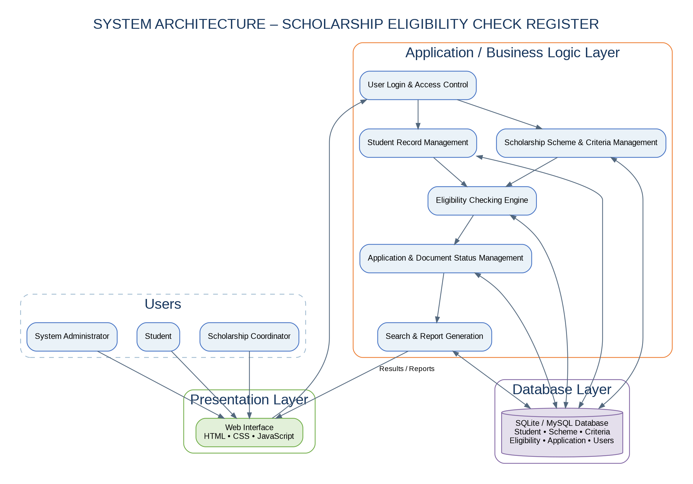

Figure 2: Level 0 Data Flow Diagram (Context Diagram)
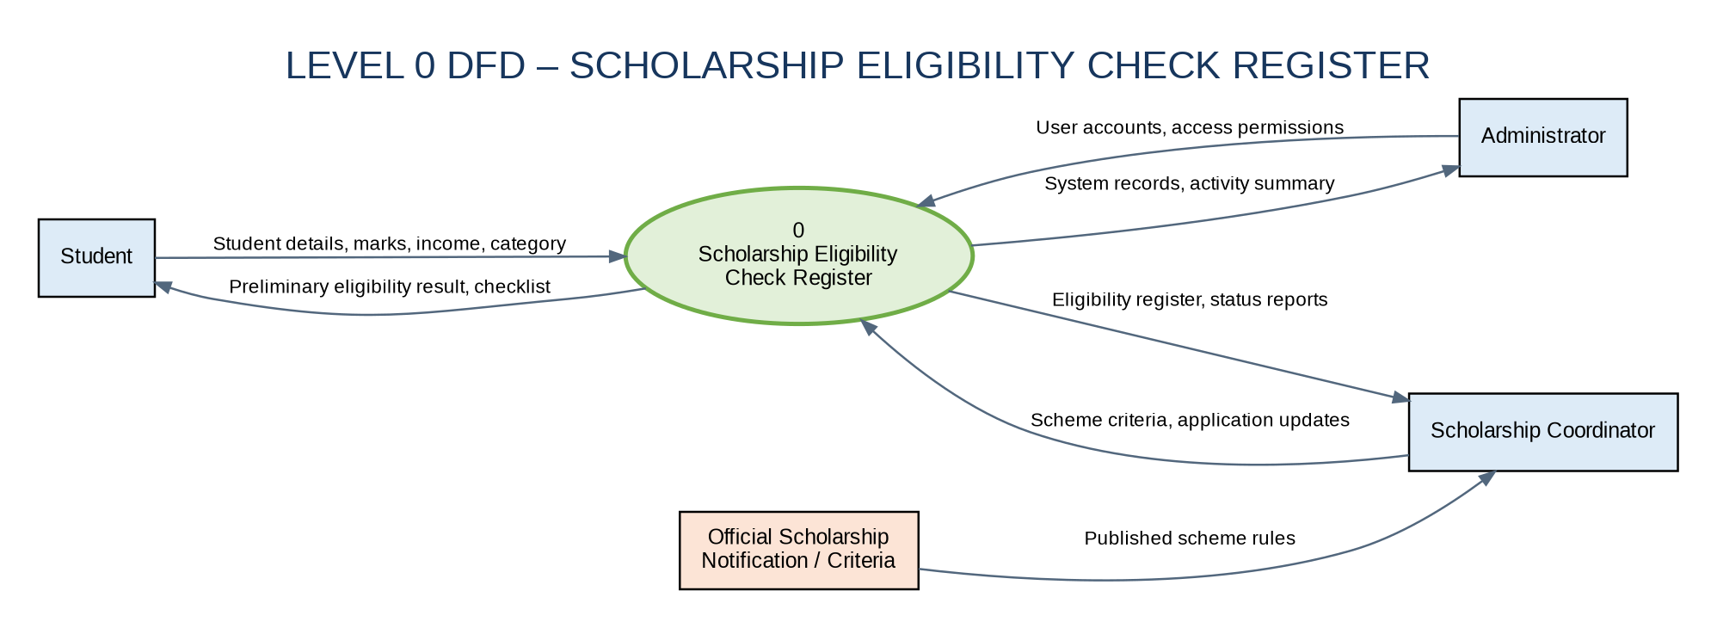

Figure 3: Level 1 Data Flow Diagram

Figure 4: Level 2 Data Flow Diagram – Eligibility Checking
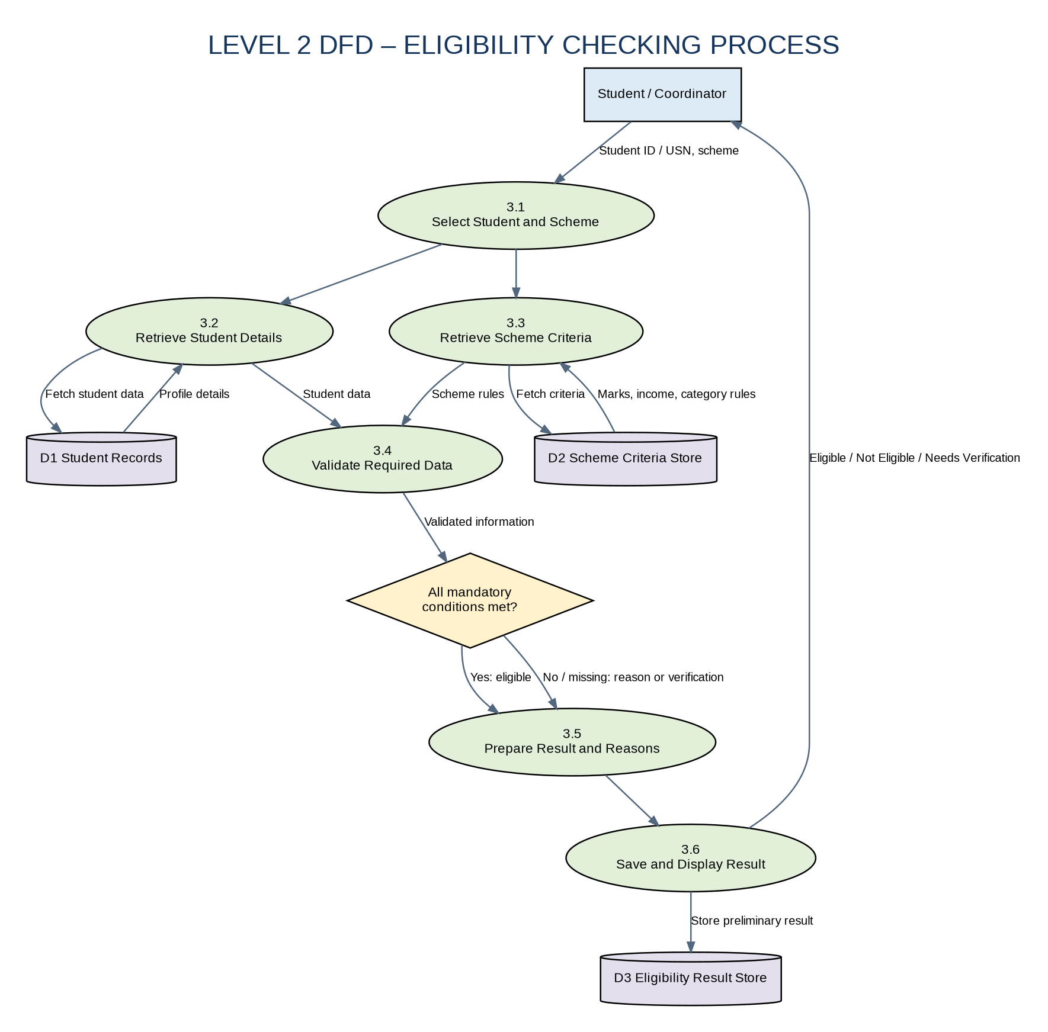

Figure 5: Use Case Diagram
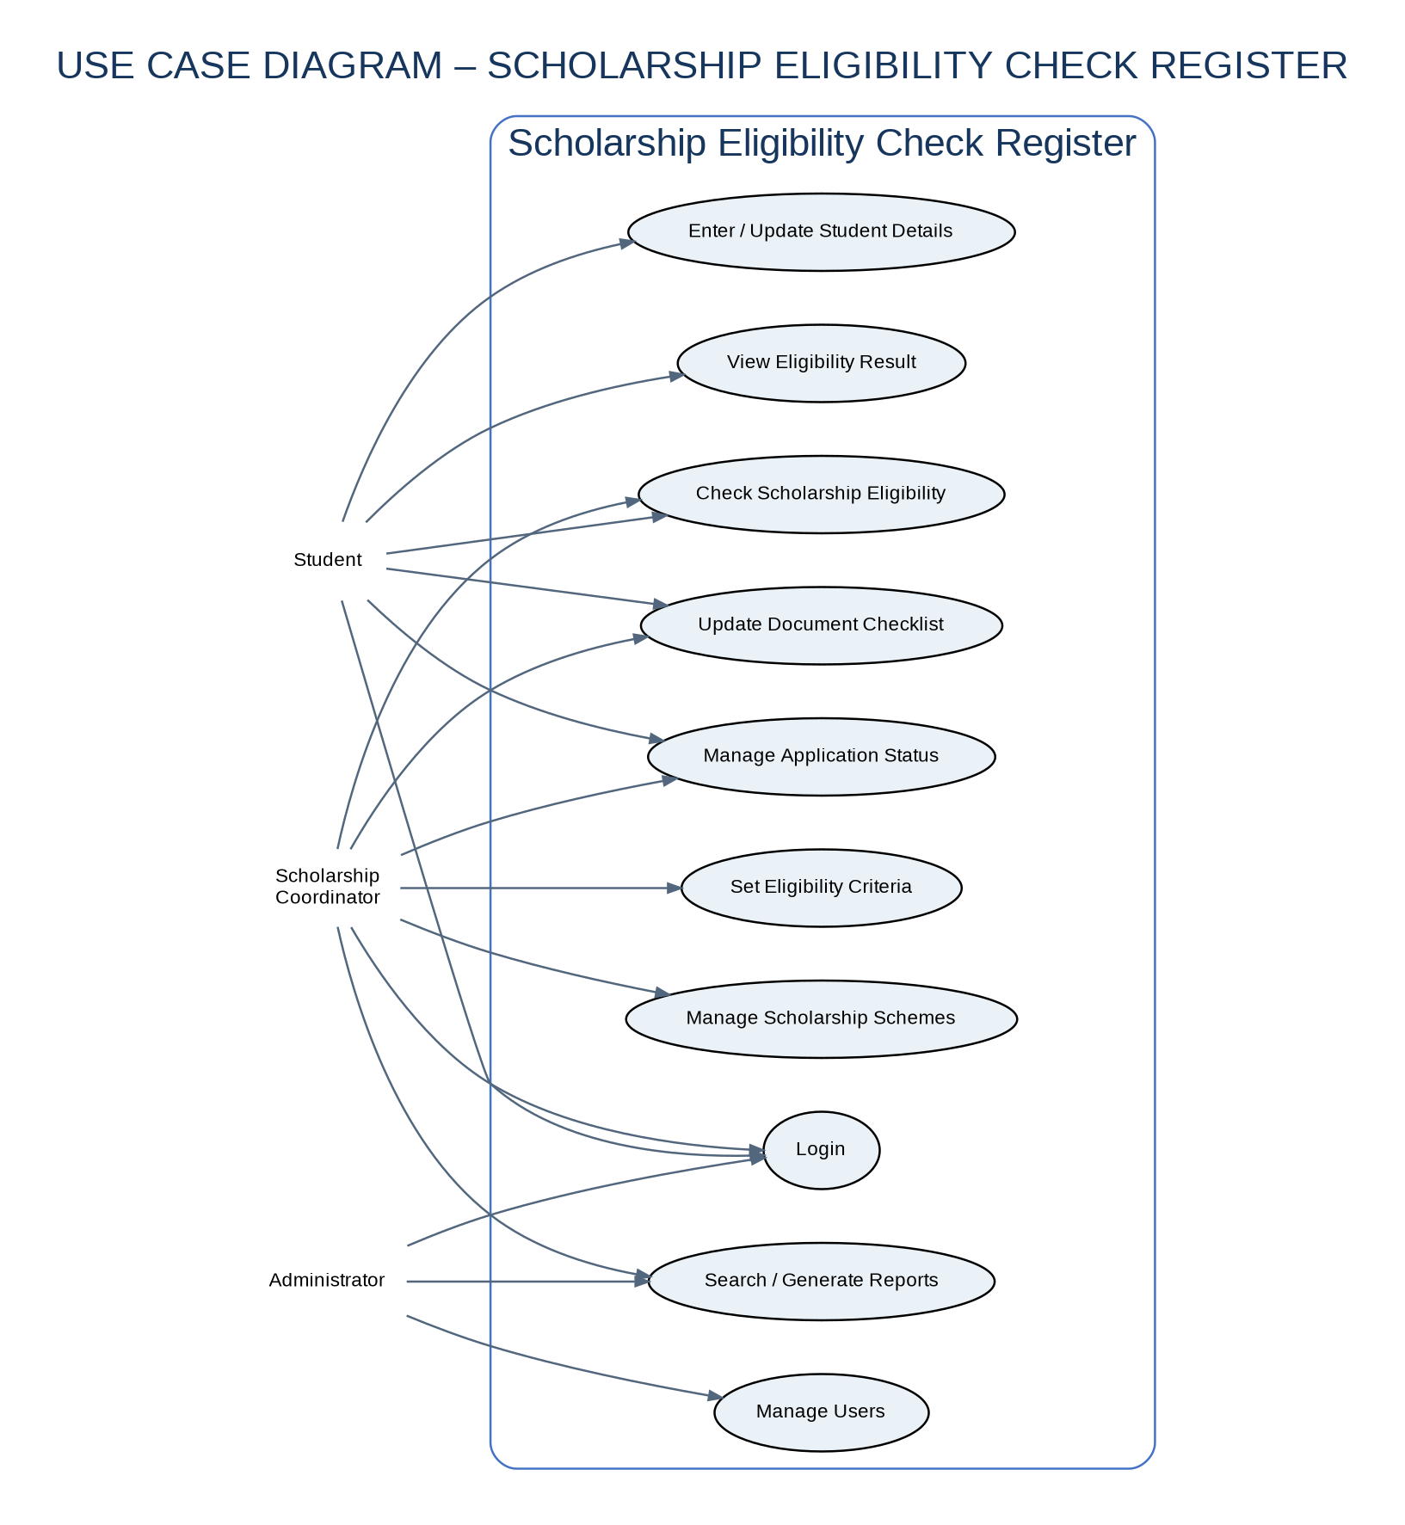

Figure 6: Activity Diagram – Eligibility Checking
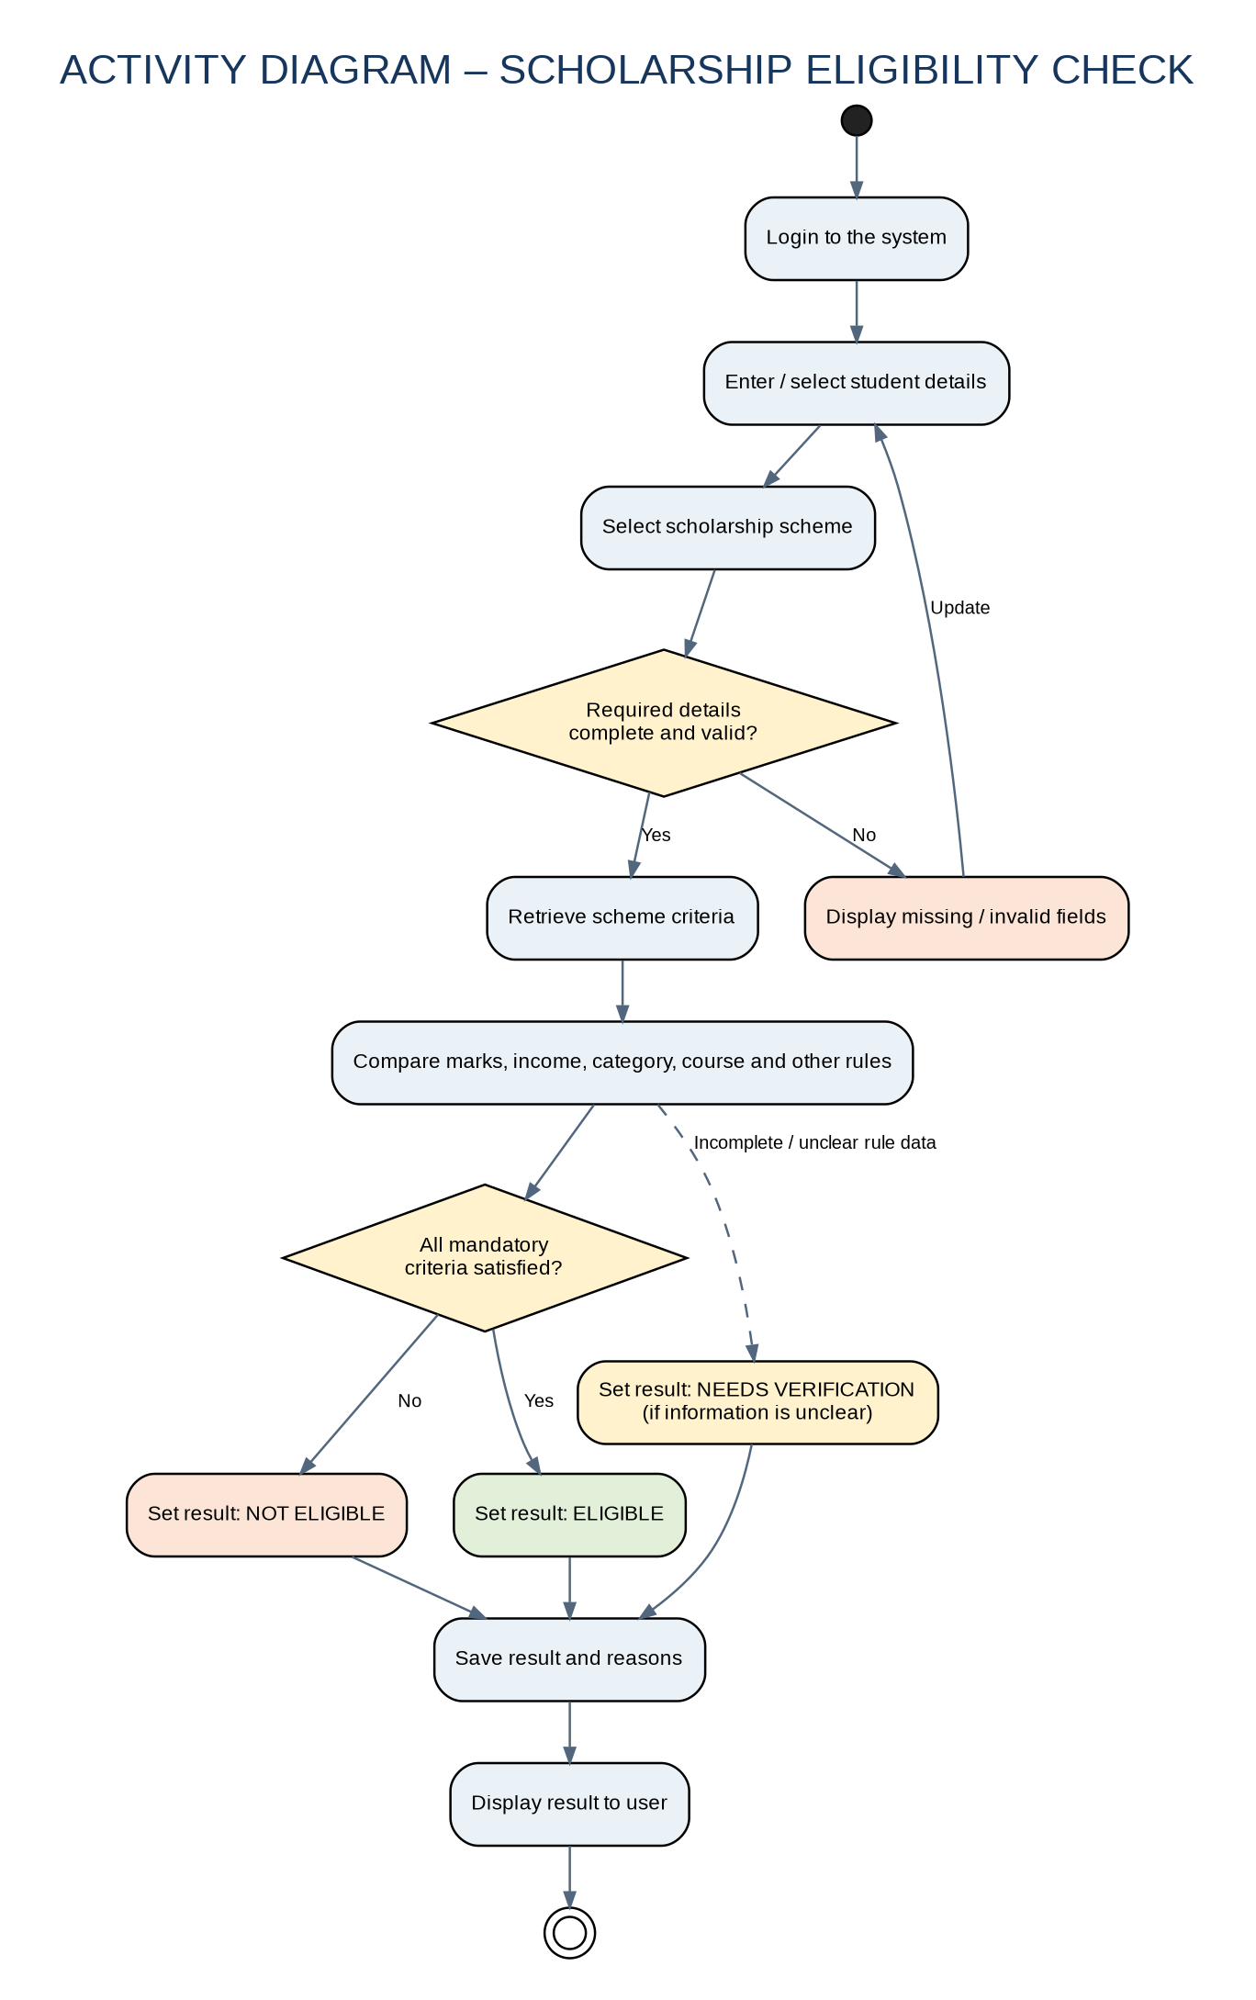

Figure 7: Sequence Diagram – Eligibility Check
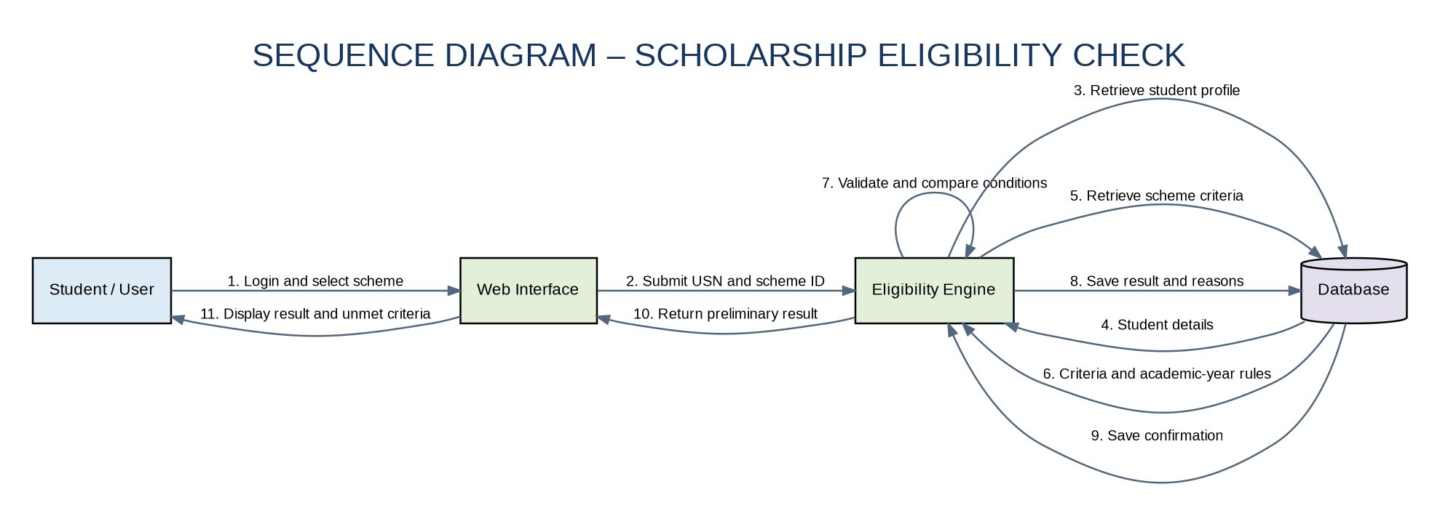

Figure 8: Class Diagram
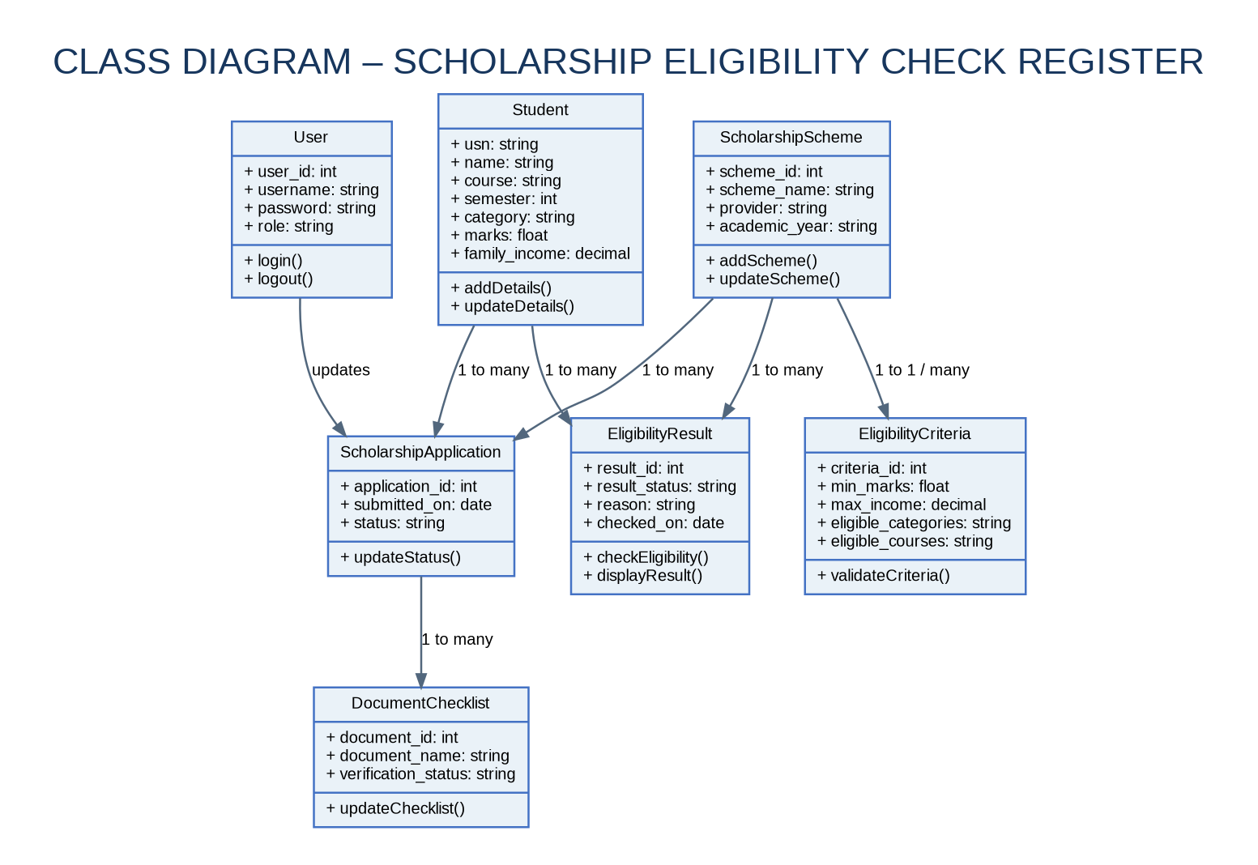

Figure 9: State Diagram – Application Status
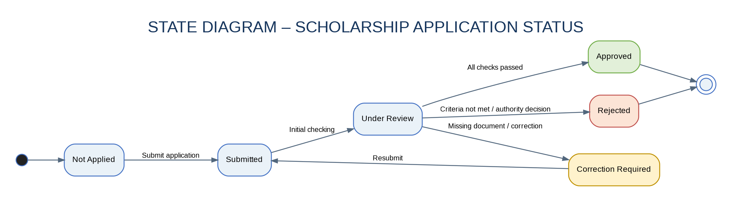

4. REFERENCES
The following references may be used during project development:
- Software Engineering textbooks covering requirements analysis and specification.
- Database Management System textbooks.
- Python Documentation: https://docs.python.org/3/
- Flask Documentation: https://flask.palletsprojects.com/
- SQLite Documentation: https://www.sqlite.org/docs.html
- MySQL Documentation: https://dev.mysql.com/doc/
- MDN Web Docs for HTML, CSS, and JavaScript: https://developer.mozilla.org/
- National Scholarship Portal: https://scholarships.gov.in/ (for scheme information and official notifications, where applicable).
- Karnataka State Scholarship Portal: https://ssp.postmatric.karnataka.gov.in/ (for applicable state scholarship information).
Scholarship eligibility conditions should be taken from the official notification or portal for the specific scheme and academic year. The project should not treat example values as official rules.

5. FUTURE ENHANCEMENTS
The system can be improved by adding the following features:
- Automatic Updates: Provide a facility to update scheme criteria when official notifications change.
- Student Self-Registration: Allow students to create profiles and enter their details.
- Document Upload: Allow students to upload required documents for review.
- Notifications: Send reminders about application deadlines and missing documents.
- Advanced Reports: Generate scheme-wise, category-wise, and academic-year-wise reports.
- Portal Integration: Integrate with official scholarship portals if approved APIs and permissions are available.
- Application Tracking: Provide a timeline showing application progress and status changes.
- Audit History: Maintain a record of changes made to student details and scholarship criteria.
- Multi-Year Records: Maintain scholarship information across multiple academic years.
- Mobile-Friendly Interface: Improve access through smartphones and tablets.
These enhancements can make the Scholarship Eligibility Check Register more useful for students and scholarship coordinators.

6. CONCLUSION
The Scholarship Eligibility Check Register provides an organized way to maintain student details, scholarship scheme information, eligibility conditions, and application records. It compares student information with the configured criteria and displays a preliminary eligibility result.
The system helps reduce the effort involved in manual checking, makes it easier to identify conditions that a student satisfies or does not satisfy, and supports the maintenance of scholarship application status and document checklists. Its search and reporting features make scholarship records easier to manage.
The project also provides practical experience in software engineering, web development, database management, rule-based processing, data validation, and report generation.
In the future, document upload, notifications, official portal integration, and advanced reporting can further improve the system. Overall, the Scholarship Eligibility Check Register offers a practical solution for organizing scholarship information and carrying out preliminary eligibility checks. Final scholarship approval remains with the concerned authority.

