To

Dean Student Affairs

Punjab Engineering College

Chandigarh

Through

Associate Dean Student Affairs

(Technical Societies)

Punjab Engineering College

Chandigarh

2nd February 2025

Subject: Letter of Intent for sending our contingent to Techkriti’25 IIT Kanpur.

Respected Sir / Ma’am,

We, the students of INDIAN INSTITUTE OF METALS (IIM) are willing to participate in the Techkriti’25 IIT Kanpur, a premier technology festival held annually at IIT Kanpur, Uttar Pradesh, where teams from across the globe gather to compete against each other. This festival stands as a monumental platform for the educational and professional advancement of students, allowing us to represent our institute on an international stage.

Last semester, our students were honored with awards in various competitions, and have organized a 4-Day workshop on RC Aircraft Building, making sure our students have learnt it all. This semester, we are aiming to compete in the **Boeing National Aeromodelling Competition’s North Zone** and **IARC (Line follower bot)**, to gain experience and broaden our technical horizons, there by bringing laurels to our prestigious institution.

For this purpose, we request financial assistance for our team. We assure you that participating in this festival will not only be a comprehensive educational journey for the students but will also enhance the reputation of our institute.

The event is scheduled at the IIT Kanpur campus from 27th March to 30th March, 2025. The participants were meticulously selected through a rigorous internal competition, ensuring that only the most skilled team represented us. Enclosed herewith is the list of students, the brochure of the event, and photographs of their innovative model for your perusal.

Manish Sharma Kaustabh R. Kamble

(Secretary) (Office Incharge)

IIM IIM

**NATIONAL AEROMODELLING COMPETITION**

Description: The National Aeromodelling Competition challenges participants to design, build, and fly model aircraft. Teams compete in various tasks, showcasing their engineering, creativity, and flying skills. This competition tests aerodynamics, innovation, and precision in a dynamic and exciting environment. It also provides an opportunity for students to work as a team and test their skills.

List of team members:

|  |  |  |  |
| --- | --- | --- | --- |
| Team Name | Name | SID | Branch |
| NAILED IT GANG | Kushagra Bhandari | 24104075 | Electrical |
| Rudraksh Parsai | 24104065 | Electrical |
| Rudra Goyal | 24104062 | Electrical |
| Harshit Gupta | 24104059 | Electrical |

**IARC (Line follower)**

Description: The ultimate autonomous robotics challenge at Techkriti' 25. Design and build bots to solve intricate mazes, decode nodes, and tackle speed and angle tasks with precision. Showcase your innovation, engineering, and coding skills. Compete with top teams globally and achieve robotic glory.

List of team members:

|  |  |  |  |
| --- | --- | --- | --- |
| Team Name | Name | SID | Branch |
| NOSFERATU | Kushagra Bhandari | 24104075 | Electrical |
| Rudraksh Parsai | 24104065 | Electrical |
| Rudra Goyal | 24104062 | Electrical |
| Harshit Gupta | 24104059 | Electrical |
|  | Vishwa Naresh Srivastava | 24101018 | Aerospace |
|  | Abhinav Bisht | 24101022 | Aerospace |

Estimated Expenditure:

|  |  |  |  |
| --- | --- | --- | --- |
| S. No. | Category | Amount | Justification |
| 1 | Accommodation | Rs. 900 | 6 team members for 5 days  (2800 * 6 ) = Rs. 16,800 |
| 2 | Food | Rs. 6,000 | 6 team members for 5 days (100*6*5=Rs 3000) |
| 3 | Train Travel | Rs. 12,420 | 6 participants going from Chandigarh to Kanpur (1,035 * 6 * 2) – Unchahar Express 3AC |
| 4 | Local travel | Rs.3,000 | 6 participants local travel (100*6*5) = Rs.3,000 |
| 5 | Material Required | Rs. 12,031 | 1. Thermocol and foam material with fibre taping = 2,643  2. Servo Motors (x5) – 5*140 = 700  3. Electronic Speed Controller (x1) = 650  4. 3S battery 2200Mah x1 = 1,100  5. Motor Driver (x2) = 300  6. IR sensor ARRAY = 295  7.N20 motors with encoder (x4) = 1,880  8.Raspberry Pi Pico = 500  9. Battery = 1,000  10. UV sensor = 500  11. Lcd display = 400  12. Buzzer = 50  13. 3D printed wing parts = 1,110  14. chassis = 525  15. Motor driver TB6612FNG (x2) = 334  16. Metal ball caster wheel = 44 |
| Grand Total | | **Rs. 47,776** |  |

Event Brochure:

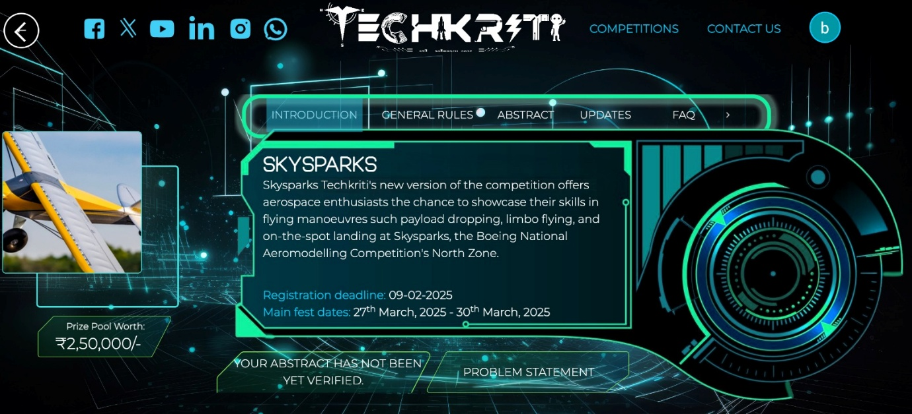

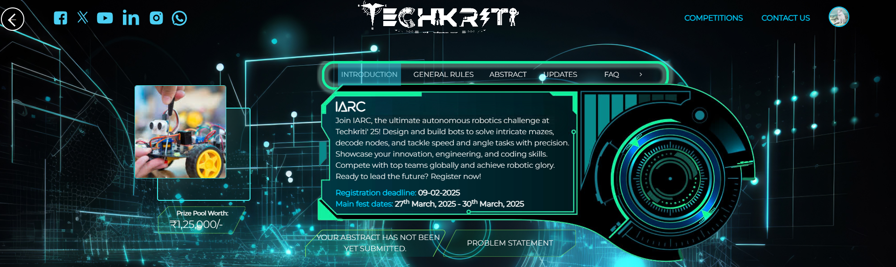

Train Tickets:

From Chandigarh to Kanpur

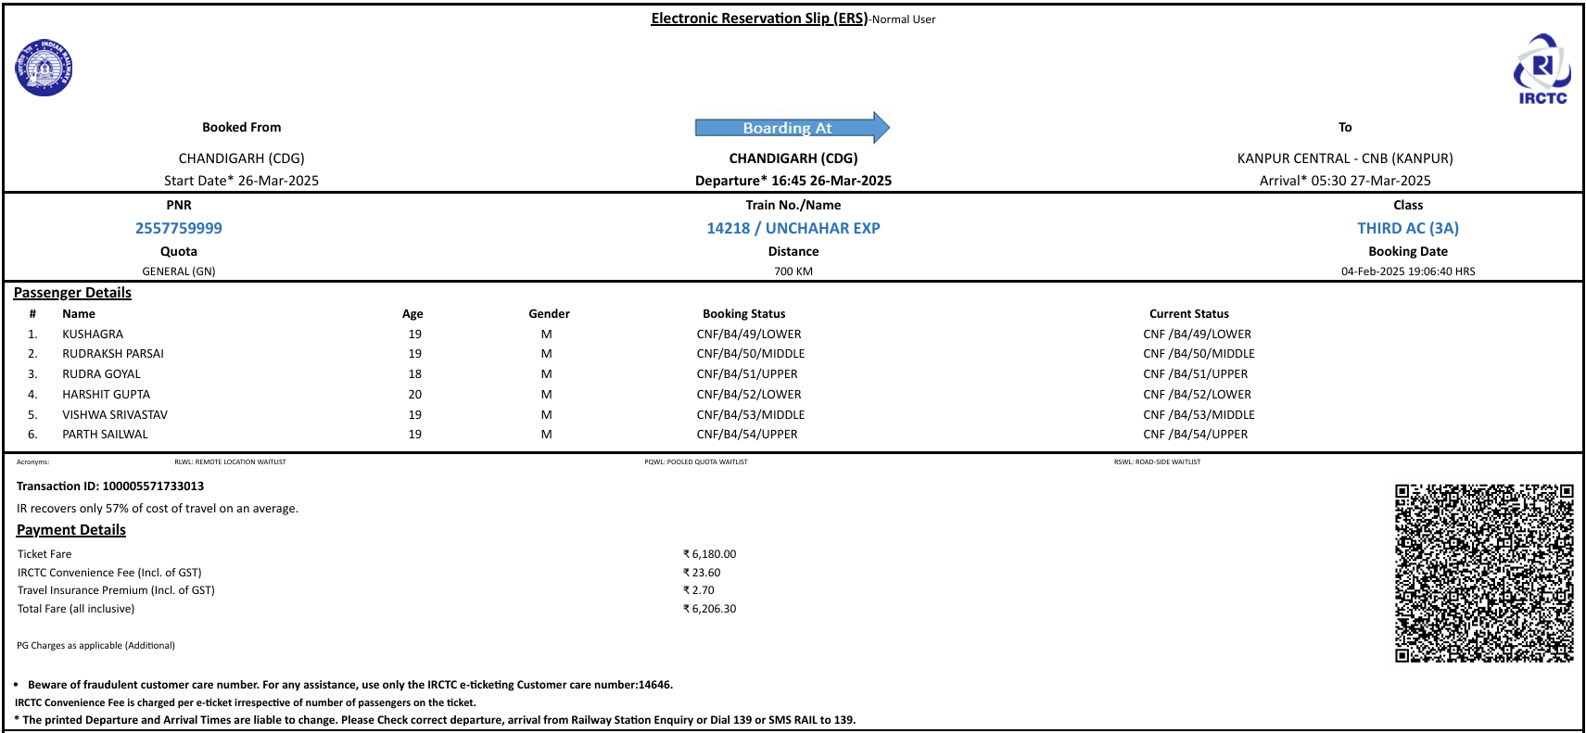

From Kanpur to Chandigarh

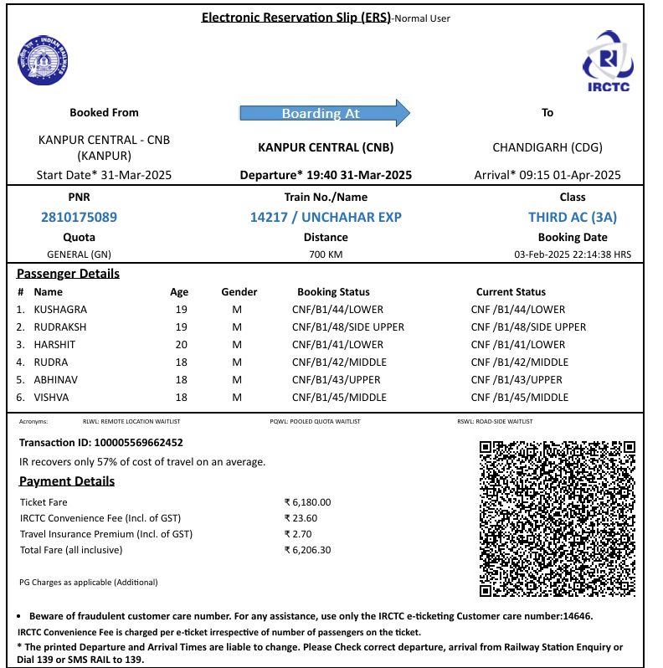

**Tickets were booked earlier due to limited availability of seats.**

Team Registration: 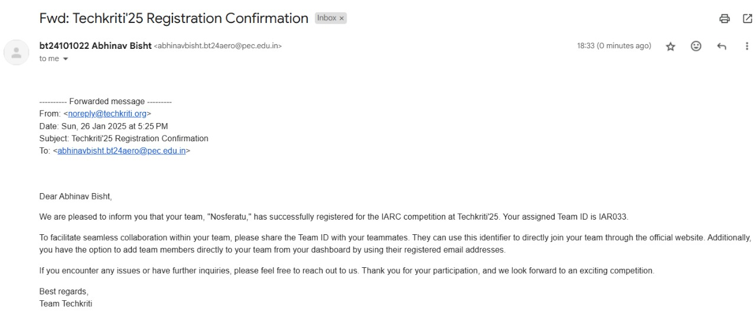

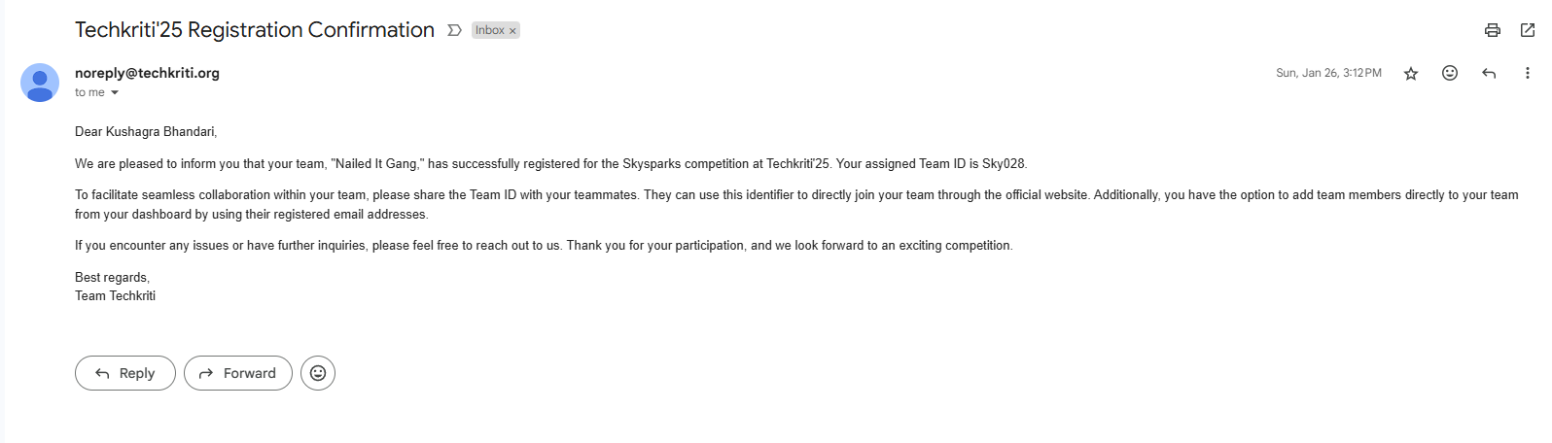

**Punjab Engineering College (Deemed to be University), Chandigarh  
 PERFORMA FOR EVENT PERMISSION AND FINANCIAL SANCTION BY CLUBS/SOCIETIES/SPORTS DEPARTMENT**

|  |  |
| --- | --- |
| **Name of Club/Technical Society:** | INDIAN INSTITUTE OF METALS (IIM) |
| **Event Name:** | Boeing Aeromodelling Competition and IARC |
| **Date:** | 27th to 30th March 2025 |
| **Venue(s):** | IIT KANPUR |
| **Time:** | All day |
| Brief Event Description:  AEROMODELLING: The National Aeromodelling Competition challenges participants to design, build, and fly model aircraft. Teams compete in various tasks, showcasing their engineering, creativity, and flying skills. This competition tests aerodynamics, innovation, and precision in a dynamic and exciting environment. It also provides an opportunity for students to work as a team and test their skills.  IARC: The ultimate autonomous robotics challenge at Techkriti' 25. Design and build bots to solve intricate mazes, decode nodes, and tackle speed and angle tasks with precision. Showcase your innovation, engineering, and coding skills. Compete with top teams globally and achieve robotic glory | |

Event Proposal signed by Club Secretary attached along with the sanction? YES/NO  
 Permission may please be granted for conducting the above-mentioned event.

**EXPENDITURE DETAILS (Enter NIL if no funding required)**

Estimated Expenditure:

|  |  |  |  |
| --- | --- | --- | --- |
| **S. No.** | **Category** | **Amount** | **Justification** |
| 1 | Accommodation | Rs. 16,800 | 6 team members for 5 days  (2800* 6 ) = Rs. 16,800 |
| 2 | Food | Rs. 3,000 | 6 team members for 5 days  100 * 6 * 5) = Rs. 3,000 |
| 3 | Train Travel | Rs. 12,420 | 6 participants going from Chandigarh to Kanpur (1,035 * 6 * 2) – Unchahar Express 3AC |
| 4 | Local travel | Rs.3,000 | 6 participants local travel (100*6*5) = Rs.3,000 |
| 5 | Material Required | Rs. 12,031 | 1. Thermocol and foam material with fibre taping = 2,643  2. Servo Motors (x5) – 5*140 = 700  3. Electronic Speed Controller (x1) = 650  4. 3S battery 2200Mah x1 = 1,100  5. Motor Driver (x2) = 300  6. IR sensor ARRAY = 295  7.N20 motors with encoder (x4) = 1,880  8.Raspberry Pi Pico = 500  9. Battery = 1,000  10. UV sensor = 500  11. Lcd display = 400  12. Buzzer = 50  13. 3D printed wing parts = 1,110  14. chassis = 525  15. Motor driver TB6612FNG (x2) = 334  16. Metal ball caster wheel = 44 |
| **Grand Total** | | **Rs. 47,776** |  |

Financial Sanction may kindly be accorded for Rs. 47,776 as per the above details. The expenditure will be met out from the SSF.

(Signature of Club Secretary) (Signature of CCS/CTS/Sports Secy.)

|  |  |
| --- | --- |
| **EVENT DETAILS & EXPENDITURE HAS BEEN VERIFIED** | |
| 1. **O/I Club/Technical Societies** | **Recommended/Not Recommended** |
| 1. **ADSA(TS)** |

Entered in Clubs/Societies Register at Page No. ______  
 Verified by Clerk, DSA Office

Sanction/Not Sanctioned  
 Dean Students Affairs

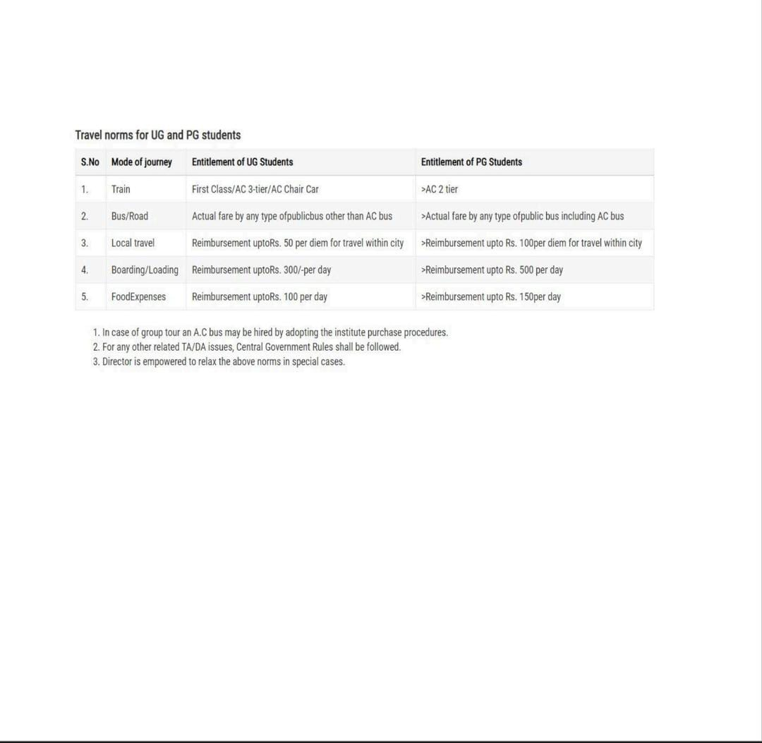

**UNDERTAKING**

**Subject**: Declaration of Responsibility for Unapproved Expenses

Dear Sir/Madam,

This is to certify that the following students, who are participating in the **Boeing National Aeromodelling Competition’s North Zone and IARC (Line follower bot)** at IIT Kanpur, understand and agree to bear all expenses that are not approved during the audit process. The students acknowledge that any bills or expenditures that fail to pass the institutional audit will be their personal responsibility.

The students accepting this financial responsibility are:

1. Kushagra Bhandari
2. Harshit Gupta
3. Rudraksh Parsai
4. Rudra Goyal
5. Vishwa Naresh Srivastava
6. Abhinav Bisht

This declaration is being submitted as an official record and acknowledgment of their understanding of the financial obligations associated with our participation.

Signed by:

1. __________________ (Kushagra Bhandari)
2. __________________ (Harshit Gupta)
3. __________________ (Rudraksh Parsai)
4. __________________ (Rudra Goyal)
5. __________________ (Vishwa Naresh Srivastava)
6. __________________ (Abhinav Bisht)

Forwarded & Recommended by:

Secretary (IIM PEC) Professor Incharge

Manish Sharma Kaustabh R. Kamble