**玩玩docker**

Author:staugur

CentOS6.5

rpm -Uih <http://mirrors.yun-idc.com/epel/6/x86_64/epel-release-6-8.noarch.rpm>

包括monit

yum install docker-io –y

CentOS7

yum -y install docker device-mapper-event-devel bridge-utils iptables-services

systemctl stop firewalld ; systemctl disable firewalld

chkconfig --add iptables ; chkconfig iptables on ; systemctl start iptables

iptables -F ; iptables –X ; service iptables save ; service iptables restart

systemctl start docker

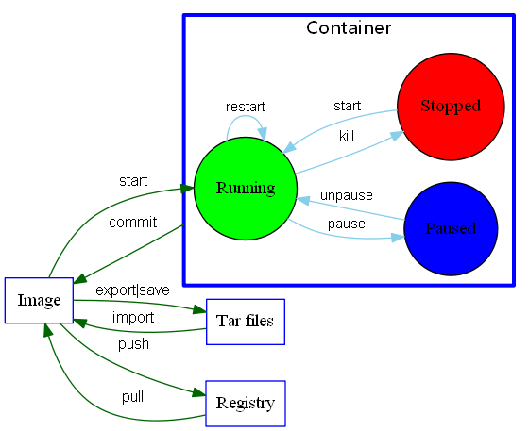

在线学习书籍：

<http://dockerpool.com/static/books/docker_practice/index.html>

命令集：

<http://www.infoq.com/cn/articles/docker-command-line-quest/>

<http://blog.csdn.net/wsscy2004/article/details/25878363>

docker-puppet管理

<http://www.widuu.com/docker/puppet.html>

**固定容器内部IP(桥接模式)：**

yum -y install subversion(如果下面这条命令报错就执行这个)

svn export <https://github.com/staugur/scripts/trunk/MyOther/docker/.docker_tools.sh>

echo “. ~/.docker_tools.sh” >> ~/.bashrc && . ~/.bashrc

**错误集锦**

一：安装问题

**1、执行 service network restart 出现以下错误**

Restarting network (via systemctl):  Job for network.service failed. See 'systemctl status network.service' and 'journalctl -xn' for details.

**2、根据上面的提示，执行“systemctl status network.service”输出以下的类似信息：**

[root@saint ~]# systemctl status network.service

network.service - LSB: Bring up/down networking

   Loaded: loaded (/etc/rc.d/init.d/network)

   Active: failed (Result: exit-code) since 三 2014-11-05 15:30:10 CST; 1min 5s ago

11月 05 15:30:10 localhost.localdomain network[2920]: RTNETLINK answers: File exists

11月 05 15:30:10 localhost.localdomain network[2920]: RTNETLINK answers: File exists

11月 05 15:30:10 localhost.localdomain network[2920]: RTNETLINK answers: File exists

11月 05 15:30:10 localhost.localdomain network[2920]: RTNETLINK answers: File exists

11月 05 15:30:10 localhost.localdomain network[2920]: RTNETLINK answers: File exists

11月 05 15:30:10 localhost.localdomain network[2920]: RTNETLINK answers: File exists

11月 05 15:30:10 localhost.localdomain network[2920]: RTNETLINK answers: File exists

11月 05 15:30:10 localhost.localdomain systemd[1]: network.service: control process exited, code=exited status=1

11月 05 15:30:10 localhost.localdomain systemd[1]:**Failed to start LSB: Bring up/down networking.**

11月 05 15:30:10 localhost.localdomain systemd[1]: Unit network.service entered failed state.

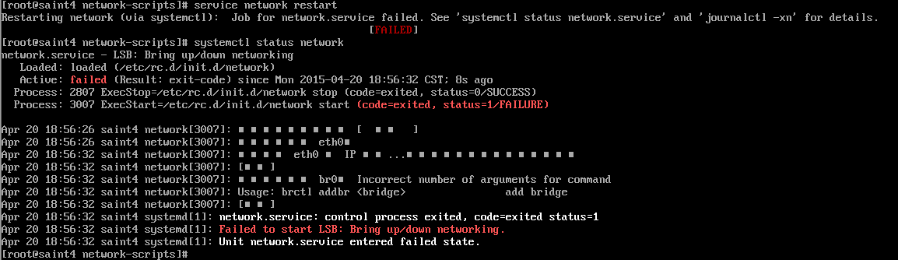

当时的网卡配置

[root@saint4 ~]# cat /etc/sysconfig/network-scripts/ifcfg-eth0

HWADDR="00:0C:29:9E:85:96"

TYPE="Ethernet"

BOOTPROTO="dhcp"

DEFROUTE="yes"

PEERDNS="yes"

PEERROUTES="yes"

IPV4_FAILURE_FATAL="no"

IPV6INIT="yes"

IPV6_AUTOCONF="yes"

IPV6_DEFROUTE="yes"

IPV6_PEERDNS="yes"

IPV6_PEERROUTES="yes"

IPV6_FAILURE_FATAL="no"

DEVICE="eth0"

UUID="c1f685ca-1347-46d9-86f3-1e25b2b7b2b3"

ONBOOT="yes"

NAME="br0"

NM_CONTROLLED="no"

桥接网卡

[root@saint4 ~]# cat /etc/sysconfig/network-scripts/ifcfg-br0

TYPE="Bridge"

BOOTPROTO="static"

IPADDR="192.168.1.5"

NETMASK=255.255.255.0

GATEWAY="192.168.1.1"

NAME="br0"

ONBOOT="yes"

**3、解决办法：**将ifcfg-eth0和ifcfg-br0中的NAME改为DEVICE。

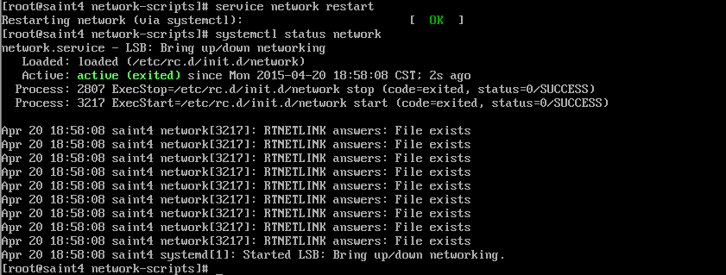

**完整的网卡配置eth0**

HWADDR="00:0C:29:9E:85:96"

TYPE="Ethernet"

BOOTPROTO="dhcp"

DEFROUTE="yes"

PEERDNS="yes"

PEERROUTES="yes"

IPV4_FAILURE_FATAL="no"

IPV6INIT="yes"

IPV6_AUTOCONF="yes"

IPV6_DEFROUTE="yes"

IPV6_PEERDNS="yes"

IPV6_PEERROUTES="yes"

IPV6_FAILURE_FATAL="no"

DEVICE="eth0"

UUID="c1f685ca-1347-46d9-86f3-1e25b2b7b2b3"

ONBOOT="yes"

BRIDGE="br0"

**br0：**

TYPE="Bridge"

BOOTPROTO="dhcp"

DEVICE="br0"

ONBOOT="yes"

service network restart

不动NetworkManager

**二：在容器里面修改用户密码的时候报错：**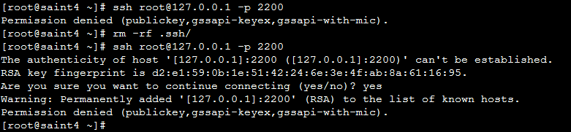

/usr/share/cracklib/pw_dict.pwd: No such file or directory

PWOpen: No such file or directory

解决： yum -y install cracklib-dicts

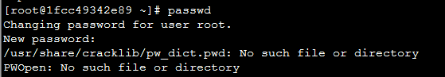

yum -y install cracklib-dicts

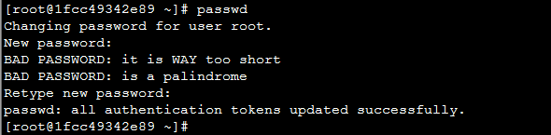

sshd_config：

PermitRootLogin yes

PasswordAuthentication yes