

**Lab Report 4**

**Submitted by: Submitted to:**

Milan Budhathoki Birodh Rijal

515 (Artificial Intelligence Lecturer)

1. **Operators on list**
2. Write on list

writelist([]) :− nl.

writelist([H|T]) :− write(H),nl,writelist(T).

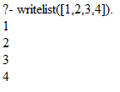

1. Membership

member(X,[X|List]).

member(X,[Element|List]) :− member(X,List).

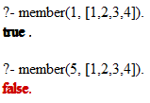

1. Concatenation

conc([],L,L).

conc([X|L1],L2,[X|L3]) : −conc(L1,L2,L3).

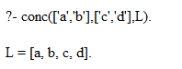

1. Take the n-th element

take(1,[H|_],H).

take(N,[_|T],X) : −N1 is N −1,take(N1,T,X).

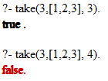

1. Length of a list

lengths([],0).

lengths([H|T],N) :− lengths(T,M),N is M + 1.

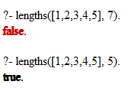

1. Sum of elements

sum([],0).

sum([X|L],Sum) :− sum(L,SL),Sum is X + SL.



1. Reverse of a list

reverse([],X,X).

reverse([X|Y],Z,W) :− reverse(Y,[X|Z],W).



1. Append

append([],L,L).

append([H|T],L,[H|TL]) :− append(T,L,TL).

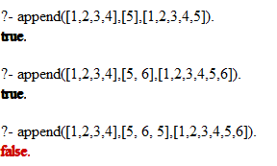

1. **DFA with input as a list**

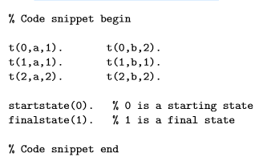

Implement a predicate checkinput(Start,Input) that checks if a word (here, input) given as a list (e.g. [a,b,b,a,b]) is accepted by the DFA starting from a start state (here State).

**Answer:**

t(0,a,1).

t(0,b,2).

t(1,a,1).

t(1,b,1).

t(2,a,2).

t(2,b,2).

checkinput(Start, []) :- Start is 1.

checkinput(Start, [H|T]) :- t(Start,H,Next), checkinput(Next, T).

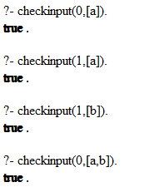

1. family( person(homer,simpson,date(7,may,1960),works(inspector,6000)), person(marge,simpson,date(7,may,1965),housewife), [ person(bart,simpson,date(7,may,1967),student), person(lisa,simpson,date(7,may,1965),student) ].

Using the family predicate, implement the following relation as rules:

1. husband(X) : true if X is someone’s husband

**Answer:**

husband(H) :- family(person(H,_,_,_),_,_).

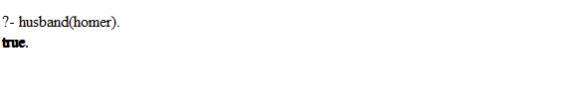

1. wife(X) : true if X is someone’s wife

**Answer:**

wife(W) :- family(_,person(W,_,_,_),_).



1. child(X) : true if X is someone’s child

**Answer:**

child(X) :- family(_,_,Children), member(person(X,_,_,_), Children).



1. exists(Person) : true if the person is in the database

**Answer:**

exists(Person) :- husband(Person);wife(Person);child(Person).

