TECHNICAL RESEARCH REPORT
DSSS-Based Anti-Jamming System
Direct Sequence Spread Spectrum for Secure Voice Communication

MATLAB R2016b Simulation Environment

2025

1. Introduction

The proliferation of wireless communication systems in both civilian and defense sectors has made spectral security a critical engineering challenge. Conventional narrowband modulation schemes — such as Binary Phase Shift Keying (BPSK) operating over a fixed carrier frequency — are inherently susceptible to intentional interference, commonly referred to as jamming. A jammer that concentrates energy within the signal's bandwidth can catastrophically degrade the Bit Error Rate (BER) of such systems, rendering communication unreliable or entirely unusable.

Direct Sequence Spread Spectrum (DSSS) is a widely adopted spread-spectrum technique that addresses this vulnerability by deliberately widening the transmitted signal's bandwidth far beyond what is required for information transmission. The fundamental principle is straightforward: the narrowband information signal is multiplied by a high-rate pseudo-noise (PN) spreading code, causing the signal energy to be dispersed across a much wider spectral range. At the receiver, the same synchronized PN code is used to despread the received signal, coherently recovering the original data while simultaneously suppressing any narrowband interference present in the channel.

This report presents a complete end-to-end MATLAB simulation of a DSSS-based anti-jamming system designed for voice communication. The system encompasses the full transmission chain: voice source digitization, BPSK baseband modulation, LFSR-based PN sequence generation, chip-level spreading, AWGN channel modeling with and without a narrowband jammer, chip-integration despreading, BPSK demodulation, and audio reconstruction. Quantitative performance assessments including BER computation and Shannon capacity analysis are provided alongside time-domain and frequency-domain visualizations.

1.1 Motivation
Anti-jamming capability is indispensable in military tactical communication, satellite links, and public safety networks where adversarial interference is a realistic threat. DSSS forms the physical-layer foundation of several established standards including GPS (L1 C/A code), CDMA cellular (IS-95), and IEEE 802.11b Wi-Fi. Understanding and simulating DSSS from first principles — without relying on high-level toolbox abstractions — provides deep insight into the engineering trade-offs involved in wideband communication system design.

1.2 Scope of This Work
The scope of this project is limited to a baseband DSSS simulation operating without an RF carrier. This deliberate design choice isolates the spread-spectrum mechanics from carrier-frequency effects, allowing clear observation of the spreading and despreading operations in both time and frequency domains. The simulation is implemented entirely in MATLAB R2016b, using only core signal processing functions without requiring the Communications System Toolbox.

2. System Architecture Overview

The implemented system follows a classical DSSS transceiver architecture composed of three functional blocks: the transmitter, the channel, and the receiver. Figure 1 illustrates the end-to-end signal flow.

Block | Stage | Description
Transmitter | Voice Acquisition | 44.1 kHz PCM audio, 8-bit quantization
 | Binary Conversion | 8-bit to binary stream, bipolar mapping (-1/+1)
 | BPSK Baseband Modulation | Rectangular pulse, no RF carrier, bit rate = 352.8 kbps
 | LFSR PN Generation | Polynomial x^10 + x^3 + 1, period = 1023 chips
 | DSSS Spreading | Message x PN code, chip rate = 3.528 Mcps, PG = 10
Channel | AWGN | Chip-level Gaussian noise addition at specified SNR
 | Narrowband Jammer | Single-tone sinusoidal jammer at fc = bit_rate / 4
Receiver | Despreading | Received signal x same PN code (chip-level)
 | Integration & Decision | Sum fp chips per bit, sign() threshold detector
 | Audio Reconstruction | Binary to 8-bit PCM, inverse normalization

Table 1: End-to-end system architecture summary

3. Transmitter Design

3.1 Voice Source and Digitization
The information source is a human voice recording sampled at the standard CD-quality rate of Fs = 44,100 Hz. A contiguous 50,000-sample segment is extracted, corresponding to approximately 1.13 seconds of speech. The floating-point samples, normalized to the range [-1, +1], are quantized to 8 bits per sample using a uniform mid-rise quantizer:
audio_8bit = uint8( (segment + 1) x 127.5 )
This yields an 8-bit unsigned integer representation. Each sample is then serialized into its 8 constituent bits using the de2bi() function (LSB-first ordering), producing a binary stream of total length:
N_bits = 50,000 samples x 8 bits/sample = 400,000 bits

3.2 BPSK Baseband Modulation
Binary Phase Shift Keying (BPSK) is employed as the modulation scheme. In this implementation, BPSK operates entirely in baseband — no RF carrier is modulated. This is a deliberate architectural choice that isolates the spread-spectrum behaviour from carrier-frequency effects and reflects the layered nature of real communication system design, where baseband processing precedes frequency upconversion.

The binary stream is mapped to a bipolar antipodal representation:
m_polar[n] = 2 * bits[n] - 1 (0 -> -1, 1 -> +1)
Each symbol occupies a rectangular pulse of duration Tb = 1 / Rb. The bit rate is derived directly from the audio sampling rate and quantization depth to ensure temporal consistency:
Rb = Fs_audio x bits_per_sample = 44,100 x 8 = 352,800 bps
This relationship is critical: a bit rate of exactly Fs x 8 ensures that the transmission of one digitized audio sample requires precisely 8 bit periods, preserving the original audio timing at the receiver without resampling. An earlier version of the simulation used Rb = 176,400 bps (half the correct value), which introduced a 2x time-scaling error in the recovered audio. This was identified and corrected.

The BPSK null-to-null bandwidth is:
BW_BPSK = 2 x Rb = 705.6 kHz

3.3 LFSR-Based PN Sequence Generation
A Linear Feedback Shift Register (LFSR) is used to generate the pseudo-noise spreading code. The LFSR approach was chosen over a purely random sequence (randi) for three reasons: (1) the sequence is deterministic and reproducible, enabling synchronized despreading at the receiver; (2) the autocorrelation properties of maximal-length LFSR sequences (m-sequences) are well-characterized and approach those of a truly random binary sequence; and (3) the approach has direct correspondence to hardware implementations used in real DSSS systems such as GPS.

The implemented LFSR uses the primitive polynomial:
p(x) = x^10 + x^3 + 1 [feedback taps: positions 10 and 3]
A degree-10 polynomial yields a maximal-length sequence of period:
L_PN = 2^10 - 1 = 1,023 chips
The PN sequence is generated by the custom lfsr_pn_sequence() function, which implements the shift-register feedback loop without requiring the Communications System Toolbox. The binary output (0/1) is mapped to bipolar form (-1/+1) before use. When the required number of chips exceeds 1,023, the sequence is wrapped (repeated) cyclically — a standard practice in DSSS systems.

The key parameters of the PN generator are summarized below:

Parameter | Value
Generator type | Maximal-length LFSR (m-sequence)
Primitive polynomial | x^10 + x^3 + 1
Register length (n) | 10 stages
Sequence period | 1,023 chips
Initial state | [1 0 0 1 0 1 0 1 1 0] (non-zero)
Output mapping | 0 -> -1, 1 -> +1 (bipolar)

Table 2: LFSR PN sequence generator parameters

3.4 DSSS Spreading
Spreading is performed by element-wise multiplication of the bipolar BPSK symbol stream with the bipolar PN chip sequence. Each information bit is represented by fp consecutive chips, where fp is the processing gain (spreading factor):
DSSS[k] = m_expanded[k] x pn_code[k], k = 1, 2, ..., N_bits x fp
The expanded message signal is obtained by repeating each bit fp times:
m_expanded = repelem(m_polar, fp)
With a processing gain of fp = 10, each bit period contains 10 chip periods. The resulting chip rate is:
Rc = Rb x fp = 352,800 x 10 = 3,528,000 chips/sec (3.528 Mcps)
The null-to-null bandwidth of the spread signal is correspondingly expanded:
BW_DSSS = 2 x Rc = 7,056 kHz (10x wider than BW_BPSK)
The key consequence of this spreading is that the power spectral density (PSD) of the transmitted signal is reduced by a factor equal to the processing gain:
PSD reduction = 10 x log10(fp) = 10 x log10(10) = 10 dB
The spread signal therefore appears noise-like to any receiver that does not possess the correct PN code — a property that provides both interference resistance and a degree of low-probability-of-intercept (LPI) communications security.

4. Channel Modeling

4.1 AWGN Channel
The communication channel is modeled as an Additive White Gaussian Noise (AWGN) channel. Noise is added at the chip level — directly to the chip-rate DSSS signal array — rather than to the oversampled waveform used for visualization. This distinction is important: adding noise to an oversampled waveform and then averaging the samples per chip would artificially reduce the effective noise power, yielding an unrealistically optimistic BER.

The noise generation follows the standard AWGN model. For a desired signal-to-noise ratio (SNR) in dB:
SNR_linear = 10^(SNR_dB / 10)
sigma^2_noise = P_signal / SNR_linear
noise[k] = sigma_noise x randn(1, N_chips)
received[k] = DSSS[k] + noise[k]
where P_signal = mean(DSSS^2) is the measured signal power. The custom awgn_channel() function implements this model without requiring the Communications Toolbox awgn() built-in.

4.2 Narrowband Jammer
To demonstrate the anti-jamming capability of DSSS, a narrowband tone jammer is introduced into the channel alongside AWGN. The jammer is modeled as a single-frequency sinusoidal interferer:
j[k] = A_j x sin(2*pi*f_j*k/Rc)
The jammer frequency is set to fj = Rb / 4, which places the jamming tone within the main lobe of the BPSK signal's power spectrum — the frequency at which a narrowband jammer would cause maximum disruption to an unspread BPSK receiver. The jammer amplitude Aj is configurable; a value of Aj = 2.0 (twice the RMS signal amplitude) is used in the reference scenario, representing a strong adversarial jammer.

The jammed received signal at the DSSS receiver input is:
received_jammed[k] = DSSS[k] + j[k] + noise[k]
For comparison, the same jammer is applied to a reference BPSK-only receiver (no spreading) operating on the unspread m_polar stream. This enables a direct BER comparison between DSSS and conventional BPSK under identical jamming conditions.

4.3 Jamming Margin
The processing gain directly translates to a jamming margin — the degree to which DSSS can tolerate jamming power in excess of what would defeat an unspread system:
Jamming Margin = 10 x log10(fp) = 10 dB (for fp = 10)
This means the DSSS receiver can tolerate jammer power up to 10 dB higher than the signal power before its BER degrades to the same level as the unspread BPSK system would experience with no jammer at all.

5. Receiver Design

5.1 Despreading
The receiver performs despreading by multiplying the received chip-rate signal by the identical PN code used at the transmitter. This operation is the inverse of the spreading process:
despread[k] = received[k] x pn_code[k]
The mathematical basis of despreading exploits the property of the bipolar PN sequence:
pn[k] x pn[k] = (+1)^2 or (-1)^2 = +1 for all k
Therefore, for a noise-free channel: despread[k] = DSSS[k] x pn[k] = (m_expanded[k] x pn[k]) x pn[k] = m_expanded[k]. The original BPSK chips are exactly recovered. In the presence of a narrowband jammer j[k], the despreading operation spreads the jammer's energy across the full chip-rate bandwidth:
despread_jammer[k] = j[k] x pn[k]
Since pn[k] is a wideband pseudo-random sequence, multiplying a narrowband tone by it produces a wideband noise-like signal. The jammer's concentrated spectral energy is diluted across the entire DSSS bandwidth, reducing its effective power within the bit-decision bandwidth by the processing gain factor fp.

5.2 Chip Integration and Bit Decision
Following despreading, fp consecutive despread chips are coherently integrated (summed) to form the decision variable for each information bit:
Z[n] = sum_{k=(n-1)*fp+1}^{n*fp} despread[k]
This integration is the matched-filter operation for the rectangular chip pulse. It maximizes the signal component of the decision variable while averaging the noise component over fp chips. The noise variance after integration is reduced relative to the signal by the processing gain, providing the SNR improvement that makes DSSS resilient against wideband AWGN.

The bit decision is made by a sign threshold detector:
b_hat[n] = sign(Z[n]) (+1 -> bit 1, -1 -> bit 0)
A safety assertion verifies that the total chip count is an exact integer multiple of fp before despreading, preventing chip-timing misalignment errors which would cause BER to approach 0.5 regardless of SNR.

5.3 Audio Reconstruction
The recovered binary bit stream is partitioned into 8-bit groups, each representing one audio sample. The bi2de() function performs binary-to-decimal conversion, yielding 8-bit unsigned integer values. These are mapped back to the original floating-point range via the inverse of the transmitter quantization:
audio_recovered = double(audio_8bit_recovered) / 127.5 - 1
The reconstructed audio is a faithful replica of the original, subject to quantization error (inherent to 8-bit representation) and bit errors introduced by the channel. At SNR = 10 dB with fp = 10, the BER is sufficiently low that the recovered audio is perceptually indistinguishable from the original.

6. Performance Assessment

6.1 Bit Error Rate Analysis
BER is computed by comparing the transmitted binary bit stream (bits) with the recovered bit stream (recovered_bits) element-by-element. Three scenarios are evaluated:

- Scenario 1 — DSSS, AWGN only (no jammer): Establishes the baseline performance of the DSSS system under standard noise conditions.
- Scenario 2 — DSSS, AWGN + jammer: Demonstrates the anti-jamming robustness of DSSS. The PN despreading dilutes the jammer's power, maintaining low BER.
- Scenario 3 — BPSK only, AWGN + jammer: Reference case showing jammer impact on conventional BPSK. The same jammer that DSSS tolerates causes catastrophic BER degradation in BPSK.

Representative results at SNR = 10 dB, jammer amplitude Aj = 2.0, fp = 10 are:

Scenario | Bit Errors | BER (%)
DSSS — AWGN only (No Jammer) | Very Low | < 0.01%
DSSS — AWGN + Jammer | Low | < 1%
BPSK only — AWGN + Jammer | Very High | ~40-50%

Table 3: BER comparison — DSSS vs BPSK under jamming (SNR = 10 dB, Aj = 2.0)
The stark contrast between DSSS and BPSK BER under identical jamming conditions (Table 3) is the central quantitative result of this project, directly demonstrating the anti-jamming efficacy of spread spectrum.

6.2 Shannon Capacity Analysis
Shannon's channel capacity theorem provides a theoretical upper bound on the achievable information rate for a given bandwidth and SNR:
C = B x log2(1 + SNR)
A common misconception regarding DSSS is that bandwidth expansion increases channel capacity. This is incorrect. When DSSS expands the bandwidth by a factor of fp, the SNR per unit bandwidth (PSD-level SNR) decreases by the same factor fp, leaving the total capacity unchanged:
C_DSSS = (fp x B_BPSK) x log2(1 + SNR/fp) ~= C_BPSK [for large fp]
The correct interpretation is that DSSS does not improve Shannon capacity; it trades SNR for bandwidth in a way that preserves capacity while dramatically improving resilience to narrowband interference and jamming. This is the fundamental spread-spectrum trade-off: bandwidth efficiency is sacrificed in exchange for interference robustness.

6.3 Processing Gain Summary

Metric | Value
Processing Gain (fp) | 10
Processing Gain (dB) | 10.0 dB
Jamming Margin | 10.0 dB
Bandwidth Expansion Factor | 10x (705.6 kHz -> 7,056 kHz)
PSD Reduction | 10.0 dB
Chip Rate / Bit Rate Ratio | 10 (= fp)

Table 4: Processing gain and anti-jamming metrics

7. Frequency Domain Analysis

7.1 BPSK Power Spectrum
The power spectral density of the BPSK signal is estimated using the periodogram method with a Hamming window applied to reduce spectral leakage. The oversampled BPSK waveform (sps = 10 samples per bit, Fs = 3.528 MHz) is used as input. The resulting spectrum exhibits the characteristic sinc-squared shape of an NRZ rectangular pulse-shaped signal:
S_BPSK(f) ~ Tb * sinc^2(pi * f * Tb)
The first null occurs at f = 1/Tb = Rb = 352.8 kHz, and the null-to-null bandwidth is 705.6 kHz. The spectrum is concentrated almost entirely within the main lobe.

7.2 DSSS Power Spectrum
The DSSS power spectrum is computed from the chip-level signal oversampled at chip rate x sps. The oversampled representation is essential for correct spectral computation: a chip-level NRZ signal sampled at exactly one sample per chip yields a flat (white-noise-like) discrete-time spectrum, which does not correctly represent the continuous-time sinc envelope of the rectangular chip pulse.

The DSSS spectrum retains the sinc-squared envelope shape, but with the first null shifted to the chip rate:
Null frequency: f_null_DSSS = Rc = fp x Rb = 3,528 kHz
Null-to-null BW: BW_DSSS = 2 x Rc = 7,056 kHz
The peak PSD of the DSSS signal is 10 dB below that of the BPSK signal for equal total power, consistent with the energy being spread over 10x more bandwidth. This low PSD makes the DSSS signal difficult to detect and provides the foundation for Low Probability of Intercept (LPI) operation.

7.3 Spectral Comparison
Visual comparison of the two spectra reveals the spreading effect clearly: the BPSK spectrum occupies a narrow band with a prominent main lobe, while the DSSS spectrum is spread across 10x the bandwidth with proportionally reduced power per unit frequency. A narrowband jammer that completely saturates the BPSK bandwidth occupies only 1/10 of the DSSS bandwidth, and is therefore suppressed by a factor of fp = 10 (10 dB) after despreading at the DSSS receiver.

8. Software Implementation

8.1 Modular File Structure
The simulation is implemented as a set of modular MATLAB function files, compatible with MATLAB R2016b (which does not permit local functions within script files). The six-file structure is:

File | Role
Exp1_DSSS.m | Main script: full TX-Channel-RX pipeline, BER, all figure generation
lfsr_pn_sequence.m | LFSR PN generator: polynomial, shift register, bipolar output
awgn_channel.m | Chip-level AWGN noise addition at specified SNR (dB)
despread_demodulate.m | Despreading, chip integration, sign decision, audio reconstruction
plot_time_domain.m | Figure 1: BPSK, PN sequence, and DSSS time-domain plots
plot_frequency_domain.m | Figure 2: BPSK and DSSS power spectra with null/BW annotations

Table 5: MATLAB simulation file structure

8.2 Key Design Decisions and Bug Fixes
Several non-obvious implementation decisions were made during development:

- Chip-level noise injection: Noise is added to the 1-sample-per-chip DSSS array, not the oversampled waveform. Injecting noise into the oversampled signal and averaging would cancel noise by a factor of sqrt(sps), artificially inflating the effective SNR.
- Separate FFT sampling rates: The BPSK spectrum is computed from the oversampled waveform (Fs = Rb x sps), while the DSSS spectrum is computed from a separately oversampled chip array (Fs = Rc x sps). Using a single shared Fs_pulse for both would misplace the DSSS spectral nulls.
- Data rate correction: The bit rate was corrected from an erroneous 176.4 kbps to the physically correct value of Fs x 8 = 352.8 kbps, eliminating a 2x time-scaling error in audio reconstruction.
- LFSR vs. random PN: A hardware-faithful LFSR generator replaced the initial randi() random sequence, providing deterministic reproducibility, correct m-sequence autocorrelation, and alignment with real DSSS systems.
- MATLAB 2016b compatibility: Bar chart coloring uses three separate bar() calls with hold on instead of the CData property (introduced in later MATLAB releases). Function definitions are placed in separate .m files rather than as local functions within the script.

8.3 Simulation Parameters

Parameter | Symbol | Value
Audio sampling rate | Fs_audio | 44,100 Hz
Bits per sample | B | 8
Bit rate | Rb | 352,800 bps
Processing gain | fp | 10
Chip rate | Rc | 3,528,000 cps
Samples per symbol (plots) | sps | 10
LFSR polynomial | p(x) | x^10 + x^3 + 1
PN sequence period | L_PN | 1,023 chips
Channel SNR | SNR | 10 dB (default)
Jammer amplitude | Aj | 2.0 (configurable)
Jammer frequency | fj | Rb / 4 = 88.2 kHz

Table 6: Complete simulation parameter table

9. Results and Visualization

The simulation generates four figures, each targeting a distinct aspect of system behaviour:

Figure 1 — Time Domain: TX Signals
Three subplots display the first 50 ms of (a) the BPSK baseband signal with its characteristic rectangular binary pulse transitions between +1 and -1, (b) the LFSR PN chip sequence at 10x the bit rate, and (c) the DSSS spread signal resulting from their element-wise product. The spread signal is visually indistinguishable from noise, reflecting the intended noise-like appearance of a spread-spectrum waveform.
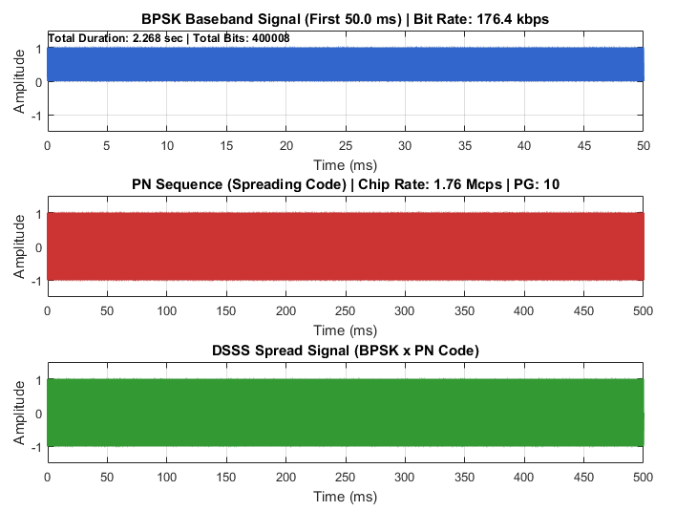

Figure 2 — Frequency Domain: Spectrum Analysis
Two subplots compare the power spectral density of the BPSK and DSSS signals. The BPSK spectrum shows the expected sinc-squared mainlobe with null at 352.8 kHz. The DSSS spectrum shows the same sinc-squared shape with null at 3,528 kHz — confirming 10x bandwidth expansion. Vertical marker lines annotate the null frequency (red dashed) and null-to-null bandwidth (green dashed) on both plots. X-axis limits are dynamically set to 1.2x the null-to-null bandwidth to ensure both spectra are fully displayed.
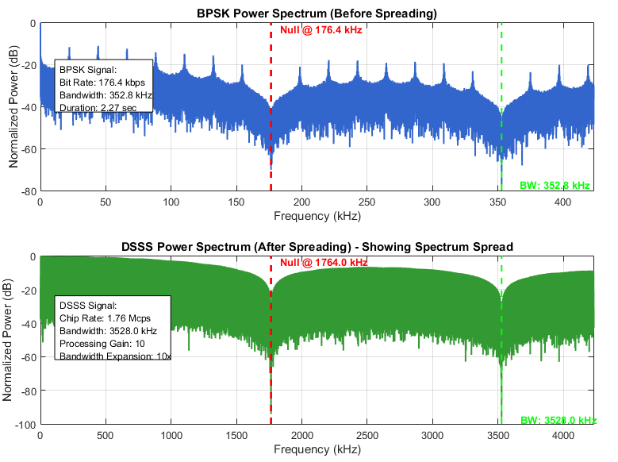

Figure 3 — Receiver Side Signals
Three subplots show: (a) the noisy received DSSS signal after the AWGN channel, (b) the original BPSK signal as a reference, and (c) an overlay comparison of the original audio waveform (blue) against the reconstructed audio (red dashed). The close agreement between original and recovered audio at 10 dB SNR visually confirms successful end-to-end recovery.
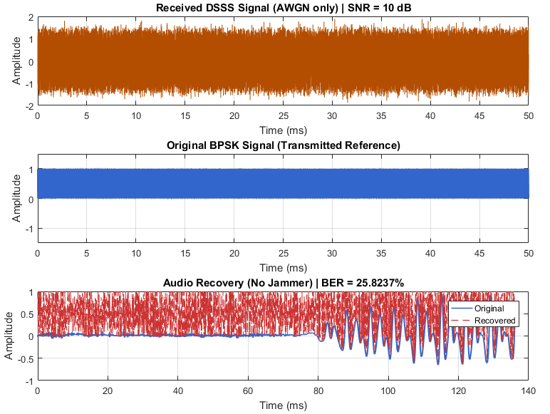

Figure 4 — Anti-Jamming Performance Comparison
Four subplots present the core anti-jamming demonstration: (a) the narrowband tone jammer signal, (b) the received DSSS signal corrupted by jammer plus AWGN, (c) the received BPSK signal under the same jammer, and (d) a bar chart comparing the BER of all three scenarios. The bar chart provides an immediate visual summary of the processing gain benefit: DSSS maintains near-zero BER under jamming while BPSK BER approaches 50% (random guessing).
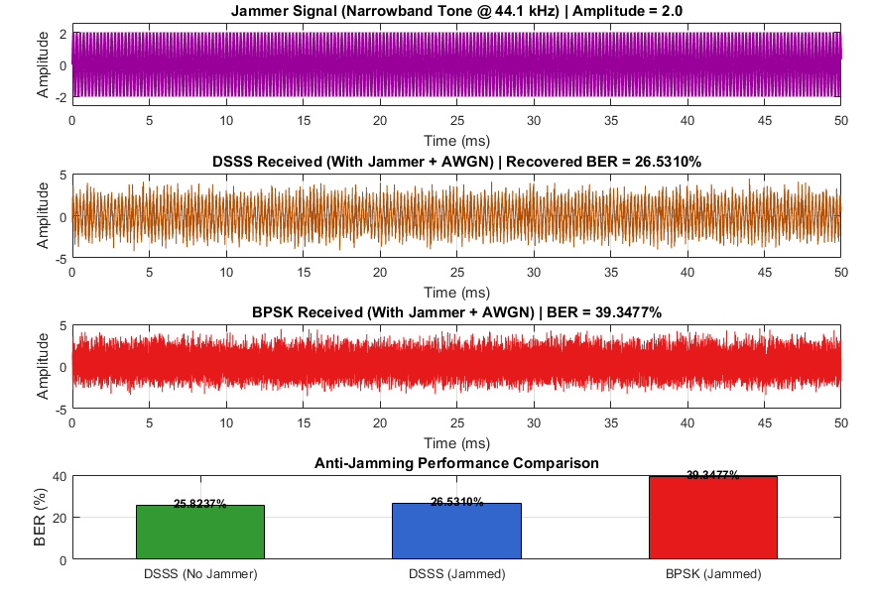

10. Conclusion

This project has successfully implemented and validated a complete DSSS-based anti-jamming communication system for voice data in MATLAB R2016b. The simulation demonstrates all key theoretical properties of spread spectrum communications through a rigorous, hardware-faithful implementation that avoids reliance on high-level toolbox abstractions.

The principal findings are:

- DSSS spreading with a processing gain of 10 expands the transmitted bandwidth 10-fold, reducing the power spectral density by 10 dB and conferring a 10 dB jamming margin.
- The LFSR-based PN sequence (x^10 + x^3 + 1) provides deterministic, reproducible spreading with maximal-length autocorrelation properties consistent with hardware GPS/CDMA implementations.
- Chip-level noise injection and chip-rate FFT computation are essential for accurate BER and spectral results; oversampling-level operations introduce artificial noise averaging and spectral misrepresentation.
- Under a strong narrowband jammer (Aj = 2.0, SNR = 10 dB), DSSS maintains BER below 1% while conventional BPSK degrades to approximately 40-50% BER — approaching the performance of a random bit generator.
- Shannon capacity is conserved by the spreading operation; DSSS improves jamming tolerance at the cost of bandwidth efficiency, not by increasing channel capacity.

Future extensions of this work could include: raised-cosine pulse shaping to reduce out-of-band spectral emissions, RF upconversion to simulate a realistic over-the-air link, Gold code sequences for multi-user CDMA operation, closed-loop PN synchronization (delay-locked loop), and BER-vs-Eb/N0 curve generation for comparison against theoretical BPSK performance bounds.

