1. Three places are needed to be reworked: MIC, R or L output and GND as below.

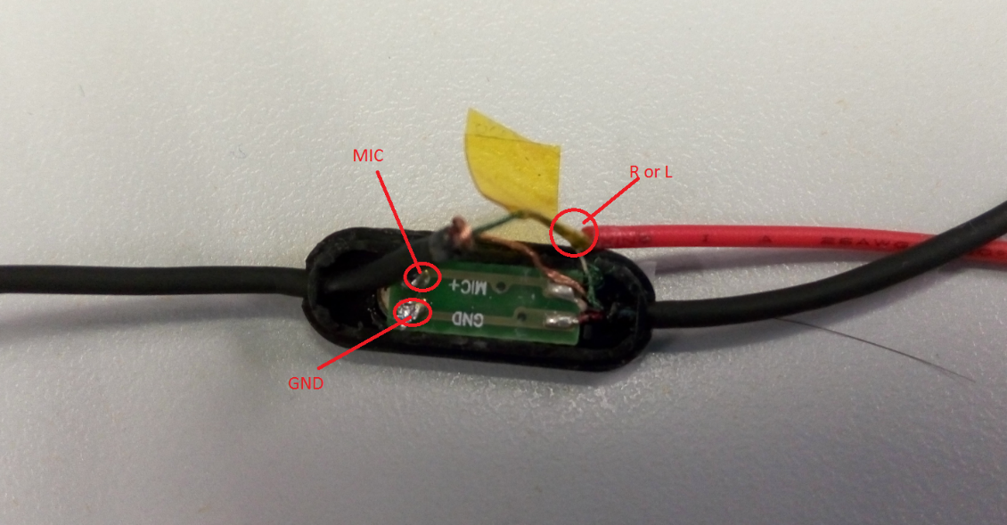

1. Weld three wires to these three places as below

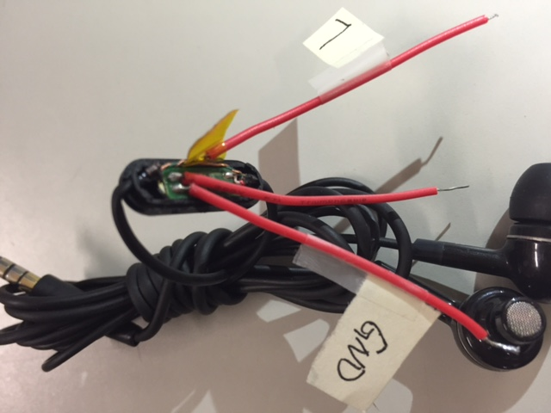

1. Using the insulation glue to reinforce the re-worked headset.

