**Android* Example Applications to Communicate with Sensors Using PIO APIs of Android Things**

1. **Android Things:**

Android Things is a comprehensive solution for building Internet of Things (IoT) products with the power of Android. Now any Android developer can quickly build a smart device using Android APIs and Google services, while staying highly secure with updates directly from Google. Android Things includes familiar tools such as Android Studio, the Android Software Development Kit (SDK), Google Play Services, and Google Cloud Platform.

One major feature Android Things provides is Peripheral I/O APIs to communicate with sensors and actuators using industry-standard protocols and interfaces.

PIO protocols supported by Android Things are GPIO, I2C, SPI, UART, and PWM.

It supports a System-on-Chip (SoC, Intel® Edison module), System-on-Module (SoM, Intel® Joule™ module) architecture that allows for a wide range of flexibility on product design.

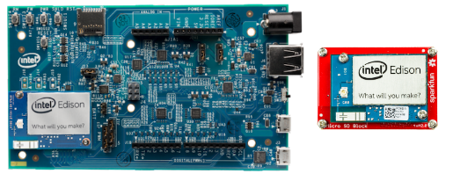

Img 1.1: Arduino board, Intel® Edison module

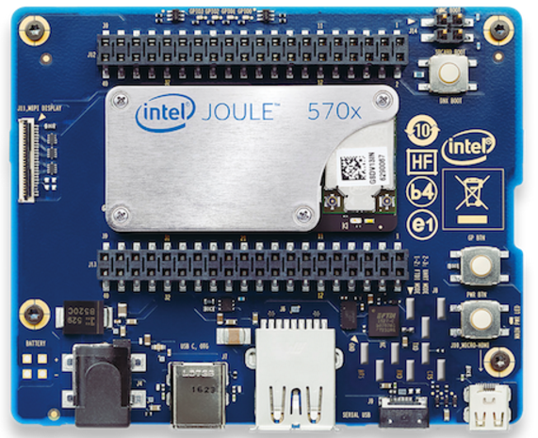

Img 1.2: Intel® Joule™ Compute Module

1. **UPM (Useful Packages & Modules) Sensor/Actuator repository for MRAA**

The UPM repository provides software drivers for a wide variety of commonly used sensors and actuators. These software drivers interact with the underlying hardware platform (or microcontroller), as well as with the PIO APIs, through calls to [MRAA](https://github.com/intel-iot-devkit/mraa) APIs.

Programmers can access the interfaces for each sensor by including the sensor’s corresponding header file and instantiating the associated sensor class. In the typical use case, a constructor initializes the sensor based on parameters that identify the sensor, the I/O protocol used, and the pin location of the sensor.

UPM provides support for 180 sensors. This sensor library can be extended by the community as well.

UPM source code is obtained from the Github link provided. Also, a link is provided that describes the sensors supported by UPM.

UPM drivers are written in C and C++ native languages. They provide wrappers for various other languages like Java, python, Node JS, and more.

1. **Example Applications:**

Apps for embedded devices bring developers closer to hardware peripherals and drivers than phones and tablets. In addition, embedded devices typically present a single app experience to users. This is good news for embedded developers who are interested in interacting with hardware peripherals using high-level languages like Java on Android Studio. The examples/Sample android applications Intel provides help achieve it. These samples provide a starting point for developers; using this template, they can further extend the functionality of how and for what they use the sensors.

Initially, Intel will provide examples for Grove kit sensors for both the Intel Edison module on an Arduino board and the Intel Joule module. Later, these android example applications will be extended to other sensors connected externally to the boards.

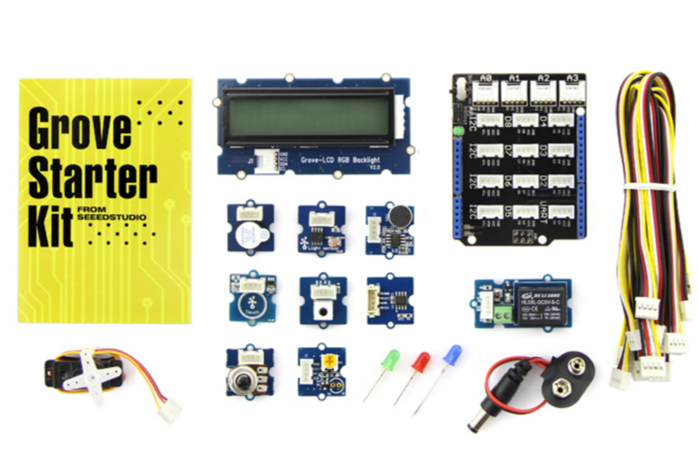

Image 3.1: Grove kit Sensors

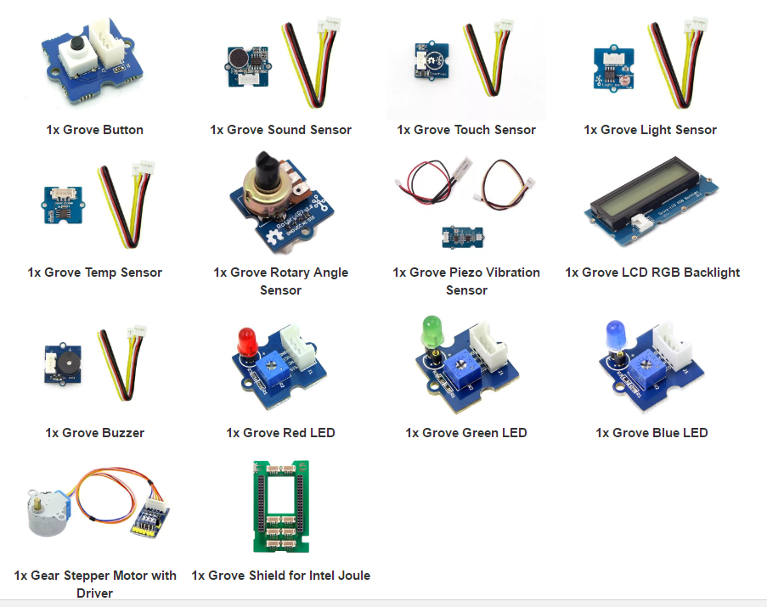

Img 3.2: Grove maker kit sensors for Intel Joule module.

The Example applications use UPM sensor libraries, MRAA libraries, and the Android Things PIO. These libraries are provided as Shared objects and are packaged into an Android Archive (aar) according to the sensor requirements.

For example, to write an application for LCD sensor (jhd1313m1) which uses i2c protocol, the application needs libmraa.so, libmraajava.so, libjavaupm-jhd1313m1.so, libupm-jhd1313m1.so, libupmc-jhd1313m1.so, and libupmc-utilities.so. All the So’s are packaged into an aar and published to JCenter. The developer only needs to include a line in the gradle scripts to access the LCD sensor apis, as shown in the example below:

**compile ‘com.intel.ssg.otc:mraa:0.0.2’**

**compile ‘GROUP_ID:ARTIFACT_ID:VERSION’**

Similarly, this is done for all the other sensors, which makes the developer’s life easy and helps them concentrate more on the sensor functionality, rather than getting stuck on identifying the sensor dependencies.

Example Applications source code will be launched soon on Github page.

* 1. **Pre-Requisites**
* Android Things Compatible board
* Sensors
* Android Studio
* Grove starter kits for the Intel Edison module and the Intel Joule module
  1. **Resources:**
* Examples in Android studio will soon be placed on Github: <https://github.com/01org/android-things-examples>
* UPM Github: <https://github.com/intel-iot-devkit/upm>
* Sensors supported by UPM: <https://software.intel.com/en-us/iot/hardware/sensors>
* Android Things Wiki: <https://developer.android.com/things/hardware/index.html>
* IO Pinout for the Intel Edison module: <https://developer.android.com/things/hardware/edison-arduino-io.html>
* IO pinout for the Intel Joule module : <https://developer.android.com/things/hardware/joule-io.html>
* Where to buy the Grove kit for the Intel Edison module: [https://www.seeedstudio.com/Grove-Starter-Kit-V3-p-1855.html#](https://www.seeedstudio.com/Grove-Starter-Kit-V3-p-1855.html).
* Where to buy the Grove Maker kit for the Intel Joule module: <http://www.mouser.com/new/seeedstudio/seeed-grove-joule/>