Intel WhR   
2WD Robot for ROS Learning and Development

# Preamble

The WhR robot is designed as a simple learning platform for autonomous robotics. Despite its small size and low cost, it is capable of performing advanced robotics computations, including simultaneous localization, mapping, and navigation. It is built around the Intel® RealSense™ Robotic Development Kit, which includes the Intel® RealSense™ R200 3D camera as well as a powerful single-board computer, the UP Board* from Aaeon*. The later includes a quad-core Intel® Atom™ x5-z8350 processor, 4GB of RAM, and 32GB of flash.

The purpose of this kit is to provide a gateway for people who may have experience with Edison, Galileo or Arduino and would like to learn more about the advanced and fascinating world of autonomous navigation and ROS (Robotic Operating System). It, and in particular its software stack, can also serve as a starting point for those seeking to develop more sophisticated robots based on the Intel® RealSense™ RDK.

While designed around the Intel® RealSense™ RDK, all frame components for the WhR are parametrically designed with OpenSCAD and can be easily adjusted to accommodate geometry of new electronic components if required.

The WhR has a simple design and uses a minimal number of easily available the off-the-shelf parts, making this platform easy to assemble. This allows you to and move faster into the ROS development phase, rather than spending time on mechanical assembly and custom electronic components. In particular, WhR's locomotion is based on two Dynamixel MX-12 servos, which provide accurate odometry feedback and speed control, and are well-supported by ROS and the robotics community.

The following document outlines all mechanical/electronic components and assembly steps of Whr robotic system. Note that for convenience low-resolution images have been inlined into this document but links are provided to high-resolution files and even 3D models as appropriate.

# Mechanical Assembly and Electric Wiring.

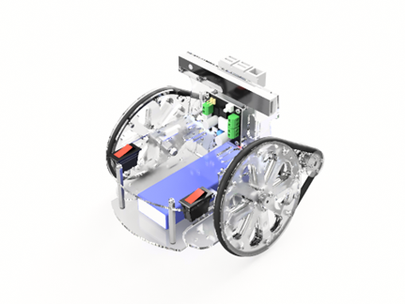

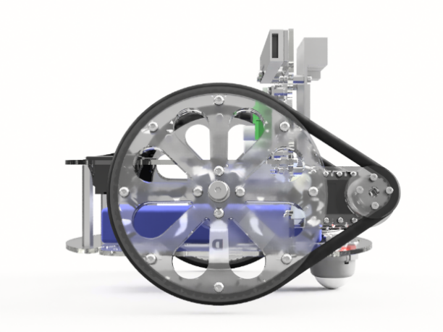

**A.** All mechanical drawings, 3D assemblies, and electrical schematics presented in this document are also available in the form of web links to CAD cloud storage. In general, the online versions of these images and models may be more up-to-date than the images in this document, in addition to in many cases allowing interaction, such as rotating the 3D model. Therefore, please follow the links in any case where a clearer view is needed or to ensure you have the latest version of the figure.

**B.** All Fasteners specifications and p/n provided in the BOM and 2D drawings. P/n are from McMaster-Carr catalog [http://www.mcmaster.com/#](http://www.mcmaster.com/)

All fasteners are metric. In many cases equivalent parts can be substituted, so in addition to McMaster-Carr part numbers we also provide (in BOM and drawings) generic specifications of each part so you can find appropriate substitute parts if necessary.

**C.** Frame, driver and wheel components are laser cut from two 450mm x 300mm (18x12 in) Acrylic or Delrin sheets, one 2mm thick and the second 3mm thick. Acrylic is perfectly fine and is low-cost, but Delrin (also known as POM or Acetel or Duracon) is more durable and is recommended for heavy use, such as in a classroom.

Note: If you just want to laser-cut the file, start with the PDF file, being careful not to resize it. If you do not have access to this size of sheet, you can rearrange the parts using Inkscape, a free 2D drawing tool. In this case, you want to start from the SVG file. If you need to rearrange the file with Adobe Illustrator, however, start from the PDF file, as AI tends to resize SVG on import. In addition, the lines in these files have been colored red and blue. Red lines should be cut first, followed by the blue lines (Trotec conventions). Depending on your laser cutter (i.e. if you have a Universal laser cutter), you may have to modify the colors to get the right cutting order. Depending on the laser cutter model the cut time is between 24 min to 1 hr.

Sheet 1:450X300x2 mm (18x12x0.078 in) – 1 each.

* [**Download Laser Cut file for 2mm sheet in SVG format**](http://a360.co/2aKxAYn)(Select Download from the Web page)
* [**Download Laser Cut file for 2mm sheet in PDF format**](http://a360.co/2iRK3wz)

 Sheet 2:450x300x3mm (18X12x0.118in) – 1 each.

* [**Download Laser Cut file for 3mm sheet in SVG format**](http://a360.co/2iRDmuA)(Select Download from the Web page)
* [**Download Laser Cut file for 3mm sheet in PDF format**](http://a360.co/2iRBB0e)

Here is a drawings of all laser cut components with the names we will be using to refer to them in the assembly notes:  [**Drawing A**](http://a360.co/2a88Qpd)**and Drawing B**

Please note that Tower plate has option to mount both: RDK kit (UP board and Intel RealSense RS200) and Intel Joule board with ZR300 camera.

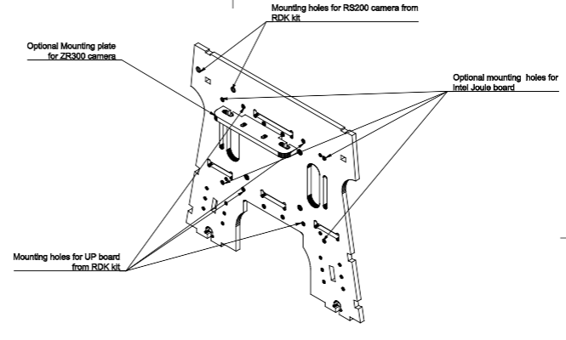

**D.** Here is a bill of Materials, with estimated cost of parts. This is for reference only, as you may be able to find alternative suppliers for these parts.

* **Download BOM(Bill of Materials) in**[**XLS format**](http://a360.co/2c8y1bV)
* **Download BOM(Bill of Materials) in**[**CSV format**](http://a360.co/2c8xRBg)

# Wheels Assembly

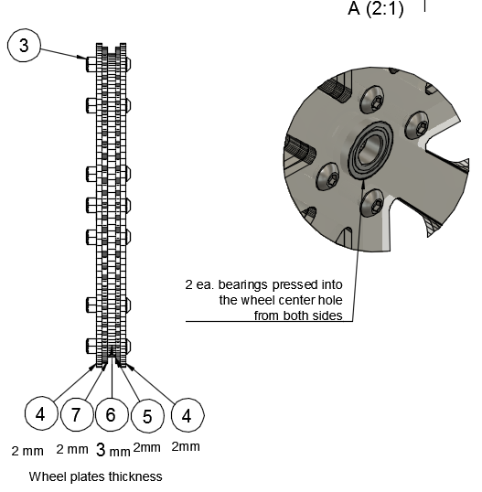

Drawing 1

[**Drawing 1**](http://a360.co/29UsC8R)

[**Wheel 3D Assembly**](http://a360.co/2agnle2)

Wheels are assembled from five layers of laser cut components. The outer profile of the wheel has a “U” shape to capture an O-ring tire. Note that the center layer is 3mm thick, and all other layers are 2mm thick. The total wheel thickness is therefore 11mm.

* Press in two bearings into the center holes of two pairs of the outer 2mm wheel layers. This is easiest to do first (before bolting the wheel layers together) as you can press in the bearing using a flat surface.
* Secure all 5 layers of the wheel with 12 ea. M3 lock-nuts and M3x14 screws.  Note that the central layer’s hole is slightly smaller than the outer diameter of the bearing, so the bearings will not pass through the center layer.
* Repeat for the second wheel.

# Frame and assembly of other components

It is advisable to assemble the rest of the robot in the following order. Note the location of the holes on the top of the tower: the orientation of the tower plate matters, it is not reversible! In particular, when viewing the tower from the side with the servos, the square notch along the top edge of the tower should be on the left. (outdated – to Remove)

      1. Attach components to the Tower plate in the following order: **(Drawings 2 A, B, C)**

[**Tower 3D Assembly**](http://a360.co/2ago66G)

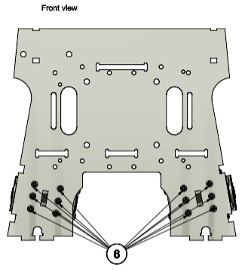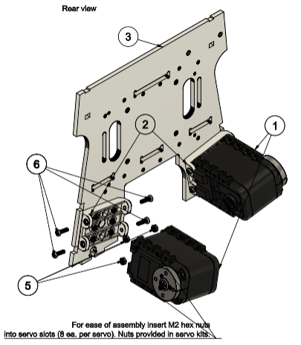

Drawing 2A

* Attach two brackets to the tower. For each bracket, install 6 hex nuts (provided in servo kit) in the bracket and use 6ea. M2x8 screws to secure bracket to the Tower. Repeat for the second bracket.[**Drawing2A**](http://a360.co/2covpJj)
* Insert M2 nuts into the servos, both along the outer faces (8 ea.) and along the slide where the bracket goes (4 ea.). We will only be using the latter for now but it is much easier to install the nuts in the servos before mounting them on the robot than afterwards.
* Attach two servos to the brackets. For each servo, use 4 ea. M2x8 screws and 4 ea. M2 hex nuts (nuts provided with servo kits). [**Drawing 2A**](http://a360.co/2covpJj)

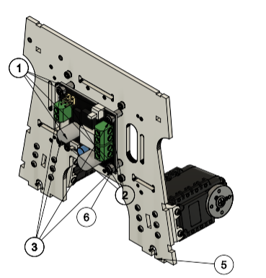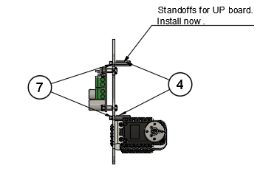

Drawing 2B

* Install DFRobot DC-DC Power Convertor. The power convertor goes on the opposite side of the tower from the servos. Note the orientation of the connectors; when viewed from the side the power converted is mounted on, the 5V output should be on the left. When viewed from the “back”, where the servos are, the 5V output will be on the right. Use 4ea. M3x6mm spacers, 4ea. M3 locknuts and 4 ea. M3x14 screws. Refer to [**Drawing 2B**](http://a360.co/2coACk9)
* Install standoffs for the UP board, but do not install UP board yet. We will install UP board last after we organize the wiring. Use 4ea M2.5x16 mm standoffs and 4ea. M2.5x6 screws. Refer to **[Drawing 2B](http://a360.co/2coACk9)**

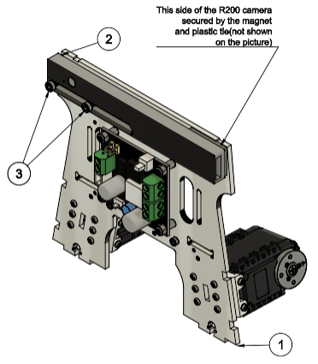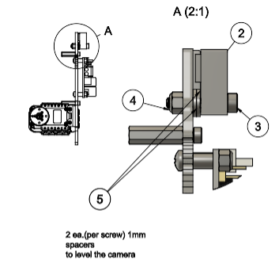

Drawing 2C

* Install the Intel® RealSense™ RS200 3D Camera. Use 2ea M3x18 socket head screws, 2 ea. M3 locknuts, 1 ea. sticky magnet (included in camera kit) and 1 ea. cable tie. Use 4ea. (2ea. per screw) M3x1mm washers as a spacers between camera and Tower. Refer to [**Drawing 2C**](http://a360.co/2afYBTa)**.** The following procedure is recommended to install the camera with precise horizontal and vertical alignment :

1. Insert 1ea. M3x18 screw into slot in camera.
2. Add 2 ea. M3x1mm washers to the screw between camera and Tower.
3. Loosely secure screw with M3 locknut in the outer camera mount hole in the tower. The camera should be able to rotate and slide freely still
4. Attach the magnet to the other side of the camera, making sure it is in an accurate position (the bump in the magnet should be in the slot on the back of the camera) and remove protective paper from the magnet.
5. Align camera vertically and horizontally - top edge of the camera should be level with the tower edge.
6. Attach sticky side of the magnet to tower.
7. Secure the locknut.
8. Secure the second screw with washers and a locknut

Do not overtighten either screw. The locknuts and screws should hold the camera firmly without bending the case.

2.   Top Plate**(Drawing 3A, B, C)**

[**Top 3D Assembly**](http://a360.co/2a3N9qc)

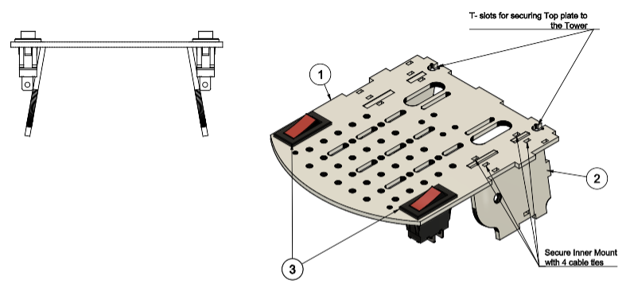

Drawing 3A

* Attach 2 ea. Inner Mount Plates to the Top Plate and secure with 2 ties. Leave ties semi loose. Don’t cut ties excess length yet. Refer to [**Drawing 3A**](http://a360.co/2a3nbTS)**.**
* Install 2 ea. Power On-Off switches. Refer to [**Drawing 3A**](http://a360.co/2a3nbTS)**.**

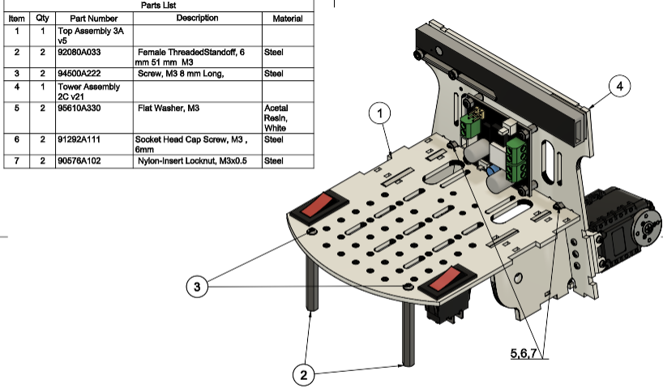

Drawing 3B

* Attach Top Plate to the Tower with 2 ea. M3x6 screws, M3nuts, M3x1 washers in T-slots. Tighten ties and cut off excess of ties’ length. Refer to [**Drawing 3B**](http://a360.co/2a3n1Mc)**.**
* Install 2 ea. M3x51mm standoffs. Use 2ea. M3x8 button head screws. Refer to [**Drawing 3B**](http://a360.co/2a3n1Mc)**.**
* Secure Outer Mount Plate to the Servo with 8ea. M2x8 screws and 8ea. M2 hex nuts**.**Repeat for the second Outer Mount.

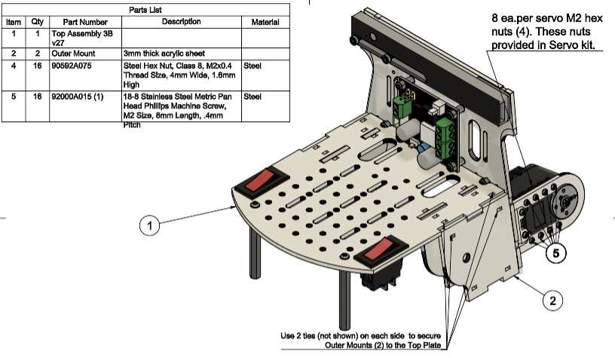

Drawing 3C

* Attach Outer Mount Plates to Top Plate with ties. Refer to [**Drawing 3C**](http://a360.co/2a3orGD)**.**

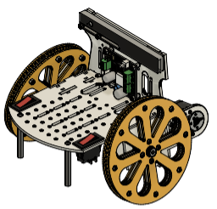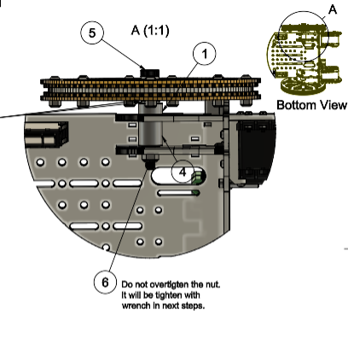

Drawing 4

   3.  Install axles and Wheels, ([**Drawing 4**](http://a360.co/2a3nPRi)**,**[**3D Assembly**](http://a360.co/2a3N1Y2)**)** but do not secure the M5 axle nut tightly yet. Repeat for the second Wheel. NOTE: it is possible to substitute an M6 nut and bolt for the shoulder bolt used here, as long as at least 12mm of the shaft of the bolt is unthreaded and is actually 6mm in diameter.

**At this point, for the ease of future assembly, it is advisable to address Servo wiring as described in Servo Wiring section below.**

4. Base Plate**(Drawings 5A, B)**

[**Base 3D Assembly**](http://a360.co/2agoFxm)

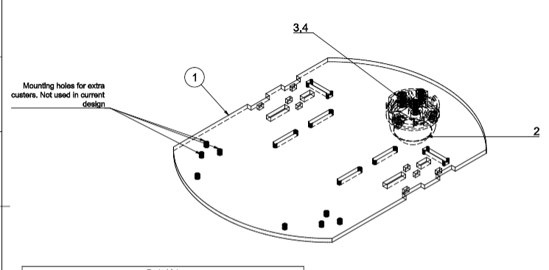

Drawing 5A

* Install ball caster on the Base plate with 3ea. M3x8 screws and 3 ea. M3 locknuts. . Current design is using one caster in the rear part of the robot, but you may add 2 more front casters if you want; this will reduce the ability of the robot to go over obstacles but will also make it less liable to tipping. The mounting holes on the front of the Base plate serve this purpose. Refer to [**Drawing 5A**](http://a360.co/2a3zOys)**.**

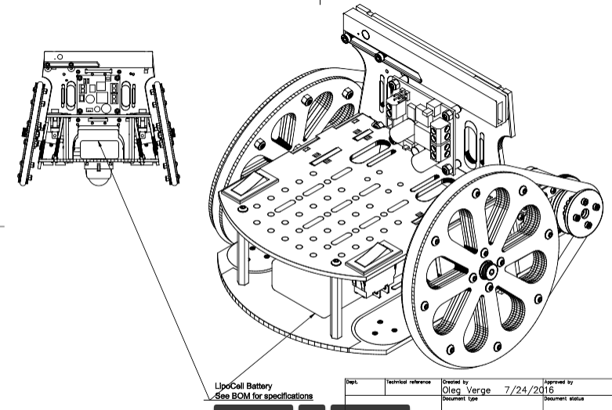

Drawing 7

* Insert Velcro straps in the slots of the Base Plate and Install the Battery. Refer to [**Drawing 7**](http://a360.co/2a88AGJ)**.**
* You should remove the battery after fitting it, then add it back in afterwards.

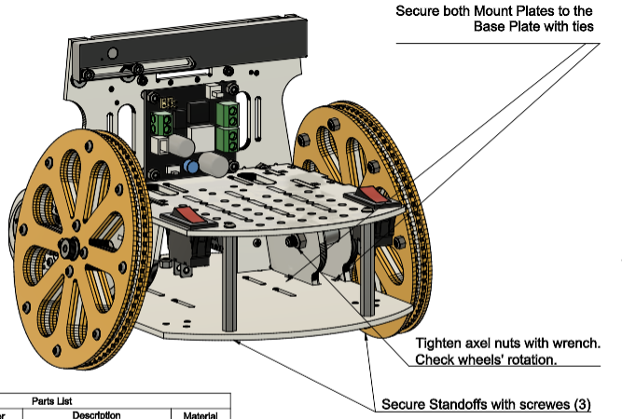

Drawing 5B

* Secure front Standoffs to the Base Plate with 2 ea. M3x8 screws [**Drawing 5B**](http://a360.co/2a3zYpA)
* Attach Base Plate to the Tower and secure it with 2ea. M3x6screws, 3ea. M3 nuts, and 3ea. M3x1mm washers in T-slots. Refer to [**Drawing 5B**](http://a360.co/2a3zYpA)
* Secure Outer and Inner Mount Plates to the Base Plate with ties. (On both sides). Refer to [**Drawing 5B**](http://a360.co/2a3zYpA)
* Tighten Axel screw M5 with a wrench. Do not overtighten. Check that Wheels rotate freely on the Axel. Refer to [**Drawing 5B**](http://a360.co/2a3zYpA).

   5. Install driver and O-rings. (**Drawings 6 A, B)**

[**Driver and O-Ring installation 3D**](http://a360.co/2akV7Pf)

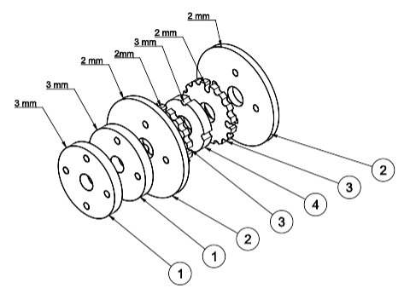

Drawing 6A

* Assemble driver from Driver components in your hand. Parts will be loose. [**Drawing 6A**](http://a360.co/2a813Yx)Using 4 ea. M2x20mm screws secure driver on the servo hub.

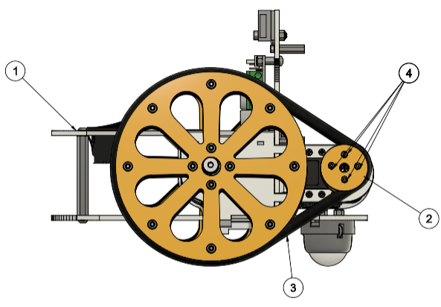

Drawing 6B

* **I**nstall Driver and O-Ring. [**Drawing 6B**](http://a360.co/2akV0mX) by placing O-Ring over the Wheel and Driver and snapping it into the groves.

6.  [**3DAssembly with battery installed**](http://a360.co/2akZt8Y)

# Wiring Components

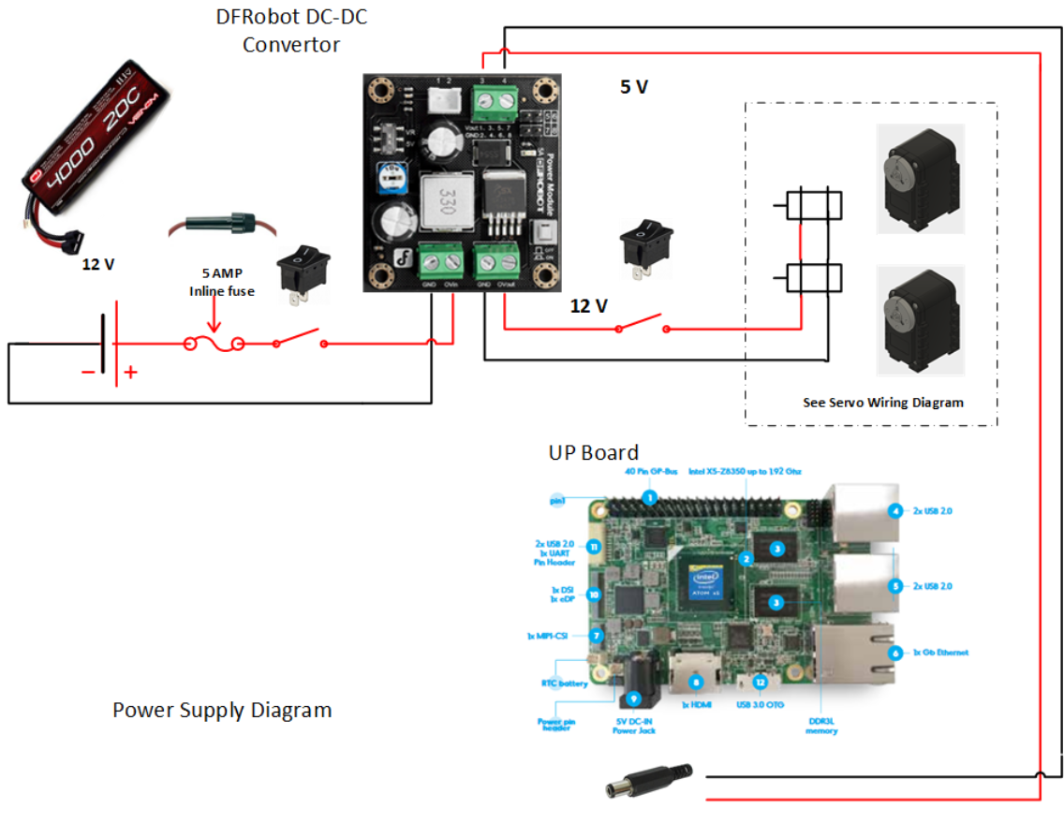

1. Electrical power supply. [**Power Supply diagram**](http://a360.co/2a8p4yC)

In this design we are using Venom 20C 3S 4000mAh 11.1V LiPo Battery with Universal Plug. In our tests this battery provides enough power for 60 min of robot's operation.

Main electrical power is distributed from the battery through an in-line 5 AMP fuse. The positive side is routed through the main power rocker switch to the DC-DC convertor, where it splits into 5V and 12V supply lines. The 12V line is used to power the Servos using a modified Dynamixel cable while the 5V line is used to power UP board with a barrel connector.

Pay special attention to the correct polarity of the wires when connecting to DC-DC convertor. If you get this wrong you can destroy your UP Board and/or your servos. It is strongly recommended to use a voltmeter to check the output voltage and polarity before plugging in the servos or the UP Board ([Manufacturer instructions](http://www.dfrobot.com/index.php?route=product/product&product_id=752#.V5etZTU2eXg))

2. Servo Wiring (For the ease of assembly it is advisable to complete this step after step 3 of the mechanical assembly)

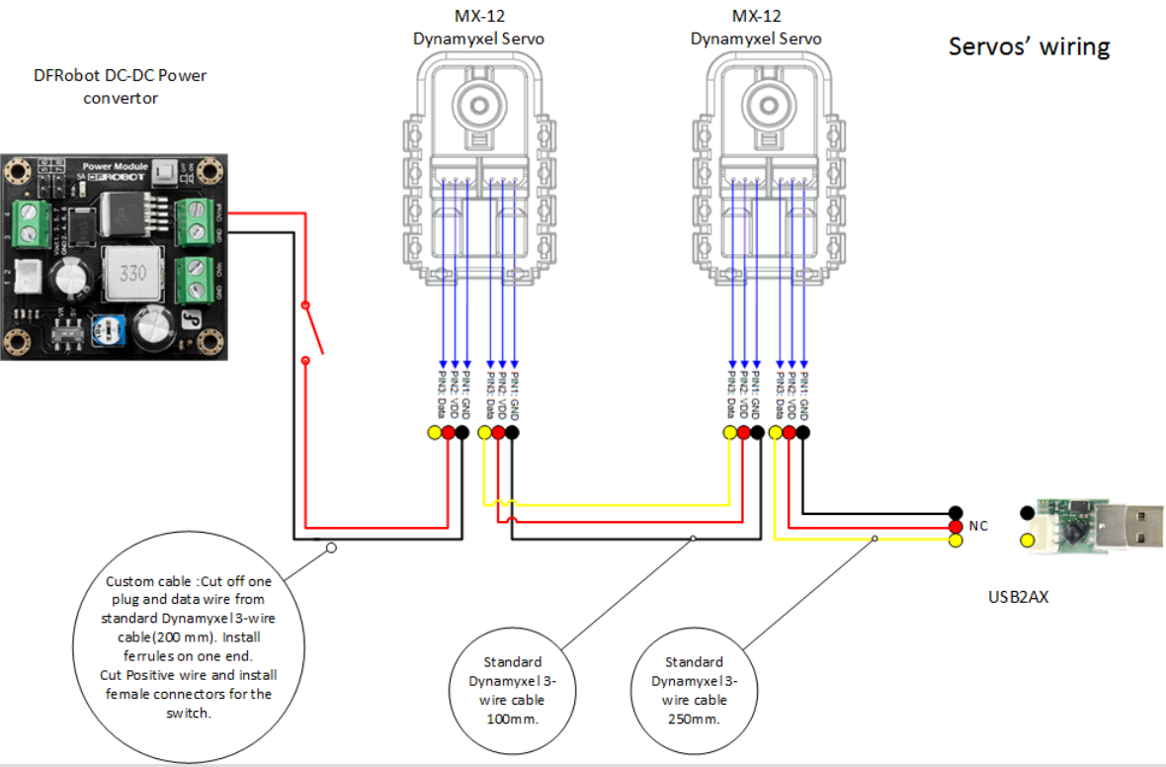

* [**Servo wiring Diagram**](http://a360.co/2a8p5CN)
* Connect USB2AX to 1st servo using a 250mm Dynamixel cable.
* Interconnect both servos with Dynamixel 100mm cable
* Using custom made cable, connect the 2nd servo to pass-through power connector of DC-DC power convertor. This cable can be created by modifying a normal Dynamixel cable. Pay attention to the polarity of wires. Red wire (the center wire of the Dynamixel cable) connects to OV out on the DC-DC convertor and the Black wire connects to GND. See wiring diagram, and note especially the keying on the Dynamixel cables… you will have to use the connector keying to distinguish the ground and the signal cables since they are not colored.
* Red wire of the custom cable has 2 female connectors to be attached to the rocker switch. This rocker switch will control power supply to motors only and will allow you to turn off motors, but keep UP board powered. This is useful both to preserve battery life when you need to work on UP board configuration and programming, and to stop or reset the motors if necessary without crashing the UP Board.

3. Camera and UP Board.

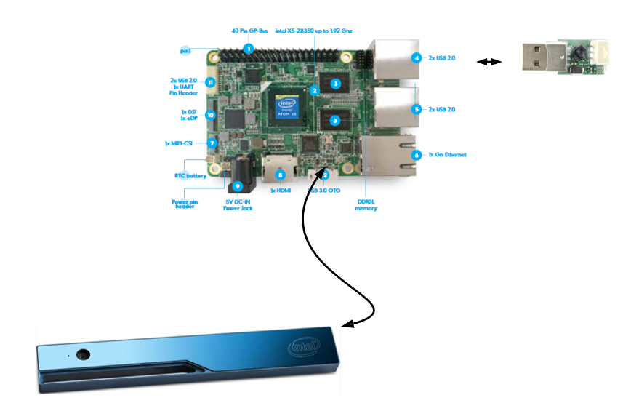

* [Connection Diagram](http://a360.co/2ci6REp)
* Connect RealSense R200 Camera to USB3 OTG port with the USB 3 cable provided in the camera kit.
* Plug in USB2AX adapter into USB2 port of the UP Board.
* It is advisable to route camera's and USB2AX cables between Tower and UP Board. Address cable management and secure UP Board to the Tower plate with 4ea. M2.5x6 screws. [Drawing 8](http://a360.co/2ajdTqA)
* Insert Wi-Fi USB dongle in UP board

This section completes Mechanical and Wiring assembly of WhR robot.