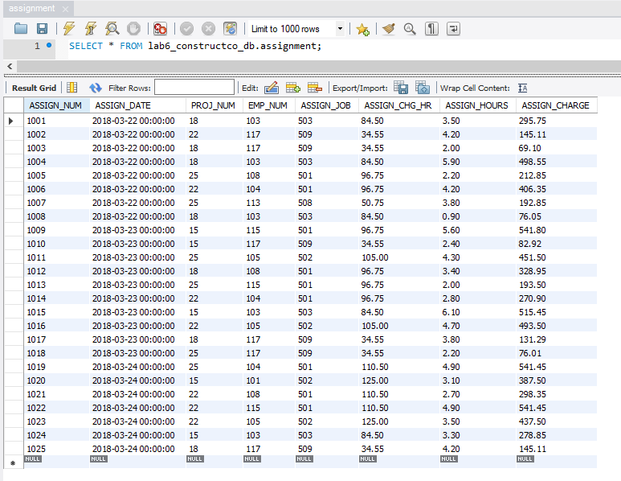

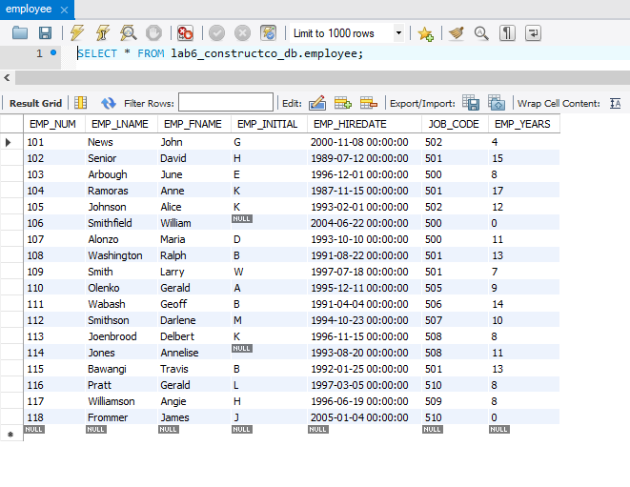

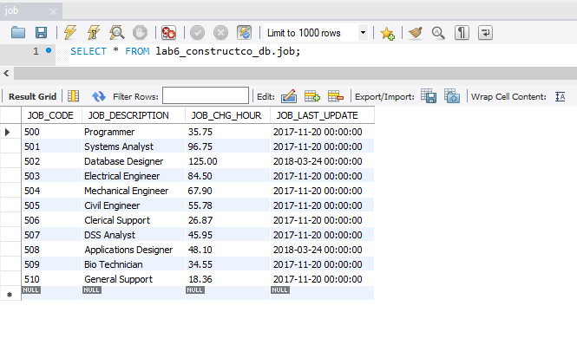

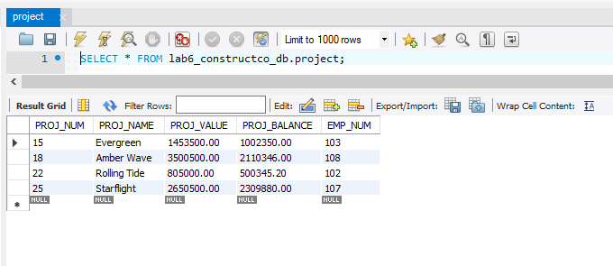

4. BEGIN;

“COMMANDS GOES HERE”

COMMIT;

6. UPDATE EMP_1

SET JOB_CODE = 501

WHERE EMP_NUM = 107;

DELETE FROM EMP_1

WHERE EMP_LNAME = 'Smithfield';

8.ALTER TABLE EMP_2

ADD (

EMP_PCT NUMERIC(4,2),

PROJ_NUM CHAR(3)

);

10. UPDATE EMP_2

SET EMP_PCT = 5.00

WHERE EMP_NUM = 105

OR EMP_NUM = 107

OR EMP_NUM = 101;

12. UPDATE EMP_2

SET EMP_PCT = EMP_PCT + 0.15

WHERE EMP_LNAME = 'Alonzo';

14. UPDATE EMP_2

SET PROJ_NUM = 25

WHERE JOB_CODE >= 502;