3. SELECT COUNT(BOOK_NUM) AS "Available Books"

FROM BOOK

WHERE PAT_ID IS NULL;

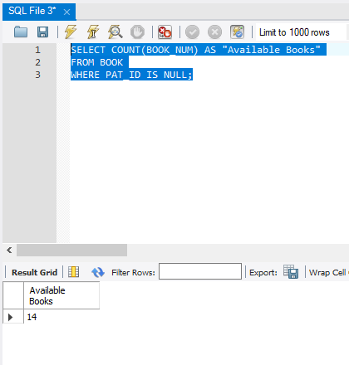

5. SELECT MIN(BOOK_COST) AS "LEAST EXPENSIVE"

FROM BOOK;

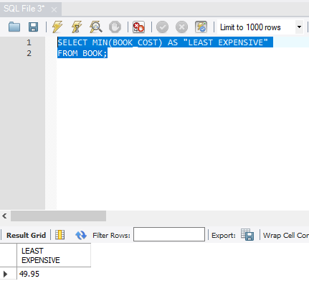

6. SELECT SUM(BOOK_COST) AS "LIBRARY VALUE"

FROM BOOK;

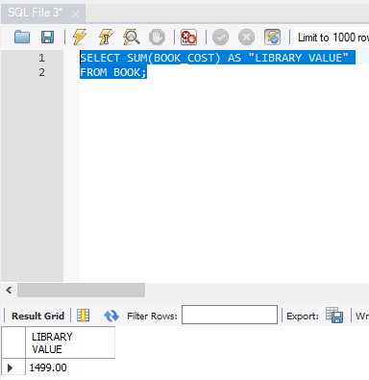

7. SELECT COUNT(DISTINCT PAT_ID) AS "different patrons"

FROM CHECKOUT

WHERE CHECK_OUT_DATE IS NOT NULL;

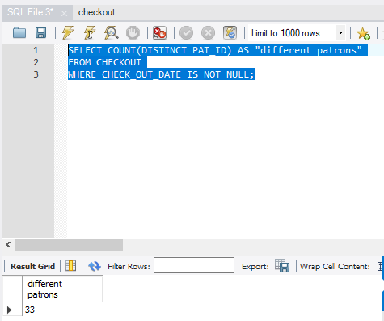

10. SELECT (BOOK_NUM), COUNT(*) AS "TIMES CHECKOUT"

FROM CHECKOUT

GROUP BY BOOK_NUM

ORDER BY COUNT(*) DESC, BOOK_NUM

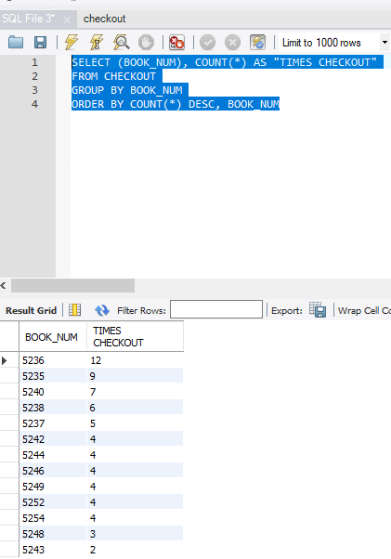

12. SELECT AUTHOR.AU_ID, BOOK.BOOK_NUM, BOOK.BOOK_TITLE,

BOOK.BOOK_SUBJECT

FROM WRITES

INNER JOIN AUTHOR ON WRITES.AU_ID = AUTHOR.AU_ID

INNER JOIN BOOK ON WRITES.BOOK_NUM = BOOK.BOOK_NUM

ORDER BY BOOK_NUM, AU_ID;

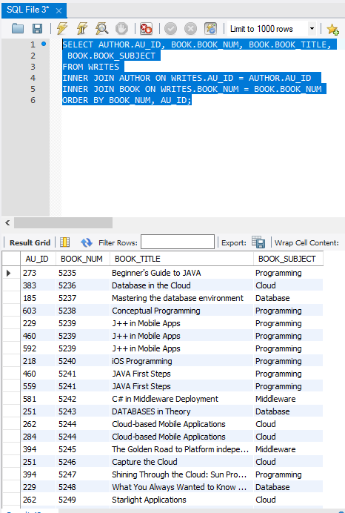

14. SELECT PATRON.PAT_ID, BOOK.BOOK_NUM,PATRON.PAT_FNAME,PATRON.PAT_LNAME,

BOOK.BOOK_TITLE

FROM PATRON

INNER JOIN BOOK ON PATRON.PAT_ID = BOOK.PAT_ID

ORDER BY PAT_LNAME,BOOK_TITLE;

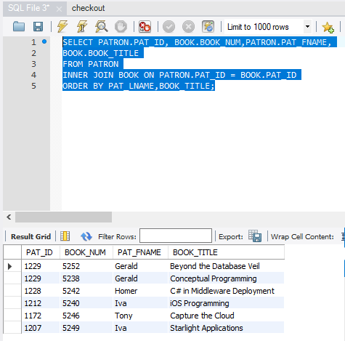

15. SELECT AUTHOR.AU_ID, AUTHOR.AU_FNAME , AUTHOR.AU_LNAME,

BOOK.BOOK_NUM, BOOK.BOOK_TITLE

FROM AUTHOR

INNER JOIN WRITES ON AUTHOR.AU_ID = WRITES.AU_ID

INNER JOIN BOOK ON BOOK.BOOK_NUM = WRITES.BOOK_NUM

WHERE BOOK.BOOK_SUBJECT = "Cloud"

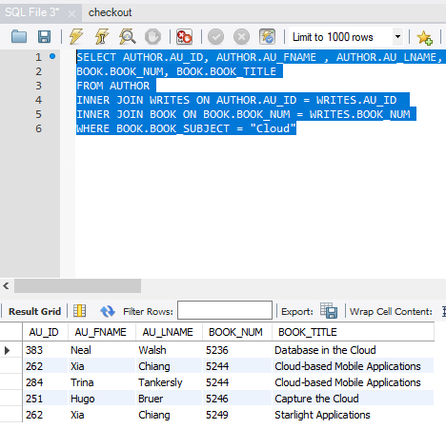

16. SELECT BOOK.BOOK_NUM, BOOK.BOOK_TITLE, AUTHOR.AU_LNAME,

AUTHOR.AU_FNAME,PATRON.PAT_ID,PATRON.PAT_LNAME,PATRON.PAT_TYPE

FROM BOOK

INNER JOIN WRITES ON BOOK.BOOK_NUM = WRITES.BOOK_NUM

INNER JOIN AUTHOR ON WRITES.AU_ID = AUTHOR.AU_ID

INNER JOIN PATRON ON PATRON.PAT_ID = BOOK.PAT_ID

ORDER BY BOOK_TITLE;

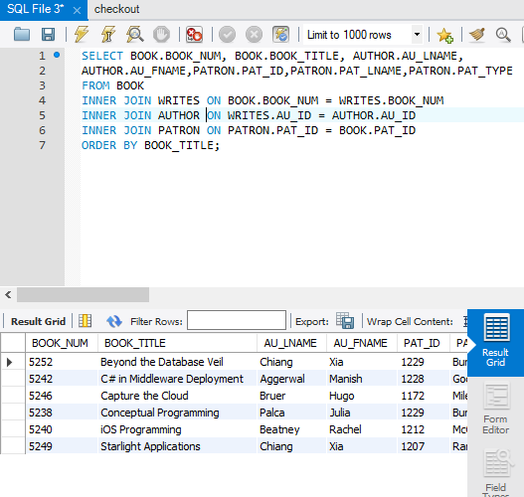

18.SELECT AUTHOR.AU_ID, AUTHOR.AU_LNAME, BOOK.BOOK_TITLE,

CHECKOUT.CHECK_OUT_DATE,patron.PAT_LNAME

FROM CHECKOUT

INNER JOIN WRITES ON checkout.BOOK_NUM = WRITES.BOOK_NUM

INNER JOIN AUTHOR ON WRITES.AU_ID = AUTHOR.AU_ID

INNER JOIN PATRON ON PATRON.PAT_ID = CHECKOUT.PAT_ID

INNER JOIN BOOK ON CHECKOUT.BOOK_NUM = BOOK.BOOK_NUM

WHERE AUTHOR.AU_LNAME = "Bruer" AND PATRON.PAT_LNAME = "Miles"

ORDER BY CHECKOUT.CHECK_OUT_DATE;

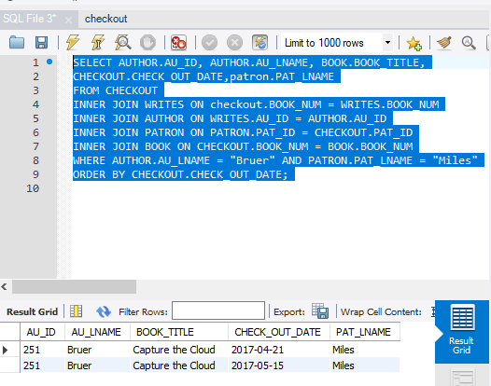

19. SELECT PATRON.PAT_ID,PAT_FNAME,PAT_LNAME

FROM PATRON LEFT JOIN CHECKOUT ON PATRON.PAT_ID = CHECKOUT.PAT_ID

WHERE CHECK_NUM IS NULL

ORDER BY PAT_LNAME, PAT_FNAME

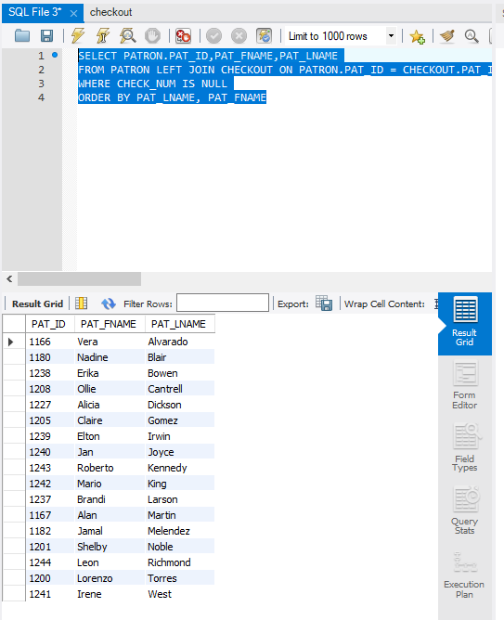

21. SELECT PATRON.PAT_ID,PAT_LNAME,

COUNT(CHECK_NUM) AS "NUM CHECKOUT",

COUNT(DISTINCT BOOK_NUM) AS "NUM DIF BOOK"

FROM CHECKOUT

JOIN PATRON ON CHECKOUT.PAT_ID = PATRON.PAT_ID

GROUP BY PATRON.PAT_ID, PAT_LNAME

HAVING COUNT(CHECK_NUM) > 2

ORDER BY COUNT(DISTINCT BOOK_NUM) DESC, COUNT(CHECK_NUM) DESC,

PATRON.PAT_ID

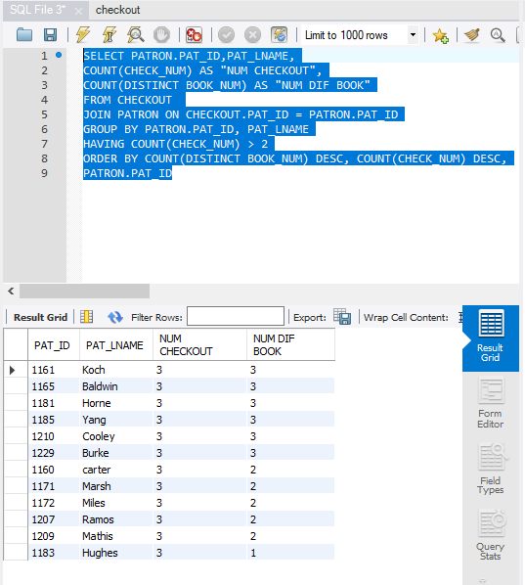

23. SELECT PAT_ID,

ROUND(AVG(DATEDIFF(CHECK_IN_DATE, CHECK_OUT_DATE)),2) AS

"AVERAGE DAYS KEPT"

FROM CHECKOUT

GROUP BY PAT_ID

HAVING COUNT(CHECK_NUM) > 2

ORDER BY ROUND (AVG(DATEDIFF(CHECK_IN_DATE, CHECK_OUT_DATE)),2)

DESC;

