2. SELECT AU_ID, AU_FNAME, AU_LNAME
FROM AUTHOR
WHERE AU_ID NOT IN (SELECT AU_ID FROM book JOIN WRITES USING (BOOK_NUM)
WHERE BOOK_SUBJECT = "Programming")
ORDER BY AU_LNAME;
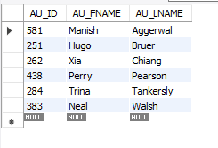
4. SELECT BOOK_NUM, BOOK_TITLE, BOOK_SUBJECT, AU_LNAME, NUMBOOKS AS 'Num Books by Author'
FROM BOOK JOIN WRITES USING (BOOK_NUM) JOIN
(SELECT AU_ID, AU_LNAME, Count(*) AS NUMBOOKS
FROM AUTHOR JOIN WRITES USING (AU_ID)
GROUP BY AU_ID, AU_LNAME) AS TEST USING (AU_ID)
WHERE BOOK_SUBJECT = 'Cloud'
ORDER BY BOOK_TITLE, AU_LNAME;
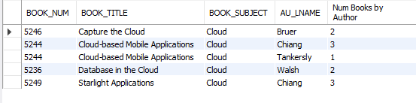
5. SELECT Min(AVGCOST) AS 'Lowest Avg Cost', MAX(AVGCOST) AS 'Highest Avg Cost'
FROM (SELECT BOOK_SUBJECT, Round(Avg(BOOK_COST), 2) AS AVGCOST
FROM BOOK
GROUP BY BOOK_SUBJECT) AS TEST;
