2. SELECT EMP_FNAME, EMP_LNAME, EMP_PHONE, EMP_TITLE, DEPT_NUM
FROM LGEMPLOYEE
WHERE DEPT_NUM = 300 OR EMP_TITLE = "CLERK I"
ORDER BY EMP_LNAME, EMP_FNAME;
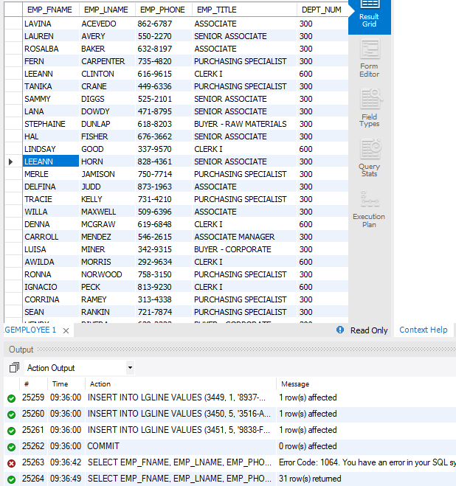

4. SELECT DISTINCT CUST_FNAME, CUST_LNAME, CUST_STREET, CUST_CITY, CUST_STATE, CUST_ZIP
FROM LGCUSTOMER AS C JOIN LGINVOICE AS I ON C.CUST_CODE = I.CUST_CODE
JOIN LGLINE AS L ON I.INV_NUM = L.INV_NUM
JOIN LGPRODUCT AS P ON L.PROD_SKU = P.PROD_SKU
JOIN LGBRAND AS B ON P.BRAND_ID = B.BRAND_ID
WHERE BRAND_NAME = "FORESTERS BEST"
AND PROD_CATEGORY = "Top Coat"
AND INV_DATE BETWEEN '2017-7-15' AND '2017-7-31'
ORDER BY CUST_STATE, CUST_LNAME, CUST_FNAME
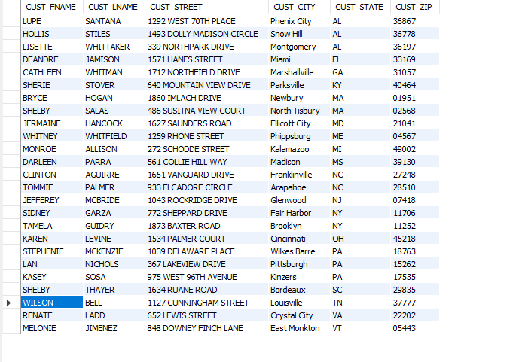
6. SELECT B.BRAND_NAME,
COUNT(P.PROD_SKU) AS ‘NUMPRODUCTS’
FROM LGBRAND B INNER JOIN
LGPRODUCT P
ON B.BRAND_ID = P.BRAND_ID
GROUP BY B.BRAND_NAME
ORDER BY B.BRAND_NAME
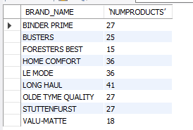
8. SELECT B.BRAND_ID, B.BRAND_NAME, ROUND(AVG(P.PROD_PRICE), 2) AS AVGPRICE
FROM LGBRAND B INNER JOIN LGPRODUCT P
ON B.BRAND_ID = P.BRAND_ID
GROUP BY B.BRAND_ID, B.BRAND_NAME
ORDER BY B.BRAND_NAME;
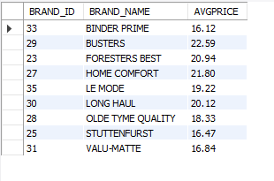
10. SELECT D.DEPT_NUM, DEPT_NAME, DEPT_PHONE, D.EMP_NUM, EMP_LNAME
FROM LGDEPARTMENT AS D JOIN LGEMPLOYEE AS E ON D.EMP_NUM = E.EMP_NUM
ORDER BY D.DEPT_NAME;
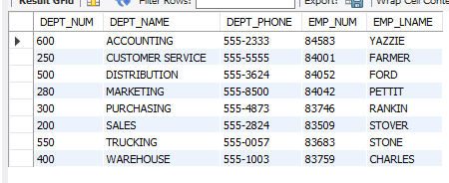

12. SELECT MAX(AVGPRICE) AS 'LARGEST AVERAGE'
FROM (SELECT P.BRAND_ID, ROUND(AVG(P.PROD_PRICE),2) AS AVGPRICE
FROM LGPRODUCT P
GROUP BY P.BRAND_ID) AS AVGPRICE;
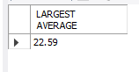
14. SELECT E.EMP_NUM, EMP_LNAME, EMP_FNAME, SAL_AMOUNT
FROM LGEMPLOYEE AS E JOIN LGSALARY_HISTORY AS SH ON E.EMP_NUM = SH.EMP_NUM
WHERE SAL_END IS NULL AND DEPT_NUM = 300
ORDER BY SAL_AMOUNT DESC;
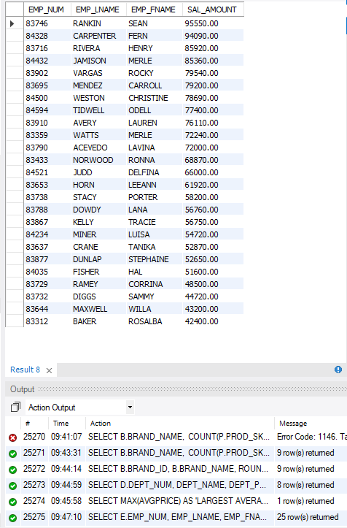

16. SELECT L1.INV_NUM, L1.LINE_NUM, P1.PROD_SKU, P1.PROD_DESCRIPT,
L2.LINE_NUM, P2.PROD_SKU, P2.PROD_DESCRIPT, P1.BRAND_ID
FROM (LGLINE AS L1 JOIN LGPRODUCT AS P1 ON L1.PROD_SKU = P1.PROD_SKU)
JOIN (LGLINE AS L2 JOIN LGPRODUCT AS P2 ON L2.PROD_SKU = P2.PROD_SKU)
ON L1.INV_NUM = L2.INV_NUM
WHERE P1.PROD_CATEGORY = 'Sealer' AND P2.PROD_CATEGORY = 'Top Coat' AND P1.BRAND_ID = P2.BRAND_ID
ORDER BY L1.INV_NUM, L1.LINE_NUM, L2.LINE_NUM DESC;
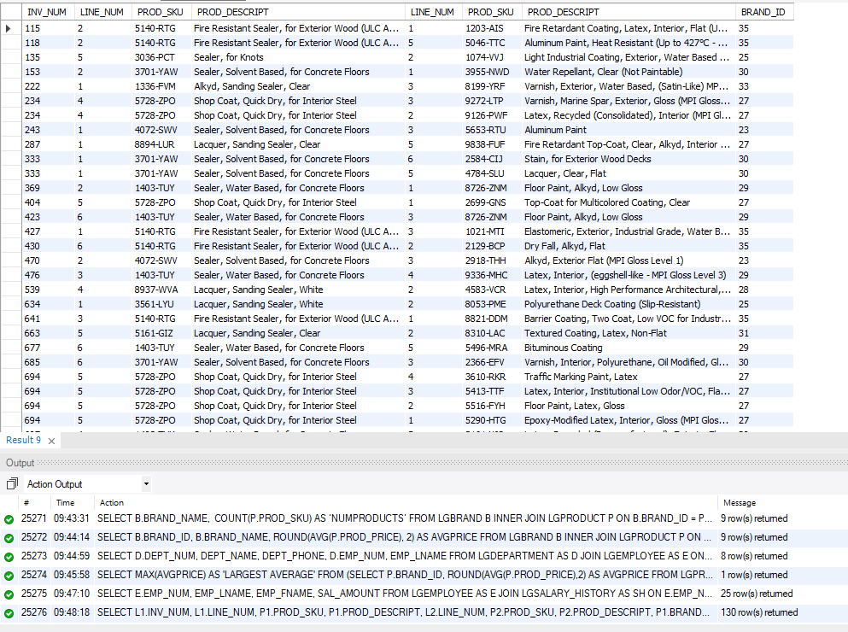
18. SELECT DISTINCT C.CUST_CODE, CUST_FNAME, CUST_LNAME
FROM LGCUSTOMER C JOIN LGINVOICE I ON C.CUST_CODE = I.CUST_CODE
WHERE EMPLOYEE_ID = 83649 AND C.CUST_CODE IN (SELECT CUST_CODE FROM LGINVOICE WHERE EMPLOYEE_ID = 83677)
ORDER BY CUST_LNAME, CUST_FNAME;
