**Toaster**

An **Android** Toast is a small message displayed on the screen, similar to a tool tip or other similar popup notification. A Toast is displayed on top of the main content of an activity, and only remains visible for a short time period.

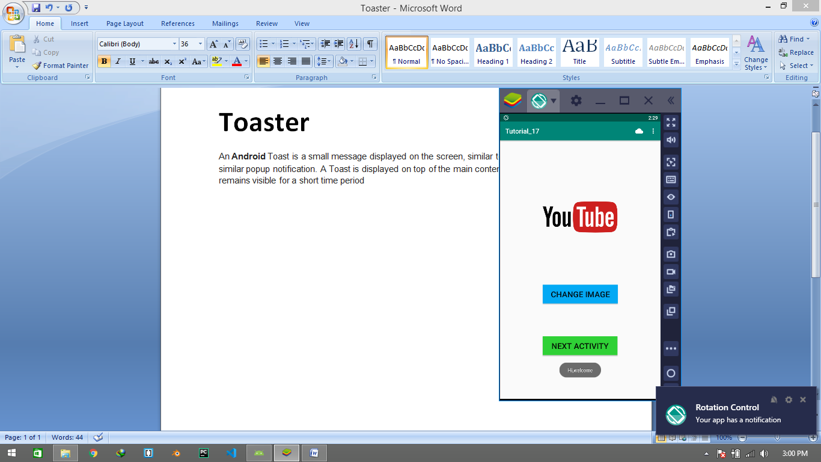

Creating a toast in android is just really really very easy we just have to use this code in our main **Oncreate** function.

//Creating Toast  
Toast.makeText(this,"Hi,welcome",Toast.*LENGTH_LONG*).show()

//Toast.LENGTH_LONG Define the time period for toast

**NOW Run the Resource FILE**

