**In this file we learn how to Create new Activity**(as we say new panel) **and use a button to go from one activity to another using Intent.**

1. Create a new Button and Give it a unique id . This button will lead us to new Activity.

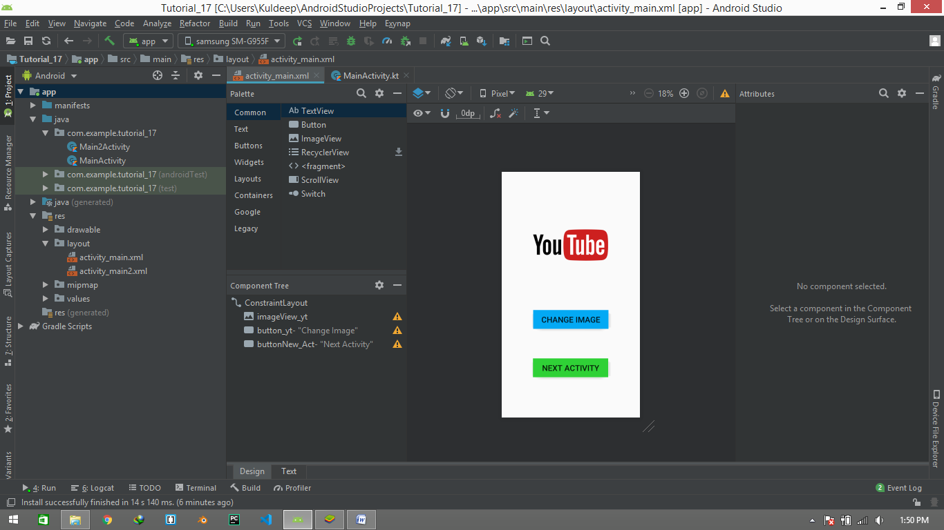

1. Now it’s time to create New Activity. In order to Create new Activity Follow below Steps :-
2. Go to **res>layout**. Right Click on **layout** ,then **New>Activity>Gallery** . Choose your layout and press the next and fill further requirements.

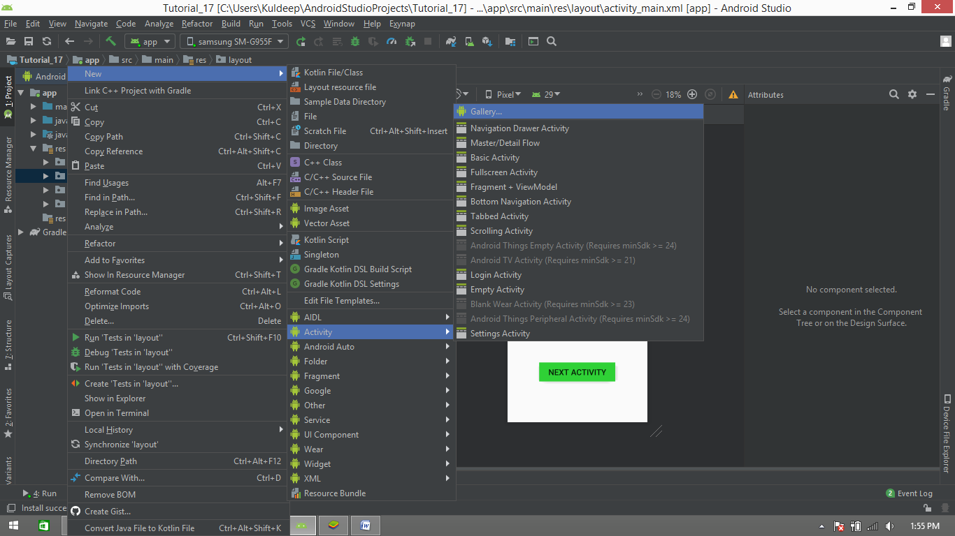

1. Now you will see in java folder and res folder one more Activity file and layout are creates which are your new one.

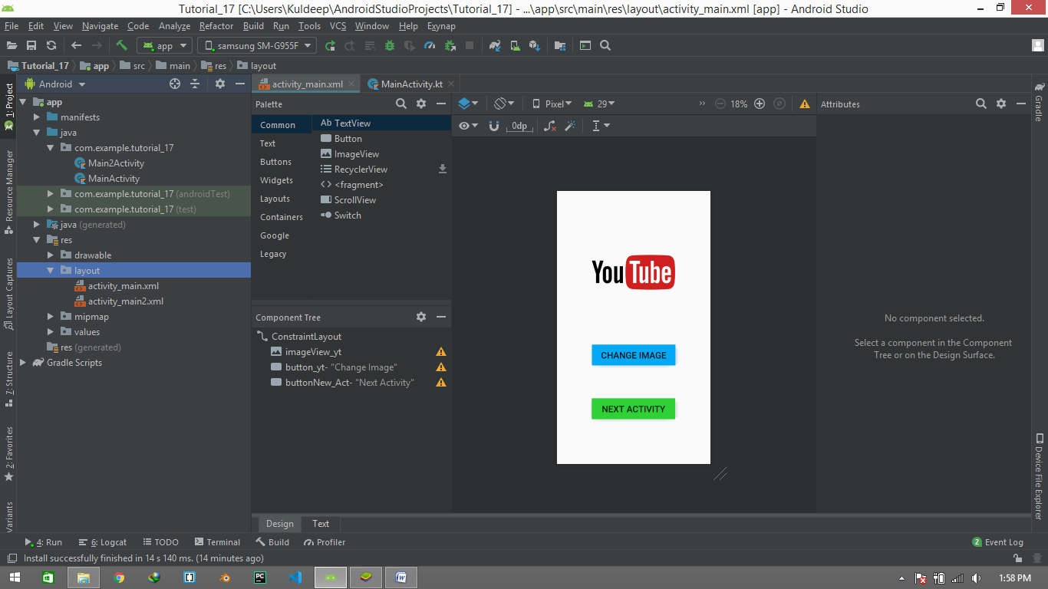

**3**. Now simply just create a text view in new activity so that we can recognize it.

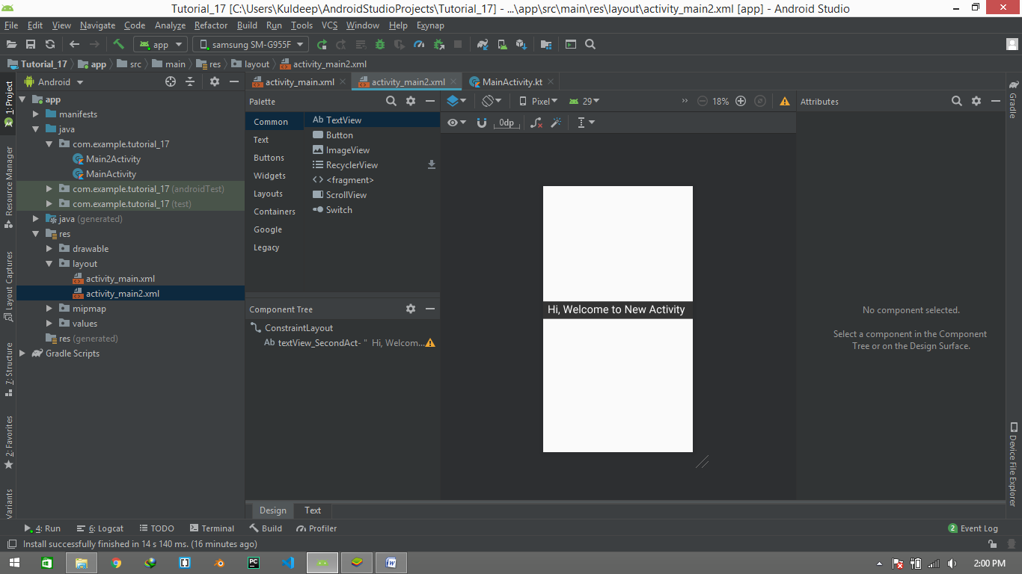

**4.** Now got to the **MainActivity.kt** file and create a **object** and **setOnClickListener** for new Activity button .

//Create button object for New Activity  
val button_NewAct: Button = findViewById(R.id.*buttonNew_Act*)  
  
//Give Activity to Go to the next Activity  
button_NewAct.setOnClickListener **{**//Further Activity work will be done here  
 **}**

5. It’s time to create the object for NewActivity. To create object and declaration we use **“Intent”.**

**Intent** is a messaging object used to request another app component to perform an action. **Intent** facilitates users to communicate with app component through several ways such as starting an activity, starting a service, delivering a broadcast receiver, etc

button_NewAct.setOnClickListener **{**

//Create Object for New_Activity  
val newActivity_intent = Intent(this, Main2Activity::class.*java*)

//Intent is an predefined object

//Main2Activity is the new Activity

// class.java helps to calling the main class from newActivity **}**

6. Now the last step is to Start the Activity by using the **object** of the NewActivity and the function **“startActivity(obj)”.**

button_NewAct.setOnClickListener **{** //Creating object for New Activity  
 val newActivity_intent = Intent(this, Main2Activity::class.*java*)  
  
 //Start the Activity  
 startActivity(newActivity_intent)  
**}**

**7.** Rest of the part is only to run the file. And click on NewActivity button

