**Menu and Submenu**

1. Right Click on **res** folder the click on option New > **Android Resource directory** .

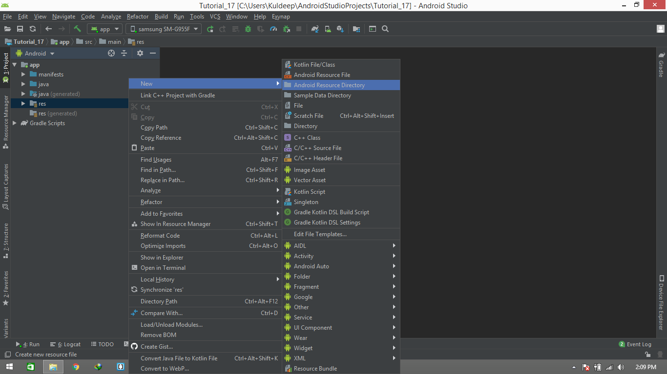

1. **A New Resource directory** dialogue box will be Opened. Change the **Resource type** into **menu** and press **ok**.

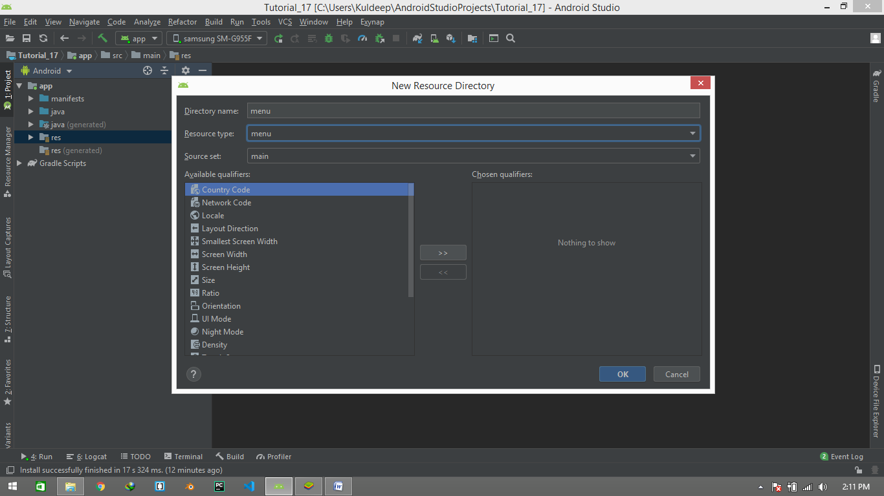

1. Now right click on **menu** folder which we created in **res** folder. Then, Click on **New** > **Menu resource File**.

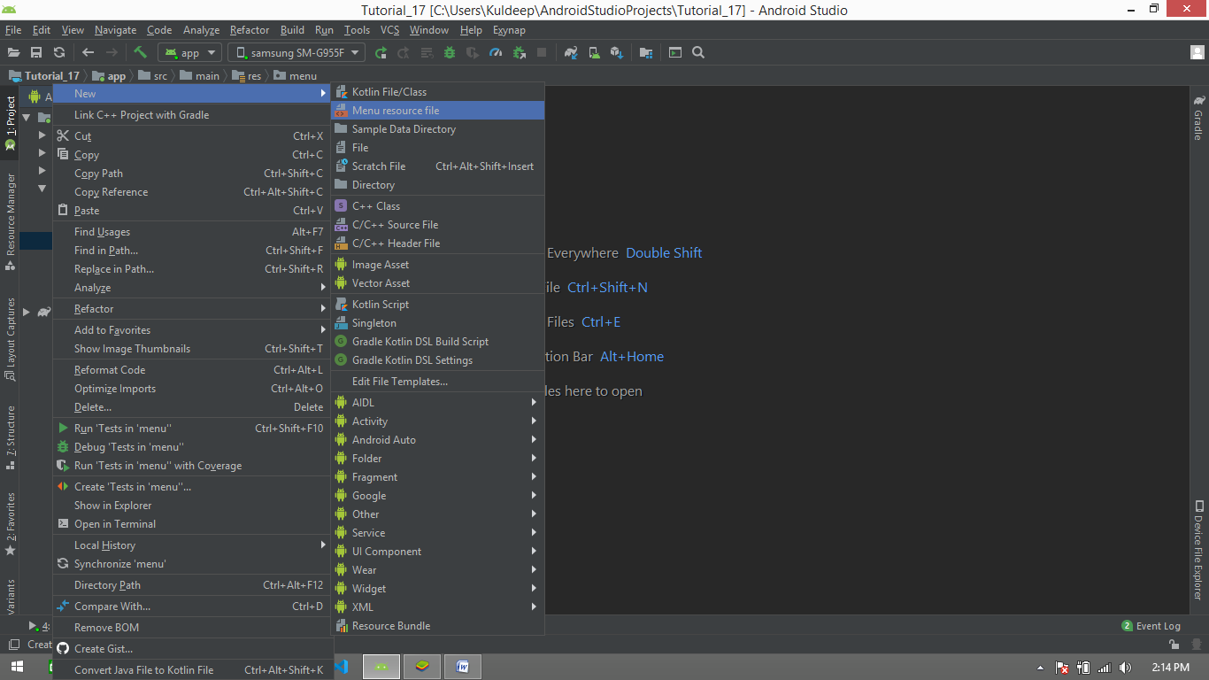

1. A **New resource file** Dialog box is opened. Give your file name (like examplefor_menu ) and then press ok.

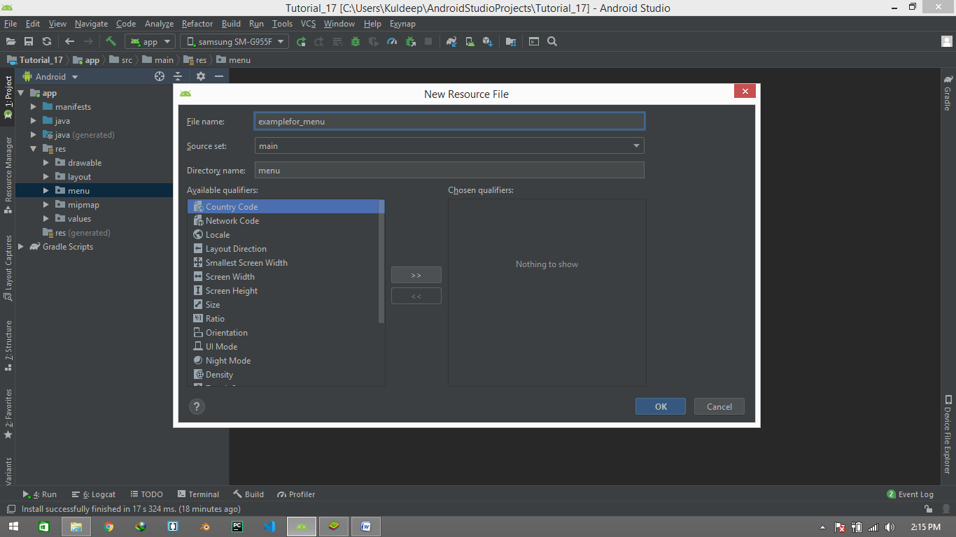

1. A new xml file is created in like this , opened it up.

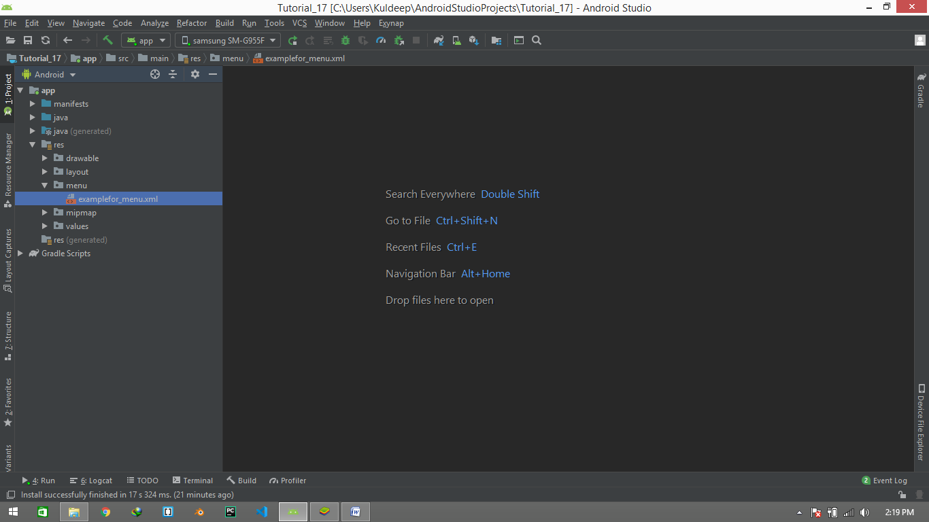

1. A new type of layout file will be opened. Where you will see different tools in palette section which are only used for menu making. Now follow the below component tree and create your ui .

Note you have to give your each component different Textvalue and id.

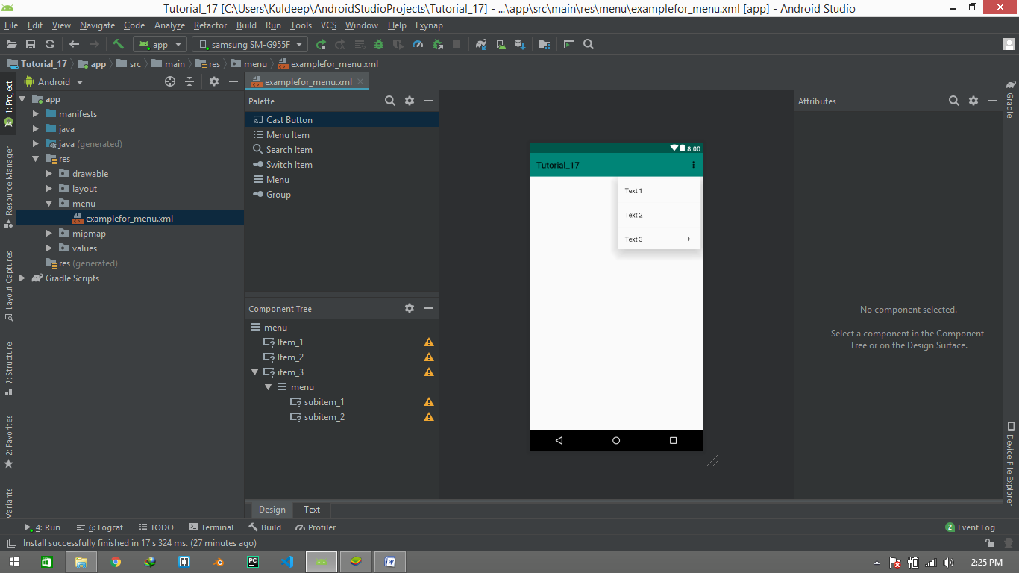

Your UI should be look like this.



1. Now we are going to use our first menu item to create this **cloud** button.

But first of all we have to make this cloud svg icon , so lets do it

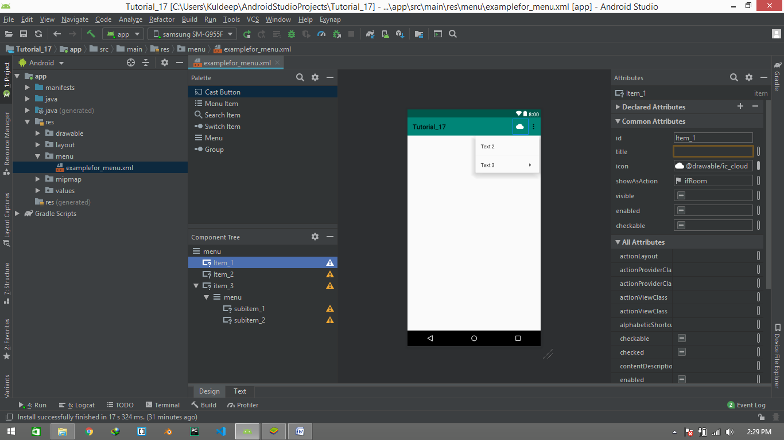

* Right click on **drawable** folder. Click on menu **New > Vector Assets .**

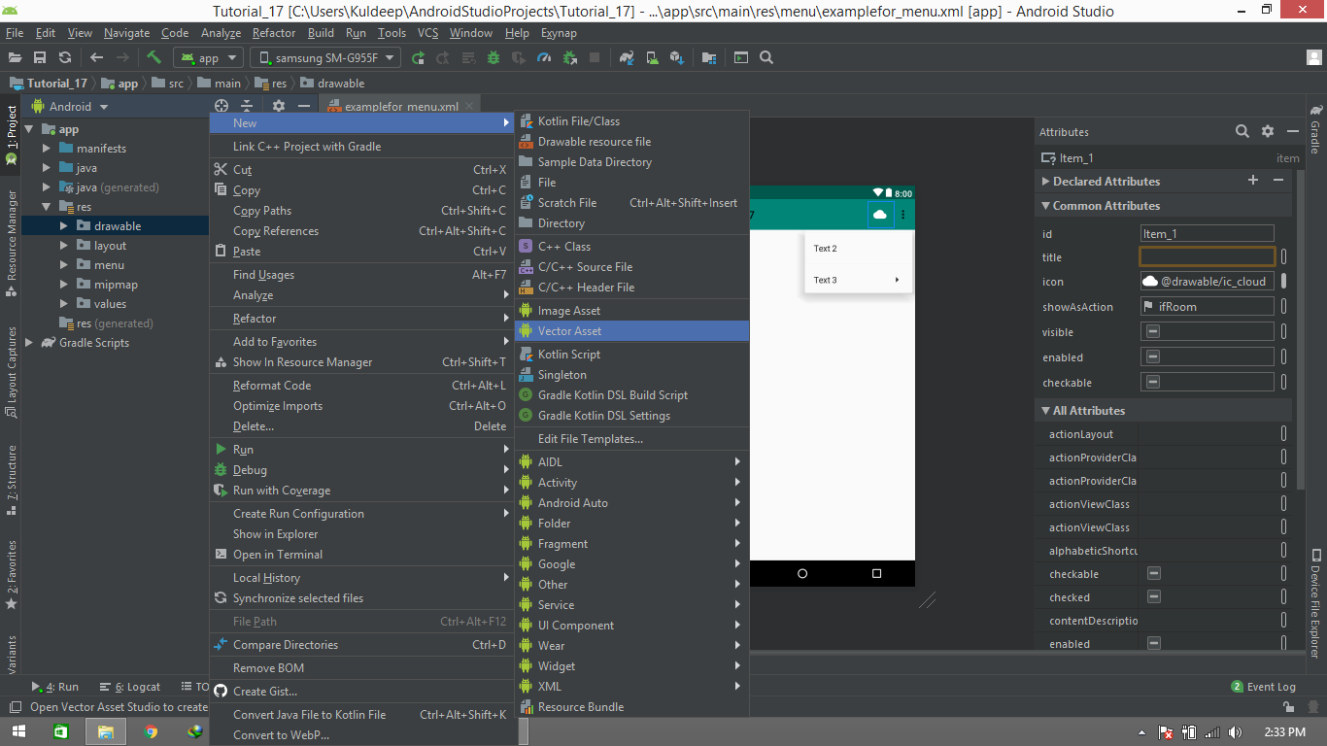

* No this type of dialogue box will be opened.

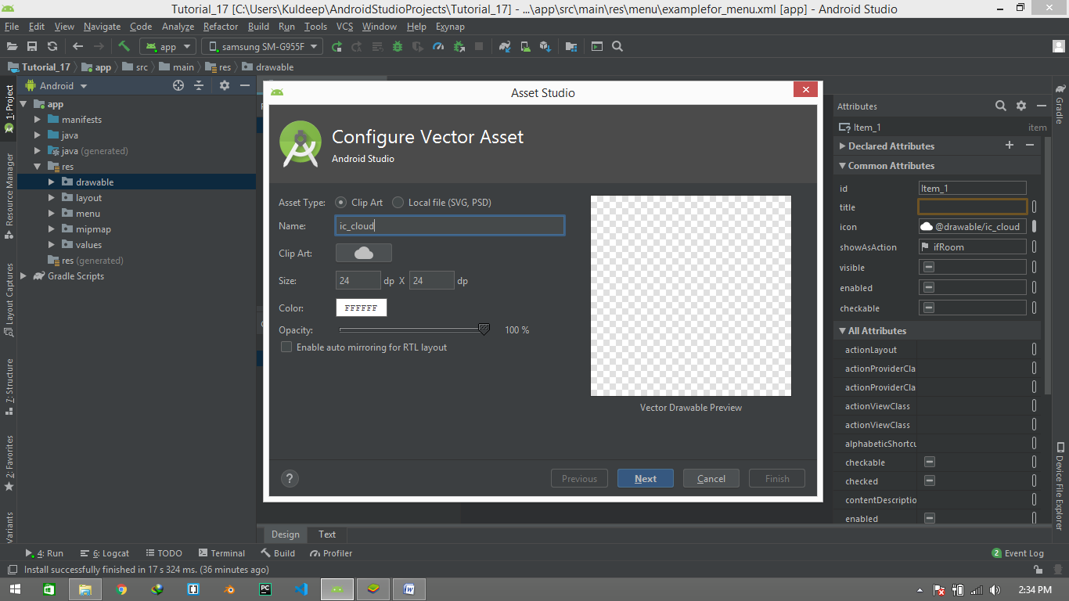

Here we can choose icon , color , size , opacity etc. but in our case we need cloud having white color. Press next And then finished

* No this ic_cloud.xml file is created in drawable folder.
* 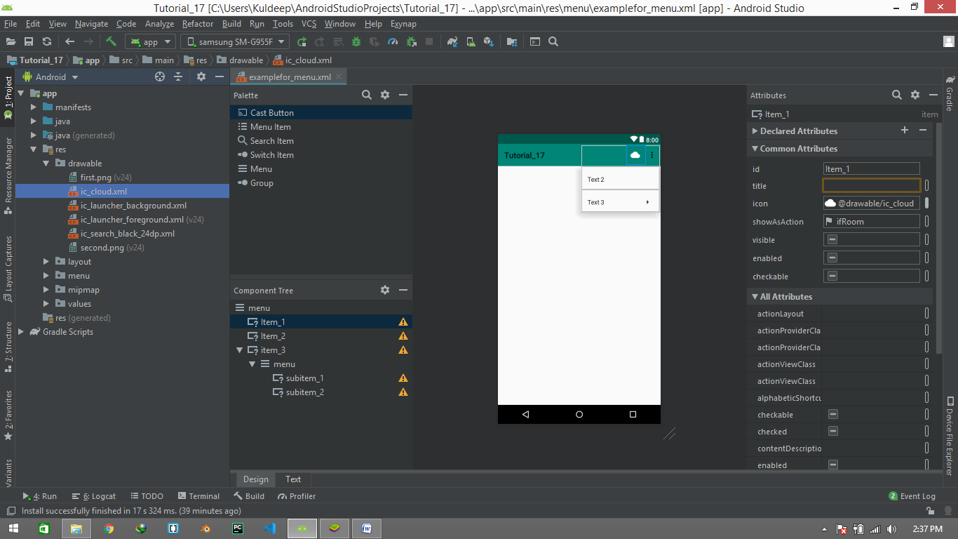

1. Now select item_1 and change its attribute like this . and **its imp. to fill the title with a space.**

**And** for item_2 and item_3 just change the value of **showAsAction** to **never.**

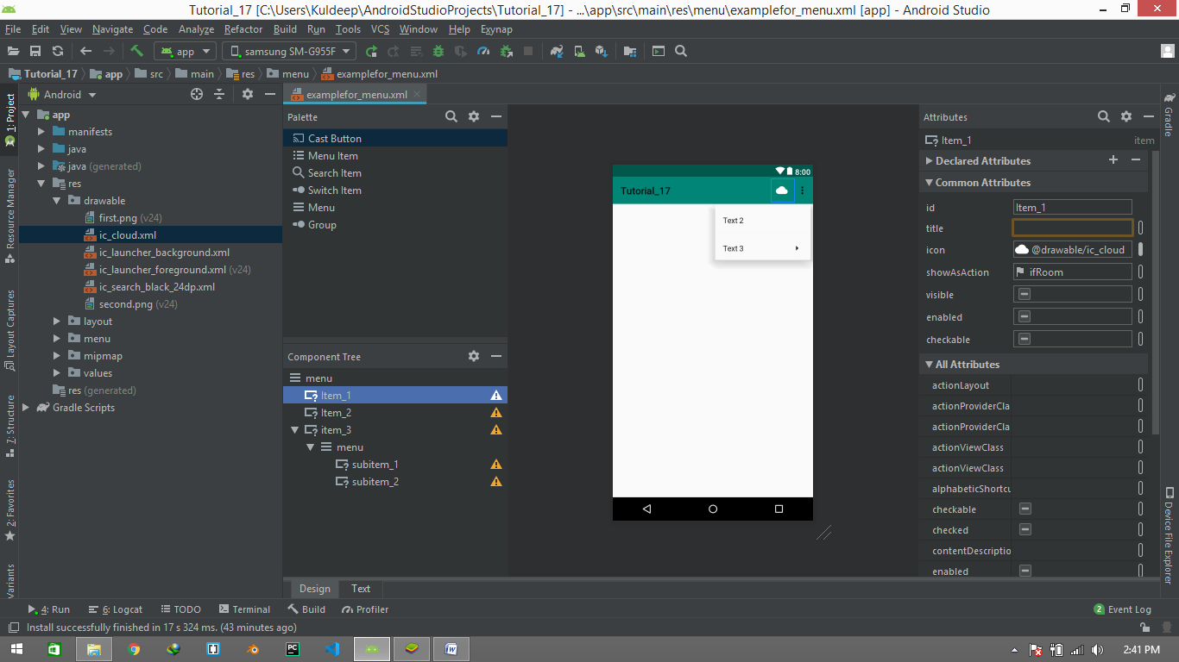 

1. Now your panel should be look like this.



1. Now its time to implement all these **menu item** in **MainActivity.kt** file.
2. Open **MainActivity.kt** file, press shortcut **“Ctrl+O”** and Search for **onCreateOptionmenu.** and choose that function, press ok.

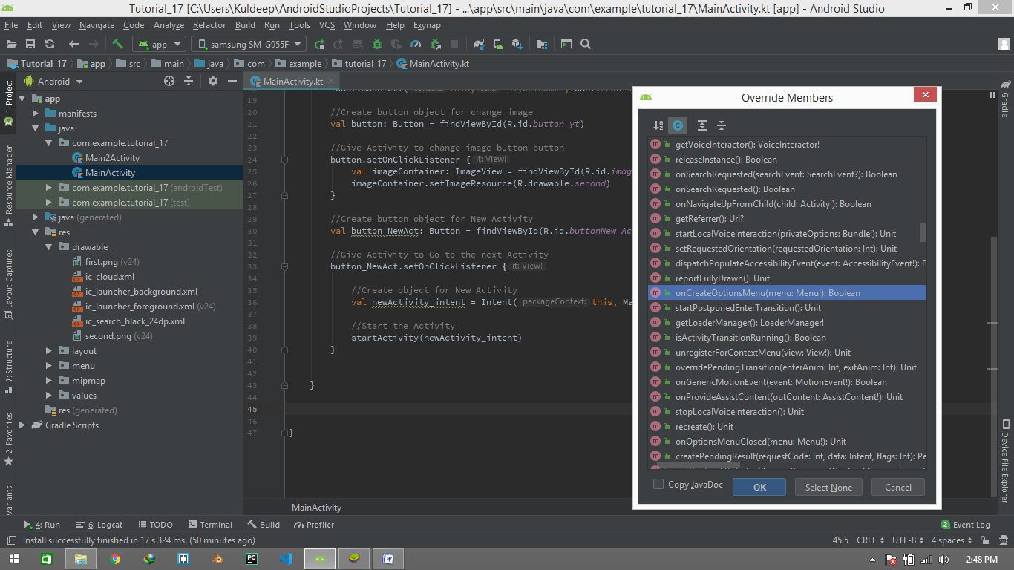

1. A new function will be automatically created .

override fun onCreateOptionsMenu(menu: Menu?): Boolean {  
 return super.onCreateOptionsMenu(menu)  
}

1. Change the return **super.onCreateOptionsMenu(menu)** in

**return True.**

1. Follow the below code to make menu active

//function for menu  
override fun onCreateOptionsMenu(menu: Menu?): Boolean {  
 val menu_obj = *menuInflater* menu_obj.inflate(R.menu.*examplefor_menu*, menu)  
 return true  
}

1. Now just run your Resource File.

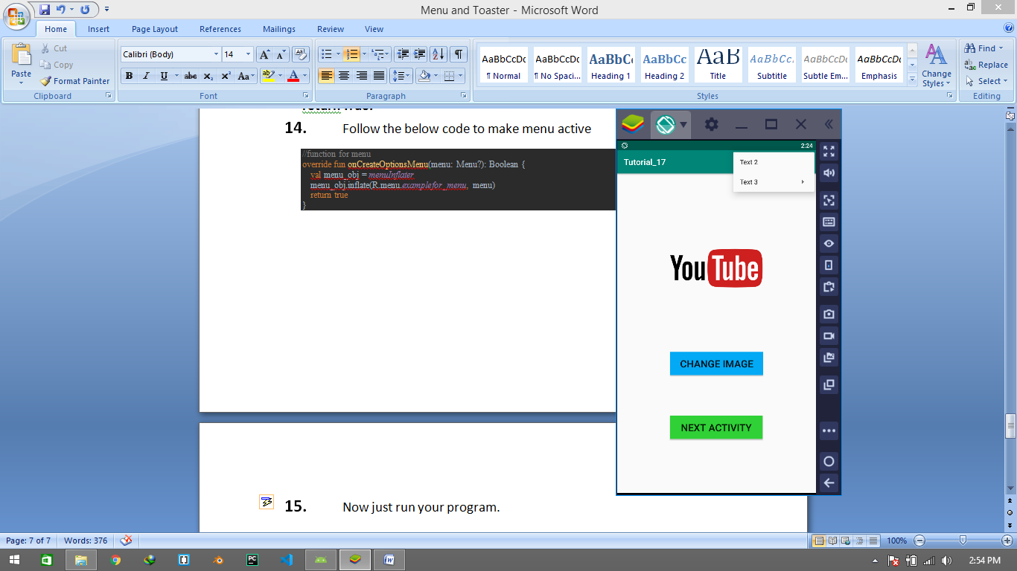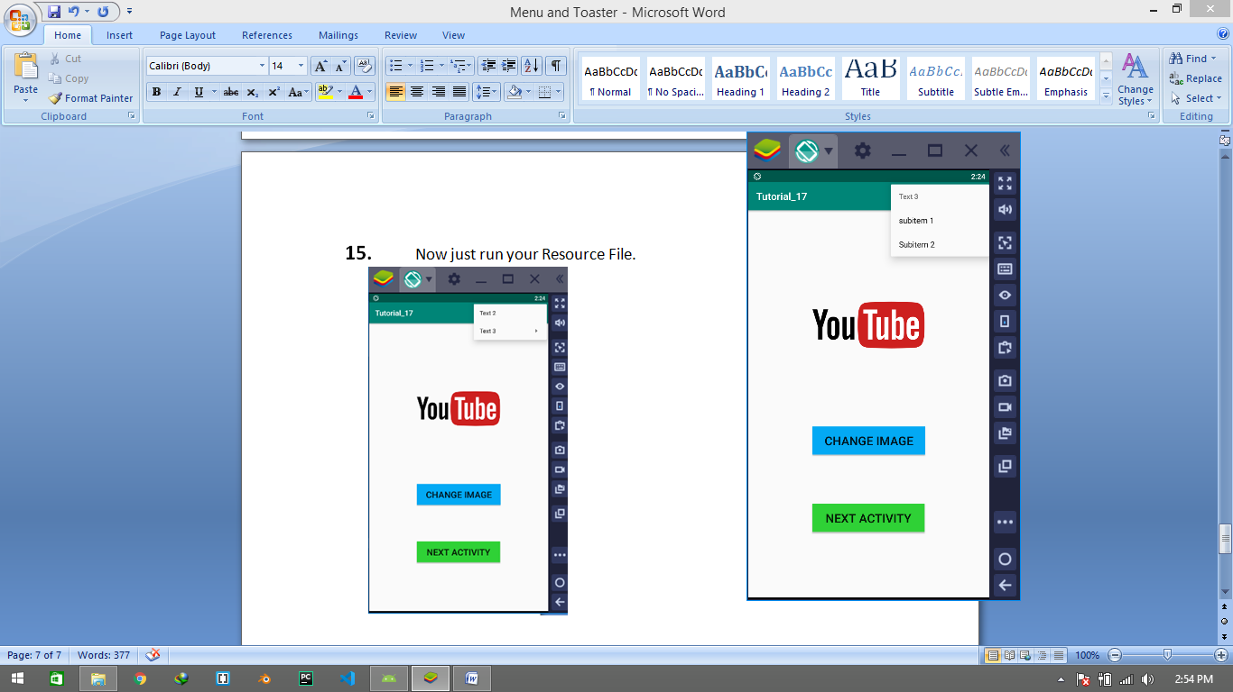

**Menu Submenu**