Simultaneous Wireless Information And Power Transfer

Shreeya S
210907022
ECE Department
Manipal Institute Of Technology
Manipal
Garikina Nithin Sai
210907034
ECE Department
Manipal Institute Of Technology
Manipal

Abstract—Simultaneous Wireless Information and Power Transfer is a technology that enables wireless device to receive data and harvest energy from RF signals simultaneously. SWIPT offers the potential to enhance energy efficiency in wireless networks an IoT applications by integrating data communication and energy harvesting functionalities. This dual-purpose functionality is crucial for energy-constrained wireless systems.

Introduction
SWIPT (Simultaneous Wireless Information and Power Transfer) technology allows for the wireless transmission of both data and energy simultaneously via radio waves. It has the potential to revolutionize wireless power and communication, sparking significant interest in recent years. SWIPT operates by utilizing the same wireless channel to transmit both power and information. This can be accomplished using various techniques such as TDM (Time Division Multiplexing), FDM (Frequency Division Multiplexing), PDM (Power Division Multiplexing), and SDM (Spatial Division Multiplexing)
In SWIPT, there's a compromise between sending power and transmitting data. More power means reaching farther or powering bigger devices, but it also affects communication quality. Engineers need to find the sweet spot between effective energy transfer and reliable data transfer. SWIPT is useful for charging devices wirelessly (e.g., phones, sensors, IoT devices) and in wireless networks (e.g., cellular, Wi-Fi, satellite), where it can help extend battery life and improve communication efficiency..
SWIPT, while promising, encounters technical hurdles like channel fluctuations, signal loss, and interference. These challenges affect the effectiveness of both energy and data transfer. To address these issues and unleash SWIPT's full potential, researchers are actively developing innovative techniques and algorithms.

Literature Review

SWIPT (Simultaneous Wireless Information and Power Transfer) is a booming area of research. It involves transferring both energy and data wirelessly, allowing devices to receive power and communicate without external power sources. An early breakthrough in SWIPT was by Zhang et al. in 2013. They developed a WPCN (Wireless Powered Communication Network) using a special access point to send energy and data to multiple devices that need energy. The system operated in a time-sharing manner.
Since the initial research, numerous studies have explored multiple facets of Wireless Powered Communication Networks (WPCNs), such as allocating resources, dividing power, and scheduling users. Additionally, there has been a focus on the application of Simultaneous Wireless Information and Power Transfer (SWIPT) in Wireless Sensor Networks (WSNs). WSNs often employ a large number of sensors powered by batteries that are situated in isolated or hard-to-reach areas, presenting challenges in battery replacement. This has led to a heightened interest in energy harvesting techniques like SWIPT within this domain.
In multi-antenna systems, SWIPT has been studied to leverage the spatial diversity offered by multiple antennas for wireless signal transmission and reception. These systems can enhance energy and data transfer efficiency compared to systems with a single antenna. Furthermore, research in SWIPT explores the use of non-orthogonal multiple access (NOMA) techniques. NOMA enables simultaneous access to the same frequency band by multiple users. It enhances SWIPT's spectral efficiency and flexibility, leading to potential improvements in throughput and energy efficiency in wireless communication systems.
Other research has concentrated on implementing and testing SWIPT systems with different hardware platforms and energy harvesting techniques. These studies have shown SWIPT's practicality and potential, offering valuable information and direction for the practical design and deployment of SWIPT systems. SWIPT is a promising technology that has the potential to transform how we power and communicate wirelessly. While this field has advanced significantly, there are still numerous challenges and opportunities for future research, particularly in areas like resource allocation, power splitting, channel estimation, and system optimization.

Methodology for MATLAB

Define the System Model
Define your system model which include the transmission, receiver and wireless channel characteristics. Here a simple setup is considered with one transmitter and receiver .

Channel Modelling
It can be done by wireless channel using free space path loss, Rayleigh fading or log normal shadowing based on the requirement.

Transmitter Design
The model is designed to transfer both information and power. At transmitter side, we can split power or split time. This is used to allocate resources for power and information transfer; these resources are taken from then transmitter node

Receiver Design
The primary role of receiver is to decode the received signal for the information and to extract the power from the signal. Receiver design has several subunits, including energy harvesting processes such as rectification and power management.

Signal Generation and Processing
It covers the generation of the information-carrying signal that will be transmitted and the receiver’s side processing of the received signal to split the information and power part.

Performance Metrics
Power Transfer relies on data rate (bits per second), which is measured in data per seconds, power transfer efficiency, and system efficiency. The simulation will be implemented in the four steps of MATLAB code, using the function and the script to organize the line of code.

Methodology For Antenna Design
The designing process of antennas for WPT is the optimization of the characteristics of the antenna for the effective use of this wireless technology. The proposed method will include the design of an antenna for WPT using ANSYS HFSS, which is one of the leading electromagnetism simulation software products. The methodology involves the following steps to design an antenna for WPT system

Define requirements:

The specification usually considers the operating frequency, transmitting and receiving power, the distance between the transmitter and the receiver, efficiency to achieve, and dimensions limitations

Select an antenna type:

Commonly used in WPT are patch, dipole, and loop antennas. Dependent on frequency range, polarization, and radiation, the choice can be made.

Antenna Geometry Setup:

At this step, the user should set up the antenna geometry in ANSYS HFSS. The dimensions of the antenna, substrate material properties, feeding mechanism , such as a microstrip feed for patch antennas, and other components such as matching networks must be defined

Simulation Setup:

The next step is to set up the simulation environment in ANSYS HFSS. The simulation frequency range, boundary conditions, and simulation type , such as S-parameters, far-field radiation pattern, and efficiency analysis must be defined at this stage.

Perform Simulation:

Once the simulation is complete, the user is now ready to run the simulation to check the performance of the antenna. Parameters such as return loss , input impedance matching, radiation pattern, gain, and efficiency are critical parameters to analyze

Optimization and Tuning:

The antenna design can be further optimized to enhance its performance by using the optimization feature in ANSYS HFSS. The user can further optimize the antenna dimensions, substrate, feed position, and components in the matching network to achieve the desired result.

Evaluate Safety and Regulatory Compliance:

Safety and regulatory compliance should be considered, such as SAR and EMI compliance during the design of antenna. Antenna for WPT applications

Prototype Fabrication and Testing:

A prototype of your final antenna design from the simulation and test it in the real world. Similarly, measure the efficiency of power transfer, radiation characteristics, and the effect of temperature on the antenna.

Iterative design improvement:

Based on the testing results, if required, iterate the design to correct any performance gap faced during the real-world testing. It is a sequence through which the antenna design meshes consolidated to garner the best performance possible for the WPT.

Documentation and reporting:

Record all phases of the antenna design, including simulation setup, optimization results, prototype testing data, and a concluding performance evaluation. Prepare an extensive report outlining the design strategy and its results.

Results

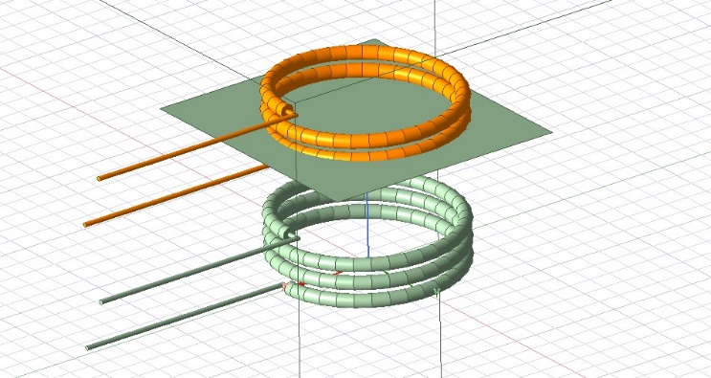
- Coil Antenna Model

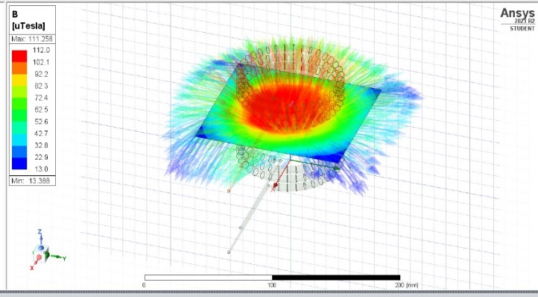
- Magnitude diagram of Magnetic Field.

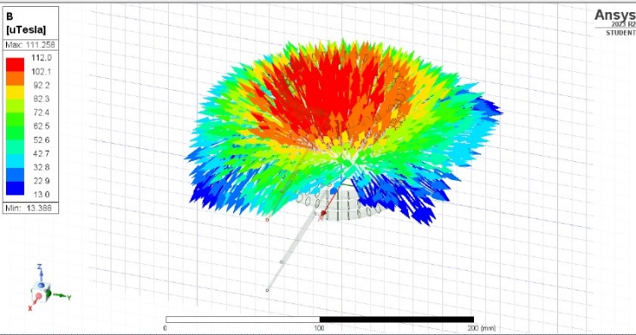
- Vector diagram of Magnetic field
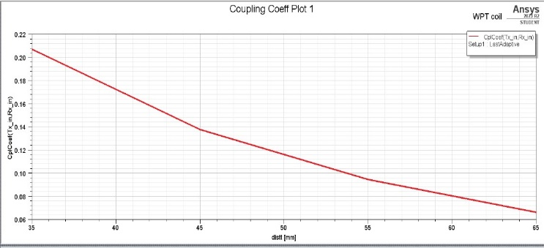
- Coupling Coefficient Plot
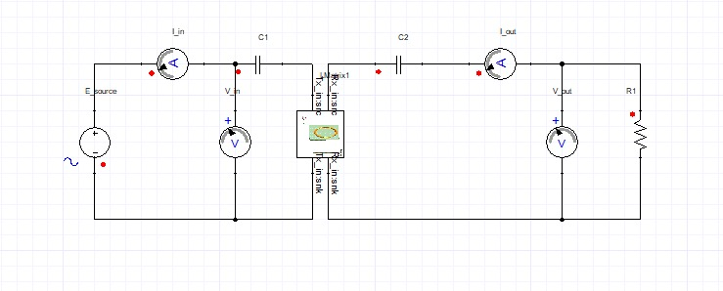
- Circuit Diagram for WPT
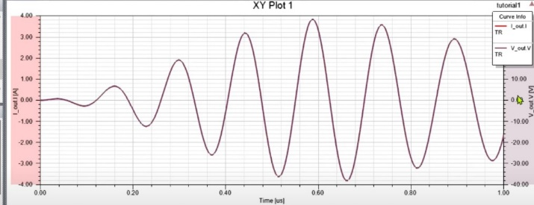
- Transient Analysis for WPT Circuit
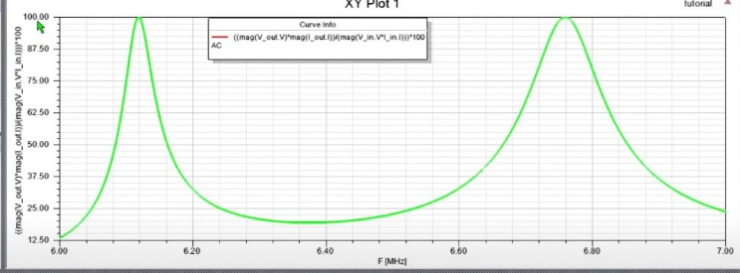
- AC analysis for WPT Circuit

Conclusion
SWIPT system consists of a Transmitter and Receiver. The receiver comprises an ID circuit and RF-EH circuit. Each node has its own single Omnidirectional Antenna. The transmitter and receiver engages in block wise operation and block time duration, (T).

At Receiver, during a symbol period
Here Ts , assuming the receive power at the RF-EH circuit is Prx, the amount of harvested energy can be represented as

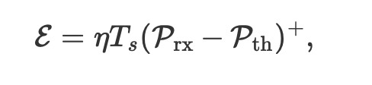

The operation of SWIPT, uses PS and TS scheme.

PS : here in each time block, the transmitter sends modulated data signal with average transmit power. The receiver splits the received signal accordingly with a PS ratio for separate EH-ID
First, the average transmission power Ptx should satisfy the average power constraint, i.e., Ptx≤Pave.

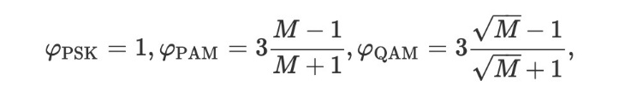

TS: during this, each time block is divided into two phases,
Power transfer phase and IT phase. First, the transmitter transmits the energy signal with an average transmit power during the first T seconds, this is PT phase. During this the receiver harvest’s energy from the received signal. Now, the transmitter transmits the modulated signal with average transmit power during the remaining T seconds, this is IT phase and the receiver decodes the information received.

First, the transmit power should satisfy average power constraint as ρTSPtx,1+(1−ρTS)Ptx,2≤Pave.

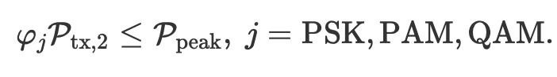

For the TS scheme we see the effect of different modulations scheme that of PS scheme. this happens because IT phase is affected by modulation. When the average power requirement is high, the TS scheme give better results then the PS scheme. This is because of the optimized energy signal for the TS scheme, which results in EH more efficient under the presence of RF-EH sensitivity level, but for the PS scheme the signal for EH cannot be optimized.

we used two schemes: Power splitting and Time splitting, both employing practical modulation techniques. To account for real-world receiver sensitivities, we considered the RF-EH capabilities of the receiving device. Wee optimized system parameters to ensure that the system adheres to limits on average and peak transmitted power. Simultaneously, we aimed to maximize the performance of the information decoding process while meeting energy harvesting requirements.

For the power splitting technique, using a modulation method with a higher peak-to-average power ratio enhances energy harvesting efficiency. However, for the time switching technique, we present an optimal energy signal during data transmission that maximizes energy availability, channel fluctuations can improve energy harvesting, especially in situations where realistic radio frequency energy harvesting sensitivity is considered. Our study emphasizes the need to thoroughly analyze the influence of RF energy harvesting sensitivity in simultaneous wireless information and power transfer (SWIPT) systems. Future research should investigate the effects of varying RF energy harvesting efficiency on SWIPT performance.

References

- SWIPT with practical modulation and RF energy harvesting sensitivity | IEEE Conference Publication | IEEE Xplore
- Simultaneous Wireless Information and Power Transfer (SWIPT): Recent Advances and Future Challenges | IEEE Journals & Magazine | IEEE Xplore.
- Simultaneous Wireless Information and Power Transfer: Technologies, Applications, and Research Challenges | IEEE Journals & Magazine | IEEE Xplore.
- Simultaneous Wireless Information and Power Transfer (SWIPT) for Internet of Things: Novel Receiver Design and Experimental Validation | IEEE Journals & Magazine | IEEE Xplore

