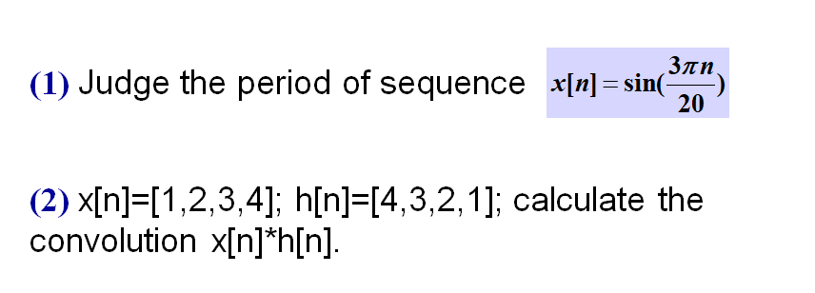

# 2.1

The system $T$ in Figure 2-1 is known to be *time invariant*. When the inputs to the system are $x_{1}\left[n\right]$, $x_{2}[n]$, and $x_{3}[n]$, the responses of the system are $y_{1}[n]$, $y_{2}[n]$, and $y_{3}[n]$, as shown.

*T*

-3 -2 -1 0 1 2 3 4 n

3

2

1

2

$$y_{1}\left[n\right]$$

4

2

$$y_{2}\left[n\right]$$

-3 -2 -1 0 1 2 3 4 n

-3 -2 -1 0 1 2 3 4 n

2

$$x_{2}\left[n\right]$$

-5 -4 -3 -2 -1 0 1 2 n

1

$$y_{3}\left[n\right]$$

2

3

$$x_{1}\left[n\right]$$

$$x_{3}\left[n\right]$$

-3 -2 -1 0 1 2 3 4 n

-3 -2 -1 0 1 2 3 4 n

Figure 2-1

1. Determine whether the system *T* could be linear.
2. If the input $x\left[n\right]$ to the system *T* is $δ\left[n\right]$, what is the system response $y\left[n\right]$?
3. What are all possible inputs $x\left[n\right]$ for which the response of the system T can be determined from the given information alone?

# 2.2

For the system in Figure 2-2, determine the output $y\left[n\right]$ when the input of $x\left[n\right]$ is $δ\left[n\right]$ and $H\left(e^{jω}\right)$ is an ideal lowpass filter as indicated, i.e.,

$$H\left(e^{jω}\right)=\left\{\begin{aligned}1, &|ω|<π/2, \\ 0, &π/2<|ω|≤π.\end{aligned}\right.$$

$$H\left(e^{jω}\right)$$

$$x\left[n\right]$$

$$w\left[n\right]$$

$${(-1)}^{n}$$

$${(-1)}^{n}w[n]$$

$$y\left[n\right]$$

$$×$$

+

$$H\left(e^{jω}\right)$$

1

$$-2π$$

$$-π$$

$$-\frac{π}{2}$$

$$\frac{π}{2}$$

$$π$$

$$2π$$

$$ω$$

$$⋯$$

$$⋯$$

Figure 2-2

# 2.3

An ideal lowpass filter with zero delay has impulse response $h_{lp}\left[n\right]$ and frequency response

$$H_{lp}\left(e^{jω}\right)=\left\{\begin{aligned}1, &\left|ω\right|<0.2π, \\ 0, &0.2π≤|ω|≤π.\end{aligned}\right.$$

1. A new filter is defined by the equation

$$h_{1}\left[n\right]={\left(-1\right)}^{n}h_{lp}\left[n\right]=e^{-jπn}h_{lp}\left[n\right].$$

Determine an equation for the frequency response of $H_{1}(e^{jω})$,and plot the equation for $\left|ω\right|<π$. What kind of filter is this?

1. A second filter is defined by the equation

$$h_{2}\left[n\right]=2h_{lp}\left[n\right]\cos\left(0.5πn\right).$$

Determine the equation for the frequency response $H_{2}(e^{jω})$, and plot the equation for $\left|ω\right|<π$. What kind of filter is this?

1. A third filter is defined by the equation

$$h_{3}\left[n\right]=\frac{\sin{(0.1πn)}}{πn}h_{lp}\left[n\right].$$

Determine the equation for the frequency response $H_{3}(e^{jω})$, and plot the equation for $\left|ω\right|<π$. What kind of filter is this?