Project
“TV-Tennis”

Completed by:
Moiseev Nikita Denisovich,
Safonova Maria Maksimovna,
Matievich Kirill Vitalievich

Group:
25215

Novosibirsk State University
Faculty of Information Technologies
Digital Platforms

2026

Contents

- Introduction
- Video System
- Controller
- Processor
- Robot Algorithm
- External Elements and Overall Schematic

Part 1. Introduction

Our project is called TV-Tennis. The history of this game began with Tennis for Two, presented by William Higinbotham on October 18, 1958. In the first version, an analog computer was used for calculations, and an oscilloscope served as the display.

Over time, the game mechanics constantly changed and evolved. The idea of two paddles fixed at the extreme edges of the field and controlled by joysticks was proposed by Ralph Baer in his "Brown Box" prototype (1967). In 1975, the Japanese company Epoch developed this concept in the TV Tennis Electrotennis system.

In our project, we implemented this game using the CDM-8 processor. The rules of the game remained the same: on a 32 by 32 bit field, two paddles (3 consecutive vertical bits) are fixed on columns 3 and 28 respectively, with the ability to move only up and down; the ball (1 by 1 bit), bouncing off them, changes its flight trajectory. If the ball bounces off a wall, a point is awarded to the player opposite that wall. The left paddle is controlled by a real player using a joystick. The role of the second player is performed by a robot, whose algorithm is implemented in Assembler.

Part 2. Video System

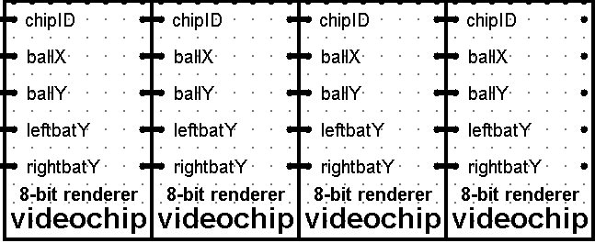
General view of the video system
(Connection of 4 sections of 8 chips)

The video system in the project is responsible for converting calculations into an image. The video chip is the most important component of the video system. Its task is to control one column (1x32 pixels) on a 32x32 pixel screen. The video system is built according to the following principle: 8 chips are combined into a section (videochip8), after which 4 such sections are connected in series, respectively, the entire display field remains covered. Using this method simplifies connections and minimizes the probability of errors.

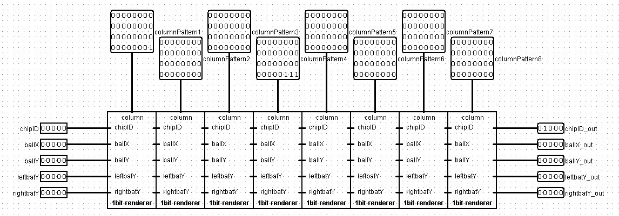
Fig. 1 – videochip8

The section (videochip8) is a block consisting of 8 interconnected chips. Such a section generates a quarter of the image (8 columns of 1 pixel). It receives as input the coordinates of the ball (ballX and ballY) and paddles (leftbatY and rightbatY), as well as chipID, which corresponds to the video chip number (i.e., column number) and is incremented by 1 after each passed chip (Fig. 2).

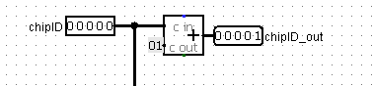
Fig. 2

ChipID is compared with leftbatX (3) and rightbatX (28) to generate the paddle in case of a match. Each of the paddles is generated as follows: we have leftbatY/rightbatY, i.e., the bottom pixel of the paddle, then we obtain the coordinates of the two pixels above it by adding ones sequentially to each (coordinate scheme for the left paddle in Fig. 3, the right one is similar). These values are 5-bit, so we convert them using decoders into 3 sets of 32 lines, where only the pixel corresponding to the given coordinate remains active; all three lines are fed to the output.

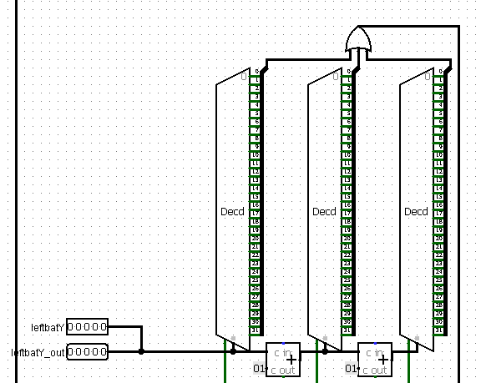
Fig. 3

The video chip also renders the ball (Fig. 4): it checks whether it is in the given column; if so, it outputs it at the ballY coordinate (the multiplexer transmits the ball's Y coordinate, converted by the decoder).

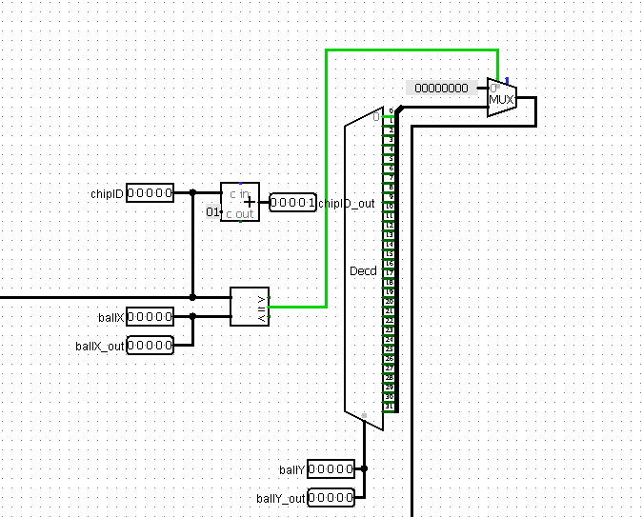
Fig. 4

Part 3. Controller

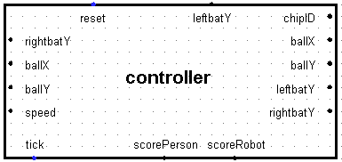
Fig. 1 - General view of the controller

We move on to one of the most complex and important parts of the circuit. The controller in our project is responsible for almost everything: storing data such as the position of the ball along the ordinate axis (Y) and the abscissa axis (X), the player's score and the robot's score, the ball's speed along the ordinate axis (Y) and the abscissa axis (X), the position of the right and left player paddles; calculating the ball's position on the next tick; the ball bouncing off the players' paddles, walls, and ceiling; resetting the game process; keeping the players' score.

Controller inputs:

- reset – 1-bit input. When a high signal 1 is applied, the game resets: the paddles move to pre-programmed default coordinates, the players' counters become zero, the ball's speed along the ordinate axis (Y) and the abscissa axis (X) assume pre-programmed default values.
- leftbatY – 5-bit input. Position of the left paddle (player's paddle position). The controller receives this value from the 5-bit joystick.
- rightbatY – 8-bit input. Position of the right paddle (robot's paddle position). The controller receives this value from the processor, where this value was obtained by executing a specific algorithm, which will be described in Chapter 5.
- tick – 1-bit input. This input is responsible for the "life" of the controller. The controller receives the clock value from a clock generator outside the microcircuit.

Controller outputs:

- chipID – 5-bit output. By default, the controller outputs the value 0, which is necessary for the correct operation of our video system.
- ballX (right) – 5-bit output. The ball's position relative to the abscissa axis (X) is transmitted to the video system for subsequent display on the 32x32 pixel screen.
- ballY (right) – 5-bit output. The ball's position relative to the ordinate axis (Y) is transmitted to the video system for subsequent display on the 32x32 pixel screen.
- ballX (left) – 5-bit output. The ball's position relative to the abscissa axis (X) is transmitted to the processor for further use of this data in calculations by the algorithm.
- ballY (left) – 5-bit output. The ball's position relative to the ordinate axis (Y) is transmitted to the processor for further use of this data in calculations by the algorithm.
- leftbatY – 5-bit output. Position of the left paddle (player's paddle) relative to the ordinate axis (Y). Transmitted to the video system for subsequent display on the 32x32 pixel screen.
- rightbatY – 5-bit output. Position of the right paddle (robot's paddle) relative to the ordinate axis (Y). Transmitted to the video system for subsequent display on the 32x32 pixel screen.
- speed – 8-bit output. The speed relative to the ordinate (Y) and abscissa (X) axes is stored in the format 00yyyxxx, where xxx is the 3-bit speed of the ball along the abscissa axis (X), and yyy is the 3-bit speed of the ball along the ordinate axis (Y).
- scorePerson – 8-bit output. Transmits the player's score value.
- scoreRobot – 8-bit output. Transmits the robot's score value.

Now let's examine the controller's operation in more detail, considering individual parts of the microcircuit.

- chipID. The simplest part of the microcircuit. The corresponding output simply receives the constant 0.

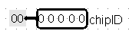
Fig. 2 - chipID output

- Game reset and clock input.
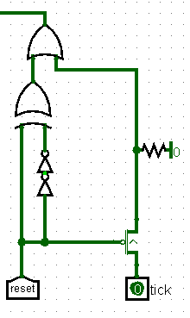
Fig. 3 - Reset and clock input

The tick input receives the value from the external clock generator. When reset = 0, the value of this input is transmitted to the controller without any changes, since the p-type transistor is always open.
If reset = 1, the transistor blocks the tick input, the controller receives signal 1, then using the delay of paired NOT logic gates, the reset value and NOT(NOT(reset)) are divided modulo 2, and the value 0 is supplied to the controller. Our microcircuit uses registers of different edges – front and back. To reset registers with a front edge, a rising signal is required; to reset registers with a back edge, a falling signal is required. We achieve a universal reset of all registers by using the delay of NOT logic gates and the XOR logic gate.

- Registers with ball speeds relative to two axes.
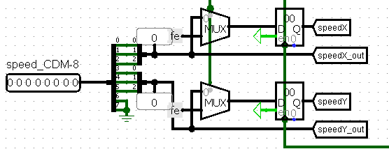
Fig. 4 - Speed registers

These two registers are responsible for storing the ball's speeds relative to the ordinate (Y) and abscissa (X) axes. Both are on the front edge to fix the speed values on the rising clock input for calculating the new position of the ball on the field and, possibly, correcting the speeds themselves. Upon reset, signal 1 is supplied to the multiplexer, whereby the input to the register receives not the old speed value, but the value we programmed by default – values -2 and -2 for both speeds. The second input of the multiplexer is occupied by the new value of the ball's speeds relative to the axes (which, of course, may remain unchanged). These two values are converted from 8 bits to 3 bits and, using three splitters, are assembled into one 8-bit number, which goes to the output of the microcircuit and which the processor later uses for calculations.

- Registers with ball coordinates on two axes.
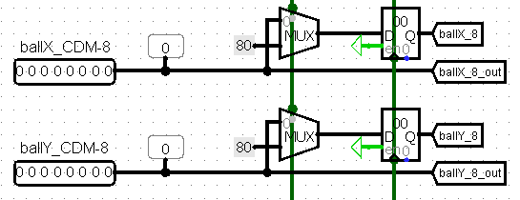
Fig. 5 - Ball coordinate registers

These two registers are responsible for storing the ball's coordinates along the ordinate (Y) and abscissa (X) axes. Both are on the back edge because the value needs to be written on the falling signal, accepting the new coordinate value that was calculated on the rising signal. Upon reset, signal 1 is supplied to the multiplexer, whereby the input to the registers receives not the old ball position values, but the values we programmed by default – values 128 and 128 for both coordinates. The second input of the multiplexer is occupied by the new ball coordinate values that were calculated on the last tick.

- Game score registers.
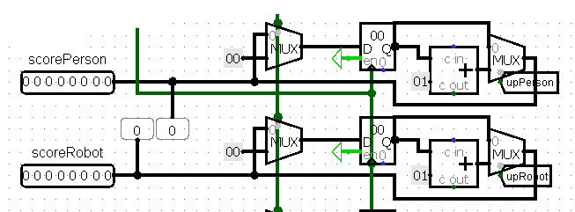
Fig. 6 - Game score registers

These two registers are responsible for the game score; one stores the player's points, the second stores the robot's points. Both are on the front edge because the value must be fixed before calculating new data. Upon reset, signal 1 is supplied to the multiplexer, whereby the input to the registers receives not the old score values, but the values we programmed by default – values 0 and 0 for the player and the robot. The second input of the multiplexers is connected to wires originating from other multiplexers: they increase the register value by one if upPerson or if upRobot supplies the value 1.

- Receiving and converting data about the right robot paddle.

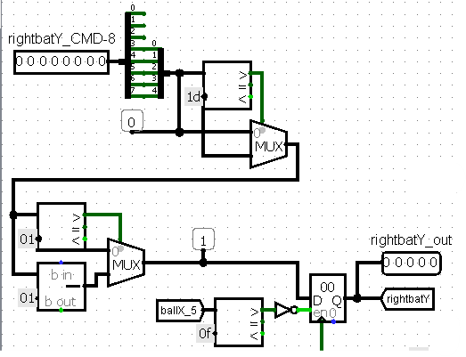
Fig. 7 - Data conversion (rightbatY)

As noted earlier, the controller receives an 8-bit value of the right paddle's position relative to the ordinate axis (Y) from the processor. We convert this value using a splitter into a 5-bit value, using the first five most significant bits for greater accuracy.

It is worth noting a certain feature of our circuit. If the right paddle's value is greater than 29, the paddle will protrude from the bottom of the 32x32 pixel screen, which is unacceptable. After converting to a 5-bit number, we check that this value does not exceed 29; if it does, the multiplexer outputs a pre-programmed value of 29, which solves the described bug.

There is also a feature in calculating the right paddle's position value. Our algorithm outputs a value intended for the bottom (third from the bottom) pixel, so sometimes the ball may simply fly past the paddle from below, which is also unacceptable. We forcibly decrease the calculated value by one, which solves the described problem.

To store the right paddle's position value, we use a front-edge register. For this register, the enable input is not just power (constant 1), but a value that the comparator outputs: if the ball is in the right half of the playing field, that is, the ball's coordinate relative to the abscissa axis (X) exceeds 15, the robot cannot change the position of its paddle. This is necessary for game balance, otherwise the robot would be unbeatable.

- Ball bouncing off the ceiling and floor.

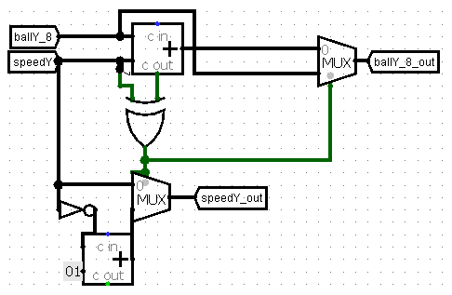
Fig. 8 - Ball bouncing along the ordinate axis (Y)

This part of the microcircuit receives the ball's position relative to the ordinate axis (Y) and the speed relative to the ordinate axis (Y). Then these two values are added: if the speed is positive and overflow occurs (that is, a carry-bit appears), it means the ball touched the ceiling; if the speed is negative and overflow does not occur, it means the ball touched the floor. In both cases, we convert the speed and transmit new speed and ball position values relative to the ordinate axis (Y).

- Ball bouncing off walls and paddles.

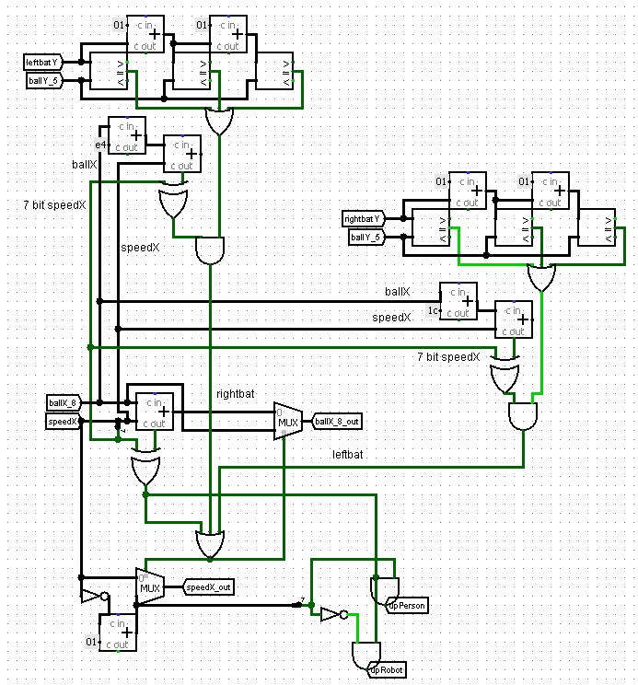
Fig. 9 - Ball bouncing off walls and paddles

Let's start with the ball bouncing off the walls. This part is completely analogous to the ball bouncing off the ceiling and floor, except we also supply a 1-bit signal into the tunnel upPerson or upRobot, depending on who exactly missed the ball. Then this 1-bit array goes to the multiplexer near the register and increases the player's or robot's score by one. This was described above.

Let's move on to bouncing off the paddles. In general, both bounces are similar, differing only in the positions of the player's and robot's paddles – 3 and 28 respectively. The general idea: if the ball's coordinate relative to the ordinate axis (Y) matches one of the paddle's coordinates relative to the ordinate axis (Y) and, at the same time, the ball and paddle have the same coordinate relative to the abscissa axis (X), then it is necessary to bounce the ball.

- Conversion and output of ball position data.
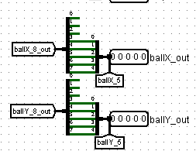
Fig. 10 - Ball data output

The calculated ball position values are converted from an 8-bit number to a 5-bit number because our video system works specifically with 5-bit numbers.

- Output of the left player paddle position value.

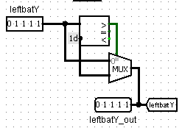
Fig. 11 - Output of left player paddle position data

The same trick used for the right paddle is applied here to prevent the left paddle from protruding from the bottom of the screen.

Thus, we have described in detail the operation of our controller; we move on to other microcircuits of our project.

Part 4. Processor
The following shows how the CdM-8 is connected to the circuit and how data exchange occurs between the processor and the controller.
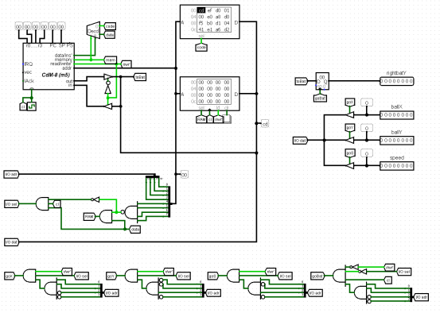
Fig. 1 – general processor connection diagram
As can be seen from the diagram presented above, we used the Harvard architecture with RAM and ROM. The choice was made based on ease of implementation, as well as the reliability and speed of such a system. The processor sequentially reads the contents of the ROM. The decoder allows determining whether the read was an instruction that needs to be executed, or data that needs to be processed.
In the case when a RAM cell is accessed, the signal is processed by the following structure (2), which checks whether data exchange is taking place with one of the cells of interest to us, extracts its number, and sends a signal that a RAM access or I/O device access is occurring.
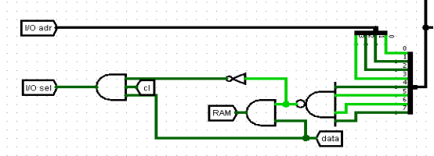
Fig. 2 – structure for processing the access location
Next, each of the "turnstiles" checks whether a write or read is occurring, whether we are accessing I/O devices, as well as the memory cell number. We designated the devices for data exchange with the controller as cells 0xf (3-5). When the "turnstile" receives the values defined for it, it sends a positive signal to the controlled buffer, which regulates the exchange of corresponding data with the controller, and the processor receives (or writes) these values.

Fig. 3 – "Turnstiles"

Part 5. Robot Algorithm
In this chapter, we will describe the operation of our algorithm for the robot. First, we present the assembler code, then in a simpler pseudocode form.

asect 0x00

setsp 0xef

while
ldi r0, 1
tst r0
stays nz
if
ldi r0, 0xf5
ld r0, r0
ldi r1, 0b00000100
and r0, r1
is z
if
ldi r2, 0xf3
ld r2, r2
ldi r1, 120
cmp r1, r2
is ls
ldi r2, 0xf3
ld r2, r2
ldi r1, 224
sub r1, r2

move r0, r1
ldi r3, 0b00000111
and r3, r1

ldi r3, 0b00111000
and r3, r0
shra r0
shra r0
shra r0
if
ldi r3, 0b00000100
and r0, r3
is nz
ldi r3, 0b11111000
or r3, r0
fi

if
ldi r3, 1
cmp r1, r3
is nz
if
ldi r3, 2
cmp r1, r3
is z
shra r2
ldi r3, 0b01111111
and r3, r2
else
push r0

ldi r0, 0
shla r1
while
cmp r2, r1
stays hi
inc r0
move r1, r3
sub r2, r3
move r3, r2
wend

ldi r3, 2
sub r2, r3

move r0, r2
add r2, r2

if
tst r3
is pl
inc r2
fi

pop r0
fi
fi

if
ldi r3, 0b00000100
and r0, r3
is nz
ldi r1, -1
else
ldi r1, 1
fi

push r2

while
cmp r0, r1
stays nz
if
ldi r3, 0b00000100
and r0, r3
is nz
dec r1
else
inc r1
fi
pop r3
push r3
add r3, r2
if
is cs
push r0

ldi r3, carry
ld r3, r3
inc r3
ldi r0, carry
st r0, r3

pop r0
fi
wend
pop r3

if
ldi r3, 0b00000100
and r0, r3
is nz
neg r2
fi

if
ldi r3, 0b00000100
and r0, r3
is nz
ldi r0, 0xf4
ld r0, r0
add r0, r2

ldi r3, carry
ld r3, r3

if
is cc
inc r3
fi
else
ldi r0, 0xf4
ld r0, r0
add r0, r2

ldi r3, carry
ld r3, r3

if
is cs
inc r3
fi
fi

if
ldi r0, 0b00000001
and r3, r0
is nz
neg r2
fi

if
ldi r0, 0xf3
ld r0, r0
ldi r1, 112
cmp r1, r0
is pl
if
ldi r0, 0xf5
ld r0, r0
ldi r1, 0b00000100
and r0, r1
is z
ldi r0, 0xf3
st r0, r2
fi
fi

ldi r0, 0
ldi r1, carry
st r1, r0
fi
fi

wend

halt

INPUTS>
ENDINPUTS>
carry: ds 1
end

Now let's provide the pseudocode.

carry_counter = 0

while True:
speed = read(0xf5)
speedX = speed & 0b00000111
speedY = (speed >> 3) & 0b00000111

if (speedX < 0):
continue

if (coordinateX > 120):
continue

result = read(0xf3)
result = 224 - result

result = result / speedX

result = abs(result * speedY)

if (carry_bit == 1):
carry_counter = carry_counter + 1

result = result * sign(speedY)

coordinateY = read(0xf4)

result = result + coordinateY

if (carry_bit == 1):
carry_counter = carry_counter + 1

if (carry_counter % 2 == 1):
result = not(result)

if (coordinateX < 112):
if (speedX > 0):
write(0xf3, result)

carry_counter = 0

Our algorithm takes the speed value. If it is positive, it means the ball is moving towards the robot's paddle – we proceed further. If the ball's coordinate relative to the abscissa axis (X) is greater than 120, it means the processor will no longer have time to calculate the new paddle position, we skip the iteration; otherwise, we start calculations.

We read the ball's coordinate relative to the abscissa axis (X) from address 0xf3. Then we subtract this value from 224. We get the distance from the ball to the robot's paddle. Next, we divide this value by the ball's speed relative to the abscissa axis (X) – we get the number of iterations after which the ball will be in the column of the right paddle. Then we multiply this number of iterations by the ball's speed relative to the ordinate axis (Y). We get the vertical displacement of the ball during its horizontal flight to the right paddle. We add the current ball coordinate relative to the ordinate axis (Y) to this value. If during addition we got a carry-bit for a positive speed (or did not get it for a negative speed), it means the ball bounced off the ceiling or floor. As a result, if carry_counter becomes odd, we subtract the calculated result from 256. Then we transmit this value to the controller, and from there to the video system.

To ensure the robot is not unbeatable, we use a technical feature of Logisim: because the processor may not have enough cycles to calculate the right paddle's position, it can sometimes place it in the wrong position, which allows achieving some balance. When supplying 15 times more clock cycles to the processor than to the controller, the robot misses approximately half the cases.

Part 6. External Elements and Overall Schematic

Let's briefly review the remaining microcircuits of the project.

- Score indicators.

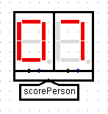
Fig. 1 – Score display
The inputs of the hexadecimal indicators are connected to the outputs of a special microcircuit, which converts the player's score and the robot's score from a regular number into the number of ones and the number of tens.
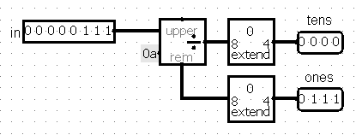
Fig. 2 – Auxiliary schematic
- Reset button and joystick.
The reset button supplies a 1-bit signal to the controller upon game reset; the joystick transmits the left player paddle's position to the controller along the ordinate axis (Y).
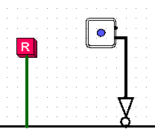
Fig. 3 – Other elements

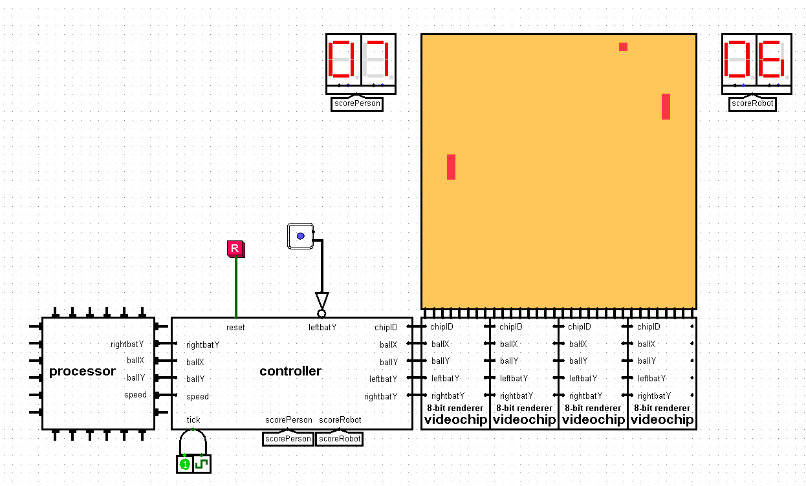
Fig. 4 – Overall schematic view

